­­­­­­­­

**My visit to Brimbank Park**

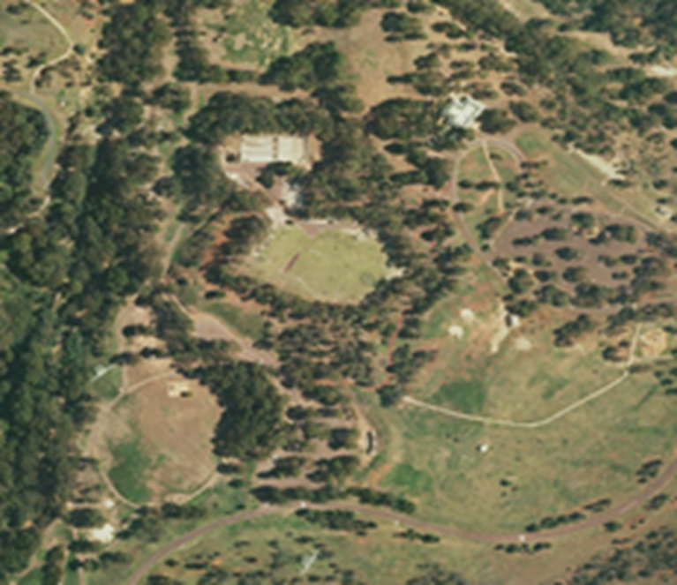

I am going to Brimbank Park. There will be people at the park.

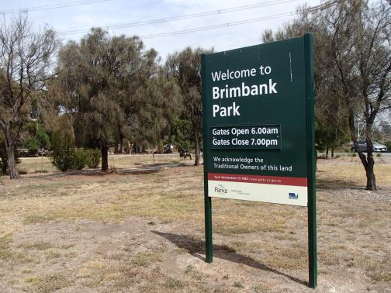

At Brimbank Park I can do many different things.

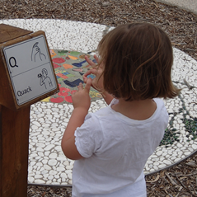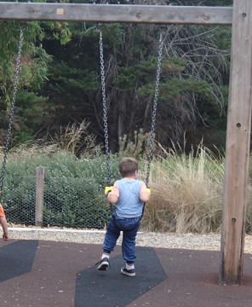

I can play in the playground.

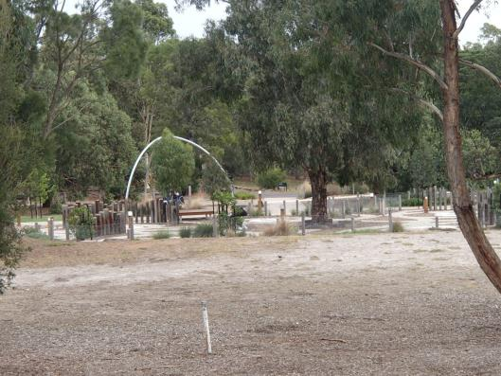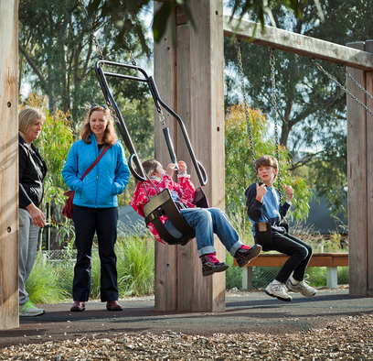

I can play in the sandpit. I can sit in the sandpit and play.   
I can stand next to the sandpit and play.

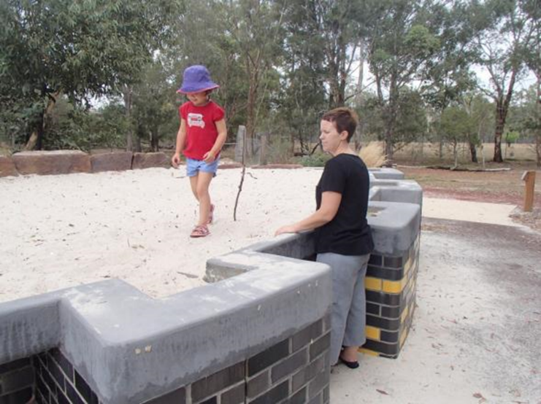

­­­­­­

I can play in the big bird’s nest. I can go inside the bird’s nest. Inside the bird’s nest it is quiet. I can go here if I need/want to be by myself.

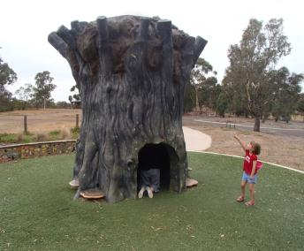

I can climb to the top of the ladder inside the bird’s nest. I can stand at the top and look down. I need to be safe when I am up at the top.

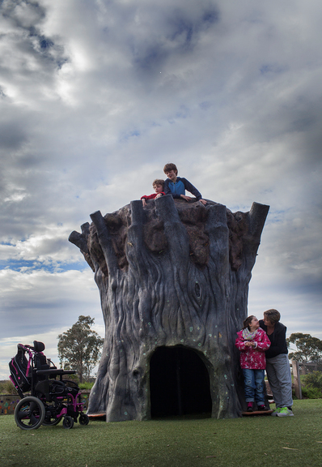

I can build a cubby. I can play in the cubby. I can do this with my   
friends or family. I can go here if I need to be by myself.

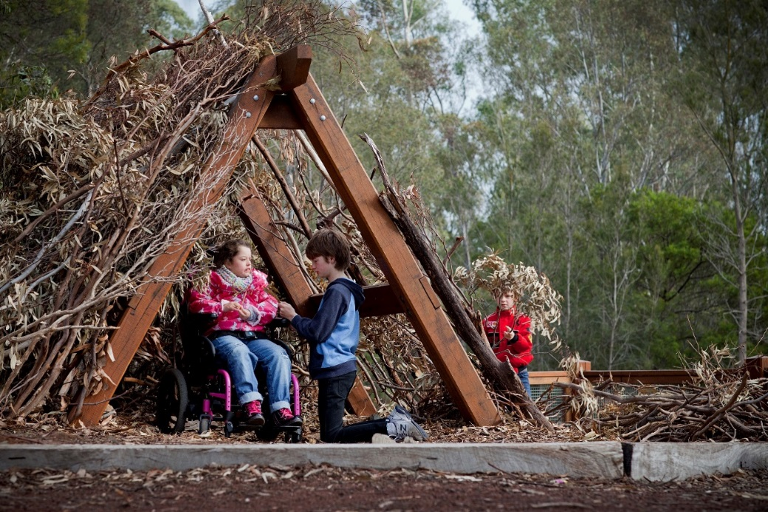

I can use the music box. It makes lots of different sounds. I can choose what sound I want it to make. I have to turn the handle to make it work. I can ask my adult or friend for help.



Music

Move both extended index fingers, palms down, from side to side in opposite directions as though conducting music.



Box

Open both hands, in front of body, palms facing. Turn hands to palms facing body, one in front of the other.

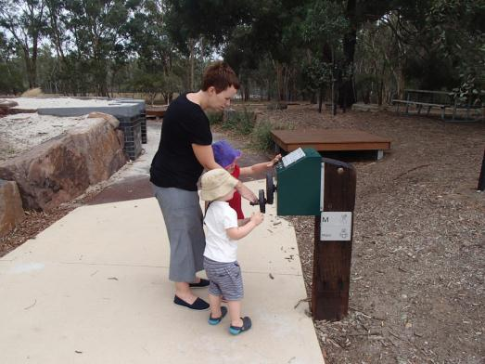

In the playground there are wooden platforms. I can sit and rest here. I can sit and eat here.

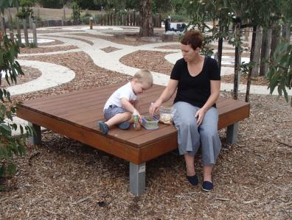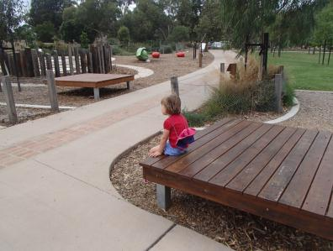

When I am in the playground, I have to be safe. I have to stay near my adult. Next to the playground there is a road. It has this sign next to it. That means a car might drive on it. I have to look for cars.



Safe

Move blade of slightly cupped dominant hand, across open palm of non-dominant hand towards body.

.

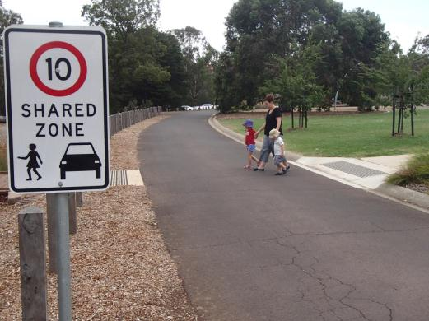

There are toilets near the playground. If I need to go to the toilet, I need to tell my adult.

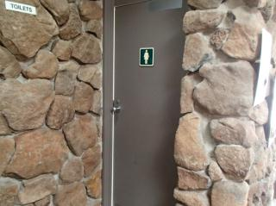

There are hand dryers in the toilets. People use them to dry their hands. They have a push button. If I push that button it will start. These hand dryers make a lot of noise

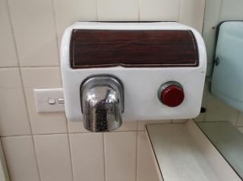There are places in the park where people can cook their food. There are places in the park where I can eat my food. I can sit at a table and eat my food. I can sit on a blanket and eat my food.

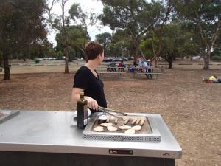

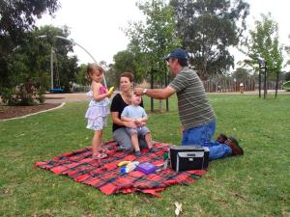

There are people that work in the park. They are called park rangers.   
They wear a uniform. If I meet a park ranger I can ask them questions about the park.

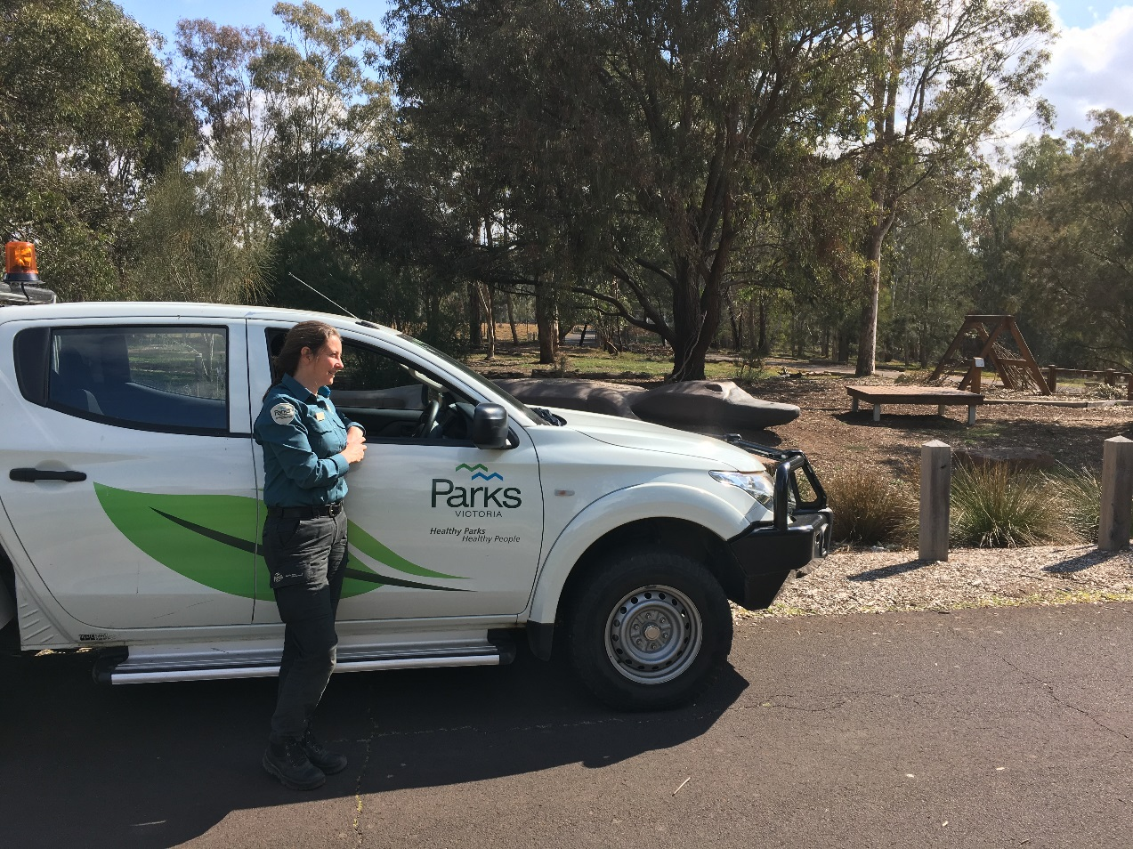

I can go for a walk in the park. I have to stay with my adult.   
This keeps us safe.

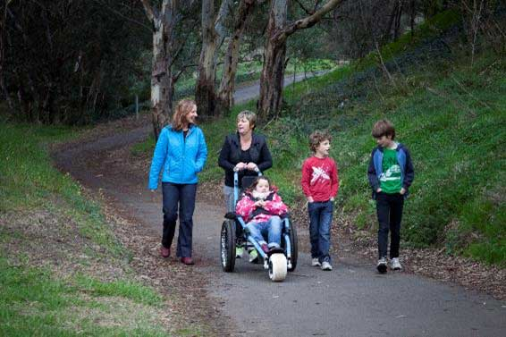

There are many aeroplanes that fly over the park.

I might hear the noise from the aeroplanes.

I might see the aeroplanes.

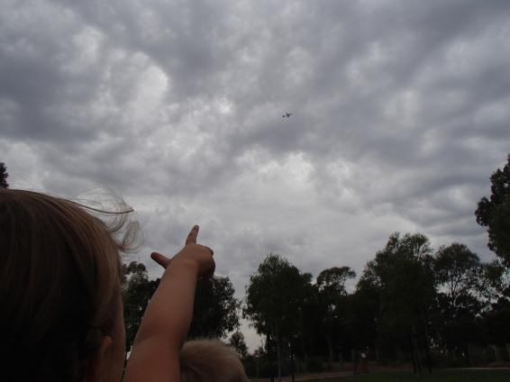

There is a café in the park. Sometimes the café is closed. I can eat my food  
in the café. I can buy things to eat at the café.

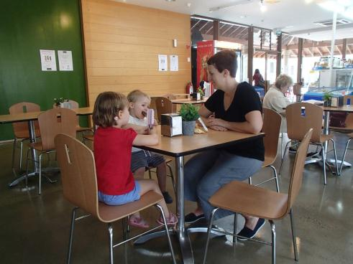

In the café, there are maps of the park. In the café, I can find out more information about the animals in the park.

