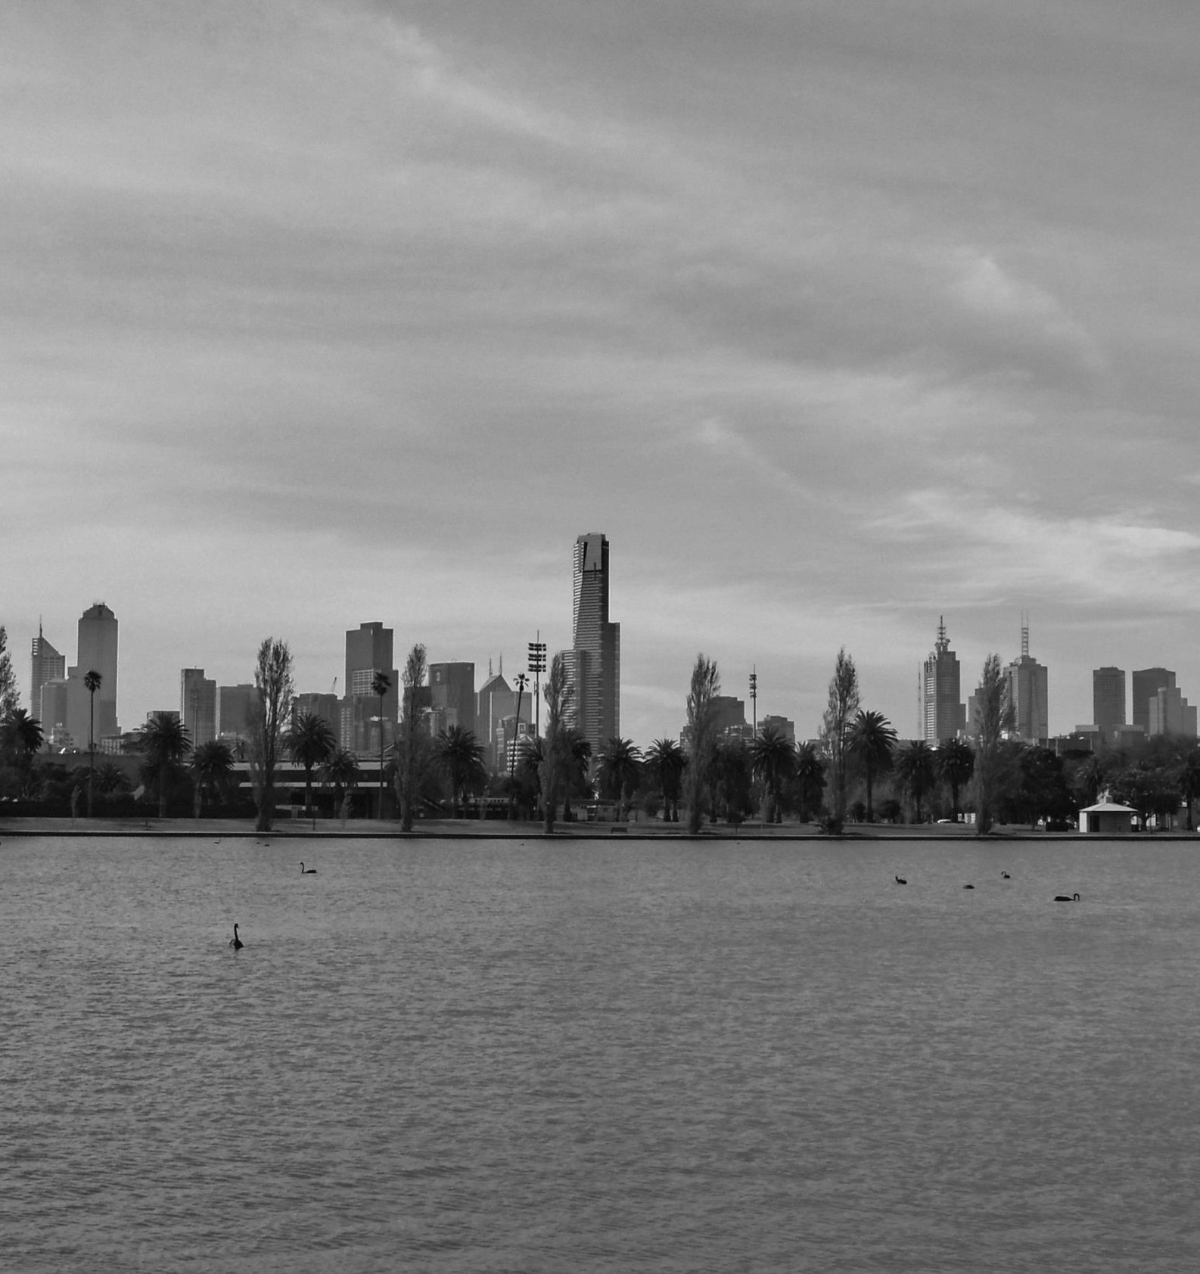

Albert Park Master Plan | Engagement Summary

Albert Park Master Plan

Engagement Summary – Internal Report

CONTENTS
Project background 4
Participation 5
Key findings 7
- Lake Promenade 8
- Wetlands 10
- Play, Picnic and Fitness 12
- Event and Community Spaces 14
- Lake Bridge 16
- Welcoming Entrances 18
- Park Landscape 20
- Roads and Parking 22
- Parklands 24
- Sport grounds 26
- General advice 28

Project background

Introduction

Parks Victoria commissioned Andrew Howard Consulting to undertake analysis of the feedback collected during the final phase of engagement on the Albert Park Master Plan.

Albert Park has a long history and plays a significant role in the lives of both locals and greater Melburnians,
and visitors.

The plan contains a wide range of proposals focused on enhancing the park and increasing its usability and viability into the future.

About this report

This report presents the broad range of values, ideas and aspirations provided by community members and stakeholders during the engagement period, from December 2017 to January 2018.

The feedback has been collated and categorised, to understand topics, themes, demographics and support using both qualitative and quantitative analysis techniques.

Report limitations

Several factors influenced the analysis of this data and should be considered in reading this report. Factors include the following:

- The information presented within this report is a collation of the feedback collected from community and stakeholder participants and does not necessarily reflect the views of a representative sample of community.
- This report summarises key feedback from participants and does not preclude the project team from considering community submissions – particularly longer and more in-depth feedback – when developing the final plan.
- Comments from individuals have been combined or separated out based on the type of comments and the number of separate points, opinions or advice presented – as such the report focuses on both the number of comments and the number of participants who provided comment, and care should be taken in the reading and reporting of figures.
- The information and views presented in this report have not been independently validated. It is a summary of the opinions, perceptions and advice provided across the engagement period. As such, information presented within this report may be factually incorrect, or unfeasible.
- Due to the variety of formats through which community feedback was received, not all participant demographics have been captured across all feedback, where data was not captured or provided the term “Not known” or “NK” is used.
- Participants did not have to respond to all sections of the draft Plan, as such, feedback is primarily focused in certain areas of the plan, and on certain themes within these areas – this has been heavily influenced in this instance by the focus of news and social media on issues such as the golf course.

Participation

Channel and type

This report assessed 2,907 comments collected from 1,366 participants.

87 per cent of comments were received via the online survey, and 9 per cent of comments were from individuals rather than organisations.

The average number of comments per participants was about two. The highest number of comments from one participant was 27.

Engagement channel

Online Submission Email Face-to-face Series1 2536 131 62 178

Participant type

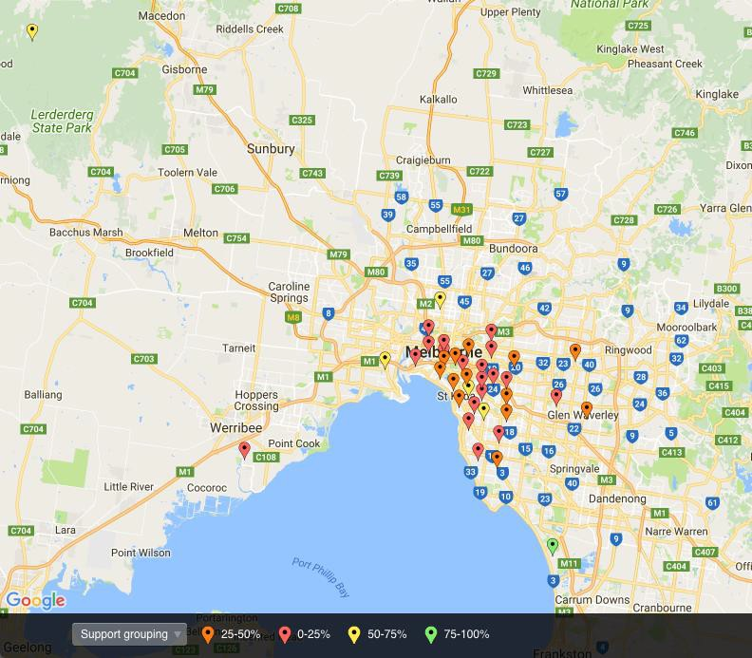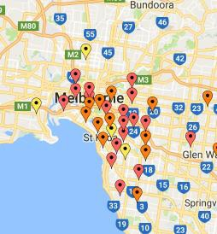

Spatial information

Approximately 6 per cent (183) of comments did not include a postcode. 39 postcodes had 10 or more comments, representing more than 78 per cent of the data. These are shown spatially below and grouped by the proportion of supportive comments in each postcode. The data shows comments were most often negative within a 4-6km radius of the park, and slightly more supportive in the immediate vicinity of the park.

A total of 34 comments came from interstate participants – representing a small proportion ( about 1 per cent) of the total comments.
Organisation 4%

Individual 96%

Gender and age

Nearly two-thirds (60 per cent) of comments came from male participants.

Just over a quarter (27 per cent) of responses came from female participants, and the remaining 13 per cent comprised organisations or individuals who did not provide this data.

All age groups were represented within the responses. The highest proportion (39 per cent) of comments came from the 50- 69 age group.

Age groups were distributed similarly across both genders, as graphed. For a small number of comments, the age and gender was ‘not known’ (NK on the graph).

800

700

600

500

400

300

200

100

0

Age and Gender

<15 15-24 25-34 35-49 50-69 70-85+ NK F M NK

Connection

Curling Walking Bowls

Rowing

Connection to the park

Participants were asked to indicate any relevant connection to the park, through particular sporting clubs or interest groups.

Nearly two-thirds (60 per cent) of comments were provided without identifying a specific or relevant connection to Albert Park.

Of the remaining, 18 per cent indicated a connection through ‘Golf’, following by ‘Football’ (4 per cent).

Cricket Action Group Social clubs
Tennis Athletics Triathlon Council Swimming Hockey Running
Local resident Sports Clubs
Cycling

Yachting/Sailing

Football

Golf

Blank

0 500 1000 1500 2000

Key findings

About the following section

The key findings have been separated into the 12 sections
– covering the key proposals,
some general advice and comments on the engagement process.

Each section looks at the demographics, themes and levels of support within that section.

Comments on Golf

Throughout the data a common reason for participation was the proposed reduction in size of the 18-hole golf course, and the relocation of the existing driving range.

It is noted that over half (52.5 per cent, or 1,524 comments) of all responses related to the issue of golf within Albert Park.

These comments have been left within the data set for sections where they do not significantly impact the legibility of other data, or shifted to separate segment within each section and commented on separately.

About golf?

No Yes

Lake Promenade

A total of 116 comments
(~4 per cent of the total) came related to the
‘Lake Promenade’.

Levels of support within this section were high, with 81 per cent of comments supporting this element of the plan.

Themes in support

Facilities - Toilets Maintenance Widening
Surface treatment

100

80

60

40

20

0

Support

Support Neither Oppose

Safety - Separation Safety - Lighting Rigging area Promote exercise
More bins and dog bags

General support Design - Enhance
5km track

0 5 10 15 20 25

Support Strong support

ABOUT PARTICIPANTS
- 95% from individuals
- 78% from online surveys
- 47% male respondents
- 30% female respondents
• 37% aged 50-60
• 22% aged 35-49
- Top postcodes:
o Not known (16%)
o 3205 (16%)
o 3182 (15%)
o 3004 (14%)
- Comments about golf? 9%

KEY SUPPORT:
- Widening the promenade
- General support
- 5km running track
- Promotion of exercise
- Separation of cycling/walking

NEUTRAL COMMENTS:
- Fine as it, just needs proper ongoing maintenance
- Propose timeclocks along running track

Safety - Separation

Maintenance

Themes in oppose

COMMENTS ABOUT GOLF
  - No significant impact to results from golf responses
  - General support if no
‘land grab’ for Golf Course

General oppose

Fine as is

Widening

Design - Natural

Cafes and restaurants

0 1 2 3 4 5 6 7

KEY OPPOSITION:
Oppose Strong Oppose

- Widening is not needed
- Works on the promenade will take away from the natural beauty of the area
- Don’t change, just repair what’s there

Wetlands

A total of 128 comments (~4 per cent of the total) came related to the ‘Wetlands’.

Levels of support within this section were balanced, with 47 per cent of comments supporting this element of the plan.

Support

70

60

50

40

30

20

10

0

Partnership More vegetation Maintenance Litter/Debris Lake usage Impact to sailing General support
Fishing Design - Natural Design - Enhance
Boardwalk

Themes in support

0 5 10 15 20 25 30

Support Neither Oppose
Support Strong support

ABOUT PARTICIPANTS
- 91% from individuals
- 75% from online surveys
- 50% male respondents
- 27% female respondents
• 41% aged 50-60
- 25% age not known
- Top postcodes:
o 3004 (20%)
o 3182 (12%)
o 3206 (11%)
o Not known (10%)
- Comments about golf? 7%

KEY SUPPORT:
- General support
- Tidying up the lake and managing litter
- Support for a boardwalk that is in keeping with the natural surrounds
- Increasing native vegetation
- Support but with care to impacting sailing
- Partnerships with Melbourne Water

NEUTRAL COMMENTS:
- Fine as it, just needs proper ongoing maintenance and litter management
- Need to manage or remove Gunn Island
- Reservations about boardwalk impact on wildlife

Safety - Drowning Remove Gunn Island

Themes in oppose

COMMENTS ABOUT GOLF
  - No significant impact to results from golf responses
  - General support if no
‘land grab’ for Golf Course

Reduce golf course

Maintenance

Litter/Debris

Impact to sailing

Impact to rowing

General oppose

Fishing

Boardwalk

0 2 4 6 8 10 12 14 16

Oppose Strong Oppose

KEY OPPOSITION:
- Location of boardwalk and its impacts on rowing
- No faith in Parks to deliver based on existing levels of litter and debris
- Picnic areas within the boardwalk and risk of drowning, litter, or to wildlife
- Opposition to fishing – animal cruelty and impacts to rowing
- Vegetation impacts on sailing
- Reduction of the gold course to 9 holes

Play, Picnic and Fitness

A total of 87 comments (~3 per cent of the total) came related to the ‘Play, picnic and fitness’.

Levels of support within this section were fairly balanced, with 44 per cent of comments opposing this element of the plan.

Support

40
35
30
25
20
15
10
5
0

More trees Reduce golf course
Picnic areas Parking concern General oppose Fitness elements Facilities - BBQ Design - Natural

Themes in oppose

0 5 10 15 20

Support Neither Oppose
Series1 Series2

ABOUT PARTICIPANTS
- 92% from individuals
- 84% from online surveys
- 54% male respondents
- 29% female respondents
• 51% aged 50-60
• 15% aged 35-49
- Top postcodes:
o 3004 (21%)
o 3182 (20%)
o 3206 (15%)
o 3205 (14%)
- Comments about golf?
24%

KEY OPPOSITION:
- Reduction of the golf course to 9 holes
- General opposition – fine as it is
- Built forms that introduce
‘more concrete’
- Elements that detract from a natural walk – ‘this is not Disneyland’

NEUTRAL COMMENTS:
- Play grounds should be nature-based
- Reservations about impacts to Golf Club and parking
- Needs proper ongoing maintenance and litter management

Facilities - Other Safety - Shade trees
Picnic areas Partnership

Themes in support

COMMENTS ABOUT GOLF
  - Some impact to results from golf responses
  - ‘If it impacts golf, don’t do
it’
  - Comments oppose the reduction of a sport that is considered inclusive of ages, abilities and gender

More for youth

Litter

General support

Fitness elements

Facilities - Toilets

Design - Natural

Cafes and restaurants

Access - Inclusive

0 2 4 6 8 10 12 14

Support Strong support

KEY SUPPORT:
- General support – promoting fitness and inclusive elements
- Support for design that is in keeping with the natural environs
- Support for facilities to engage/cater for youth
- Partnerships with Council and community

Event and Community Spaces

A total of 728 comments (~25 per cent of the total) came related to the ‘Event and community spaces’.

Levels of support within this section were strongly influenced by impacts to golfing – 88 per cent oppose.

With the golfing comments removed, 66 per cent of comments oppose this element of the plan.

Support (no Golf)

120

100

80

60

40

20

Themes in oppose (Golf comments removed)

Waste Management Underutilised land School facilities
Safety Parking concern
More trees General oppose Fitzroy St plaza Facilities - Toilets Event impacts Design - Natural

0
Support Neither Oppose
0 10 20 30 40 50

Oppose Strong Oppose

ABOUT PARTICIPANTS
- 99% from individuals
- 98% from online surveys
- 74% male respondents
- 20% female respondents
• 34% aged 35-49
• 33% aged 50-69
- Top postcodes:
o 3182 (10%)
o 3004 (8%)
o 3206 (7%)
o 3205 (6%)
- Comments about golf?
78%

KEY OPPOSITION:
- General opposition – fine as it is, plenty of land and facilities to use for picnics
- Opposition to Fitzroy St Plaza – ‘no more concrete’, ‘no more plane trees’, ‘safety risk – drugs and homeless’
- Built forms that introduce
‘more concrete’
- Oppose impacts of events, markets, and picnics (noise, litter, parking)

NEUTRAL COMMENTS:
- Reservations about impacts of events
- Comments on using native trees rather than plane trees
- Parking concerns

Underutilised land School facilities

Themes in support (no Golf)

COMMENTS ABOUT GOLF
- Significant impact to results from golf responses, (567
comments, 95% Opposed)

Support (Golf only)

More trees

Markets

General support

Fitzroy St plaza

Event impacts Design - Natural Access - Inclusive

0 2 4 6 8 10 12 14 16

Support Strong support

Neither Oppose
Strongly oppose Strongly support Support

  - Comments on the reduction of a sport that is

KEY SUPPORT:
    - Support for upgrading the Fitzroy St edge
    - General support – encouraging people to utilise the park and underutilised land
    - Support for facilities built with a natural design
    - More native trees planting was supported
    - Some support for markets, facilities for schools and more inclusive facilities
inclusive of ages and gender
    - Outrage at impacts to a long-standing, ‘iconic’ and ‘unique’ sports facility
    - Comments that there is enough land for events and picnics without impacting golf
    - Some support for reducing the grounds based on a sense of golfing ‘elitism’

Lake Bridge

A total of 218 comments (~7 per cent of the total) came related to the ‘Lake bridge’.

Levels of support were skewed towards opposition, with 72 per cent of comments opposing this element of the plan.

Support

Access - Connectivity Waste of money Safety - Drowning
Reduce golf course

Themes in oppose

180

160

140

120

100

80

60

40

20

0

Support Neither Oppose

Promote exercise Impact to sailing General oppose Amenity - Views Amenity - Setting

0 10 20 30 40 50

Oppose Strong Oppose

ABOUT PARTICIPANTS
- 98% from individuals
- 84% from online surveys
- 46% male respondents
- 37% female respondents
• 21% aged 35-49
• 47% aged 50-69
- Top postcodes:
o 3182 (14%)
o 3004 (13%)
o 3206 (11%)
o Not known (7%)
- Comments about golf? 1%

KEY OPPOSITION:
- Perception of cost/benefit
– seen as an unjustifiable
expense
- Feeling that a bridge would not be in keeping with the natural setting of the lake
- Opposed to impacts on view across the lake and to the cityscape
- Concern over impacts to sailing winds and access and the scale of a bridge that overcomes these impacts
- Concern over drowning danger, people jumping and water depth

NEUTRAL COMMENTS:
- Reservations about the potential expense of a new bridge, and a sense that the money could be better spent elsewhere

Fitness elements

Impact to sailing

Themes in support

COMMENTS ABOUT GOLF
  - No significant impact to results from golf responses
  - Comments on the reduction of a sport that is inclusive of ages and gender

Impact to rowing

General support

Design - Natural

Amenity - Views

Access - Connectivity

0 5 10 15 20 25

Support Strong support

KEY SUPPORT:
- General support – landmark feature
- Support for improved connectivity between north and south
- Support for promoting walking
- Support for a design that is sympathetic to the setting, and mitigating impacts to sailing and rowing
- Support for a new view of the city, and incorporating fitness into the bridge design

Welcoming Entrances

A total of 144 comments (~5 per cent of the total) came related to the ‘Welcoming entrances’.

Levels of support were generally positive, with 60 per cent of comments supporting this element of the plan.

Support

100

90

80

Maintenance Cycling paths Wayfinding Waste of money
Underpass revamp Safety - Traffic Safety - Lighting
Safety
Queens Rd crossing More vegetation
More trees
Improve Wright Street Improve Union Street

Themes in support

70

60

50

40

30

20

10

0
Support Neither Oppose
Improve Junction Corner
Improve Fitzroy St Improve Clarendon St Improve Cantebury Rd General support
Fine as is Design - Natural
Better pedestrian access

0 2 4 6 8 10 12 14 16

Support Strong support

ABOUT PARTICIPANTS
- 98% from individuals
- 97% from online surveys
- 51% male respondents
- 44% female respondents
• 26% aged 35-49
• 54% aged 50-69
- Top postcodes:
o 3182 (19%)
o 3206 (16%)
o 3004 (16%)
o 3205 (13%)
- Comments about golf?
17%

KEY SUPPORT:
- Strong support for better signage and wayfinding through and to the park
- Support for better lighting
– as long as the lighting is appropriate
- Support for natural landscaping, increased planting of trees and native vegetation
- Better pedestrian access, underpass revamps, traffic management and a crossing or over/underpass at Queens Rd all supported.

NEUTRAL COMMENTS:
- Reservations about the expense, some comments to leave it as is

Wayfinding Fine as is
Waste of money Underpass revamp

Themes in oppose

COMMENTS ABOUT GOLF
  - No significant impact to results from golf responses
  - Some support pending no changes to the golf course
  - General comments calling for the preservation of the 18 holes

Safety - Traffic

Safety - Lighting

Reduce golf course

Parking concern

Improve Fitzroy St

General oppose

Design - Natural

Cycling paths

Better pedestrian access

0 5 10 15 20

Oppose Strong Oppose

KEY OPPOSITION:
- General opposition – entrance points are fine as it
- Concerns about the proposed reduction of the Golf Course
- Comments on the safety of the underpasses and Fitzroy St is revamped – a sense this will invite more drugs and crime
- Confidence in Parks Victoria to deliver impacted by perceptions of poor current maintenance practices, particularly managing vegetation and cleanliness of the underpasses

Park Landscape

A total of 67 comments (~2 per cent of the total) came related to the ‘Park landscape’.

Levels of support were generally positive, with 67 per cent of comments supporting this element of the plan.

Support

50

45

40

35

30

25

20

15

10

5

0

General support Waste Management Safety - Shade trees
Paths More vegetation
More trees

Maintenance Improve Junction Corner
Design - Natural

Themes in support

0 5 10 15 20 25

Support Neither Oppose
Support Strong support

ABOUT PARTICIPANTS
- 97% from individuals
- 88% from online surveys
- 51% male respondents
- 31% female respondents
• 21% aged 35-49
• 54% aged 50-69
- Top postcodes:
o 3182 (28%)
o 3206 (15%)
o 3004 (12%)
o 3205 (10%)
- Comments about golf?
13%

KEY SUPPORT:
- Strong support for increased planting in the park – particularly native trees and vegetation.
- Trees highlighted as important for providing shade
- Support for landscaping that is sympathetic to the natural environment and improved access paths
- Support for a focus on waste and litter management, and better maintenance and upkeep

NEUTRAL COMMENTS:
- Reservations about the ability of Parks Victoria to deliver and upkeep any renewed landscaping

Waste Management

Safety - Shade trees

Themes in oppose

COMMENTS ABOUT GOLF
  - No significant impact to results from golf responses
  - Some support pending no changes to the golf course
  - General comments calling for the preservation of the 18 holes

Reduce golf course

More trees

Maintenance

Improve Junction Corner

Fine as is

0 2 4 6 8 10

Oppose Strong Oppose

KEY OPPOSITION:
- Concerns about the proposed reduction of the golf course
- Some criticism based on the selection of trees and their impacts on public health, plane trees for asthma and hay fever, and gumtrees for poor shade footprint
- Comments that planting locations are impacted by the ongoing needs of the Grand Prix
- Confidence in Parks Victoria to deliver impacted by perceptions of poor current maintenance practices, particularly managing vegetation and cleanliness of the underpasses

Roads and Parking

A total of 271 comments (~9 per cent of the total) came related to the ‘Park landscape’.

Levels of support were generally positive, with 62 per cent of comments supporting this element of the plan.

Support

180

160

140

120

100

80

60

40

20

0

Better pedestrian access Safety - Separation Road closures Queens Rd crossing Parking concern Pacify traffic General support Cycling safety Cycling paths Criterium
Access - Connectivity

Themes in support

0 20 40 60 80 100

Support Neither Oppose
Support Strong support

ABOUT PARTICIPANTS
- 97% from individuals
- 88% from online surveys
- 51% male respondents
- 31% female respondents
• 21% aged 35-49
• 54% aged 50-69
- Top postcodes:
o 3182 (28%)
o 3206 (15%)
o 3004 (12%)
o 3205 (10%)
- Comments about golf?
13%

KEY SUPPORT:
- Strong support for the introduction of a Criterium circuit
- Many users support the slowing down and ‘pacification’ of commuter traffic
- Support for the introduction of regular road closures – particularly amongst cycling community

NEUTRAL COMMENTS:
- Reservations about the impacts to pick-up and drop-offs for sporting clubs
- Comments on impacts to Queens Rd traffic and local traffic during road closures
- Comments support a Queens Rd overpass, but not an ‘at level’ crossing

Safety - Separation General oppose Access - Connectivity
Road closures

Reduce golf course

Themes in oppose

COMMENTS ABOUT GOLF
  - No significant impact to results from golf responses
  - Some support pending no changes to the golf course
  - General comments calling for the preservation of the 18 holes
  - Comments on current good access to Driving Range

Queens Rd crossing

Parking concern

Pacify traffic

Cycling safety

Criterium

0 5 10 15 20 25 30 35 40

Oppose Strong Oppose

KEY OPPOSITION:
- Concerns about the impacts of road closures to general commuter traffic, and local road and parking, reference to Grand Prix impacts
- Parking a concern, particularly overflow into local streets

Parklands

A total of 285 comments (~10 per cent of the total) came related to the ‘Parklands’.

Levels of support within this section were strongly influenced by impacts to golfing but have been retained as only a small sample of responses remain otherwise.

Levels of support were generally negative, with 82 per cent of comments opposing this element of the plan.

Support

250

200

Underutilised land Maintenance Woodlands Reduce golf course
More trees

Litter/Debris Impact to sailing General oppose

Themes in oppose

150
Fine as is

100

50

0

Support Neither Oppose

Driving range relocation

0 50 100 150 200 250

Oppose Strong Oppose

ABOUT PARTICIPANTS
- 95% from individuals
- 70% from online surveys
- 55% male respondents
- 29% female respondents
• 39% aged 50-69
- 29% age not known
- Top postcodes:
o Not known (15%)
o 3206 (12%)
o 3004 (12%)
o 3182 (9%)
- Comments about golf?
87%

KEY OPPOSITION:
- Strong opposition to the introduction of an Eastern woodland – at the expense of the golf course
- Criticism that the existing land is generally underutilised for picnicking, relaxation and socialising – so no more is necessary
- Concern that woodlands will impact on sailing winds on the lake, and decreased safety

NEUTRAL COMMENTS:
- N/A

Woodlands

Reduce golf course

Population growth

Themes in support

COMMENTS ABOUT GOLF
  - General comments calling for the preservation of the 18 holes
  - Criticism of Parks Victoria for a perceived ‘attack’ on golf
  - Calls for further investment in the golf course to enhance it ‘iconic’ status
  - Comments on current good access to Driving Range

More trees

General support

Driving range relocation

0 5 10 15 20 25 30

Support Strong support

KEY SUPPORT:
• Some support for the reduction in the golf course and relocation of the driving range due to perceptions that golf is elitist and exclusionary
• General support for the woodlands concept
• Support for additional parklands to support population growth in the area

Sport grounds

A total of 800 comments (~28 per cent of the total) came related to the ‘Sporting grounds’.

Levels of support within this section were strongly influenced by impacts to golfing – 75 per cent of comments related to golfing.

Levels of support were generally negative, with 71 per cent of comments opposing this element of the plan.

Themes in oppose

600
Waste of money

Criterium
Better dog walking
Upgrades needed

Underutilised land
Sharing grounds and buildings
Reduce golf course

500

400

300

200

100

0

Support

General oppose

Fine as is Driving range relocation
Design - Natural

0 100 200 300 400 500

Support Neither Oppose
Oppose Strong Oppose

ABOUT PARTICIPANTS
- 93% from individuals
- 91% from online surveys
- 63% male respondents
- 26% female respondents
• 44% aged 50-69
• 28% aged 35-49
- Top postcodes:
o 3206 (14%)
o 3004 (10%)
o 3182 (9%)
o 3205 (8%)
- Comments about golf?
75%

KEY OPPOSITION:
- Strong opposition to the reduction of the golf course and relocation of the driving range
- Common criticism that the existing golf course is well- patronised by a mix of genders and ages, and driving range well placed for access
- Other land is generally underutilised for sports during the week – so no more sharing or facilities are necessary

NEUTRAL COMMENTS:
- Recommend a fenced area for dogs
- Additional parking and expansion of the Aquatic centre needed

Themes in support

More swimming Upgrades needed Underutilised land
Sharing grounds and buildings

Safety - Lighting Reduce golf course
Putt-putt

Promote sports Maintenance General support Facilities - Toilets Facilities - Shelter
Facilities - Drinking fountains

Driving range relocation

Criterium

Better dog walking

COMMENTS THAT WERE NOT ABOUT GOLF
  - 600 comments in this section relate to golf, and heavily skew the result towards ‘oppose’
  - With these removed, levels of support flip – with 76% support and 20% opposed.

0 10 20 30 40 50 60 70

Support Strong support

KEY SUPPORT:
- Strong support for sharing grounds and buildings in order to accommodate more clubs and usage by various groups
- Strong support for upgrades to grounds (new ground treatments etc.), fields (lights, toilets and shelters), and clubs (more lockers, better facilities, better use of space etc.)
- Support for reducing the footprint of the golf course, and relocating the driving range in order to make a consolidate golf precinct and free up more space for other sports
- Support for introducing new sports and promoting existing one –
particularly the proposed criterium circuit

General advice

A total of 57 comments (~2 per cent of the total) came through as ‘General advice’.

Levels of support within this section were low, with 60 per cent of comments opposed to general elements of the plan or process.

Support

40
35
30
25
20
15
10
5
0
Support Neither Oppose

ABOUT PARTICIPANTS
- 90% from individuals
- 58% from online surveys
- 46% male respondents
- 23% female respondents
- 42% age not known
• 30% aged 50-69
- Top postcodes:
o 3206 (23%)
o Not known (21%)
o 3004 (16%)
o 3182 (11%)
- Comments about golf?
23%

SUPPORT COMMENTS
- Support the Grand Prix
- Support for addressing litter and waste management
- Support for more seating

NEUTRAL COMMENTS
- Not enough mention of the Grand Prix
- The language of the Plan does not positively mention golf.
- Plan maps need greater street details
- Ban smoking across the park
- Complaints about difficulty in using the online survey, or in the ‘loaded’ nature of questions

OPPOSE COMMENTS
- Strong opposition to the continuation of the Grand Prix
- Comments on the long disturbance to parklands before and after the Grand Prix
- A number of complaints about lack of consultation in the previous and current engagement process

28

