Little Desert Discovery Walk

Track Notes
Dalkaiana Wartaty – Welcome. The Wotjobaluk, Jaadwa, Jadawadjali, Wergaia and Jupagulk Peoples (collectively Wotjobaluk), the Traditional Owners of this land welcome you to country. This four-day walk has been designed to showcase the different ecosystems of the Little Desert National Park. These include heathlands, salt lakes, dry woodlands and the Wimmera River, all of which have their own appeal.
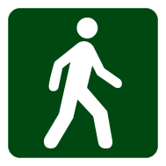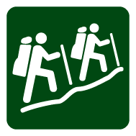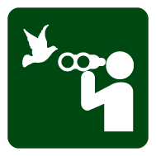
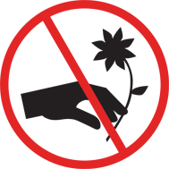

Getting there
You can begin the Little Desert Discovery Walk either from the Horseshoe Bend, Ackle Bend and Kiata campgrounds or from Conservation Volunteers, Little Desert Nature Lodge.

Walking track notes
Horseshoe Bend Campground to Yellow Gums Walkers Camp - 21km, 7 hours
Starting on the banks of the Wimmera River at Horseshoe Bend, the track winds its way along the river and through woodlands of majestic River Red Gums. The Traditional Owners of this area, the Wotjobaluk people, retain a close link with their land, particularly along the Wimmera River. Scarred trees, shell middens, stone tools and oven mounds have all been found in this area.
Follow the limestone winding track along the river; you will approach Crowhurst Flat. Old post fencing is a reminder of earlier European occupation.
Continue on until you reach Eagle Swamp. Keep an eye out for kangaroos, emus and other wildlife. After the spring rains, spectacular orchid displays can be found.
Walk along the sandy track until you reach Yellow Gums Walkers Camp.
Yellow Gums Walkers Camp to Kiata Campground - 21km, 7 hours
From Yellow Gums Walkers Camp, walk the 9km to Salt Lake. The track winds its way through the desert landscape with Common Fringe Myrtle and Broom bush along either side of the track.
Broom bush produce seeds that are a favoured food for Malleefowl. As you are walking, try and catch a glimpse of this shy desert dweller.
Salt Lake is a short lived body of water that when full, attracts numerous birds and animals.
Continue along the track until you reach Trig point. The 360 degree viewing platform gives walkers the opportunity to experience the raw beauty of the desert’s open surroundings.
You can see stunning Mount Arapiles in the distance or marvel at one of the spectacular sunsets.
Trig point was originally established for surveying purposes.
From here, walk the remaining 5km to the grassy woodlands of the Kiata Campground.

Kiata Campground to Mallee Walkers Camp - 20km, 7 hours
Take the time to explore the Kiata Campground. Evenings are a fantastic time to see possums. At dusk and dawn, listen for the laugh of kookaburras, or the warble of magpies.
As you leave Kiata Campground, the sandy track winds its way through Banksia shrubs and Flame heath. The bright red tubular flowers of the Flame heath are eaten by emus.
These hardy plants also attract native bees and butterflies.
Along this part of the track you walk by Albrecht’s Mill. Historical relics of former European settlement and grazing activities can be found throughout the park. An information board tells the story of the mill.
Pockets of Stringybark trees also occur on this section of the track.
Continue on the sandy track; as you approach Mallee Walkers Camp, you will walk past a small water hole. This was once used to provide water for stock.
Mallee Walkers Camp to Horseshoe Bend Campground - 13km, 4.5 hours
The remaining track is well defined and mostly sandy underfoot. The vegetation along the way varies from small scrubby bushes to occasional clumps of taller eucalyptus and pine trees.
Continue along until you reach the large, open and shady Horseshoe Bend Campground on the banks of the tranquil Wimmera River.
Overnight walkers are asked to register their details a week in advance via a Trip Intention Form (see additional resources) sent to LittleDesertDiscoveryWalk@parks.vic.gov.au

Facilities
The Desert Discovery Walk is marked by signposts and track markers.
Mallee and Yellow Gum Walkers Camps are accessible by walkers only. They have a fireplace, limited non potable water from a rainwater tank, a pit toilet, and an emergency shelter.
Please take all rubbish away for disposal or recycling.

Additional resources
Little Desert National Park – Overnight walking trip intention form
Little Desert National Park – Visitor guide

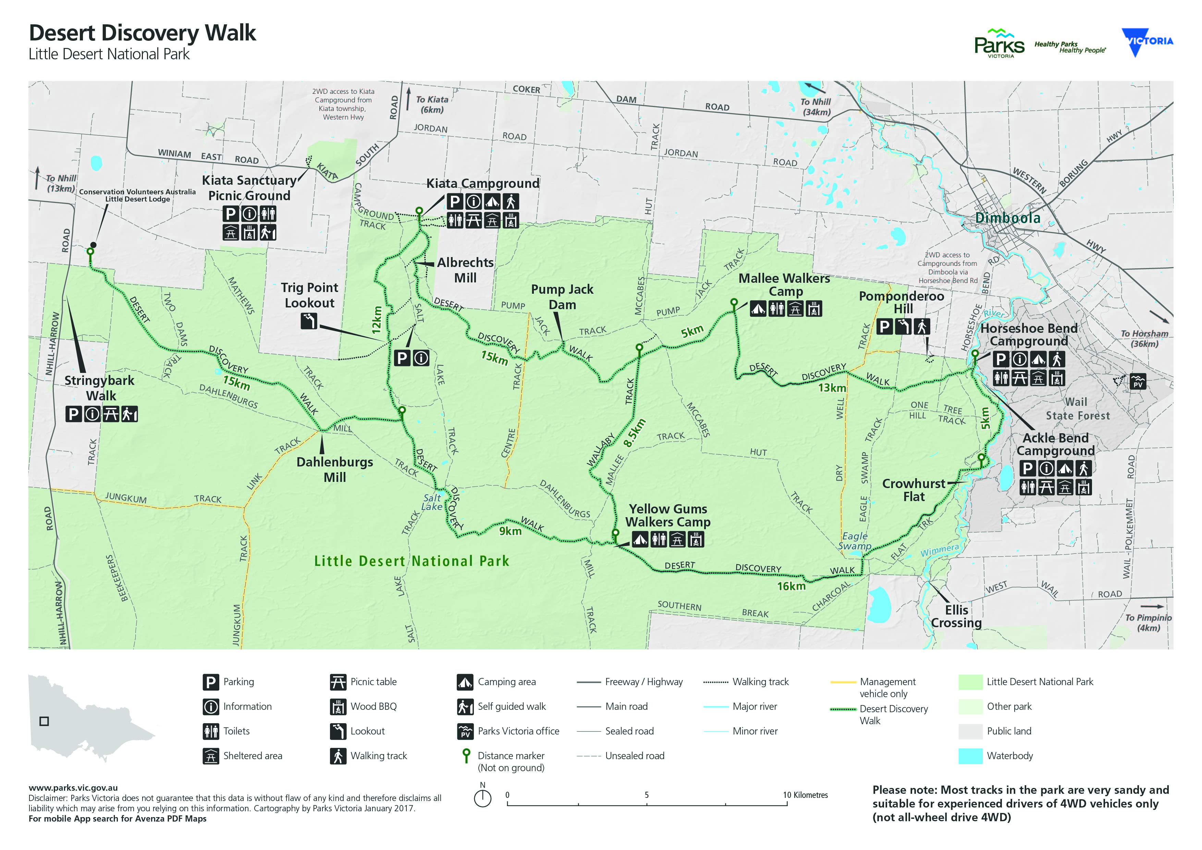

Preparing for your overnight walk

Before your trip
- Research your trip – using a current map and advice from experienced and local walkers.
- Understand the environment you are entering and the risks associated with it.
- Plan for the unexpected – extreme weather, bushfires, medical emergencies and becoming lost.

Book campgrounds
Horseshoe Bend and Ackle Bend campgrounds in the Little Desert National Park need to be booked in advance. Visit www.parks.vic.gov.au/stay or call Parks Victoria on 13 1963.
No booking fees apply for Kiata Campground or Yellow Gums and Mallee Walkers Camps.

Register your trip
The compulsory Trip Intention Form needs to be lodged at least a week in advance of your departure for an overnight hike in the Little Desert National Park. Email back to LittleDesertDiscoveryWalk@parks.vic.gov.au
Group sizes must not exceed 16 people (including leaders).

Be prepared and stay safe
- Know your limitations: Plan your route according to your group’s ability and experience.
- Water: Ensure all group members carry at least 3-4 litres per person per day. No drinking water is supplied. Limited non-potable water may be available from rainwater tanks at campgrounds and walker’s camps. For more information, visit the Parks Victoria website at www.parks.vic.gov.au/get-into-nature/safety-in-nature/be-aware-and-prepare/drinking-water
- Food: Carry enough food for every meal on your trip plus extra in case of an emergency.
- Clothing: Weather conditions can change quickly. Pack clothing suitable for a wide range of weather conditions, including waterproof jacket and pants, warm layers and clothing to protect from the sun.
- Equipment: Use the equipment checklist provided on the Trip Intention Form.
- Navigation: You should carry a current topographic map and a compass, and know how to navigate with them. GPS devices can be useful but should not be relied on as the primary navigation method. Make sure the datum corresponds to the map you are using.
- Wilderness First Aid: Carry a first aid kit that is equipped for use in a wilderness environment and know how to use it. Depending on your location, it may be many hours before help can reach you.
- Emergencies: Call Triple Zero (000) in an emergency. Have a plan for emergency situations and know when and how you will contact help. Do not rely on mobile phones as service is limited in the Little Desert. Service may only be available from higher elevations. Prior to your trip consider installing the Emergency+ smartphone app available from www.triplezero.gov.au. Consider carrying a PLB (personal locator beacon) or a satellite phone.

Know the weather
Always check weather conditions prior to your walk. Total Fire Bans are common during summer and autumn. Carry a small AM/FM radio or mobile phone to check condition updates while on your walk. Weather conditions can vary considerably at any time of year – be prepared for both extreme heat and cold weather.

Summer
Hot and dry conditions – no water in the landscape, except for the Wimmera River. Temperatures can exceed 40 degrees Celsius with a high likelihood of bushfires and extreme heatwaves.

Autumn
Milder temperatures herald the transition from warm to cold weather.

Winter
You can expect inclement weather during this month. Desert nights can become extremely cold.

Spring
This is the best season to go overnight hiking in the Little Desert. Milder temperatures and drier conditions are common.

On your trip

Minimal impact guidelines
Please respect our environment and culture:
- Stay on track and prevent trampling vegetation.
- Carry it in, carry it out; don’t bury or burn it.
- Leave campsites as you find them.
- Use toilets where available, otherwise dig a hole 15-20 cm deep, 100 metres away from water sources, campsites and walking tracks. Make sure you refill the hole with soil.
- Respect Aboriginal heritage.
- Leave all artefacts undisturbed.

Be fire ready – stay safe
Little Desert National Park is in the Wimmera fire district. Bushfire safety is a personal responsibility. Anyone entering parks and forests during the bushfire season needs to stay aware of forecast weather conditions. Check the Fire Danger Rating and for days of Total Fire Ban at www.emergency.vic.gov.au or call the Vic Emergency hotline on 1800 226 226.
No fires may be lit on Total Fire Ban days. Code Red is the highest fire danger rating and on Code Red Fire Danger Rating days this park will be closed for public safety. If you are already visiting and hiking in the park you should attempt to leave as soon as possible; this may require you to change or retrace your route. Closure signs will be erected but do not expect an official warning. Check the latest conditions at www.parks.vic.gov.au or by calling 13 1963. Consider carrying a small AM/FM radio and listen to ABC local radio 594 AM or 94.5 FM.

Walking track conditions
Walking track conditions may change due to storms, bushfires or other environmental events.
Always check current conditions when you register your walk.
Walking tracks may involve uneven, sandy and slippery track surfaces and water crossings.
Report any damage or safety concerns at the end of your trip to 13 1963.

Campsites and campgrounds
- Please only camp in designated bush camps and established campgrounds.
- Reduce your impact by using fuel stoves – campfires are only permitted in existing fireplaces.

What to do if lost
- Stop, think and remain calm.
- Recheck your map and try to locate your position using surrounding terrain and features.
- If practical, back-track a short distance to your last known point.
- Gaining some height to see better may help assist you with orientation.
- If the above does not help stay where you are.
- Attempt to contact emergency services.
- Find shelter, stay warm and dry, ration your food and water.
- Attempt to make your position visible to searchers on the land and in the air.
- If you are in a group, stay together and do not separate.

April 2017

