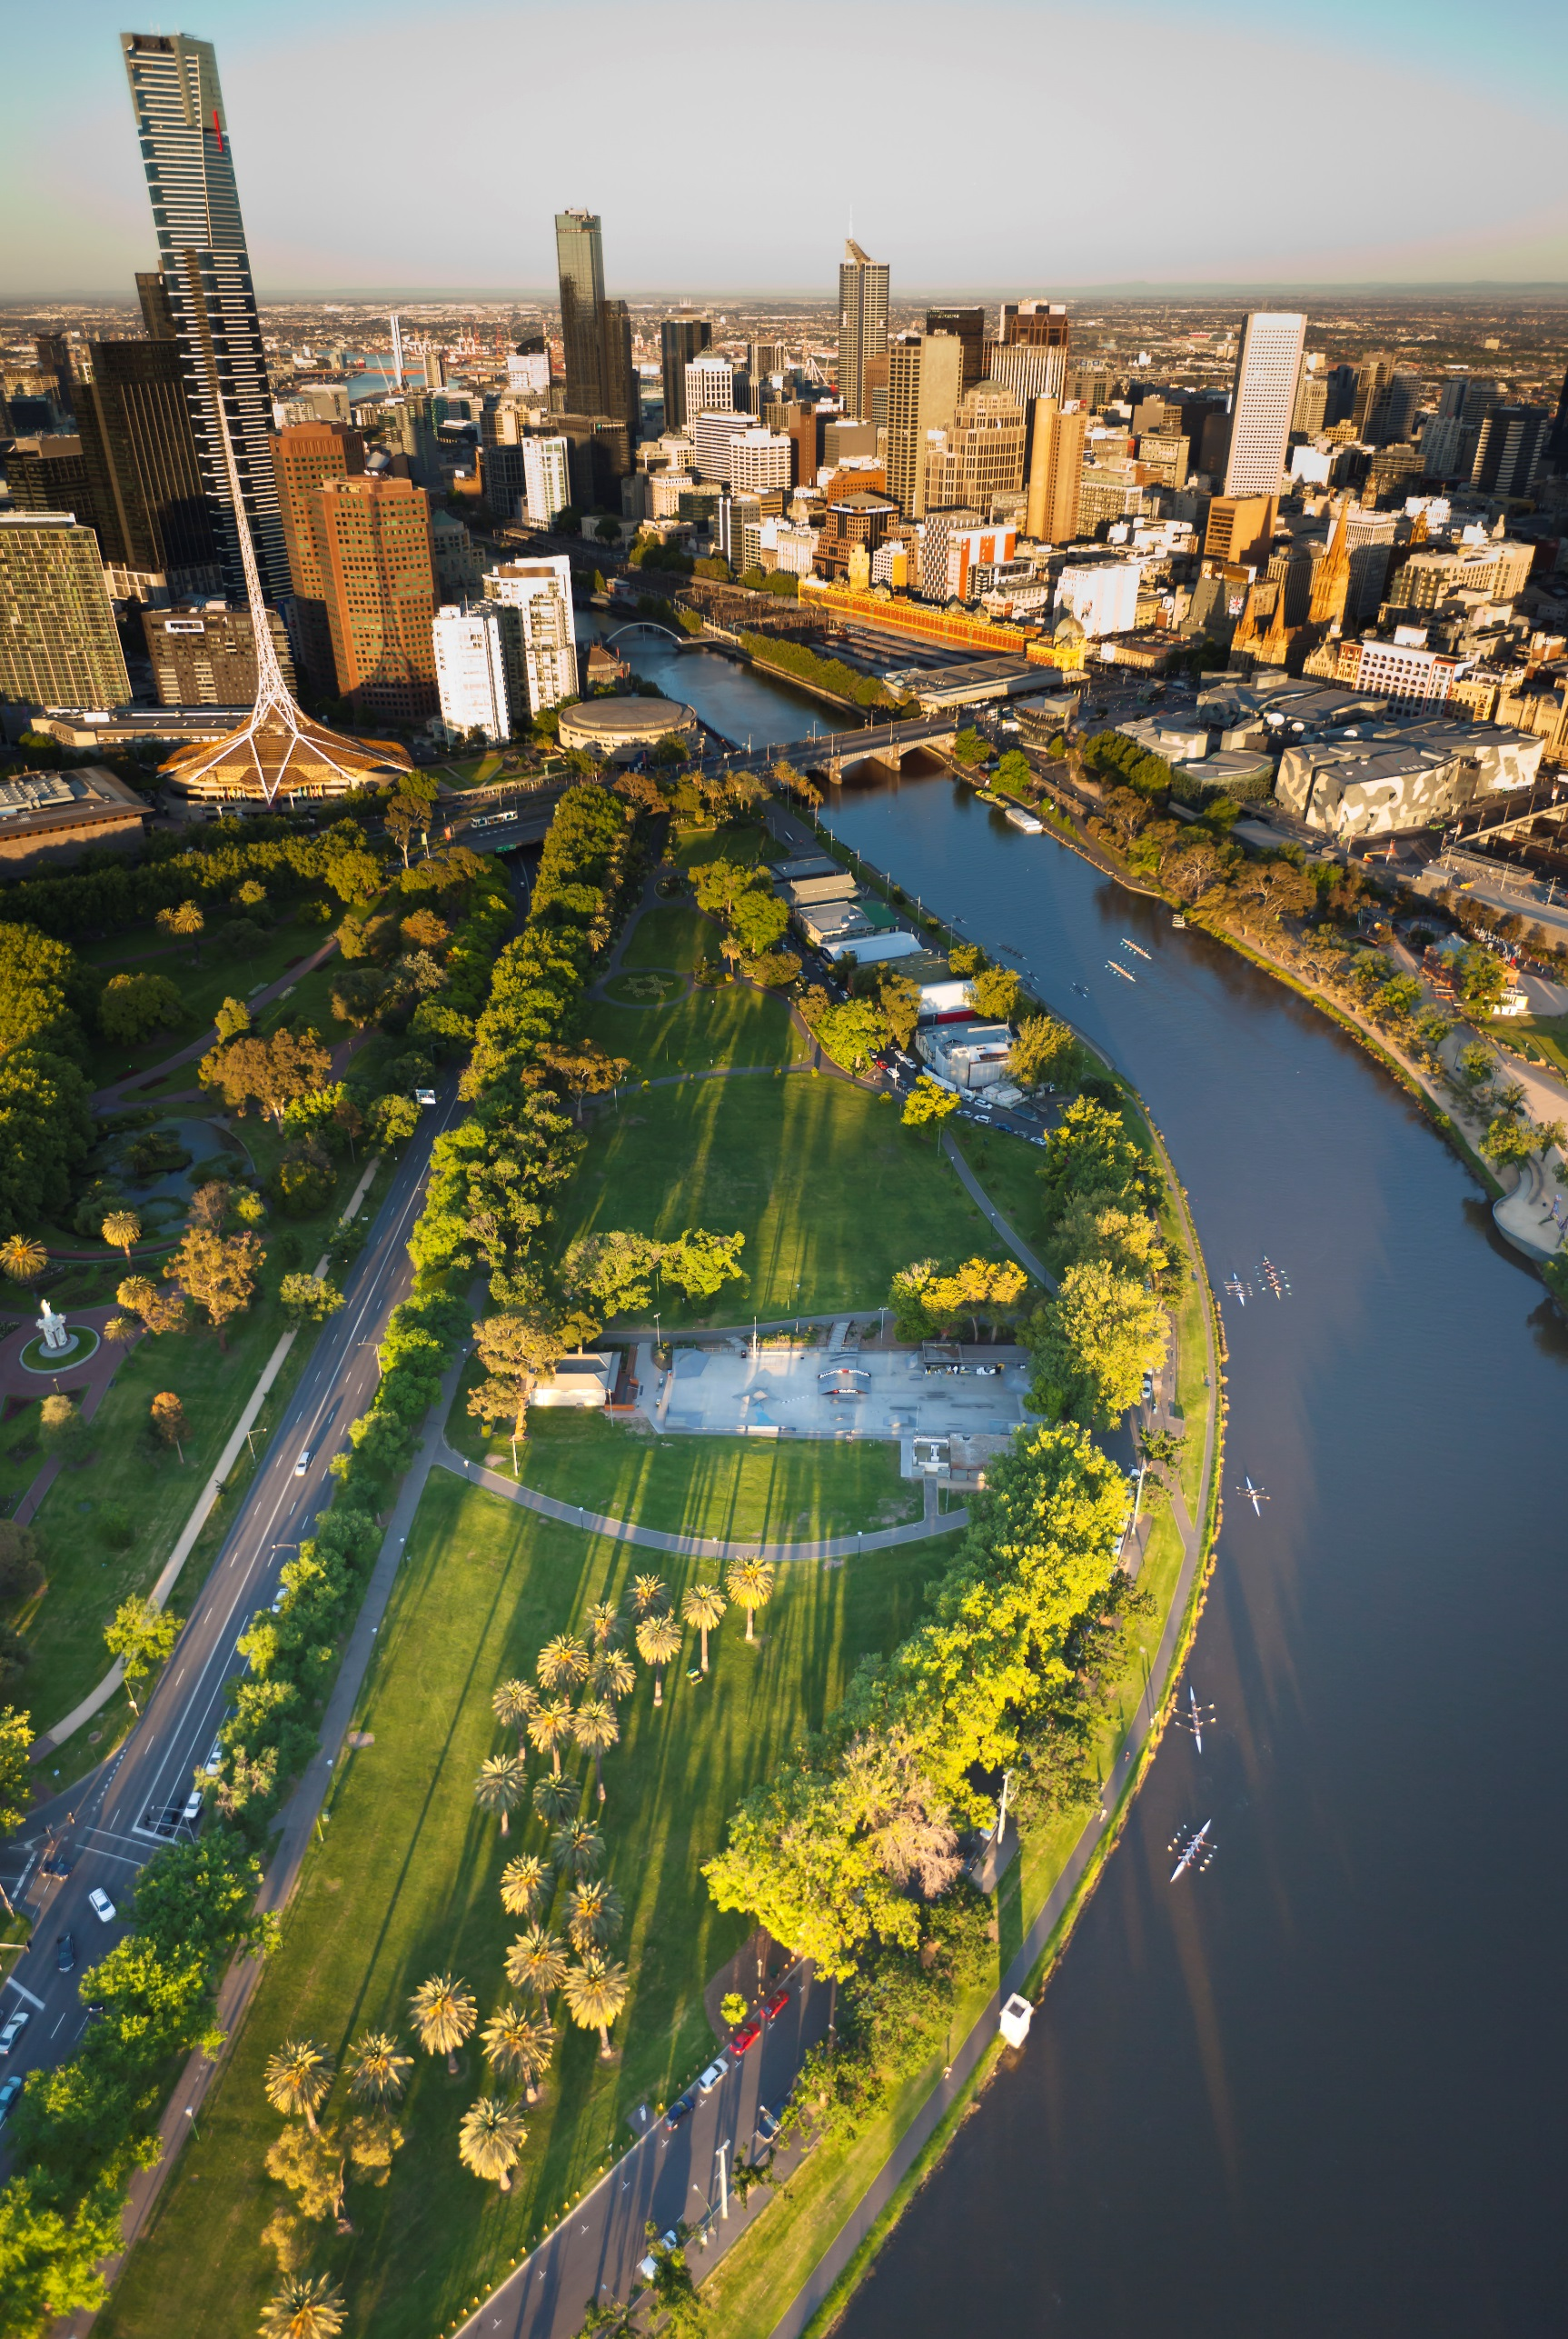
Application

Yarra, Maribyrnong rivers and Victoria Harbour (on water) Events

Call for Dates 2021/2022

Open: 15/03/2021 Close:12/04/2021

Event Permittee

Business name of organisation proposing the event:
Note: Permit is issued in this name and must match Certificate of Currency.

Event Permittee status:
Individual
Company | What is your ACN?
Sole trader | What is your ABN?
Incorporated Association | Registration number?
Charitable organisation*
Not-for-profit organisation*
* Please provide evidence of this status with your application i.e. a copy of the organisation’s constitution or articles of association with an acceptable non-profit clause. Registered for GST No Yes

Business address:
Street number and name
Suburb State Postcode

Postal address:
Same as business address OR
Street number and name/P.O. Box:
Suburb State Postcode

Name of Event Permittee: Position title
Business telephone number Mobile number Fax number
Email

Event Day Contact:

These details will be used on the day of the event by relevant Parks Victoria staff. They will also be included in the permit.

Name Position title
Business telephone number Mobile number Fax number
Email

With permission the Organisation’s name, phone number and website will be included in the Event Calendar and other promotional material. The event day contact will be used on Parks Victoria What’s On published on www.parkweb.vic.gov.au
Are you willing to have the Event Day Contact details published? No Yes

Please read Maritime Safety Victoria Fact Sheet: Boating activity exemptions and exclusion zones and Parks Victoria Bays and Waterways Event Guidelines before completing this form.

Event Details

Event name:

Name of waterway where the event is being held:

Proposed event date/s in order of preference:
a) | b) | c) | d)

Proposed weather holding event date/s in order of preference:

Please refer to the Bays and Waterways Guidelines for more information regarding holding event dates
a) | b) | c) | d)

Type of activity at this event (choose all that apply):
Waterskiing/Wakeboarding  Power-boating/IRB  Rowing  Jetski (PWC)  Other (please specify below) | Dragon Boat/Outrigger  Canoeing/Kayaking  Fishing  Drones (refer to Note 1 below) | Sailing/Windsurfing  Swimming  Filming/Photography  SUP/Kiteboarding/Surfing
Note 1: Please provide the supporting documentation confirmed in Attachments.

Detailed description of proposed event:

Insert a description or attach an event day agenda/programme. (E.g. type of competition/racing, length/duration, maximum number on the water/course at any one time, level of participants’ expertise (e.g. novice), different classes of vessels etc.).

Specific location of event on this waterway (please provide GPS coordinates (deg/dec/min) and a detailed map – see Event Management Precincts):

For example, Location – Y1 Precinct: River Mouth – Westgate Bridge

Proposed event schedule:
Event date: | Bump-in commences: | Bump-out completed: | Event start time: | Event finish time:

Has this event been held previously?
No
Yes - Please advise date and location:

Have there been any reportable marine incidents in previous events?
No
Yes

Provide a summary of the reportable marine incidents (date, what happened and who involved) and explain what measures you will implement at this event to prevent the same type of incident re-occurring.

Event numbers:
Expected number of Participants/Guests:
Expected number of Spectators:
Expected number of Participant/Guests Vehicles:
Expected number of Operational Vehicles:
Number of Marshals/Organisers:
Other:

Please provide details of entry fees for participants and/or spectators:
Free |  | Donation | Ticketed - If ticked, proposed fee:

Will your event impact on the land surrounding the waterway?
No
Yes - Please provide details below and ensure you inform the land manager:

Risk Assessment and Risk Management

Is this event operating under the rules/Safety Management Plan (SMP) of a national or state recognised body, approved by the Director, Transport Safety?
No
Yes (Name of body and attach copy of the SMP)

Are there any amendments/site specific details to these rules/SMP for this event?
No
Yes (Provide details of the amendments for this event)

Water Infrastructure

For this event will there be any infrastructure installed on water? (E.g. buoys, pontoons, moored vessels, markers etc):
No
Yes (Provide details below and identify on your event map)

Number | Type

What measures will you implement to minimise the safety risks associated with the use of or collision/impact with the infrastructure?
Note: Removal of infrastructure must occur immediately post event.

Fuel Spills/Refuelling

Will refuelling be conducted on site or other chemicals stored onsite?
No
Yes - What control measures will be introduced to ensure fuel and any other chemicals are safely stored and used on site?

What measures will be employed in the event of a fuel spill or fire or chemical spill?

Fireworks

Will this event have fireworks?
No
Yes - Please provide the additional mandatory documentation confirmed in Attachments.

Note: Fireworks will only be considered for events that are of state, national or international significance.

Rescue, Emergency and First Aid Services

What rescue, emergency and first aid services will be provided for this event?
Provide details of the number and type (e.g. 2 rescue boats, 2 qualified first aid officers, and 1 paramedic)

What criteria was used to determine the type and number of rescue, emergency and first aid services provided?
E.g. the number rescue vessels required to reach a number of people in the water at any one time, severity of injuries.

Will you have an accredited First Aider on site?
No
Yes (Provide the name, a copy of their accreditation, expiry date and contact number)

Risk Assessment of other Potential Hazards
- The matrix below provides a framework for measuring risk.
- Consider each of the Hazards/Risks associated with the event. What can happen, how it can happen given a number of different circumstances, or in conjunction with another hazard?
- Identify the Likelihood of each Hazard/Risk occurring. Is it Almost Certain, Likely, Moderate, Unlikely or Rare?
- Identify what the Consequence would be. Would it be Insignificant, Minor, Moderate, Major or Catastrophic?
- Match the Likelihood score and the Consequence score to determine the Risk Rating. Is it High, Significant, Moderate or Low?
- Any identified Risk Rating in the Moderate, Significant or High categories require some form of Control Measure to reduce the risk.

Risk assessment matrix |  | Consequence (C)
 |  | Insignificant  First aid | Minor  Medical treatment | Moderate  Hospitalisation | Major  Single death/ multiple injuries | Catastrophic  Multiple deaths
Likelihood (L) |  | 1 | 2 | 3 | 4 | 5
Almost Certain  Event expected to occur | 5 | Moderate  5 | Significant  10 | High  15 | High  20 | High  25
Likely  Event may occur | 4 | Low  4 | Moderate  8 | Significant  12 | High  16 | High  20
Moderate - Event may occur once in 3 events | 3 | Low  3 | Moderate  6 | Moderate  9 | Significant  12 | High  15
Unlikely - Event may occur once in 10 events | 2 | Low  2 | Low  4 | Moderate  6 | Moderate  8 | Significant  10
Rare - Event occurs only in exceptional circumstance | 1 | Low  1 | Low  2 | Low  3 | Low  4 | Moderate  5
Consider the risks/hazards associated with the boating activity and show what control measures will be implemented to mitigate or reduce those risks/hazards.

For example, some of the risks may include:
- Collision: Collision between: vessel/vessel, vessel/structure, vessel/bank, vessel/person, fixed or floating object, overhead obstruction/wires, And submerged object.
- Capsize/swamping.
- Person overboard or swimmers in trouble.
- Vessel Failure: Catastrophic failure, (loss of steering or power) that may result in harm to occupants of vessel, other vessels or onlookers – consider speed of vessels.
- Fire: Vessels and water infrastructure.
- Fall: Injury to a participant from a fall.
- Impact: Injury to a participant from an impact with a hard surface or structure.
- Propeller Injury: Injury to a participant from a vessel’s propeller.
- Debris in water causing hazard to other participants, users or vessels.
- Low light restricted visibility: Event to be conducted in low light/visibility, twilight or dark. Consider requirement for navigation lights, impact on rescue.
- Black water restricted visibility: Consider potential that the water turbidity, colour or available daylight might prevent seeing someone in the water or under the surface.
- Delay to event causing impact on exclusion zone/event area: Consider potential that the event may be delayed or run overtime, be late to start, or be required to pause for unanticipated activities. Consider the likely impact on safety of the event.
- Unregistered vessels or unlicensed operators: The potential that unregistered vessels or unlicensed operators of powered vessels will be present.
- Un-official vessels/swimmers: Large crowds expected on the banks/water’s edge; vessels or swimmers/spectators not involved in the event to enter the area where the event is to be held.
- Water quality: The risk for any material (liquid or solid) to enter the waterway. Consider the measures necessary to prevent any material (liquid or solid) from being discharged.
- Disturbance to wildlife: Ensure compliance with the marine mammal regulations in particular ensuring separation distances from whales, seals and dolphins.
- Habitat disruption: Will infrastructure impact on habitat e.g. sea grass beds, reed beds or bank vegetation?
- Communications: what contingencies have you in place to ensure effective communications?
- Noise: Is excessive noise expected? What duration and time of day will the noise occur?
- Other.
Risk Assessment  Consequences of a hazard occurring without control measures |  |  |  | Residual Risk Assessment  Consequences of a hazard following implementation  of control measures
Hazard/Risk: Consider the potential for each of these hazards and list any other hazards specific to this event | L | C | Risk  Rating  (LxC) | Control Measure: Please list control measures to be in place to reduce the risks identified. | L | C | Risk  Rating  (LxC)
Example only  Low light restricted visibility: Event to be conducted in twilight. Vessels will be operating at speeds greater than 5 knots in restricted visibility. Infrastructure has been installed on the waterway for the event. | 4 | 4 | 16 | This is a twilight event only. At 6.30pm, 10 industrial strength floodlights will be turned on. Event area will be well lit.  Rescue boats are fitted with spotlights.  Navigational lights fitted to all vessels.  All Infrastructure will be lit during restricted visibility. | 1 | 4 | 4
Note: If you require additional rows for entering, this table continues over the page.

Risk Assessment  Consequences of a hazard occurring without control measures |  |  |  | Residual Risk Assessment  Consequences of a hazard following implementation  of control measures
Hazard/Risk: Consider the potential for each of these hazards and list any other hazards specific to this event | L | C | Risk  Rating  (LxC) | Control Measure: Please list control measures to be in place to reduce the risks identified. | L | C | Risk  Rating  (LxC)

Request for Exemptions and / or Exclusion Zones
Note: Advertising costs required for exemptions and exclusion zones will be added to the event fee.

Vessel Operating and Zoning Rules

Are you applying for exemptions or modifications to the Marine Safety Act 2010 (Vic), Marine Safety Regulations 2012 (Vic), or State waterway rules?

(Copies of these rules are available on the Transport Safety Victoria website) http://www.transportsafety.vic.gov.au/maritime-safety/waterways)
No
Yes - In the table below specify the exemptions, modifications or substitutions you are seeking, the reason why and what control measures you will put in place to mitigate the safety risk (choose all that apply).
Exemption/modification/substitution sought | Reason | Control measure to mitigate safety risk
Vessels travelling at speeds greater than 5 knots
All waters
Clause 2. within 50m of:
person in water
vessel or buoy
Inland waters
Clause 3. within 50m of:
the water’s edge
a fixed or floating structure
Coastal waters/ enclosed waters
Clause 4.
within 200m of water’s edge
within 50m of wharf, jetty, slipway, diving platform or boat ramp
Scheduled Waterway Rules
Schedule No.
Specify clauses for exemption:
Port Management (Local Port) Regulations 2004 (Vic)
Specify regulations for exemption:
Marine Safety Act 2010 (Vic)
Specify sections for exemption:
Marine Safety Regulations 2012 (Vic)
Specify regulations for exemption:
Other (please specify)

Safety Equipment

Are you applying for exemptions or modifications for recreational vessel safety equipment?
No
Yes - In the table below specify the exemptions, modifications or substitutions you are seeking, the reason why and what control measure you will put in place to mitigate the safety risk (choose all that apply).
Exemption/modification/substitution sought | Reason | Control measure to mitigate safety risk
Personal flotation devices
Flares
Waterproof torch/lantern
Anchor
Bailer
Fire extinguisher
Navigation lights
Paddles
Bucket with lanyard
Vessels operating more than 2 nautical miles off shore
EPRIB Radio
Rocket flare Compass
Vessels 4-8 metres in length
Paddles or oars
Vessels 8-12 metres in length
Lifebuoys
Vessels over 12 metres in length
Dinghy/life raft
Other (please specify)

Exclusion Zones

Are you seeking exclusive use of any part of the waterway where your event will be held?
No
Yes - Please show the area of all exclusion zones on a map with this application.
Please detail how you will manage an exclusive use area and what measures are in place if unauthorised persons enter the area:

Details of the vessels involved in managing the proposed boating activity (e.g. marshal, official, crowd control, rescue etc.):
Vessel name and/or make and model | Registration No. | Event role

Communications Plan

Please list all relevant contacts and communications tools utilised to safely coordinate the event:
Contact / Role | Primary Communication Method (i.e. VHF / Mobile) | Channel / Number | Backup Communication Method (i.e. VHF / Mobile) | Channel / Number

Has the local land manager been advised of the event and communications plan?
No
Yes - Please provide the contact details:

Please detail the procedure to be used for crowd control / public announcements (including primary contact name and mobile phone number):

Cancellation Procedure

What is your cancellation procedure for this event?
Take into account adverse weather conditions, wind speed, wind direction, sea, swell, tide, visibility and other safety issues. Insert the procedure here or attach as a separate document.
Note: In the event of extreme weather conditions a planned event may be cancelled by Parks Victoria in the interest of public safety.

Attachments
A copy of the Event Map. Hand drawn/incomplete maps will not be considered. The map must:
- Reference all positions using Lat/Long coordinates to WGS84 (deg/dec/min).
- Show the area of the event.
- Show all proposed exclusion zones including safety distances between area of use, shore, infrastructure and direction of travel.
- Show the type and location of all infrastructure including markers/ buoys, boat ramps, moored infrastructure and moored vessels.
- Show the emergency access point from the water and first aid location.
A copy of a Certificate of Currency showing current validity of public liability insurance. You must have a minimum of $20m public liability insurance coverage for the event, noting the interest of Parks Victoria.
A copy of your Communications Plan.
A copy of your Safety Management Plan (SMP), if the event is operating under the rules/safety management plan of a national or state recognised body approved by the Safety Director.
Full programme/running sheet of the event including bump in and bump out details.
A Risk Management Plan.
If you have not provided your Cancellation Procedure at question 37, attach it as a separate document.
If drones are proposed at your event, you must also provide:
- Aircraft Operations Plan including:
- Take off and land zone;
- Proposed flight path;
- Proposed exclusion zone; and
- Proposed location of spotters.
- Factsheets of all proposed aircrafts;
- Remotely Piloted Aircraft License for all proposed pilots;
- Operator’s certificate;
- Operator’s certificate of currency of public liability insurance;
- Job Safety Analysis; and
- CASA area approval (if required).
Note: Heavy restrictions apply to the use of Remotely Piloted Aircrafts (RPAs) within the waterways precinct.

Declaration and Signature
I declare that:
- I am authorised as the holder of the position cited below to make this request on behalf of the event proponent.
- To the best of my knowledge the contents of this form and any attachments are true and correct.
- I understand that this application is not consent for the event to occur.
- I understand it is an offence under section 305 of the Marine Safety Act 2010 to provide any false or misleading information and that penalties apply.
- I understand if the event requires exemption and/or exclusion zones, Parks Victoria is required to advertise these in the statewide newspaper, Government Gazette and on its website, noting all advertising costs will be added to the event fee.
- I understand the information contained in Maritime Safety Victoria Fact Sheet: Boating activity exemptions and exclusion zones.
- I have read the Yarra, Maribyrnong rivers and Victoria Harbour Invitation document and understand the conditions of use of the site and will comply.

I acknowledge that if lodging this request electronically, Parks Victoria will accept this communication as containing my signature for the purposes of the Electronic Transactions (Victoria) Act 2000 (Vic).

Signature of applicant (if lodging electronically, type name here) Date
X
Printed name Position

