My visit to Serendip Sanctuary

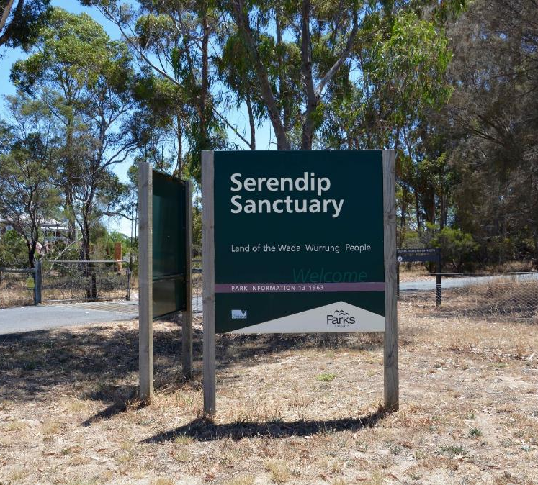

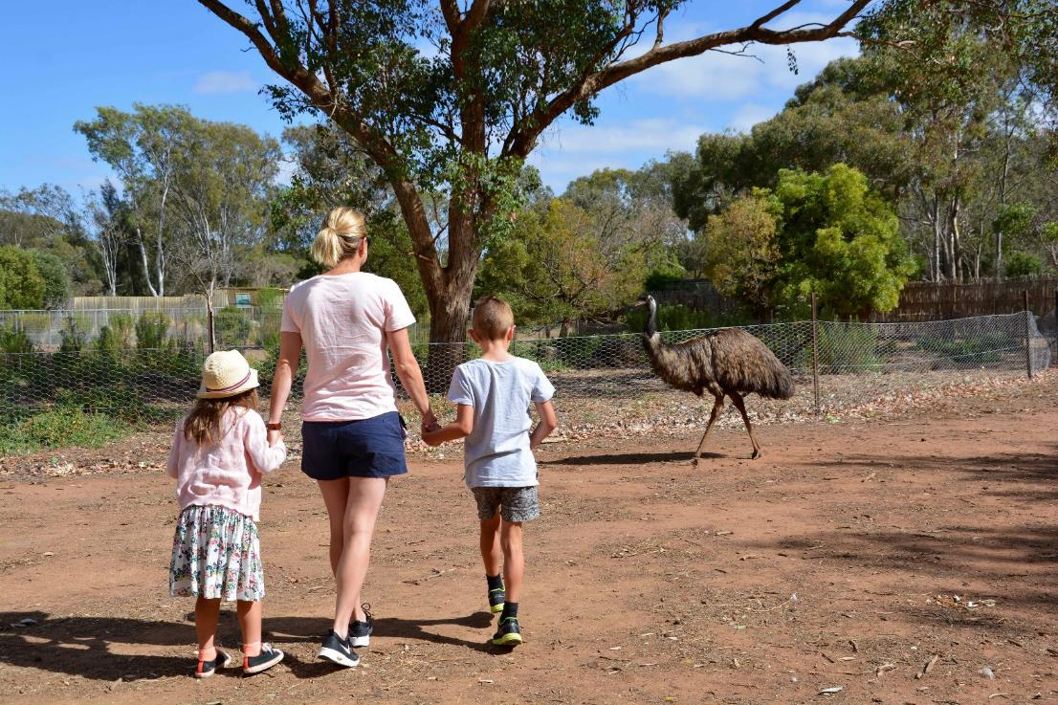
I am going to Serendip Sanctuary. A sanctuary is a safe park for Australian animals to live. Other people will be there to visit the animals too.

Here I can look at many animals. I can walk through the park and see where the animals live.
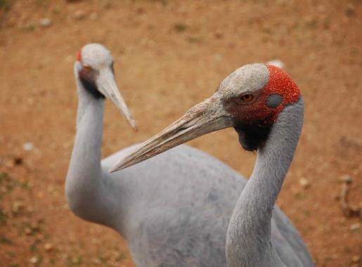
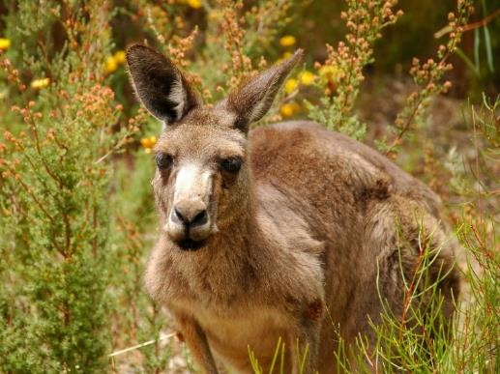

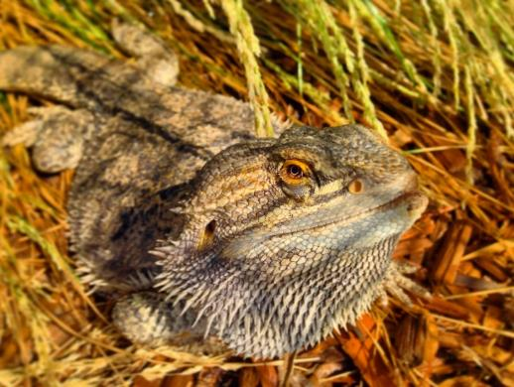
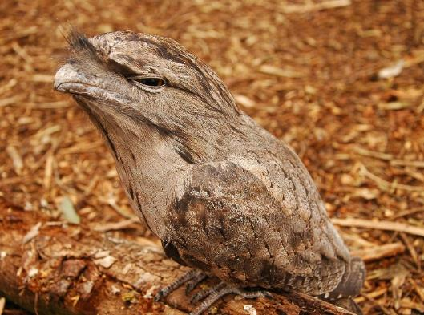

When I get to the park, I have to stay with my adult. There are many cars here, so I need to look for moving cars and be safe.
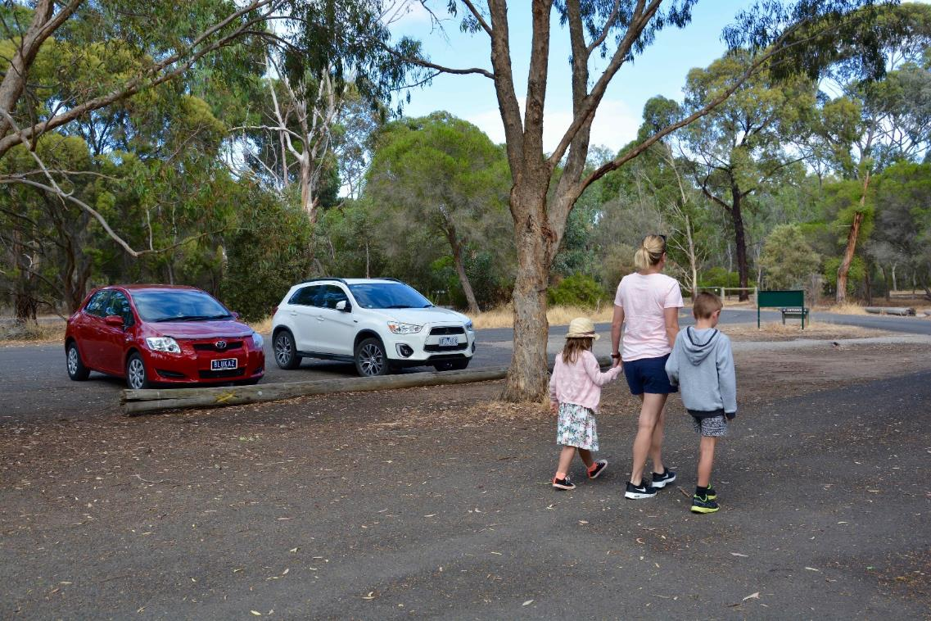

I will follow a path through the park. I will stay with my adult. This keeps me safe.
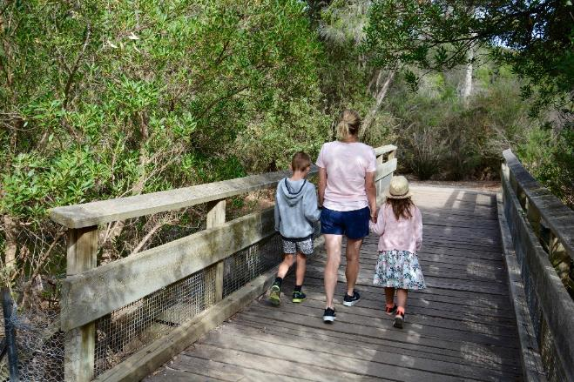
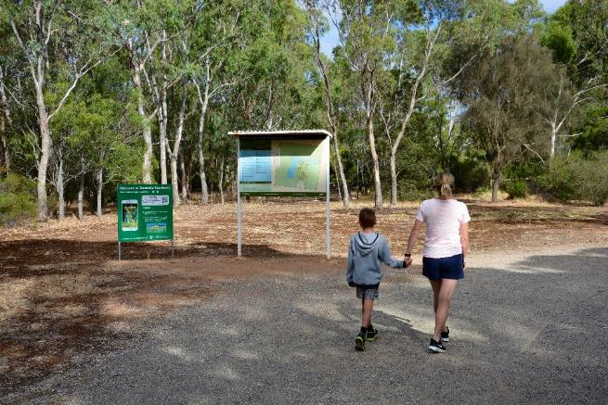

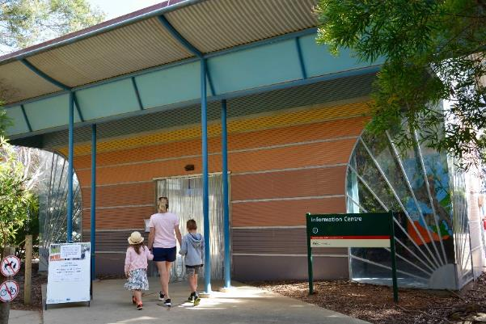
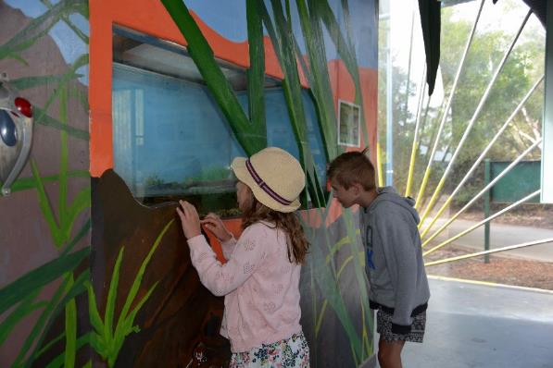
I can go into the information centre and look in the tank. I will see frogs in the tank. There is a cubby I can play in.

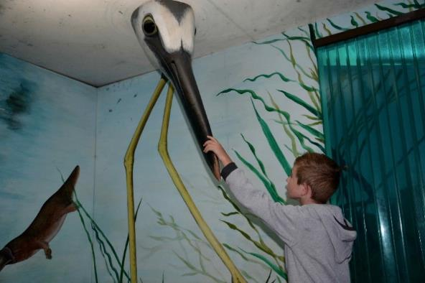
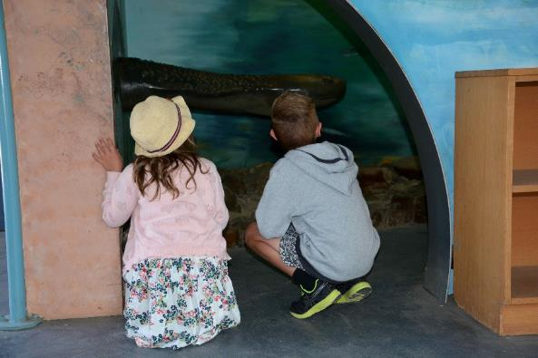

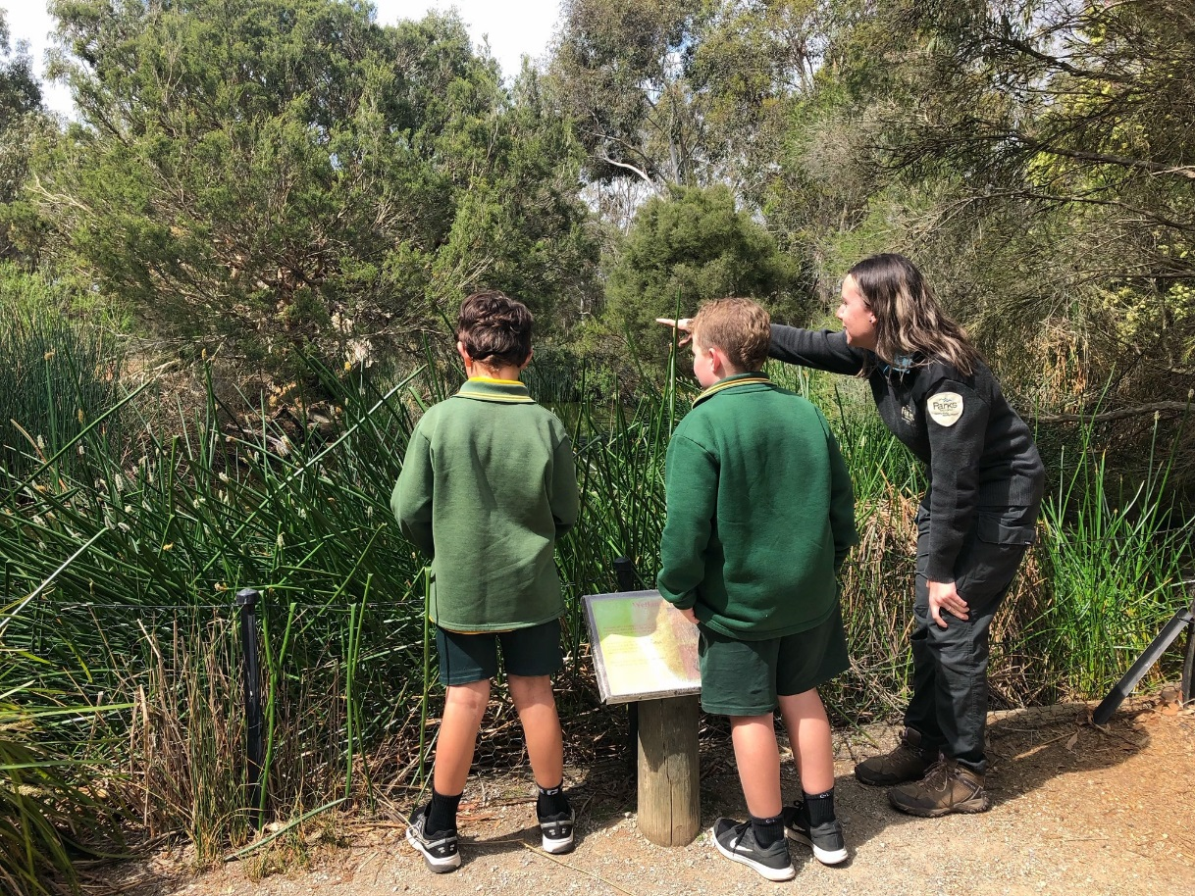
There are people who work at the sanctuary. They are called Park Rangers. They wear a uniform. I can ask them questions about the animals and the park.

On the path, there will be gates. These keep the animals safe. My adult can help me open and close the gates.
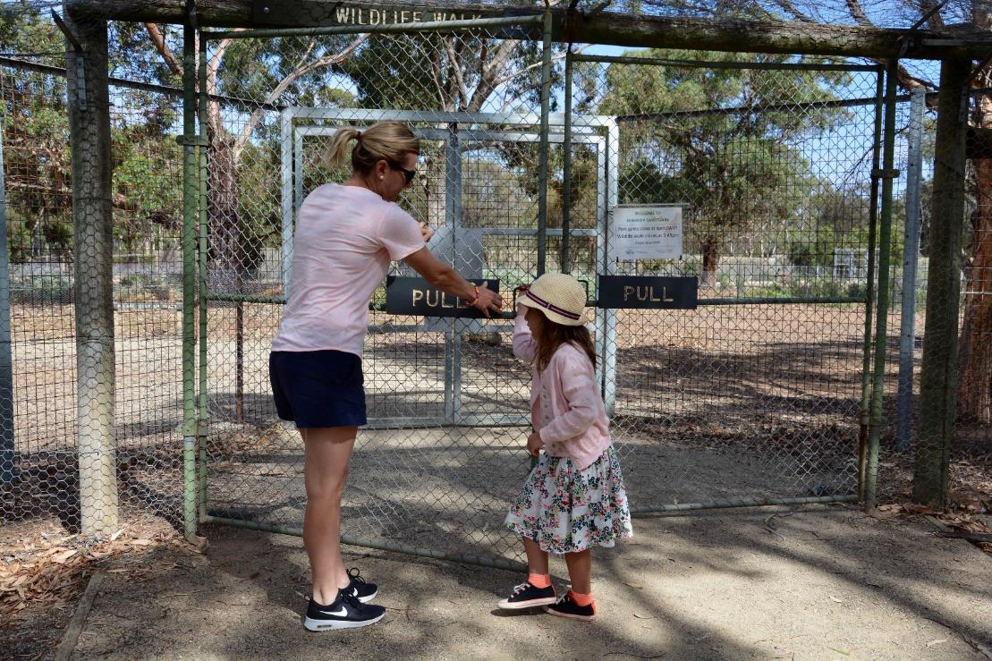

I will see animals on the walk. Sometimes they come onto the path. These animals are not pets. I will only look at the animals, as this is their home.
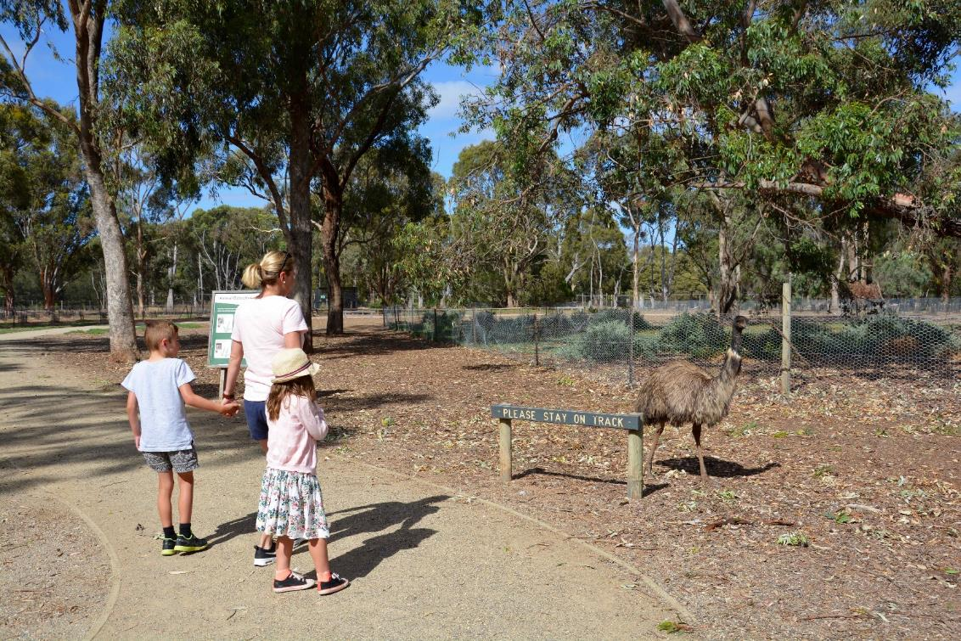

There is a sandpit and I can see how far I can jump. I can see if I can jump as far as a big kangaroo. There is a jumping place. I can see if I can jump as high as a kangaroo. 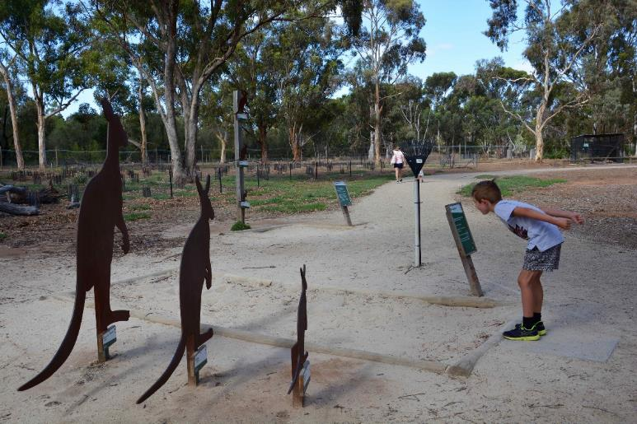 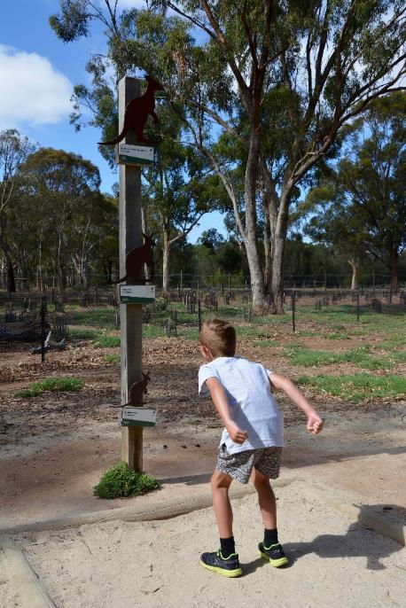
I will walk through a tunnel to a bird hide. A bird hide is a shed where I can see the birds, but they can’t see me. I can watch them eat, play and swim. Some of the windows will be open. I will be quiet when looking at the birds.
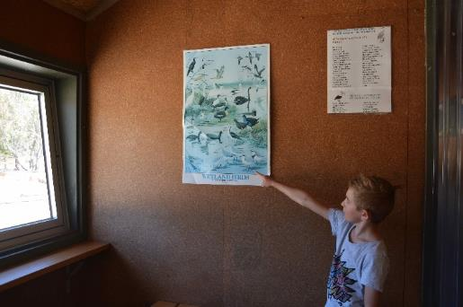
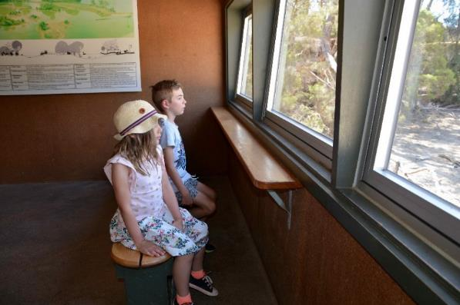
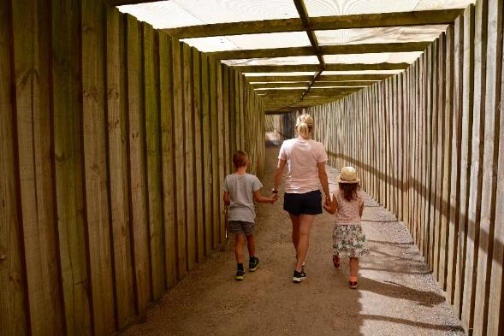

I can walk into the bird aviary. The bird aviary is a big cage where birds live. The birds may walk on the path, swim in the pond and fly around. I will be quiet, so I can see the birds and I will walk on the path with my adult.
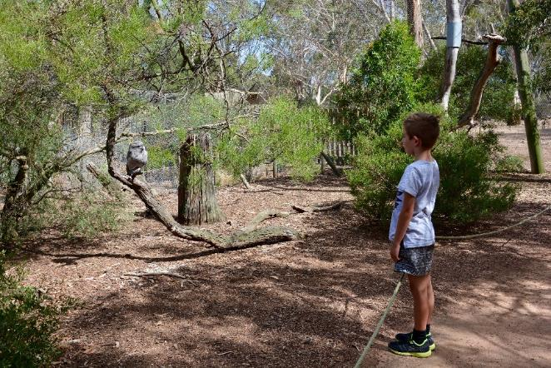
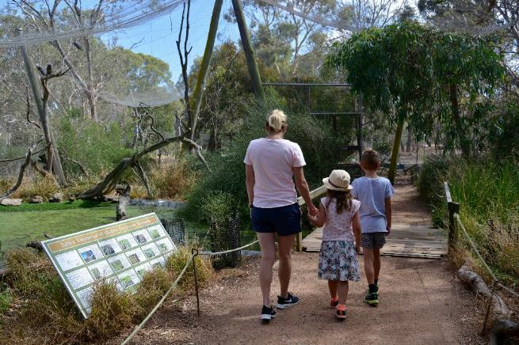
Next to the carpark, there is a place I can sit to eat my food. This is called the picnic area. I can sit at the table. My food is not for the animals. I will stay with my adult.
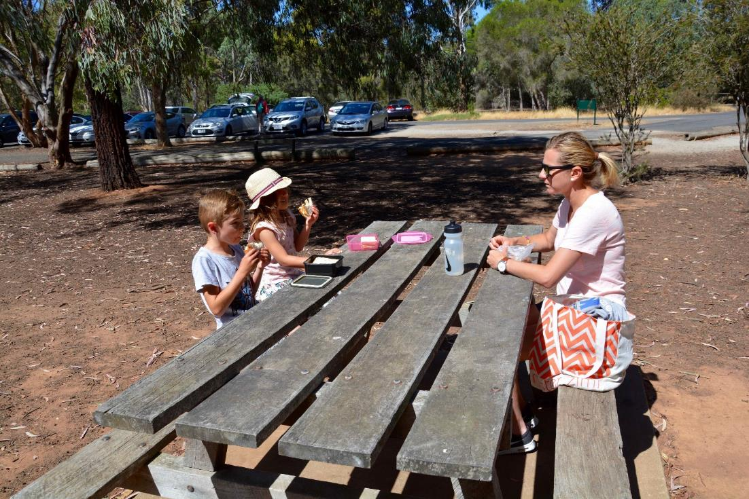

There are toilets next to the picnic area. If I need to go to the toilet, I need to tell my adult.
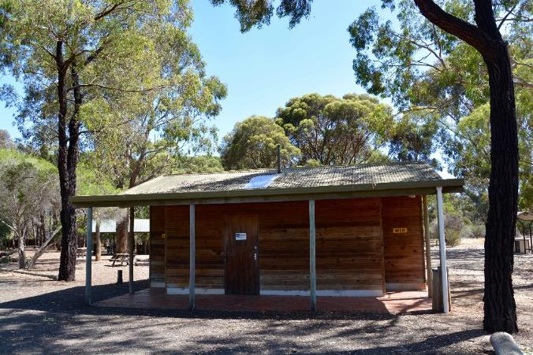 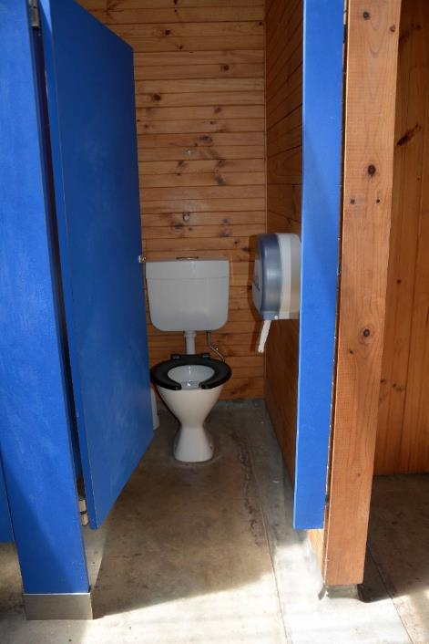
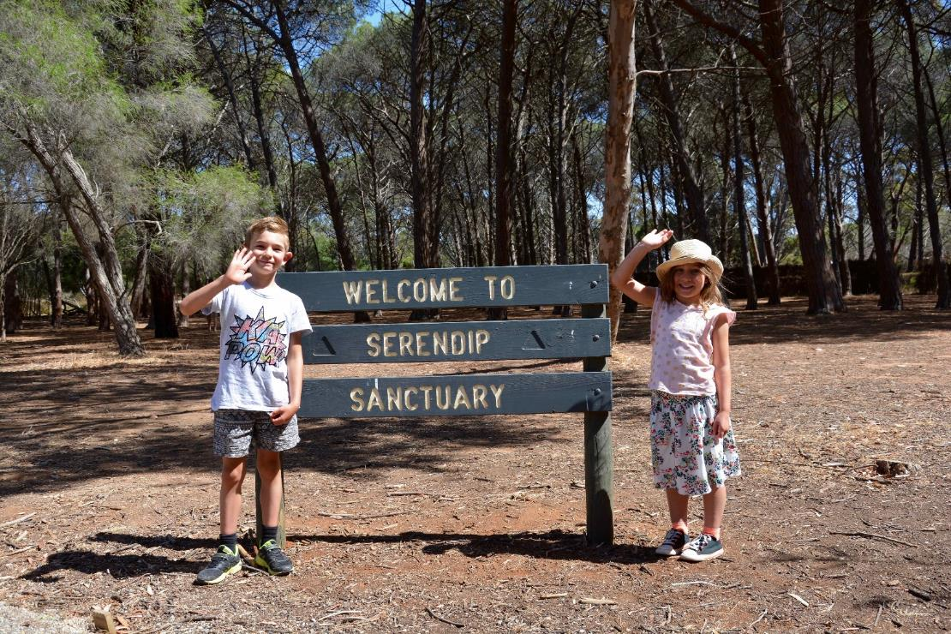
I had fun seeing the animals at Serendip Sanctuary.

