My visit to the Royal Cave
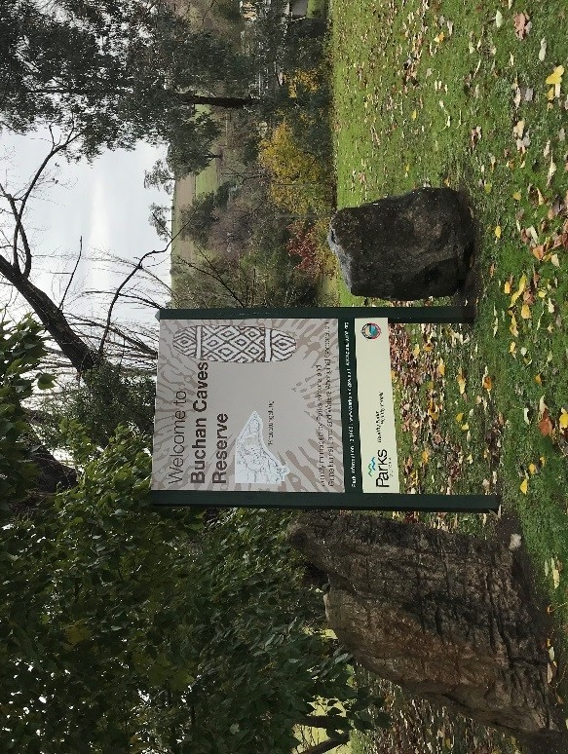

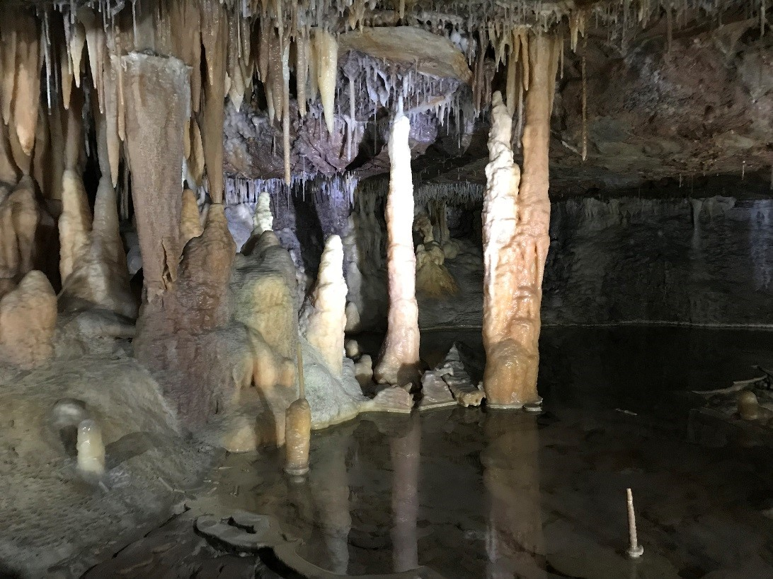
A cave is an opening that is underground. Royal and Fairy Cave has some special rocks to look at. These rocks are only found underground.

We drive into the park. We will park in the carpark. I will stay with my adult.

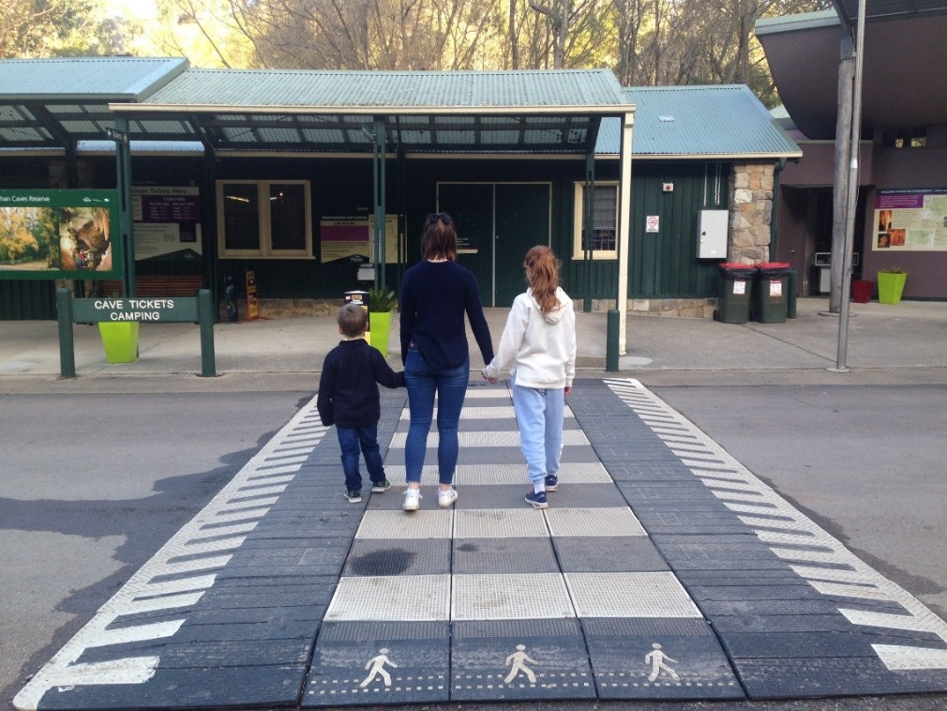
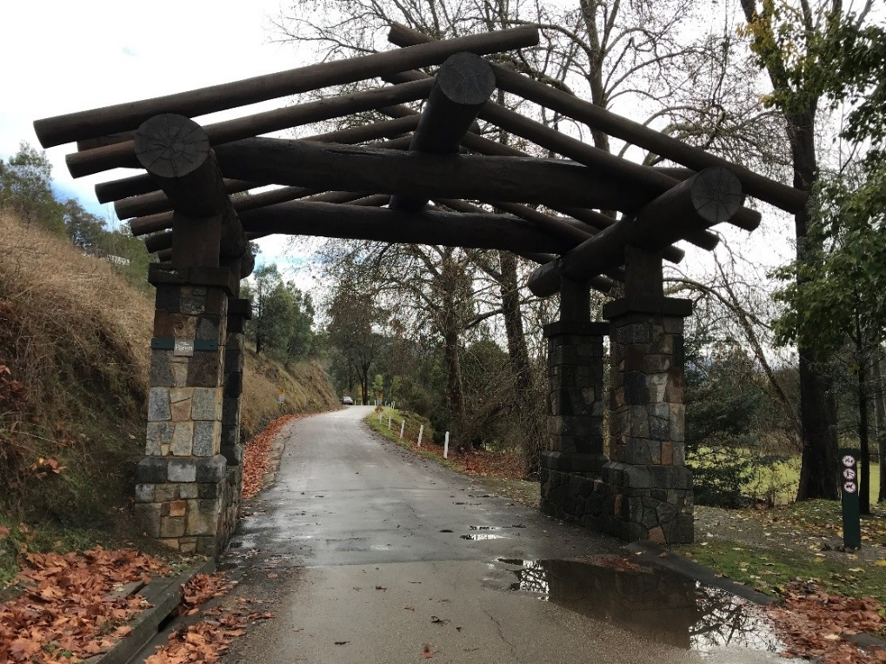

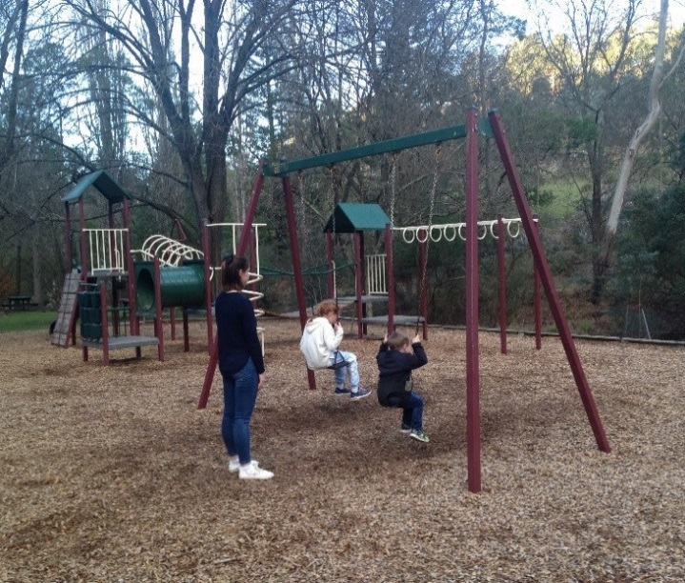
There are toilets and playground near the carpark.
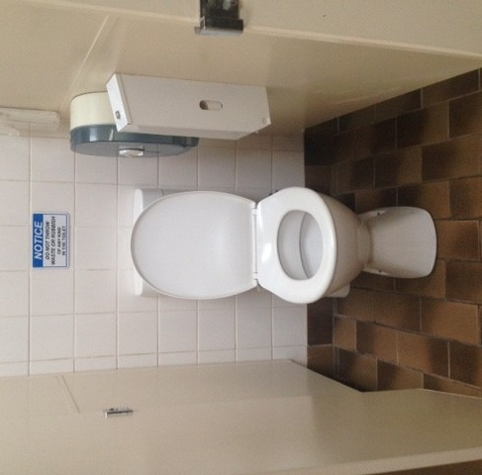
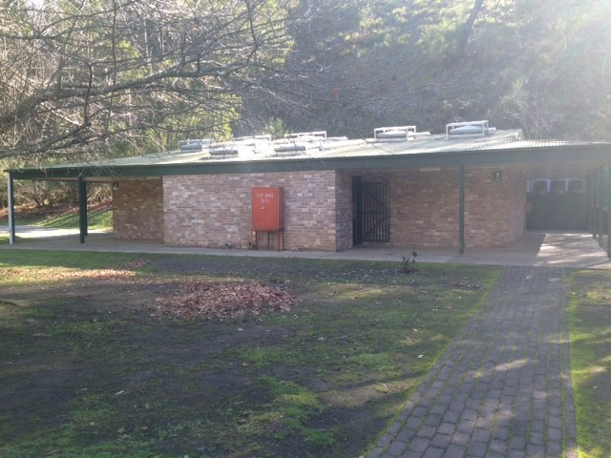

There is a Visitor’s Centre. I can buy my ticket there. The ticket is for a tour of the cave. You can choose to go through 1 Cave or 2 Caves. Royal Cave is bigger and easier to walk through. Fairy Cave is smaller and you have to bend over more.
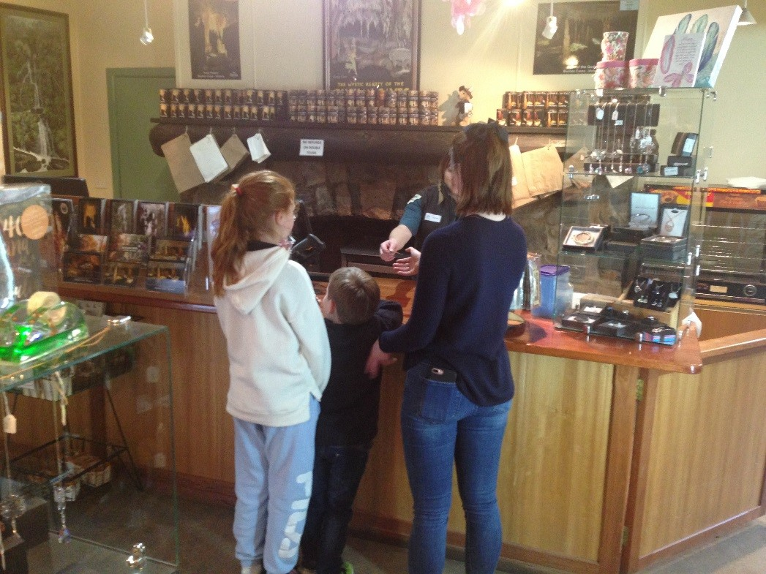
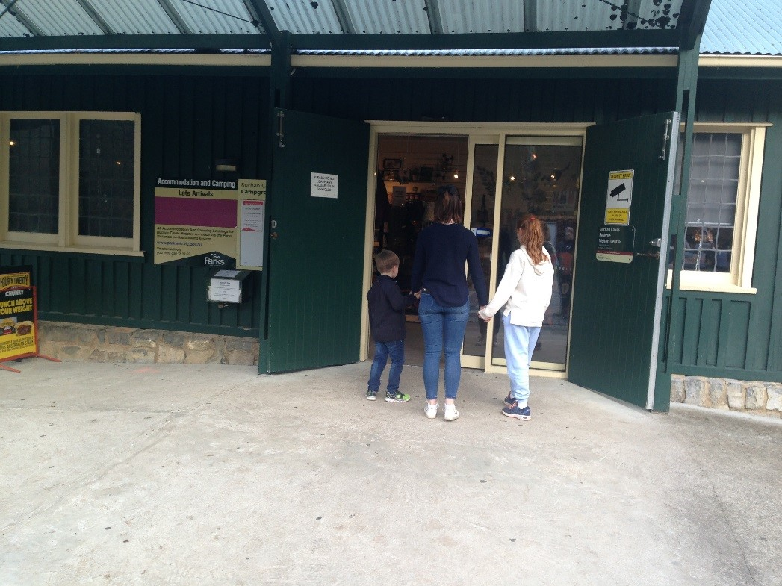
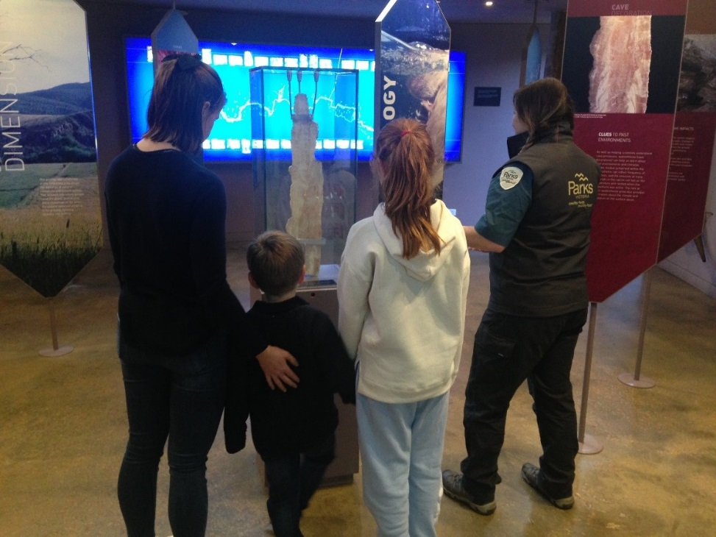
There is also a shop at the Visitor Centre. I can read and look at lots of things about caves and fossils while I wait.
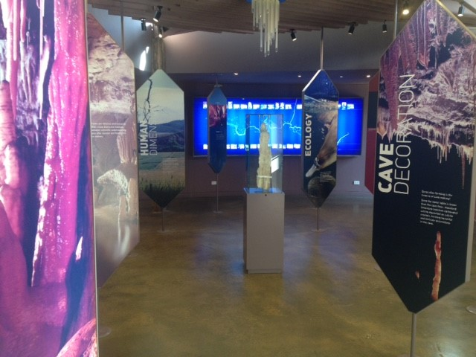
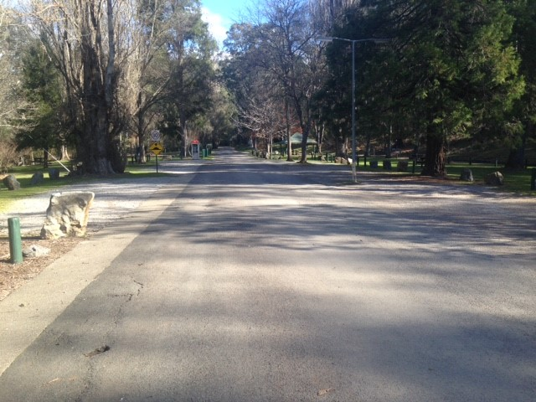
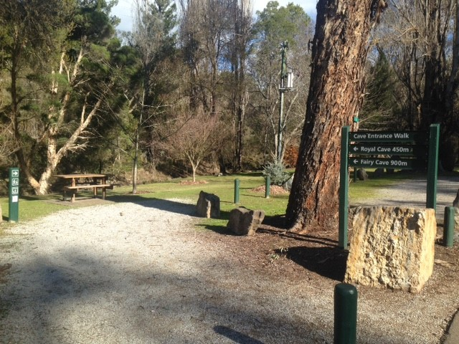
There are two ways to the cave entrance. We can walk or we can drive.

At the cave we will meet our tour guide and other people. The guide will tell us some facts about the cave.
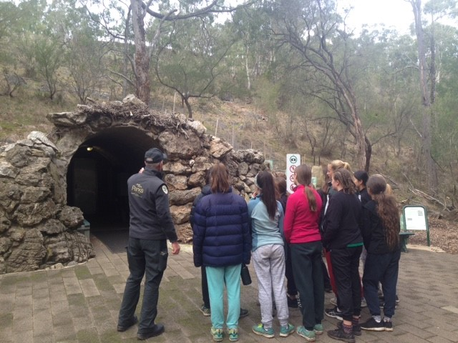

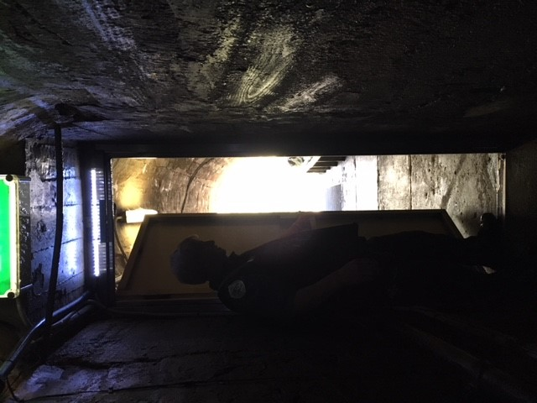
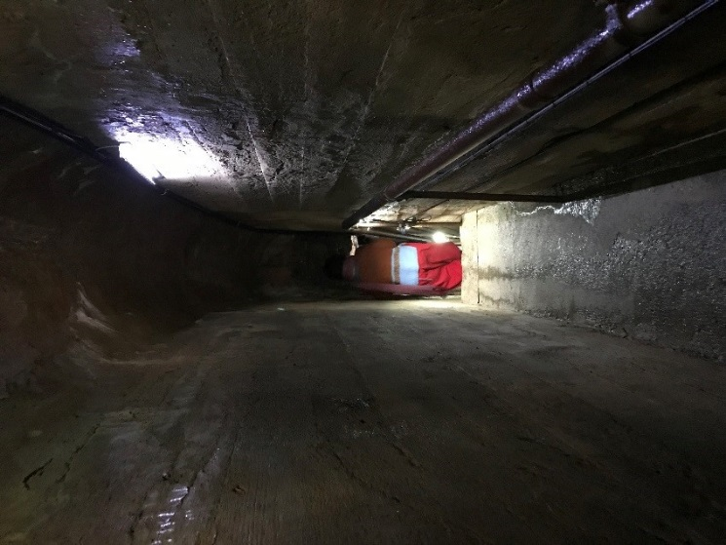
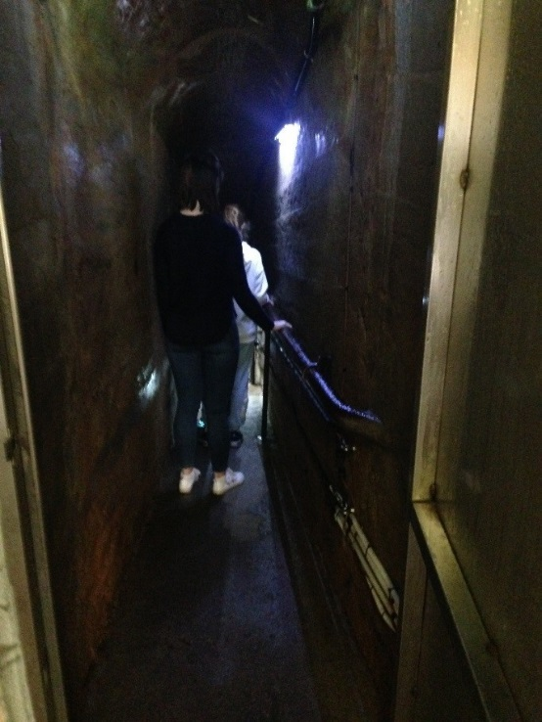
This is the Royal Cave. When we walk into the cave it will be darker than outside. If I feel scared, I can walk in last. The guide will close the door behind me. There will be lights in the cave. If I don’t like it I can tell my adult.
It is warm inside the cave. It may also be wet. I will stay with my adult and hold onto the handrail.
There are places in the cave that will be narrow. I will watch where I am walking.
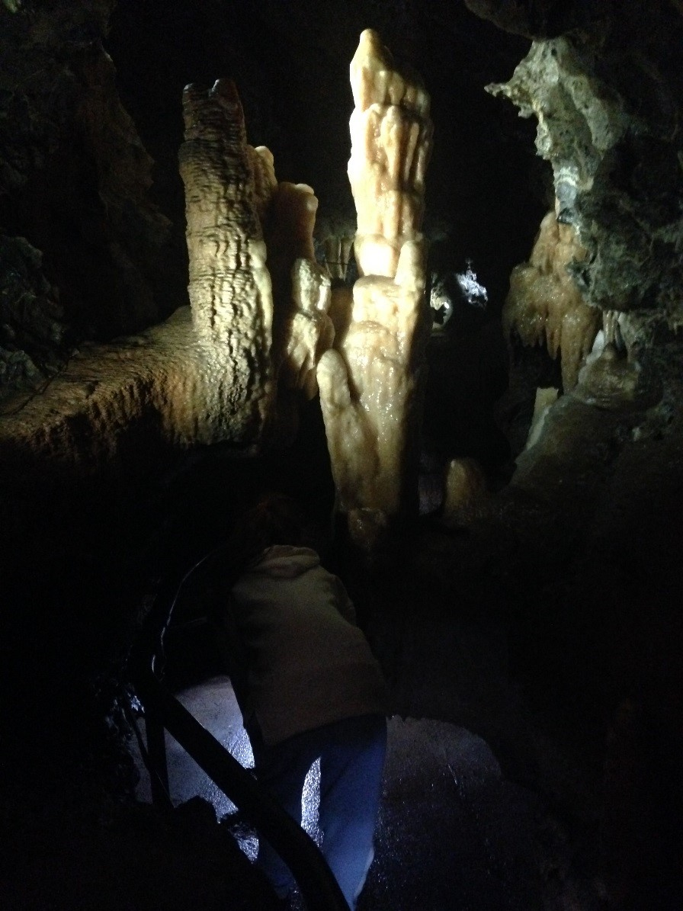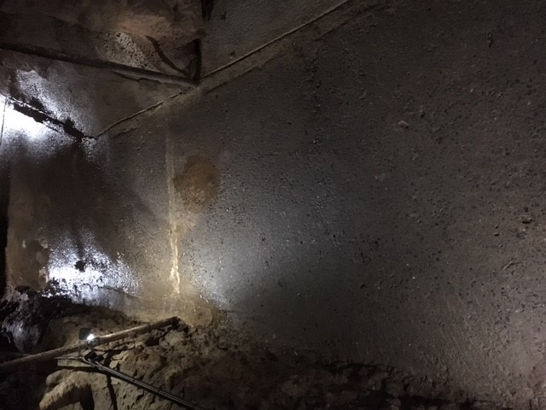
The guide will tell us things about the cave. I will listen to the guide. I can ask the guide questions.
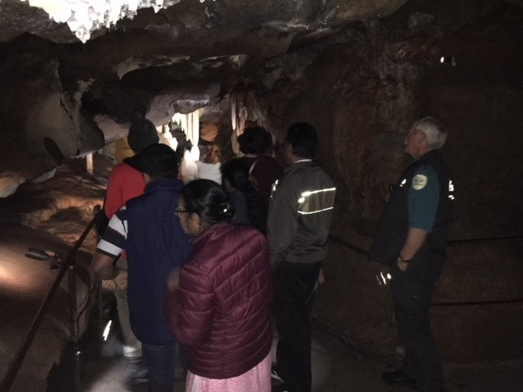

The caves are very old and need to be looked after. It is important not to touch the rocks because we can damage them. I will walk slowly and keep my hands to myself.
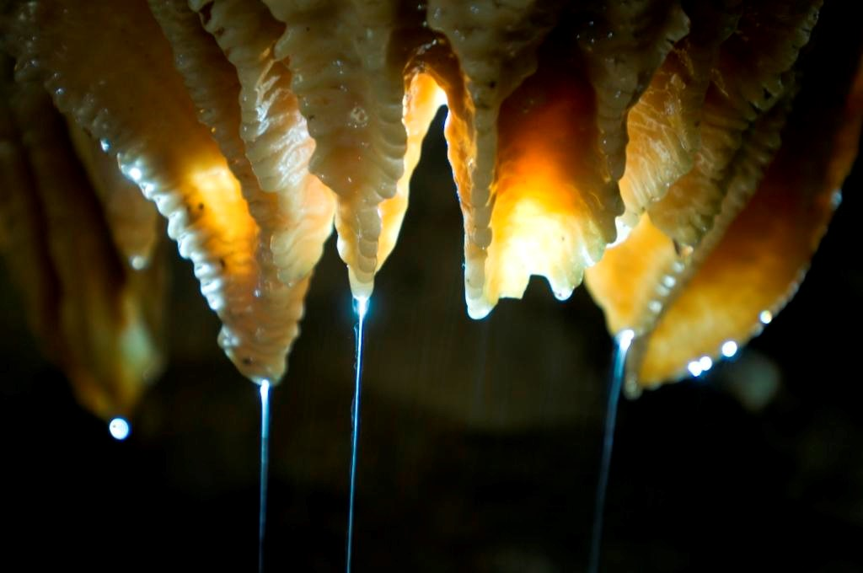

The guide will turn the lights off behind us as we walk through the cave. This is to keep the cave healthy. The guide will turn the lights off to show you what it was like, it shows us how dark it was when the caves were first found. This will last for 10 seconds only. If I don’t like this, I will tell the guide.
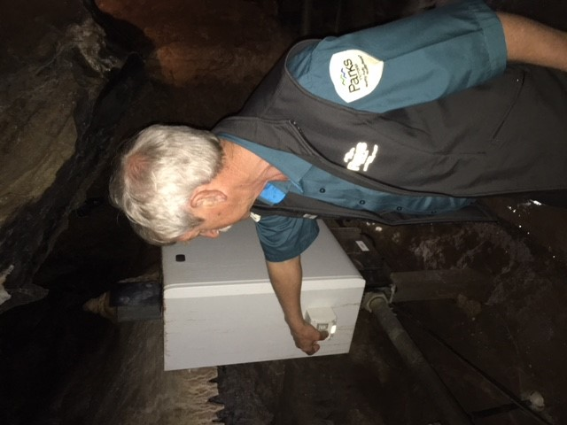

This is a picture of what it looks like when the lights are turned off, the guide only turns the lights off for approx. 10 seconds

I can take photos in the cave.
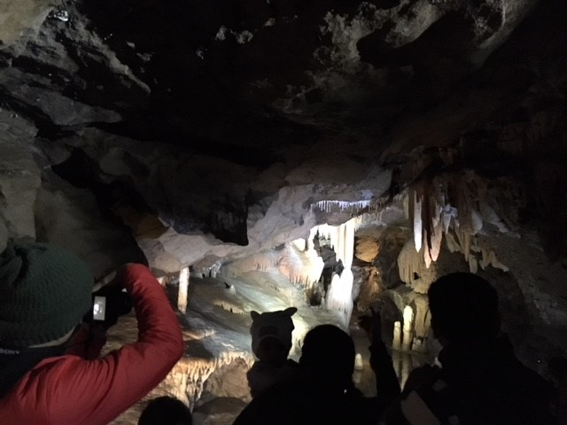
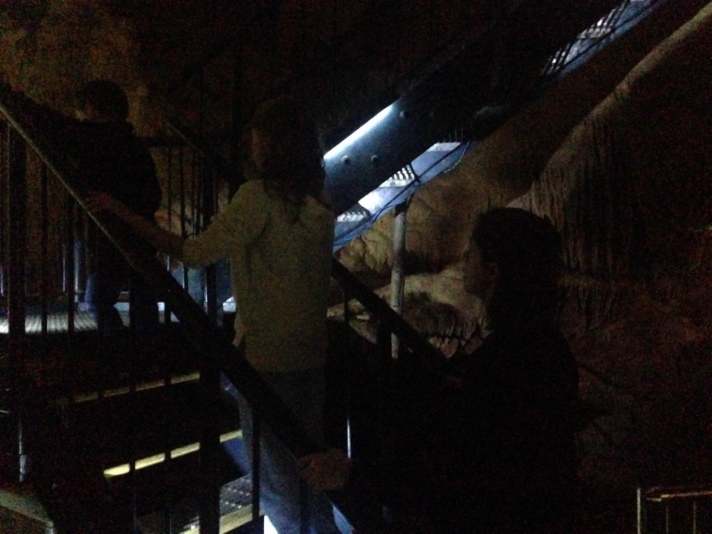
There will be steps and stairs in the cave. They will be wet. I will hold onto the handrail and walk slowly.

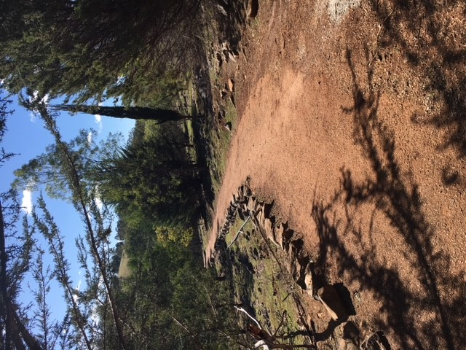
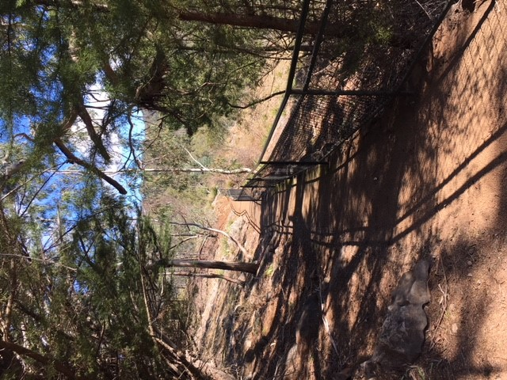
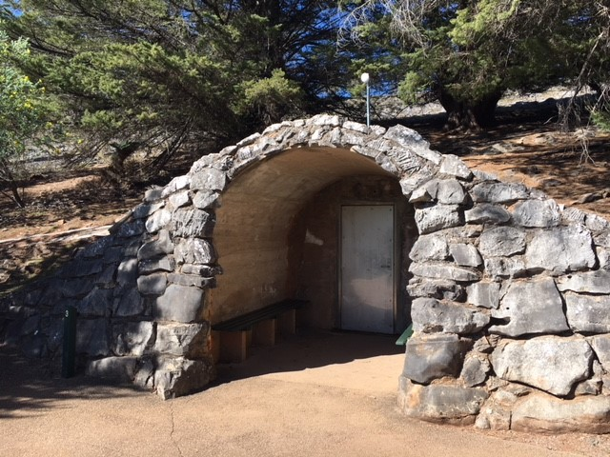
This is the exit of the Royal Cave where I will come out of the cave. If we follow the path to the left it will take you back to the entrance of the cave. If we follow the path to the right it will take us back to the visitor centre.
Path back to Visitor Centre
Path back to Royal Cave Entrance

I had fun looking at the special rocks at Buchan Caves.
Buchan Caves Parent Guide

It is a long drive from Melbourne to Buchan Caves. We would recommend staying overnight. The tours are long and require concentration.
4.5 hours from Melbourne.
45 mins from Lakes Entrance.
55 mins from Bairnsdale.

The recommended GPS address: Buchan
Christmas and Easter are the busiest times at the caves. Long-weekends can also be very popular. If you would like to come on a long weekend the better days when there are not as many people are the first or last day if you would like further detail contact Buchan Caves on 13 1963.
Tour times are as follows:
Royal Cave* - start of September school holidays until the 30 April 10.00am, 1.00pm, 3.30pm
Royal Cave* - 1 May until the start of September school holidays 11.00am, 3.00pm
Fairy Cave* - start of September school holidays until the 30 April 11.15am, 2.15pm
Fairy Cave* - 1 May until the start of September school holidays 1.00pm
Limited number of places available per tour. We recommend pre-booking online to avoid disappointment particularly during weekends, school and public holidays.
Buchan Caves is open 364 days a year- closed on Christmas Day.
At the beginning of the tour, the guide will mention that there is NO eating, drinking or smoking in the caves and NO touching of the decorations. If the decorations are touched, the oils from our hands remains on the decoration and a discolouration process occurs and they turn brown and will not grow any further. A good example is when we touch a mirror or window our finger prints remain on the window, this is from the oils in our hand, the same thing occurs if we touch the decoration then that section will no longer grow as we are unable to clean it off.
Online ticket purchases close at midnight for the following day. Tickets may still be purchased over the counter on the day at the Visitor Centre.
A tour of the Royal Cave takes 45-60 minutes. A tour of the Fairy Caves takes 45-60 minutes.
There are group guided tours through the caves. A maximum of 30 people can go through on the Royal Cave tour and 20 in the Fairy Cave tour.
The caves are 17 degrees all year round and quite humid. If you wear glasses they may fog up.
If you plan to visit both caves in a day, please allow 2.5 hours. There is a 20 minute break between the tours. Please contact Buchan Caves on 13 1963 for further information if required.
Claustrophobia – Royal Cave is the larger cave to go through if you have any claustrophobia concerns. There is a tunnel to enter the Royal Cave which is approx. 40 metres long and once through the tunnel the cave does open up more. The Fairy Cave is a little more confined and requires a fair bit more stooping compared to the Royal. If you have doubts about your capabilities please let your guide know before entering the cave.
Emergency lighting is installed throughout both the caves, when we have a power outage the emergency track lighting will be on and assists all visitors to exit the cave. The guide will also have a torch for assistance.

