Woowookarung Regional Park
  - Visitor Guide
Woowookarung - ‘place of plenty’ is part of the traditional lands of the Wadawurrung Aboriginal people.
A new park by the people, for the people - come and explore; walk, ride, drive, relax, gather and picnic.
Kim-barne Wadawurrung Tabayl - Welcome to Wadawurrung Country
Enjoy and discover the nature of Woowookarung Regional Park.
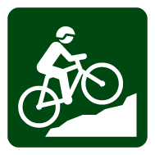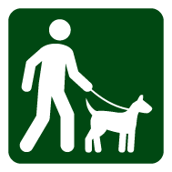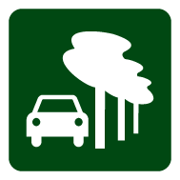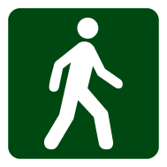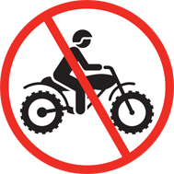

Getting there
Woowookarung Regional Park is located in Ballarat adjoining the suburbs of Ballarat East, Canadian and Mount Clear. It can be accessed from many roads including York St in Ballarat East and Recreation Road, Mount Clear.
Please be mindful of track conditions and other visitors as all park tracks are unsealed and shared by walkers, riders and drivers.

About the park
The 641 hectare park sits within the traditional lands of the Wadawurrung people.
The creation of Woowookarung Regional Park is an important expression of community participation, organisation and strength, and is the result of grass roots community activism over many years. It is a new park by the people, for the people.
The park conserves its special and unique values, and supports a happy, active and healthy community. It offers recreational, natural, social and cultural experiences in a natural setting, for all.
Historically the area was cleared for mining, forestry and commercial timber. The park currently has many internal tracks, both unmarked and informal. There are currently no visitor facilities and minimal signage, however this will be improved over time.

Shaping the Future
The Woowookarung Regional Park Strategic Directions Plan outlines the proposed visitor facilities and is available online at www.parks.vic.gov.au or call 13 1963 during business hours.
The Strategic Directions Plan has been developed to guide management of the park into the future. This Plan is the result of consultation and collaboration with the Wadawurrung Traditional Owners and local community, including Friends of Canadian Corridor, Ballarat City Council, residents, interested user groups, schools, universities and the broader Victorian community.
Park management to date has been focused on priority works to improve vehicle tracks, install signs, cap old mine-shafts and reduce rubbish dumping and weed control.
Planning an event or want to get in touch?
If you are planning an event in the park, or would like to report anything of concern (e.g. rubbish dumping) please contact Parks Victoria by calling 13 1963 or email info@parks.vic.gov.au

Things to see and do
The Park is ideal for a variety of activities including bushwalking, trail running, mountain bike riding, nature appreciation and stargazing.
Cycling, bushwalking, horse riding and mountain biking
Cycling is a great way to see the park and two mountain bike trails exist behind Mount Clear College, 700m and 2km long.
Bushwalking, trail running, cycling, dog walking and horse riding currently occur on an informal network of former state forest and plantation tracks.
Please watch out for each other as all tracks are currently shared by drivers, walkers and riders.

Caring for the park
- No firewood collection permitted
- Dogs on lead at all times while in the Park
- Prospecting and fossicking requires a current Miner’s Right, visit www.energyandresources.vic.gov.au/earth-resources or call into State Gov’t Office in Mair St Ballarat. 8.30am-4-30pm weekdays.
- Please take all rubbish with you and leave no trace of your visit
- All vehicles must stay on named, open formed roads, and all vehicles must be registered and riders/drivers licensed.
For your safety and enjoyment please note, respect and abide by signs, management track, gate and visitor site closures. These may occur due to seasonal storms, fire damage or maintenance.

Be prepared and stay safe
For emergency assistance call Triple Zero (000). If there is a green emergency marker sign near you, read the information on the marker to the operator. Woowookarung Regional Park is in the Central fire district. Bushfire safety is a personal responsibility. Anyone entering parks and forests during the bushfire season needs to stay aware of forecast weather conditions. Check the Fire Danger Rating and for days of Total Fire Ban at www.emergency.vic.gov.au, on the VicEmergency smartphone app or call the VicEmergency Hotline on 1800 226 226. No fires may be lit on Total Fire Ban days. On Catastrophic Fire Danger Rating days this park will be closed for public safety. Warnings signs may be erected, but do not expect a personal warning. Check the latest conditions at www.parks.vic.gov.au or by calling 13 1963.

