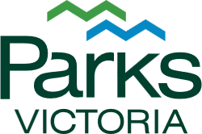


2026–27
Annual Delivery Plan

Acknowledgement of Country
The land we know today as Victoria is a land of extraordinary contrast, from vast deserts to alpine snowfields, ancient rainforests to dormant volcanoes, rugged coastlines and inland waterways. This remarkable diversity is more than scenery; it is a living record of culture, connection, and care that stretches back thousands of generations.
Across the parks and reserves in Victoria lie cultural landscapes shaped by Aboriginal peoples through millennia of knowledge, stewardship, and deep relationship with Country. These places tell stories of resilience, ingenuity, and belonging, stories written not only in books, but in the land itself.
Parks Victoria respectfully acknowledges the Traditional Owners of these lands and waters. We honour their enduring connection to Country and their continuing role as custodians. Together, we commit to protecting and celebrating these landscapes so they remain vibrant for generations to come.

Contents
Message from the Chief Executive Officer 4
About this Annual Delivery Plan 5
Our organisation 6
About Parks Victoria 6
Our vision 6
Our strategic outcomes 6
Our priorities 7
Our structure 8
Our divisions 9
Our regions 9
Our core services 10
Core management services 10
Core enabling services 13
Our key projects 16
Our performance measures 19
Strategic outcome measures 19
DPS output measures 20
Our resources 20
Our budget 21
Our people 22
Our strategic risks 22

Cover: Visitors at the observation lookout at Buchan Caves, Krauatungalung Country.
Acknowledgement of Country: View of the Plenty Gorge Parklands, Wurundjeri Country.
Contents: Rock art at Billimina, Grampians (Gariwerd) National Park, Djab Wurrung, Jadawadjali and Gunditjmara Country

Message from the Chief Executive Officer
Parks Victoria manages some of Victoria’s most valued land and seascapes. These places are important because they underpin our environmental, economic, cultural and social wellbeing.
Our responsibility is to deliver high quality, reliable services that enable people to access and enjoy our parks, ports and waterways, and to protect the things that make these places so special. This Annual Delivery Plan sets out our focus for the 2026–27 financial year – what we will deliver to meet this responsibility and achieve the strategic outcomes and priorities in the Parks Victoria Strategic Plan 2026–29.
In 2026–27, we continue our focus on getting back to basics – being a good land manager, delivering high quality conservation programs, and being a trusted and valued partner to the Traditional Owners, park users, community volunteers and local businesses that we work with every day.
Building on the foundations laid over the past year, including improvements to governance, systems and place based leadership, this Annual Delivery Plan is about practical, effective on ground action. We are also focused on improving the way we deliver, prioritise effort and respond to community needs – simplifying our ways of working and strengthening transparency and accountability.
Our people are at the heart of everything we do. We are committed to creating a safe, respectful and inclusive workplace where everyone can thrive. Many of our staff work in challenging and remote environments, often facing inherent risks. The safety and wellbeing of our people, both physical and psychological, is paramount. We encourage speaking up, proactively managing hazards, and embracing our shared responsibility for preventing harm.
Equally important is the workplace culture we build together. We are investing in developing our people, strengthening local action, risk management and problem solving, and fostering high performance and teamwork through a ‘one Parks Victoria’ approach – empowering a capable, accountable and safety-focused workforce, where our people can realise their full potential and deliver lasting value for all Victorians.
I am proud of the commitment and professionalism of our people and the work we do every day. Together, through a clear focus on the fundamentals and a renewed strategic direction, we will continue to care for Victoria’s parks, ports and waterways so they can be enjoyed by everyone – now and into the future.
Lee Miezis
Chief Executive Officer

About this Annual Delivery Plan
The 2026–27 financial year sees Parks Victoria enter its first full year of delivering our Strategic Plan 2026–29. This strategic plan defines our 10-year vision for the future, the outcomes we want to see in the next 5 years, and our 3-year strategic priorities – balanced across 4 focus areas.
Each financial year, Parks Victoria produces an Annual Delivery Plan describing what we’re aiming to deliver over the coming 12 months. The 2026–27 Annual Delivery Plan is aligned to our Strategic Plan, and details how we’ll deliver our strategic priorities and achieve the outcomes we want to see by 2031.
This 2026–27 Annual Delivery Plan identifies the core services and the key projects we will deliver this financial year. It also details the resources we are investing to deliver these services and projects, as well as how we will measure our success.
To ensure we are aligned and focused, our organisation-wide annual delivery plan is supported by divisional level planning, as well as performance and development plans for each individual member of our team. These plans provide a greater level of detail about where we are putting our efforts for the coming 12 months.
The Annual Delivery Plan will be reviewed after 6 months, to consider changes in our operating environment and make any required adjustments. This will enable us to be responsive to changes in government priorities and community needs.
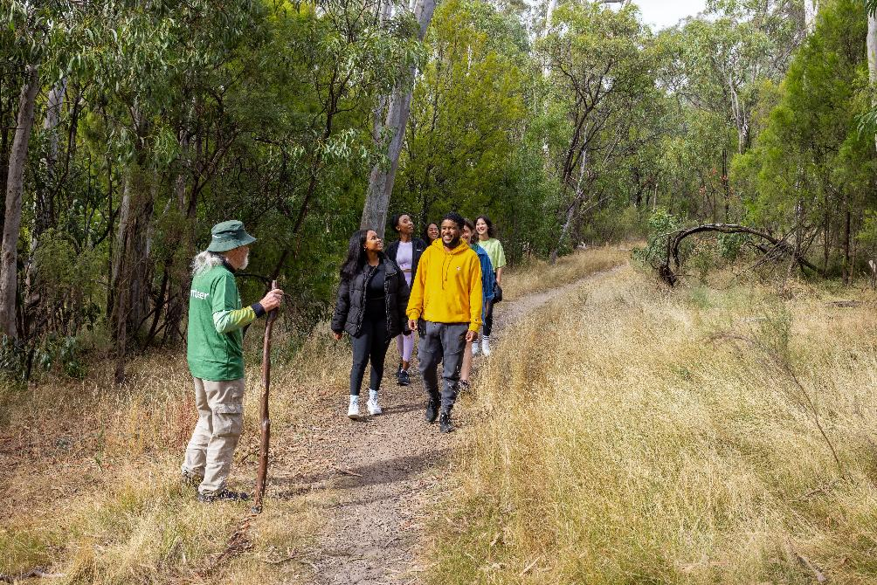
Parks Walks, Gresswell Forest Nature Conservation Reserve, Wurundjeri Country.

Our organisation

About Parks Victoria
We manage a diverse estate of parks, reserves and community facilities for all Victorians.
Parks Victoria is a statutory authority under the Parks Victoria Act 2018, managing over 4 million hectares of public land and waters across Victoria. These parks, ports and waterways attract more than 100 million visits each year and support rich biodiversity, including over 4,300 native plant species and around 1,000 native animal species, while protecting natural environments and cultural heritage.
Parks Victoria is overseen by a Board appointed by the Governor-in-Council on the recommendation of the Minister for Environment. The Board is accountable to the Minister and delegates day-to-day operations to the Chief Executive Officer (CEO) and executive team.
With around 1,000 staff working from 100 locations, Parks Victoria partners with Traditional Owners, government and non-government organisations, volunteers and user groups, licensed tour operators, lessees, research institutes and the broader community to keep parks, ports and waterways healthy and resilient for future generations.

Our vision
Parks bringing people together.
Our parks are places for connection – people with nature, communities with place, and generations with one another.
They are healthy and inviting spaces for recreation, safeguarding biodiversity, celebrating culture and maintaining our wellbeing.

Our strategic outcomes
Over the coming five years we want to achieve the following strategic outcomes:
- All Victorians can enjoy the outdoors
- Communities are vibrant and prosperous
- Natural and cultural values and places are well managed
- Volunteers feel valued and supported
- Self-determination for Traditional Owners is advanced
- We have strong and trusted partnerships

Our priorities
Our 3-year priorities define what we will focus on to achieve our strategic outcomes and long-term vision. These priorities are balanced across 4 areas:
- Access & experience
Greater opportunities to enjoy our parks, ports and waterways
  - Improve engagement with park users to better understand and deliver on their needs.
  - Build stronger partnerships with Traditional Owners, supporting their cultural, economic and environmental aspirations on Country.
  - Prioritise repair and maintenance of our built assets so parks are more reliably open and accessible.
  - Accelerate delivery of new infrastructure in parks to support improved visitor experiences.
  - Increase the diversity of recreational and commercial opportunities in our parks.
- Management & conservation
Healthy and resilient parks, ports and waterways
  - Direct more conservation investment to on-ground action, focusing on the greatest threats to park values and securing Victoria’s biodiversity.
  - Reform park management planning to better guide practical on-ground action that meets legal requirements and community expectations.
  - Improve monitoring, evaluation and reporting on park management activities to enhance transparency and decision making.
  - Drive behaviour change to ensure our parks are valued, cared for and used responsibly.
  - Strengthen how we prepare for, respond to and recover from impacts of climate change and natural disasters.
- Partners & stakeholders
Strong partnerships underpinned by trust and shared purpose
  - Communicate early, honestly and regularly with Traditional Owners, local communities and stakeholders about decisions that impact them.
  - Empower volunteers and partners by giving them the access, tools and support they need to contribute to the management of our parks.
  - Collaborate with communities, businesses and philanthropy to drive more integrated approaches to managing and enhancing our parks.
  - Deliver education and citizen science programs to increase awareness, understanding and knowledge of our environmental and cultural values.
- People & systems
A more connected, empowered and accountable team
  - Grow the capability, experience and resilience of our people to meet current and future challenges.
  - Increase accountability, agility and resourcefulness in making decisions, managing risk and realising opportunities.
  - Improve our systems, processes and ways of working, so that we are more efficient, effective and safe in delivering our core functions.
  - Ensure we are operationally sustainable through strong financial management, continuous improvement and innovation.

Our structure
Our structure and governance arrangements provide clear accountabilities and oversight of our activities.
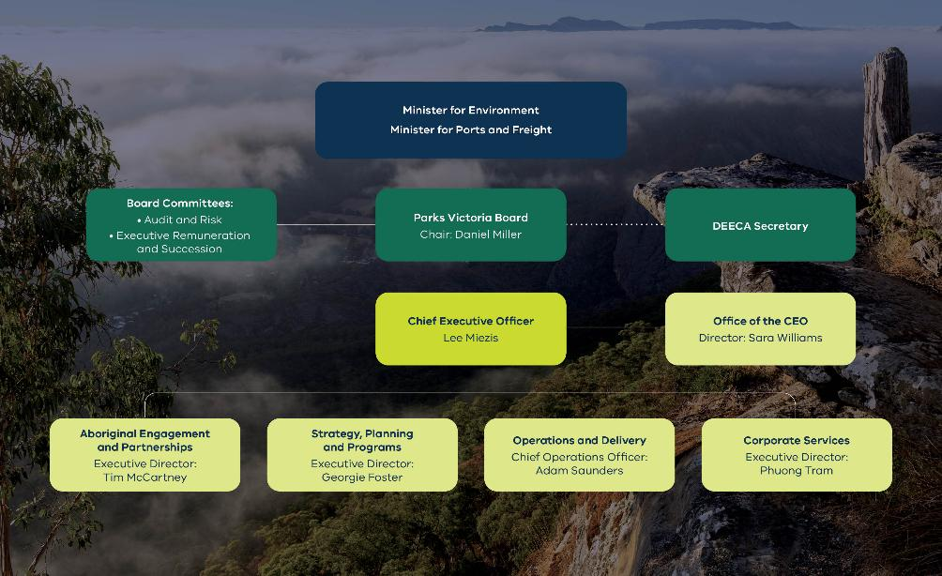
View from Boroka Lookout in Grampians (Gariwerd) National Park, Djab Wurrung, Jadawadjali and Gunditjmara Country (with graph of organisation structure overlaid on top)
Parks Victoria organisational structure:
- Ministers:
  - Minister for Environment
  - Minister for Ports and Freight
- Parks Victoria Board
Chair: Daniel Miller
  - Board Committees:
    - Audit and Risk
    - Executive Remuneration and Succession
  - Department of Energy, Environment and Climate Action (DEECA) Secretary
- Chief Executive Officer
Lee Miezis
  - Office of the Chief Executive Officer
Director: Sara Williams
- Aboriginal Engagement and Partnerships
Executive Director: Tim McCartney
- Strategy, Planning and Programs
Executive Director: Georgie Foster
- Operations and Delivery
Chief Operations Officer: Adam Saunders
- Corporate Services
Executive Director: Phuong Tram

Our divisions
Parks Victoria is organised into four main divisions:
Aboriginal Engagement and Partnerships
Leads the development and delivery of Traditional Owner strategies, provides advice and support to operational staff on Traditional Owner partnerships and cultural heritage management, and leads the Aboriginal wellbeing and capability across Parks Victoria.
Strategy, Planning and Programs
Provides organisational guardrails, services and hands-on support to drive consistent high performance in operational delivery across Parks Victoria.
Operations and Delivery
Brings together end-to-end accountability for the on-ground management of parks, ports and waterways in accordance with organisational guardrails and supported by advisory and enabling functions.
Corporate Services
Leads the provision of key enabling services and effective resource management to support operational delivery across Parks Victoria within appropriate government regulatory requirements.
In addition, the Office of the Chief Executive Officer (CEO) provides strategic advice, administrative and governance support to the CEO, Senior Executive Committee and Board, including the timely preparation of high-quality briefings, correspondence and reports for senior decision makers, and secretariat support to governance committees.

Our regions
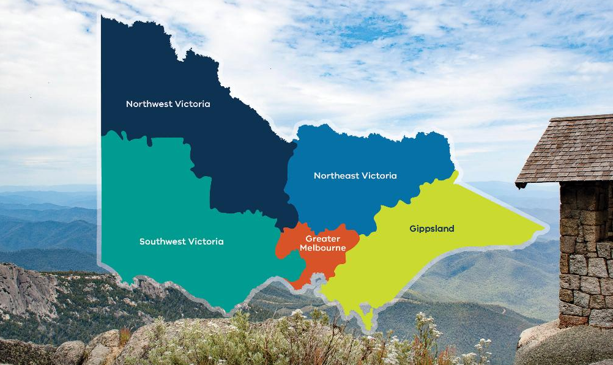
View from The Horn, Mount Buffalo National Park, Taungurung Country (with graphic overlay)

Our core services
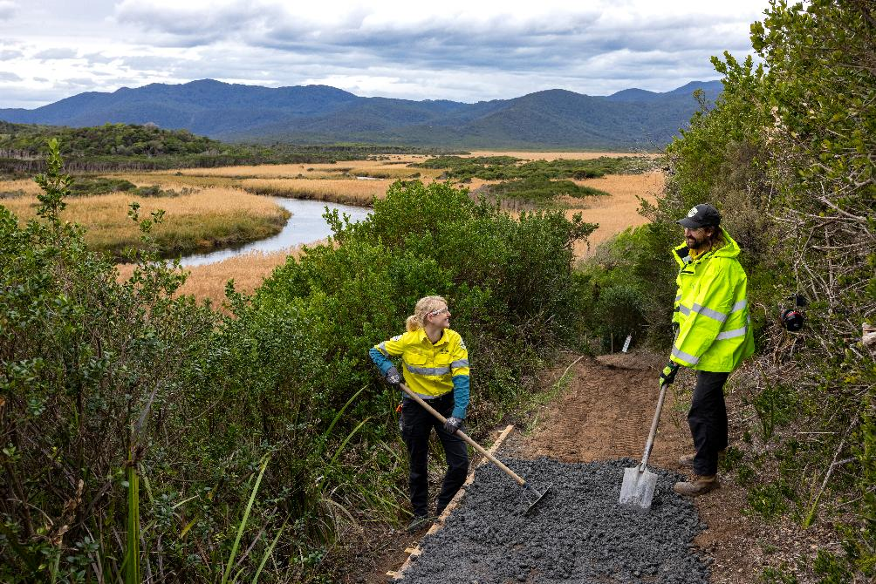
Rangers repairing a trail at Wilsons Promontory National Park.

Core management services
We deliver a broad suite of core management services that protect environmental and cultural values, support safe and enjoyable visitor experiences, and ensure the effective stewardship of parks, waterways and local ports across Victoria. These services form the operational backbone of the organisation and underpin our statutory responsibilities.

Land management
- Maintaining park landscapes, natural and cultural assets, access roads and tracks to support safe public use.
- Managing vegetation, erosion, and land stability to protect environmental and visitor values.
- Overseeing on ground works such as fencing, signage, boundary management and site rehabilitation.
- Supporting sustainable recreation through the upkeep of day use areas, picnic sites and trail networks.
- Coordinating land-based permits, leases and access arrangements.

Waterway management
- Managing rivers, lakes, estuaries and marine environments for safe and sustainable recreation.
- Maintaining navigation channels, aids to navigation and water-based visitor infrastructure.
- Overseeing moorings, vessel access points, boat ramps and water-based permits.
- Responding to waterway hazards, pollution events and environmental risks.
- Supporting water-based tourism and recreation operators.

Local port management
- Operating and maintaining piers, jetties, wharves and associated port infrastructure.
- Coordinating safe vessel movement within local ports, including compliance and risk management.
- Delivering dredging programs to maintain navigable waterways.
- Managing commercial leases, berths and maritime facilities.
- Responding to storm damage, structural failures and marine incidents to ensure port continuity.

Visitor and community services
- Managing visitor experience by designing and delivering safe, enjoyable and inclusive park experiences.
- Maintaining visitor infrastructure such as trails, lookouts, campgrounds, visitor centres, signage and amenities.
- Enabling sustainable recreational activities such as walking, camping, boating and nature-based tourism.
- Providing curriculum aligned education and interpretation programs, ranger led learning and public interpretation.
- Coordinating and supporting community, corporate and citizen science volunteers across parks and waterways.

Environmental management
- Protecting biodiversity through targeted species programs and habitat restoration.
- Managing invasive plants and animals to reduce ecological threats.
- Supporting long term ecological resilience through landscape scale planning and ecosystem monitoring.
- Implementing climate adaptation and resilience measures across park landscapes.
- Managing environmental risks such as erosion, coastal change and habitat degradation.

Cultural heritage services
- Caring for Aboriginal cultural heritage places in partnership with Traditional Owners.
- Conserving cultural heritage sites and landscapes across the park network.
- Embedding cultural values and knowledge into planning and management decisions.
- Ensuring cultural heritage protection through compliance, monitoring and restoration.
- Supporting cultural interpretation, storytelling and visitor education.

Traditional Owner partnerships
- Working in partnership with Traditional Owners to support self-determination in land and water management.
- Supporting joint management arrangements and co governance of parks and protected areas.
- Delivering on Country programs that strengthen cultural connection, healing and stewardship.
- Creating employment, training and enterprise opportunities for Traditional Owner groups.
- Ensuring cultural heritage is protected, respected and actively managed in collaboration with Traditional Owners.

Commercial services
- Managing leases, licences and permits for tourism, recreation and commercial activities.
- Overseeing commercial operators such as guided tour providers, accommodation services, cafés and marinas.
- Administering event, filming and photography approvals to ensure safe and appropriate use of park environments.
- Developing commercial partnerships that enhance visitor experiences and generate sustainable revenue.
- Ensuring all commercial activities meet environmental, cultural and safety standards.

Asset management
- Planning, maintaining and renewing built assets including historic sites, trails, lookouts, campgrounds, jetties, roads and visitor facilities.
- Managing asset risk, compliance and safety across parks, waterways and historic sites.
- Prioritising investment and capital works to maximise public value and long-term sustainability.
- Applying structured lifecycle management to keep assets functional, reliable and fit for purpose.
- Supporting continuity of visitor access through proactive maintenance and timely repairs.

Emergency management
- Supporting preparation for bushfires, floods, storms and other hazards through planning, training and readiness activities.
- As part of Forest Fire Management Victoria, supporting planned burning and fuel reduction programs to reduce bushfire risk.
- Responding to emergencies, including bushfires, severe weather and search and rescue incidents, in collaboration with emergency agencies.
- Managing public safety risks across parks, waterways and ports through hazard identification and mitigation.
- Coordinating post emergency recovery, including reopening parks, repairing infrastructure and restoring affected environments.
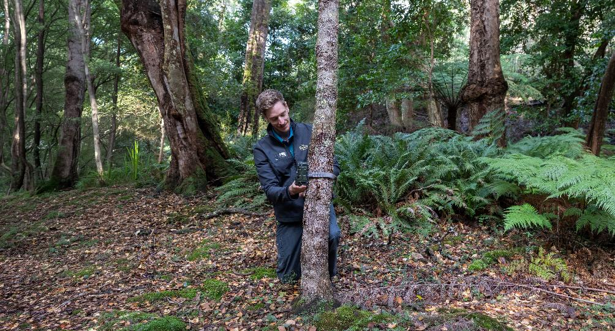
A ranger attaches a remote camera to a tree in the northern section of Wilsons Promontory National Park.

Core enabling services
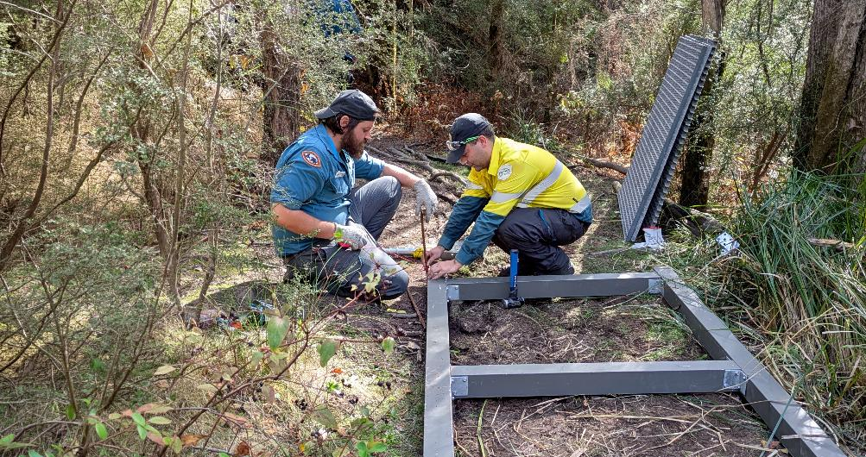
Taungurung Rangers installing a boardwalk along Neds Gully Track, Cathedral Range State Park, Taungurung Country.
Our enabling services provide the organisational foundations that support effective delivery of frontline operations, visitor services and environmental management. These functions ensure Parks Victoria is well governed, financially sustainable, safe, capable and equipped to meet its statutory responsibilities.

Scientific research and advice
- Conducting and commissioning research to inform evidence-based conservation and land management.
- Providing scientific expertise to guide planning, policy and operational decision making.
- Monitoring ecological health and environmental trends across parks and waterways.
- Collaborating with universities, research institutions and Traditional Owners on scientific programs.
- Translating scientific findings into practical management actions and organisational learning.

Safety management
- Developing and implementing safety frameworks, policies and procedures across the organisation.
- Supporting a proactive safety culture through training, awareness and leadership engagement.
- Monitoring safety performance and conducting incident investigations to drive continuous improvement.
- Ensuring compliance with occupational health and safety legislation and standards.
- Providing specialist advice to support safe field operations, visitor management and emergency response.

Corporate governance and strategic planning
- Establishing clear governance frameworks that guide organisational decision making and accountability.
- Developing long term strategic plans that align with government priorities and community expectations.
- Monitoring organisational performance and reporting against key outcomes and statutory obligations.
- Supporting executive and board governance processes, including risk oversight and compliance.
- Coordinating policy development to ensure consistent, evidence based organisational direction.

Financial management and procurement
- Managing organisational budgets, forecasting and financial controls to ensure responsible use of public funds.
- Overseeing procurement processes that deliver value for money and meet legislative requirements.
- Managing contracts, grants and commercial agreements to support efficient service delivery.
- Leading investment planning for capital works, infrastructure renewal and strategic initiatives.
- Providing financial reporting, analysis and advice to support informed decision making.

People, culture and capability development services
- Supporting workforce planning to ensure the right skills and capacity across the organisation.
- Delivering training, leadership development and capability building programs.
- Promoting a safe, inclusive and positive organisational culture.
- Managing employee wellbeing, health and safety programs.
- Overseeing recruitment, performance management and industrial relations.

Information and communications technology (ICT) services
- Maintaining secure, reliable digital systems that support field operations and corporate functions.
- Delivering technology solutions that improve efficiency, mobility and data accessibility.
- Managing cybersecurity, data protection and digital risk.
- Supporting digital transformation initiatives and modernisation of business systems.
- Providing ICT service support, troubleshooting and system maintenance.

Legal, compliance and risk management services
- Providing legal advice to support operational, commercial and strategic decision making.
- Ensuring compliance with environmental, cultural heritage, safety and organisational legislation.
- Managing organisational risk through structured frameworks and monitoring processes.
- Supporting incident investigations, regulatory reporting and audit activities.
- Strengthening organisational resilience through proactive risk mitigation strategies.

Communications and stakeholder engagement
- Managing public communications, media relations and visitor information.
- Engaging with communities, partners, and government stakeholders.
- Supporting reputation management through clear, consistent messaging.
- Delivering communication strategies for major projects, emergencies and organisational initiatives.
- Providing internal communication that supports staff alignment and organisational cohesion.

Facilities and fleet management
- Managing office, depot and operational facilities to ensure they are safe, functional and fit for purpose.
- Overseeing maintenance, upgrades and compliance of built facilities and operational bases.
- Managing the organisation’s vehicle and vessel fleet to support field operations.
- Ensuring fleet safety, efficiency and lifecycle planning, including procurement and disposal.
- Coordinating facility services such as utilities, security, cleaning and asset compliance.

Business systems and administrative support services
- Maintaining efficient administrative processes that support day to day operations.
- Managing records, information systems and organisational documentation.
- Providing office coordination, logistics and operational support to staff.
- Streamlining business processes to improve efficiency and reduce duplication.
- Supporting organisational coordination across teams, regions and service areas.
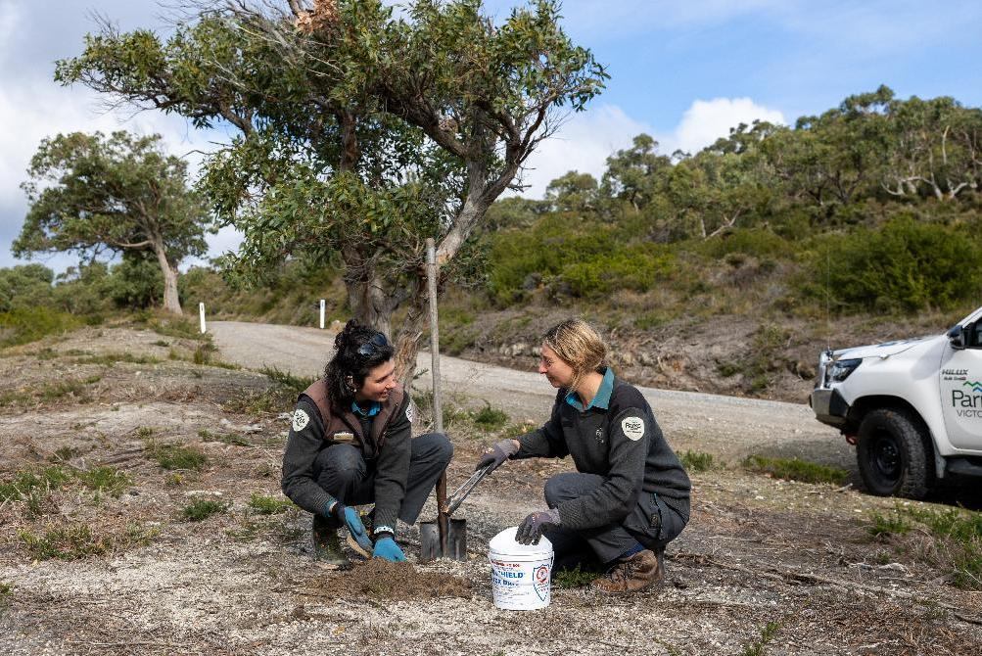
Rangers laying fox bait at Wilsons Promontory National Park.

Our key projects
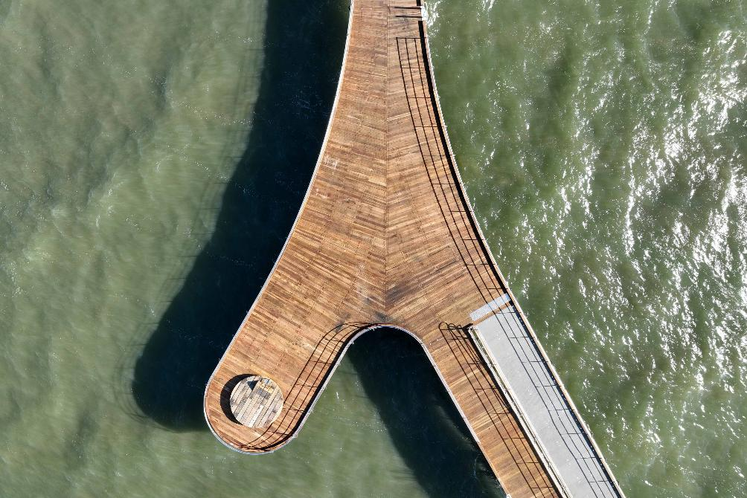
Aerial image taken at Altona Pier, Bunurong Sea Country.
We have prioritised 22 key projects for inclusion in the 2026–27 Annual Delivery Plan. The full complement of projects to be delivered in 2026–27 are identified in divisional-level plans.
Priority focus areas are identified as either Primary or Secondary in accordance with the Parks Victoria Strategic Plan 2026–2029.
Project title | Project description | Priority focus area
Improving park facilities for visitors | Renew priority visitor sites to improve safety and deliver better experiences for park users. | Primary alignment: Access & experience.  Secondary alignment: Partners & stakeholders.
Delivering infrastructure upgrades at Serendip Sanctuary | Deliver civil, landscape, building and amenity works to improve facilities for visitors to Serendip Sanctuary. | Primary alignment: Access & experience.  Secondary alignment: Partners & stakeholders.
Upgrading the Yallock-Bulluk Coastal Trail | Upgrade the Yallock-Bulluk Coastal Trail with new lookouts, seating nodes, signage and improved trail connections. | Primary alignment: Access & experience.
Improving Plenty Gorge Park | Deliver the northern and central sections of the new Plenty River Trail, and upgrades to the Hawkstone Picnic area and Nioka Bush Camp. | Primary alignment: Access & experience.
Building a new Dromana Pier | Demolish and rebuild the Dromana Pier to restore safe access and support ongoing community and visitor use. | Primary alignment: Access & experience.
Building a new St Leonards Pier | Demolish and rebuild St Leonards Pier to restore safe access and support ongoing community and visitor use (2027-28 completion). | Primary alignment: Access & experience.
Master planning for three new regional parks | Finalise and publish master plans for the new Clyde, Werribee Township regional parks, and a draft master plan for Koroit regional park. | Primary alignment: Access & experience.  Secondary alignment: Management & conservation and Partners & stakeholders.
Establishing new parks in Central West Victoria | Transfer management of 79,000 hectares of State forest to Parks Victoria and establish 3 new national parks and 2 new conservation parks and expand the Bendigo Regional Park. | Primary alignment: Management & conservation.  Secondary alignment: Partners & stakeholders and People & systems.
Constructing the Wilsons Promontory Sanctuary fence | Construct a 10-kilometre predator-proof fence to protect biodiversity and control invasive animals at Wilsons Promontory National Park. | Primary alignment: Management & conservation.  Secondary alignment: Partners & stakeholders.
Delivering fit-for-purpose park and precinct plans | Develop and deliver fit-for-purpose plans that guide on-ground park management. | Primary alignment: Access & experience.  Secondary alignment: Management & conservation and Partners & stakeholders.
Using the Victorian Species Recognition Model to improve conservation outcomes | Embed the use of Ai to speed up ecological image analysis, strengthen monitoring and improve conservation program decision-making. | Primary alignment: Management & conservation.  Secondary alignment: People & systems.
Strengthening conservation program delivery | Improve conservation planning, funding and reporting frameworks to deliver greater on-ground impacts from conservation investment. | Primary alignment: Management & conservation.  Secondary alignment: Partners & stakeholders and People & systems.
Strengthening recovery from fire and emergency events | Strengthen our capability to restore and protect visitor infrastructure, biodiversity and cultural heritage after a fire, flood or other emergency event. | Primary alignment: Management & conservation.  Secondary alignment: Access & experience.
Implementing the Managing Country Together Framework | Develop and deliver action plans for rock art, ancestral remains and cultural fire in partnership with Traditional Owners. | Primary alignment: Partners & stakeholders.  Secondary alignment: Management & conservation and People & systems.
Growing community participation | Strengthen supports for volunteering, education and citizen science programs to increase participation levels. | Primary alignment: Partners & stakeholders.
Embedding our community engagement framework | Support our staff in conducting effective community and stakeholder engagement by providing fit-for-purpose tools and training. | Primary alignment: Partners & stakeholders.  Secondary alignment: People & systems.
Improving leasing and licensing of public assets | Modernise our approach to leasing and licensing to improve the management of public assets. | Primary alignment: Partners & stakeholders.  Secondary alignment: People & systems.
Strengthening Aboriginal cultural capability | Implement our Cultural Capability Framework and Action Plan to ensure a culturally safe workplace. | Primary alignment: People & systems.  Secondary alignment: Partners & stakeholders
Strengthening leadership, culture and capability | Deliver professional development programs that strengthen leadership, culture and capability to improve delivery performance. | Primary alignment: People & systems.  Secondary alignment: Partners & stakeholders.
Creating safer workplaces | Launch a safety uplift program focused on strengthening safety culture and leadership and improving the effectiveness of safety systems and critical risk management. | Primary alignment: People & systems.  Secondary alignment: Partners & stakeholders.
Enhancing our Information Technology (IT) systems | Upgrade enterprise IT support for better service delivery, improved compliance and to enable efficient, data-driven decision making. | Primary alignment: People & systems.  Secondary alignment: Partners & stakeholders, Management & conservation and Access & experience.
Establishing an Enterprise AI Office | Establish an AI office to build capability, govern safe use and pilot initiatives that improve productivity and customer service. | Primary alignment: People & systems.  Secondary alignment: Access & experience, Management & conservation and Partners & stakeholders.

Our performance measures
Our delivery model is supported by performance measures aligned to our strategic outcomes.
Together with the Department Performance Statement (DPS) output measures that were published with the 2026-27 State Budget, these performance measures are how we will monitor progress and report on what we are delivering for Victorians.

Strategic outcome measures
Strategic outcome | Performance measure | Baseline | 2026–27 target
All Victorians can enjoy the outdoors. | Visitors satisfied with their visit to terrestrial parks. | New | 90%
All Victorians can enjoy the outdoors. | Key visitor assets open to the public. | 88% | 93%
Natural and cultural values and places are well managed. | Priority landscapes with a conservation action plan in place. | 61% | 72%
Natural and cultural values and places are well managed. | Significant asset inspection program completed in accordance with Asset Management Plan. | New | 80%
Self-determination for Traditional Owners is advanced. | Formal partnership agreements with Traditional Owners. | 2 agreements | 4 agreements
Self-determination for Traditional Owners is advanced. | Staff that have current cultural capability training. | New | 90%
Communities are vibrant and prosperous. | Increase in revenue from camping and roofed accommodation to support ongoing asset maintenance and visitor experience. | New | 23%
Communities are vibrant and prosperous. | Increase in direct operating costs recovered from commercial agreements. | New | 18%
Communities are vibrant and prosperous. | Visits to terrestrial parks involving social connection. | New | 10 million visits
Volunteers feel valued and supported. | Active volunteers in parks, ports and waterways. | New | 21,000 active volunteers
Volunteers feel valued and supported. | Volunteer hours worked in parks, ports and waterways. | New | 110,000 hours
Volunteers feel valued and supported. | Strength of relationships with partners and stakeholders. | New | 3 out of 5 rating
- A number of strategic outcome performance measures are newly introduced in this Annual Delivery Plan. Year 1 will focus on establishing methodologies and collecting baseline data. As a result, out year targets have not been set for all measures and will be developed once baseline performance is confirmed
- Strategic outcome performance will be subject to ongoing review and refinement as organisational capability in performance monitoring and data collection matures, ensuring they remain robust, meaningful and aligned to Parks Victoria’s strategic outcomes.

DPS output measures
Performance measure | Baseline | 2026–27 target
Visits to national, state, urban and other terrestrial parks | 85 million visits | 85 million visits
Visits to piers and jetties | 40 million visits | 40 million visits
Significant built bay assets managed by Parks Victoria rated in average to excellent condition | 80% | 80%
Significant built park assets managed by Parks Victoria rated in average to excellent condition | 88% | 88%
Area treated to minimise the impact of pest plants, pest animals and over abundant native animals in parks managed by Parks Victoria | 1.6 million hectares | 1.6 million hectares
Total area of estate managed by Parks Victoria | 4.12 million hectares | 4.10 million hectares
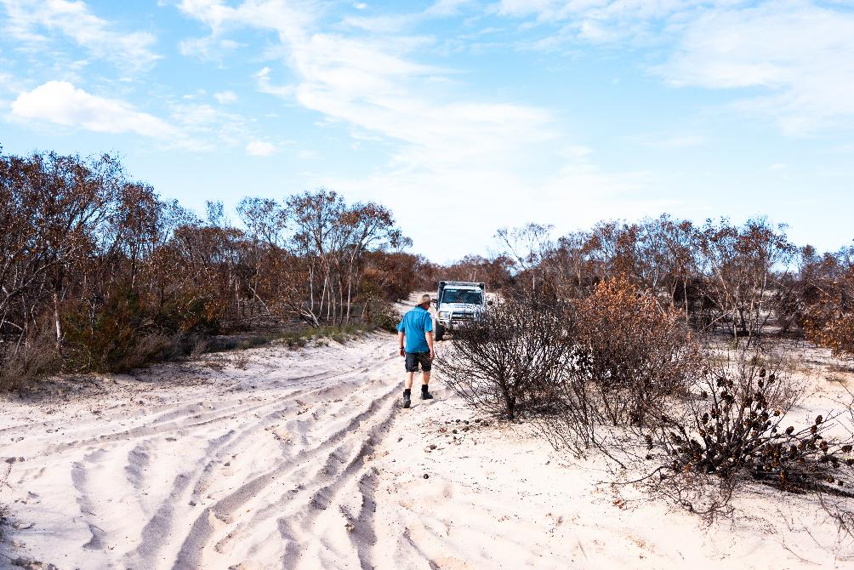
A ranger walking in Little Desert National Park, Wotjobaluk, Jaadwa, Jadawadjali, Wergaia and Jupagulk Country

Our resources

Our budget
The 2026–27 budget prioritises investment in delivering our core services and developing our capability.
Our 2026–27 revenue is forecast at $302.5 million and 2026–27 expenditure is forecast at $315.8 million, resulting in a modest operating deficit of $2.7 million after adjustments and before depreciation. Due to the timing of when revenue is received, Parks Victoria uses its cash reserves to manage cashflows and achieve a balanced budget.
Summary of 2026–27 budget | ($’000)
Revenue
Base funding | 174,463
External grants | N/A
Operating grants | 36,666
Recovery grants | 36,732
Capital grants | 13,710
Income generating activities | 32,758
Interest | 6,500
Other | 1,706
Total revenue | 302,515
Expenditure | N/A
Staff | 162,926
Operating costs | 152,888
Total expenditure | 315,815
Net result before depreciation | (13,300)
Adjusted net result before depreciation | (2,662)
Depreciation | 35,000
Net result | (37,662)

Our people
Parks Victoria continues to strengthen place-based delivery, ensuring decision-making is closer to the communities we serve, and increasing on-ground capacity to effectively manage our parks, ports and waterways.
As at 1 July 2026, Parks Victoria has a total of 1,279 positions, with 1,099 ongoing roles in the organisation.
Division | Staff positions
Operations and Delivery Division | 964
Strategy, Planning and Programs Division | 109
Aboriginal Engagement and Partnerships Division | 36
Corporate Services Division | 161
Office of the Chief Executive Officer | 9
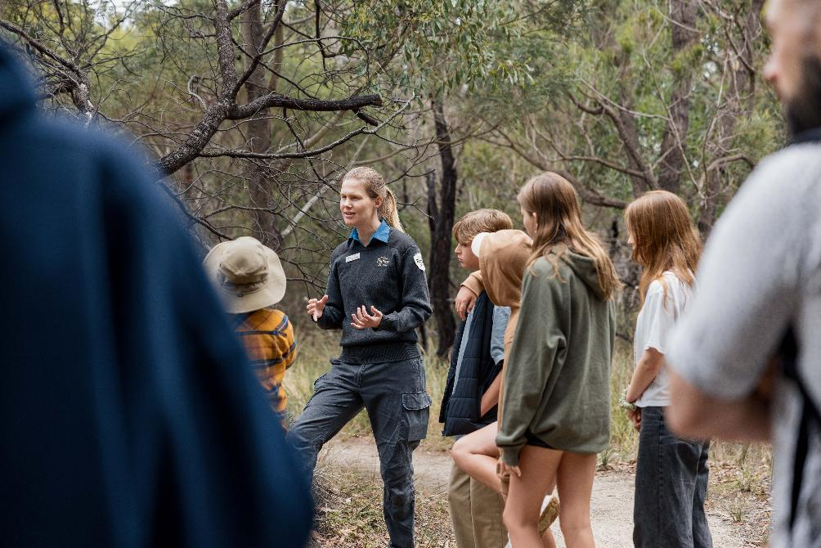
A ranger talking to a group of children at Ocean Grove Nature Conservation Reserve, Wadawurrung Country

Our strategic risks
Risks are events or circumstances that could affect our ability to deliver our objectives, services or outcomes. Managing risk means understanding what could go wrong, taking reasonable steps to reduce harm, and making informed decisions when uncertainty arises.
We continue to strengthen our approach to risk management in line with the Victorian Government Risk Management Framework. Our focus is on building organisational capability to manage risk well, supported by a positive risk culture and the integration of risk management into planning, decision-making and everyday operations.
Following the release of the Strategic Plan 2026–29, our strategic risks (SR) have been refreshed to ensure they remain relevant to our current operating environment. These strategic risks represent the most significant areas of uncertainty that could impact our ability to achieve our 5-year strategic outcomes.
Management of these risks is regularly monitored by the Senior Executive Committee and formally reported to the Board and its Audit and Risk Committee.
Operational risks are identified and managed through divisional plans and day-to-day management practices.
SR1 Health, safety and wellbeing of staff and volunteers
We protect the physical and psychological safety of our staff and volunteers through clear responsibilities, safe work practices and a culture that encourages people to speak up. This helps prevent harm, supports wellbeing and enables our people to perform at their best.
SR2 Effective land and conservation management
We plan for and manage parks, ports and waterways so that environmental, cultural and recreational values are protected over the long term, including in the face of a changing climate. This enables more people to access and enjoy the outdoors while safeguarding Victoria’s natural and cultural assets for future generations.
SR3 Confidence of the authorising environment
We build trust and confidence with government, partners and the community through clear communication, transparent decision making and accountability for our performance. This ensures strong relationships and ongoing support for Parks Victoria’s role and priorities.
SR4 Appropriate conduct and behaviour
We promote a respectful workplace where our values guide how we work and interact with others. Clear expectations and safe reporting processes ensure inappropriate behaviour is addressed promptly and appropriately.
SR5 Data integrity and security
We protect and manage information so it is accurate, secure and used responsibly, including information used in digital and automated systems. Good data governance supports better decisions, stronger service delivery and reliable reporting.
SR6 Resources to deliver our core services
We apply our people, funding and assets wisely to deliver core services and priority projects. Capable teams work together to continuously improve how we operate, find efficiencies and reduce waste.

Parks Victoria
Level 30,300 LaTrobe Street, Melbourne
13 19 63
parks.vic.gov.au


