My visit to Werribee Park Mansion

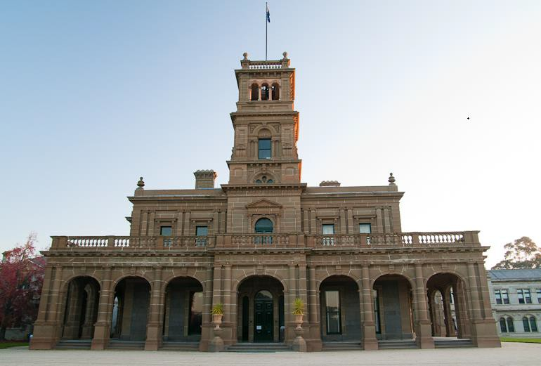

Carpark:
When we arrive at Werribee Park we will park in the car park.
I need to stay close to my adult and watch for moving cars.
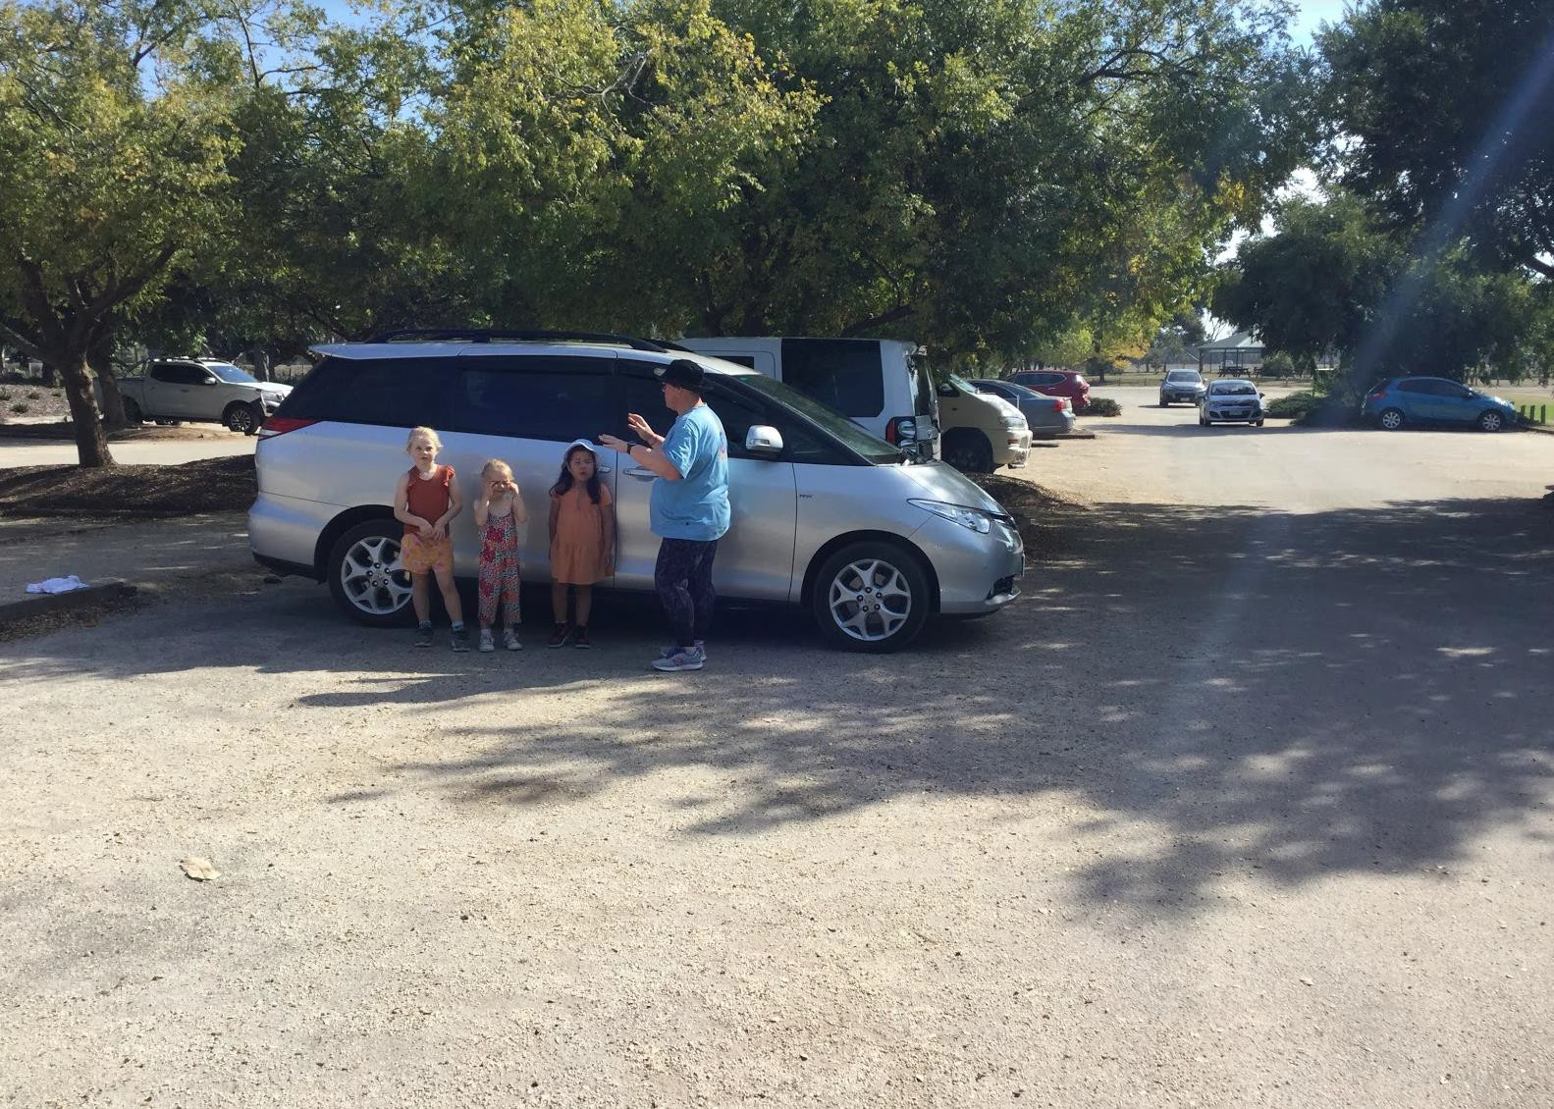

Werribee Park Entrance:
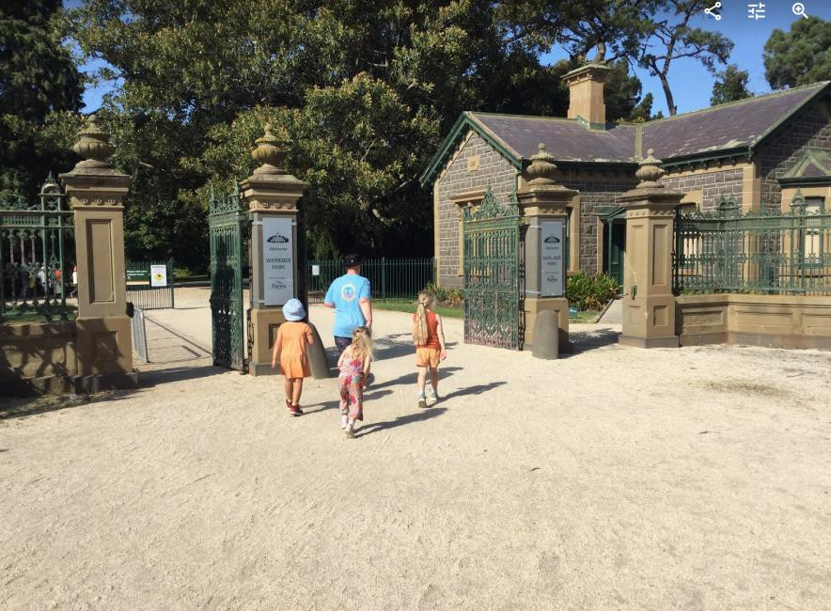
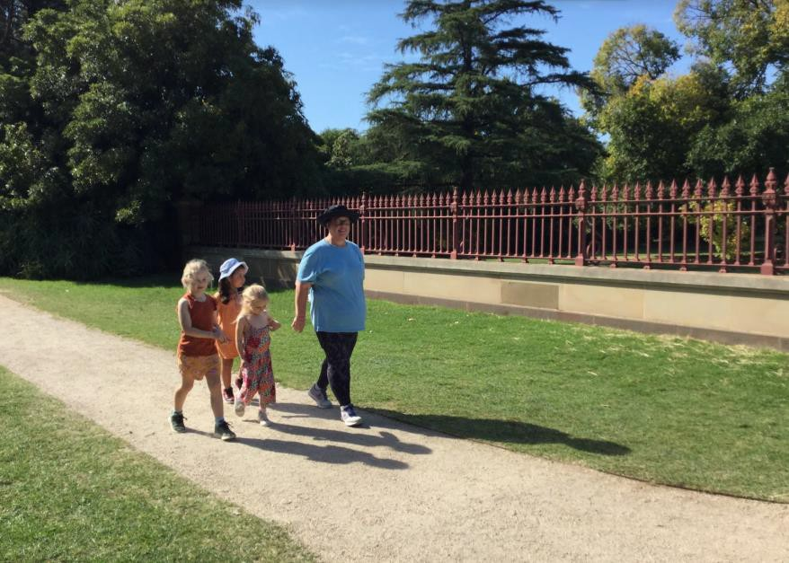
We will walk along the path towards the big green iron gates.

We might see Parks Victoria Rangers and other people working in the gardens, or on noisy machines that cut grass.
Some of them will have green uniforms on.
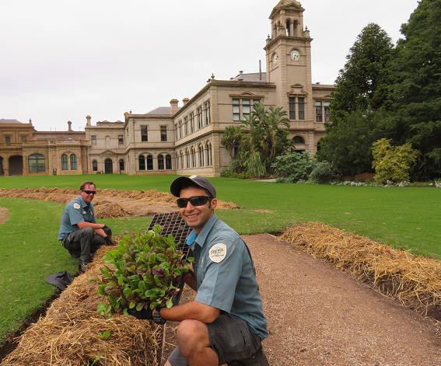
They are happy to help you.

We will walk down the path towards the big trees.
We will see a big building appearing in front of us.

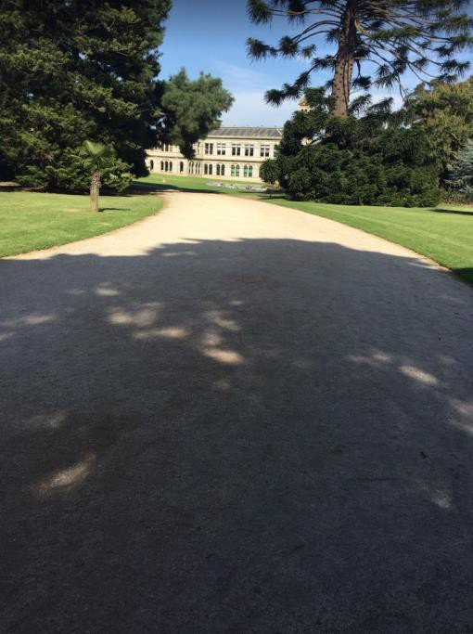

We may see animals in the park.
We have lost of birds, ducks, frogs, butterflies, and possums.
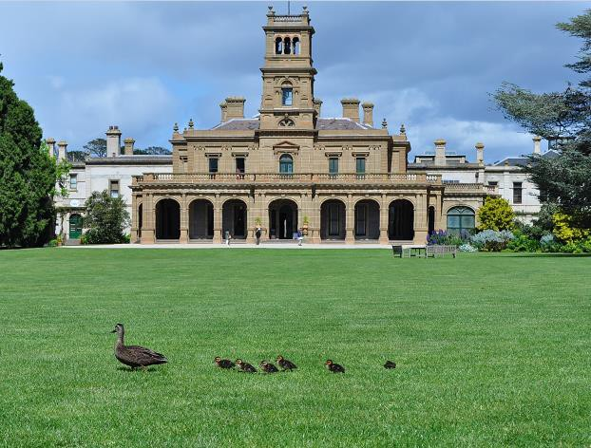

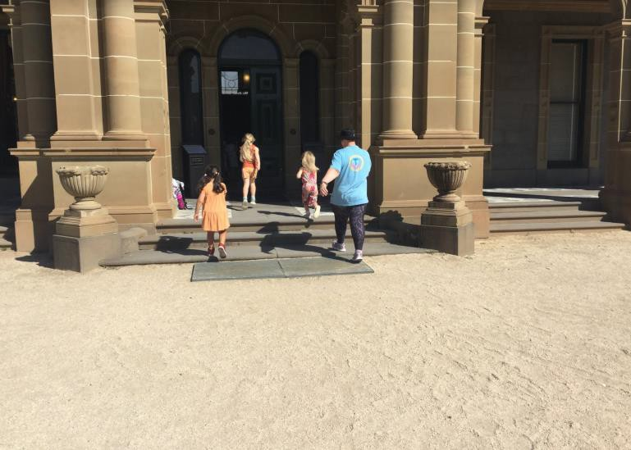
We will walk towards the big green doors.
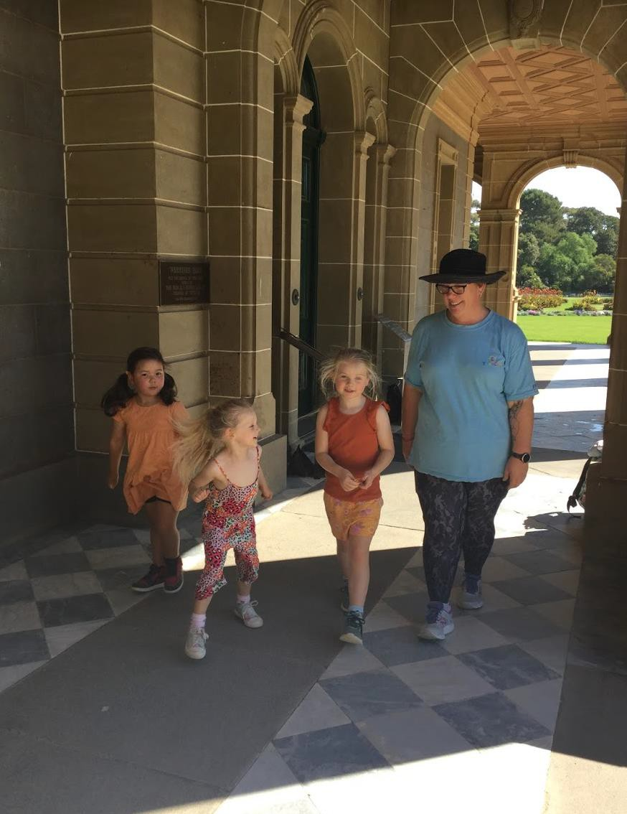

Our Friendly Staff:
When we arrive at the entrance of the Mansion there will be a staff member there to greet us.
Your adults will pay the entrance fee.
We can then walk around the Mansion.
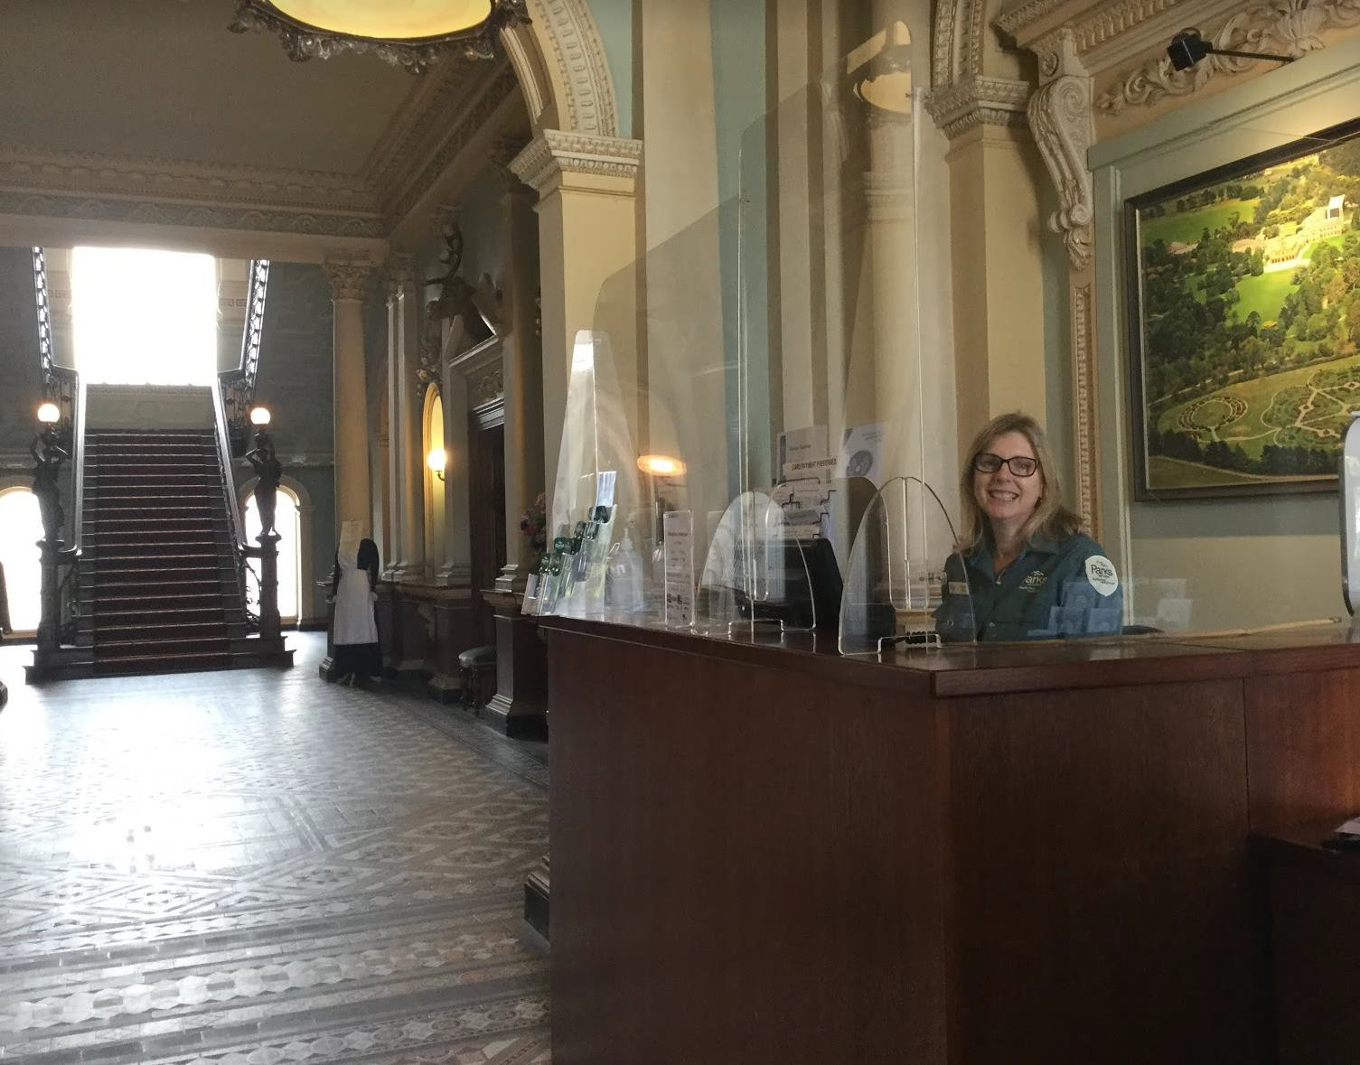

We will see barriers in the Mansion. We will stand behind the barrier and keep our hands behind the barrier.
This keeps the old things safe.
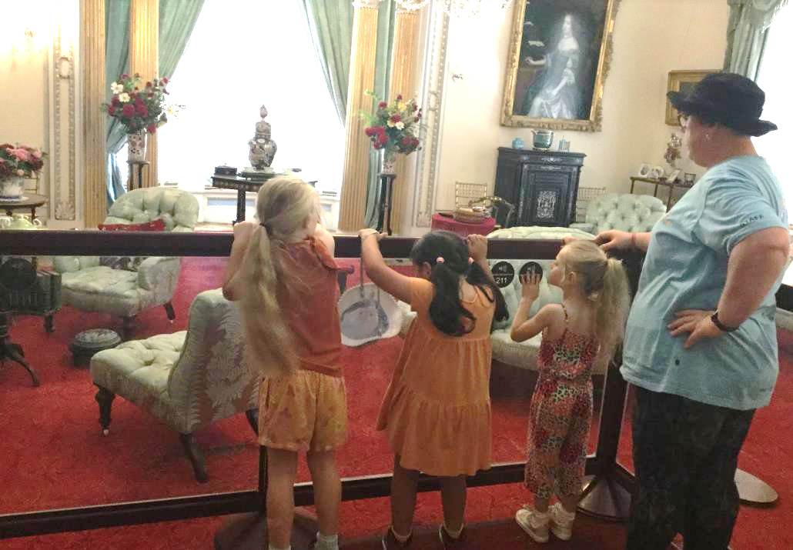

The Drawing Room:
The drawing room is the room where adults met and drank cups of tea.
There are lots of old things in this room.
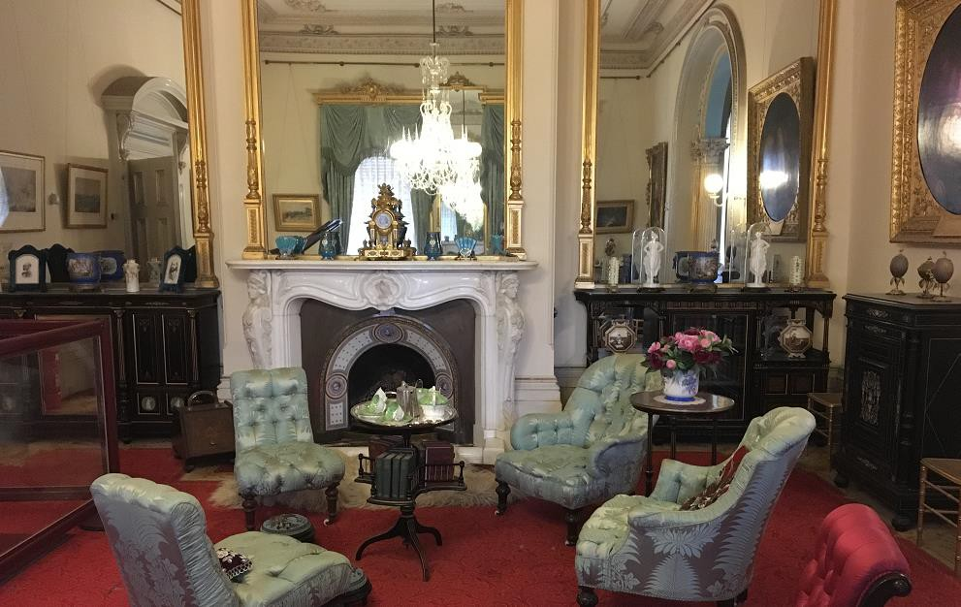

The Dining Room:
This is where the owners of the Mansion would sit with their guests and eat their meals together.
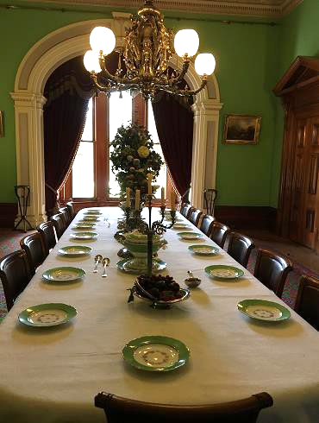

We will walk down long hallways.
We can visit all the rooms.
The doors will open, and we can have a look inside.
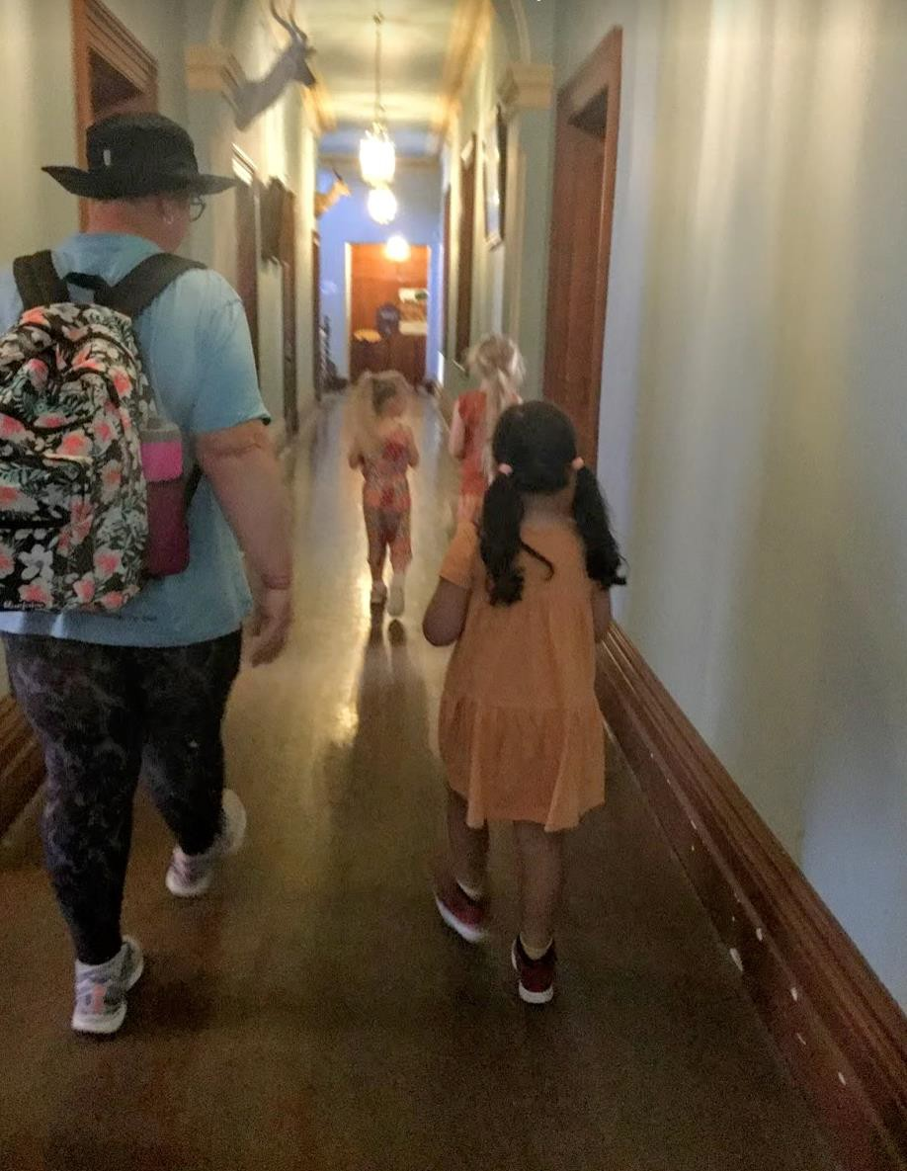

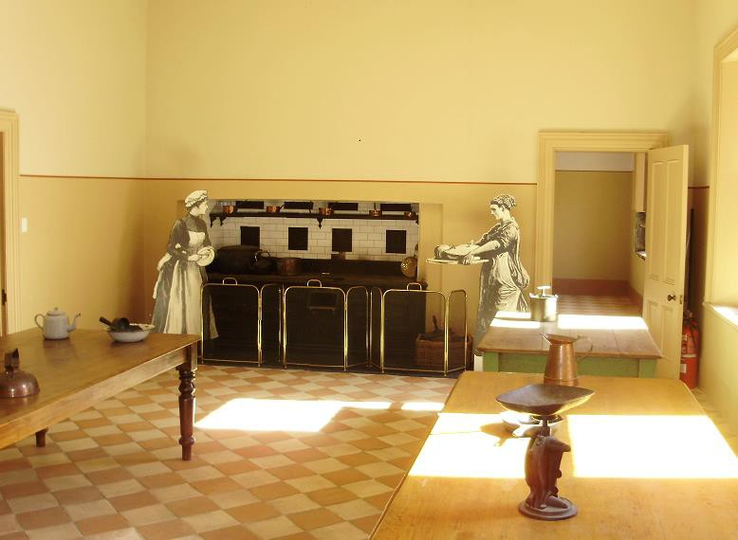
The Kitchen:
The kitchen was where all the food was made for the owner and guests.
The big stove was wood fired.
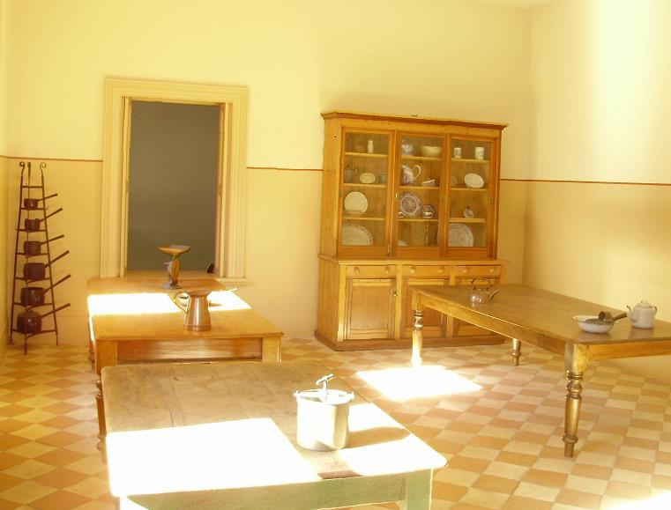
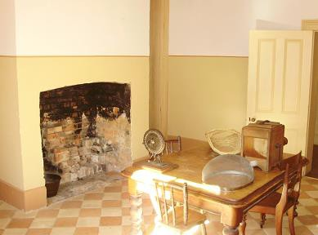

The Staircase:
The staircase takes us from the ground floor to the 1st floor rooms.
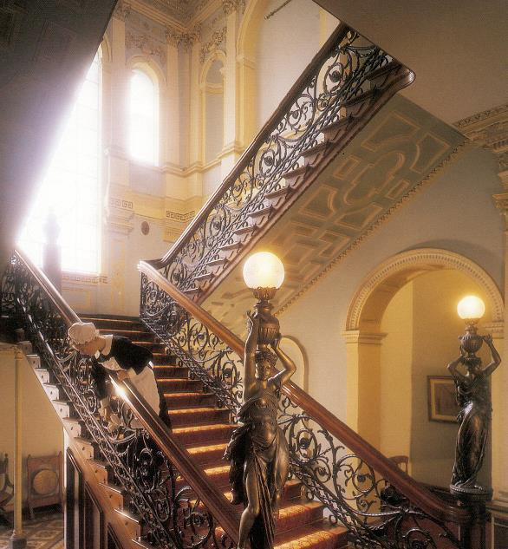

When walking up and down the staircase, hold onto the handrail.
This keeps us safe.
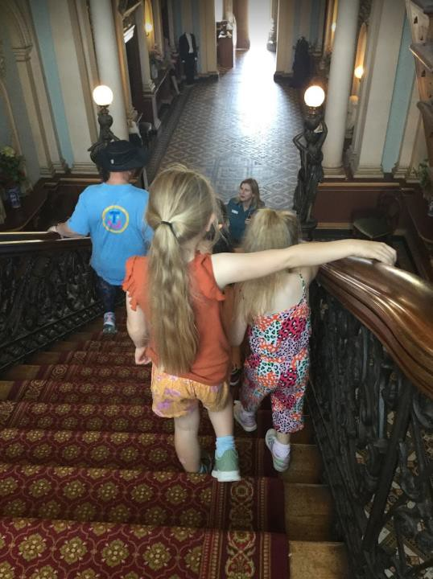

Children’s room:
We can play with the toys in the children’s room.
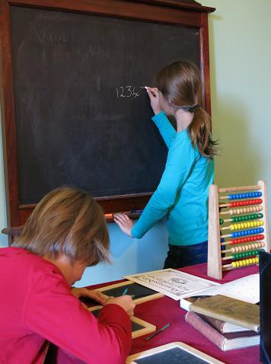
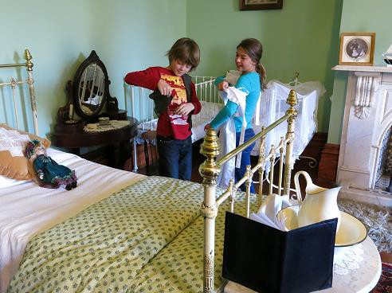

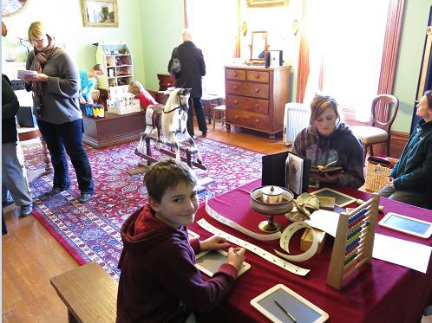
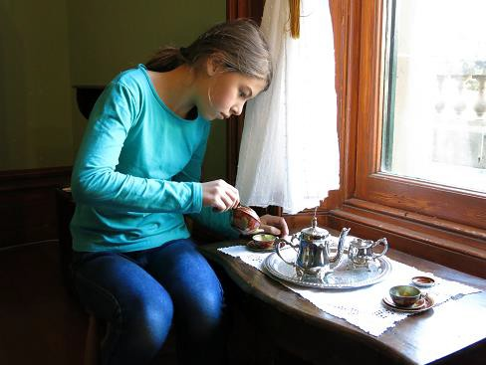

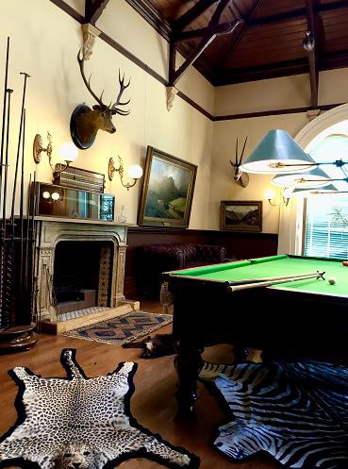
Billiard Room:
This room was used to play billiards.
Billiards is a ball game played on a table.
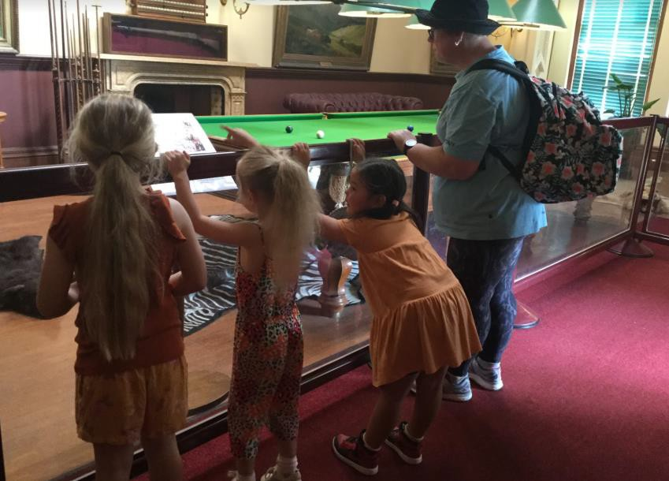
This room has some preserved animal skins and heads.

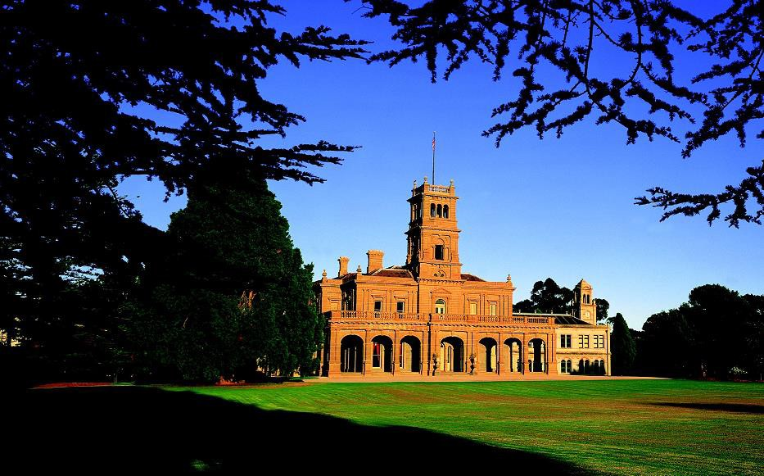
We hope you had a great time exploring Werribee Mansion and gardens.

