Wilsons Promontory National Park
  - Autism Friendly Visits – Adult Guide
General Information
The social script describes some of the popular locations to visit within the park. The walks/ activities listed in the social script can be completed in any order and pages can be edited or removed to suit your visit.
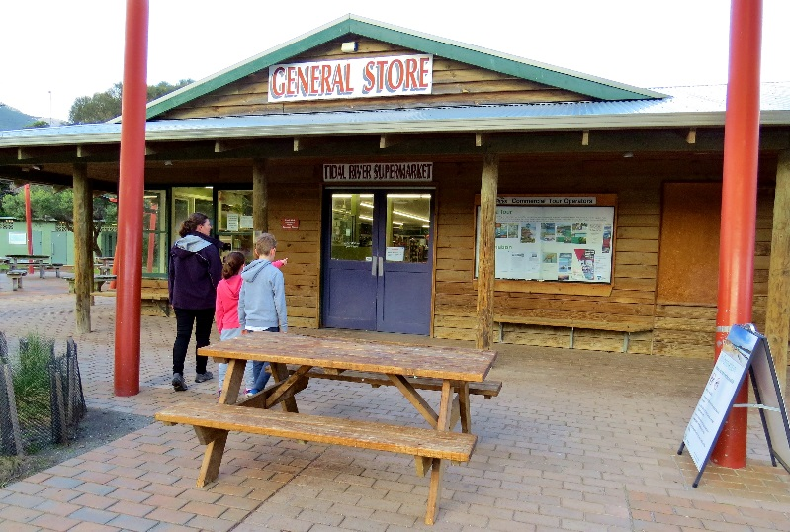
Toilets are located throughout the park. Toilets situated outside Tidal River are drop toilets. There are no hand driers within the park. For the location of toilets within the park visit the Parks Victoria website to download a Wilsons Promontory Map. A map of the park can also be obtained at the park entrance gate upon arrival.
For more information on accessibility and inclusion in parks visit the Accessibility & Inclusion page on the Parks Victoria website.
When to visit
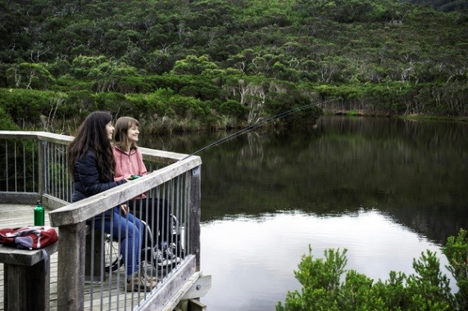
The summer school holidays in January and long weekends throughout the year are very popular. At these times popular locations such as Tidal River, Norman Beach and Squeaky Beach are very busy. The Tidal River store can also experience long queues during these periods.
Short Walks
The social script describes some of the more popular walks and locations to visit within the park. There are other walks and activities available depending upon your interests and experience. For more information please see the Wilsons Promontory National Park Visitor Guide on the Parks Victoria website.

Tidal River General Store
The Tidal River General Store stocks milk, bread, ice, gas refills and souvenirs, along with a basic range of supermarket and emergency items. Hot and cold food is available from the takeaway at the store. See the Wilsons Promontory Park Page for opening times.
Camping & Accommodation
Tidal River is the main location for camping and accommodation in the park. Advance bookings apply for selected holiday periods. Please refer to the Tidal River Campground and Tidal River Accommodation visitor guides for more details.
Wildlife
The Prom Wildlife Walk offers a good opportunity to see animals at the Prom. The best times are early in the morning or in the evening.
In Tidal River birds have been known to take food from visitors. Please help us to reduce this behaviour by not feeding wildlife within the park.
Activities
Junior Ranger programs are run on school holidays and peak weekends. Activities can be adapted to suit your needs. Please see our Junior Rangers website for more information or contact the Tidal River Visitor Centre 8427 2122.

