My visit to Wilsons Promontory

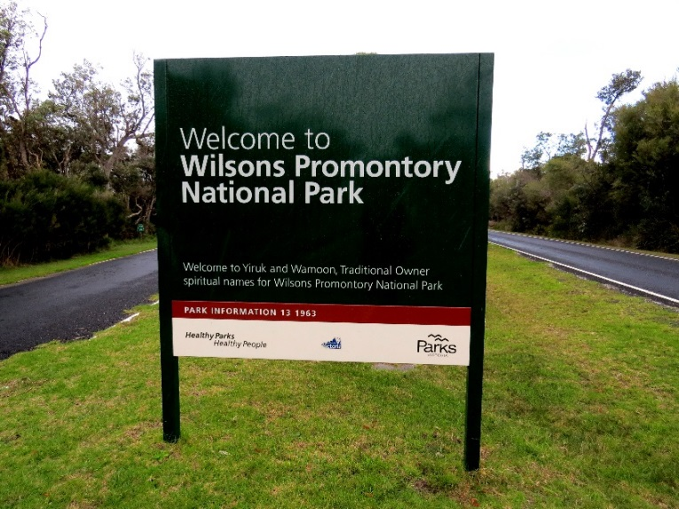

We are going to Wilsons Promontory.
It is a National Park which is a place where plants and animals are cared for.
It is a long drive. At the entrance we can stop and get a map.
At Wilsons Promontory we can do many different things.
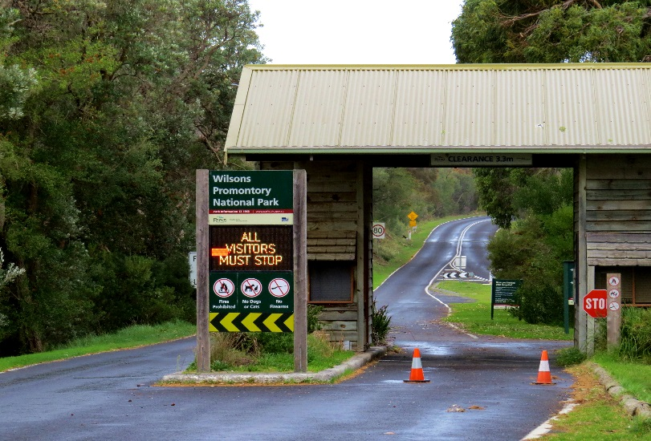

Rangers are the workers that look after the park.
They wear a uniform.
If I see a ranger I can ask them for help.

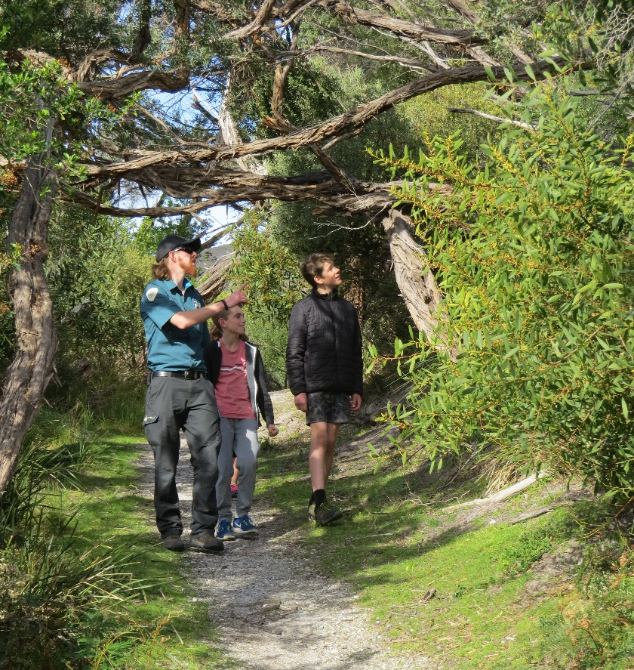
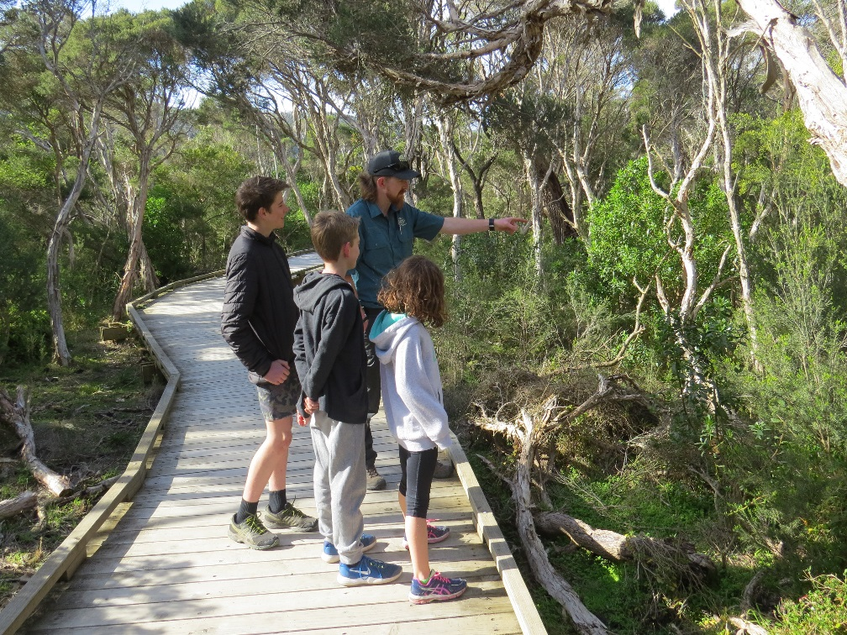
When we stop at a carpark there are other people.
I need to stay near my adult in the car park. I need to watch out for moving cars.
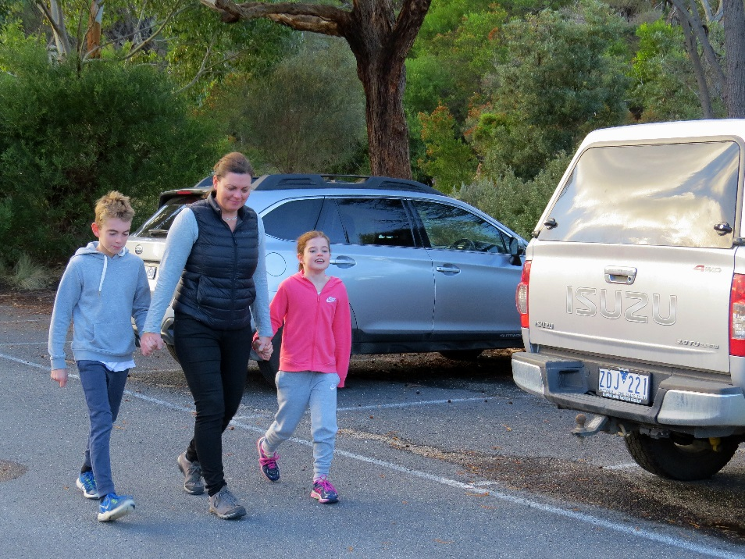

At Tidal River there is a Visitor Centre.
In the Visitor Centre we can find out more about the plants and animals in the park. There are many things for me to look at and I can get a map of the park.
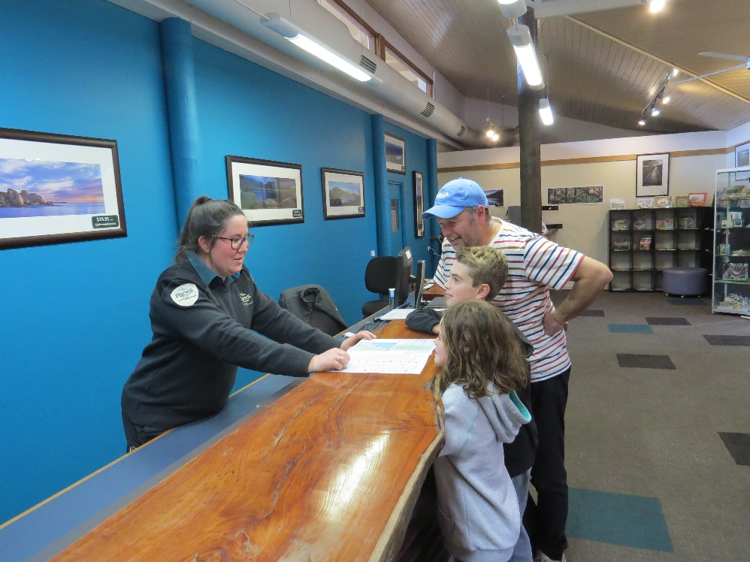
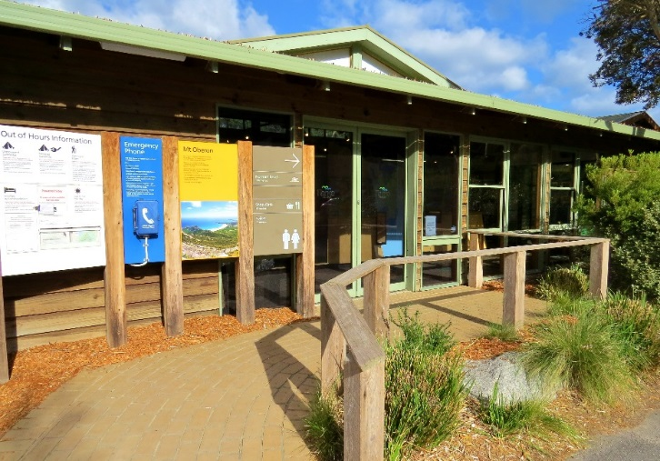
There are park rangers who can answer my questions.

At Tidal River there is a shop we can visit.
We can buy (food/souvenirs) from the shop. There are other people in the shop.
Our food stays with us. Animals have their own food to eat.
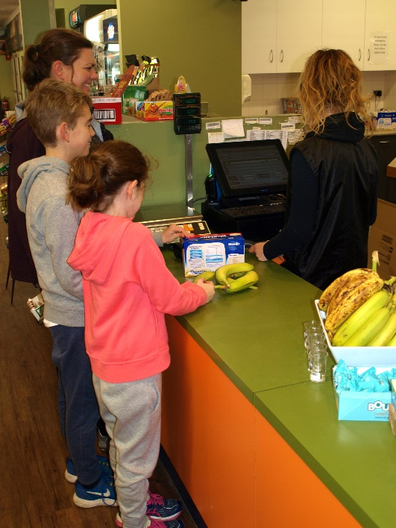
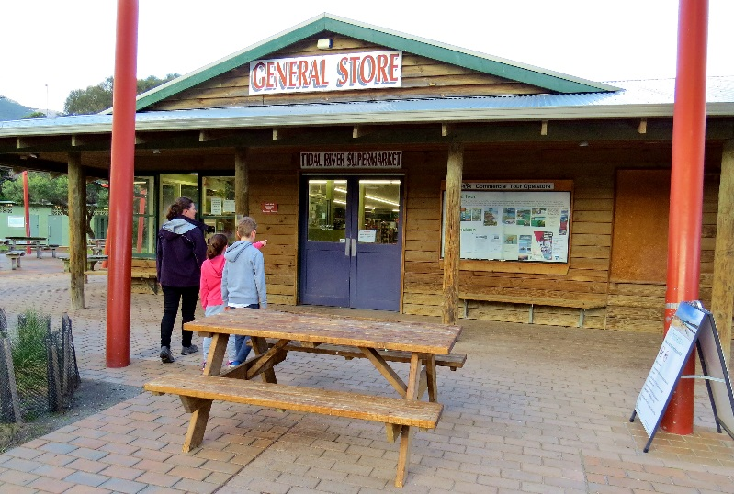

There are toilets in the park.
If I need to go to the toilet I ask my adult first.
There are no hand driers in the toilets.
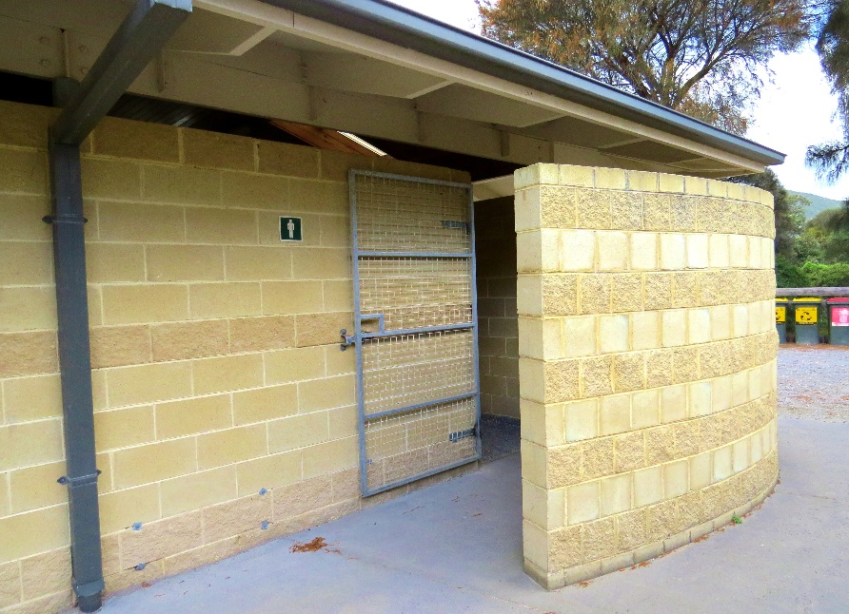
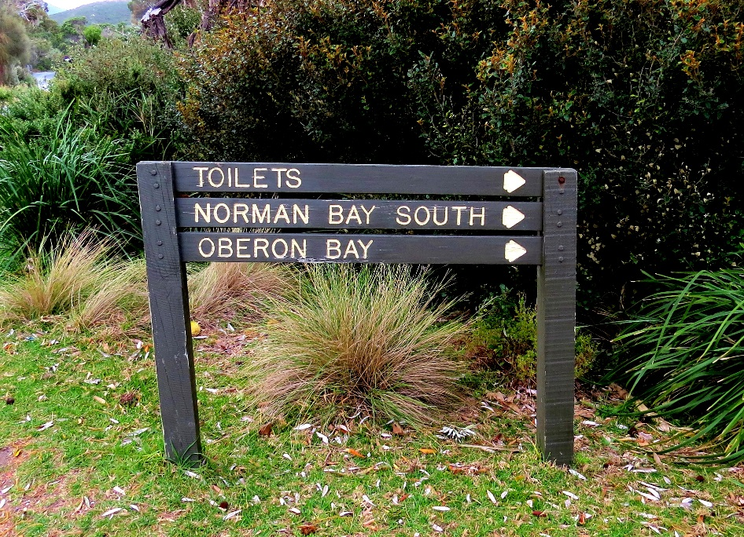

There are tables in the park we can sit at.
There are BBQ’s we can cook on.
Our food stays with us. Animals have their own food to eat.

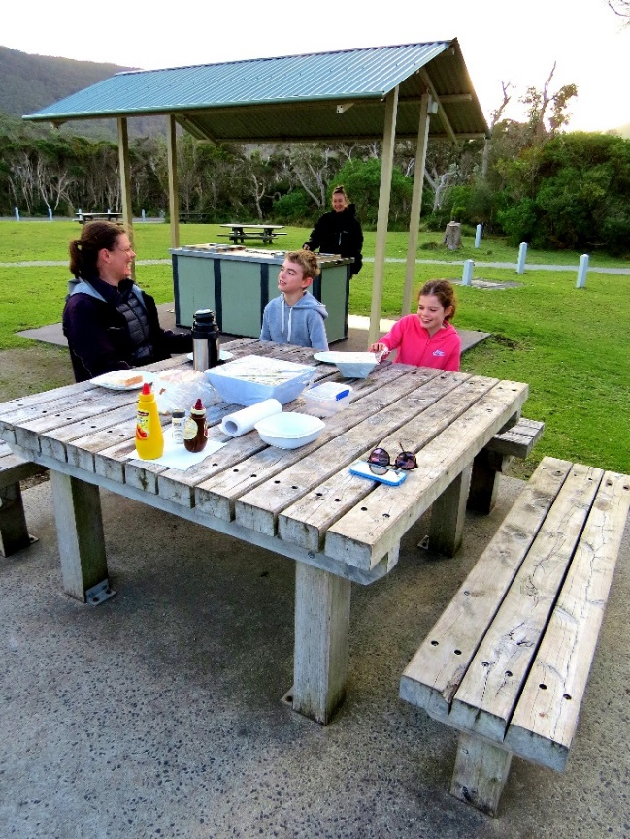

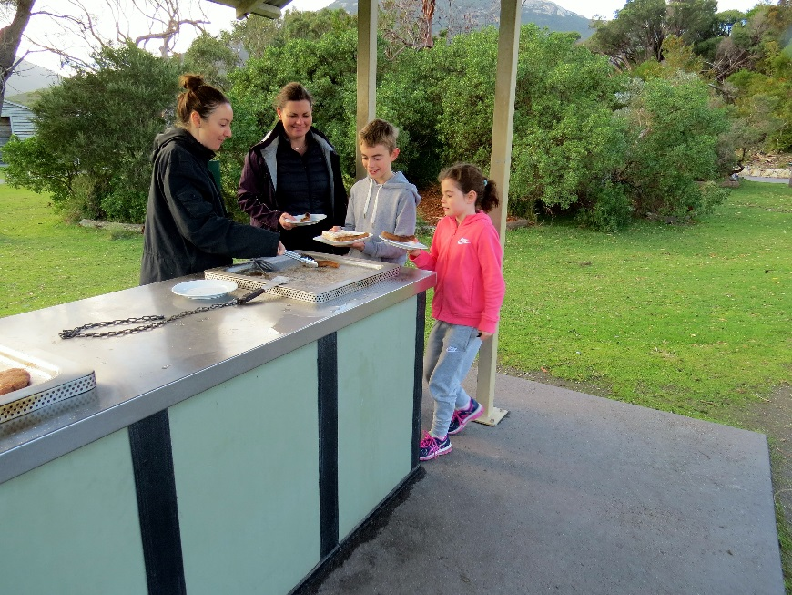

Some people stay the night in tents and caravans.
There are cars driving on the roads here. I need to be careful near the road. I need to stay near my adult.

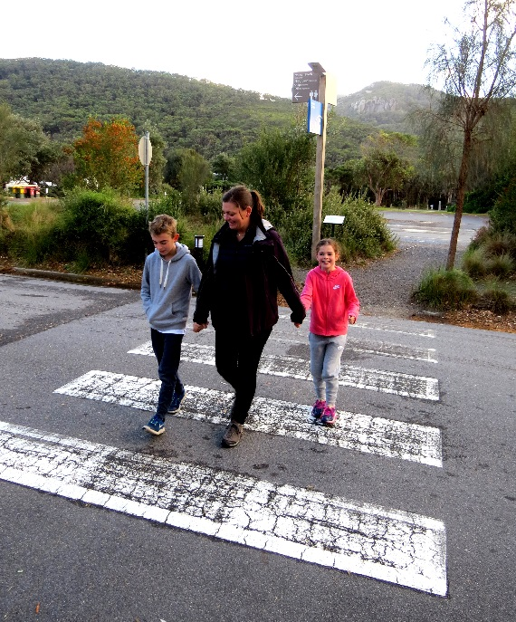
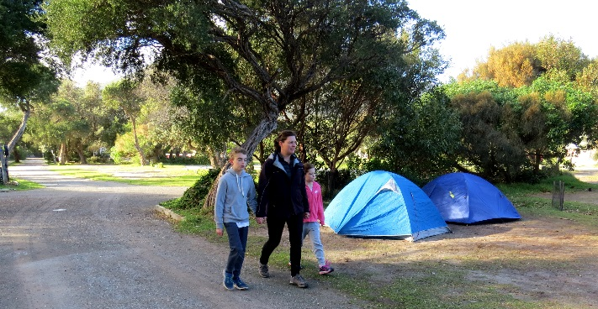

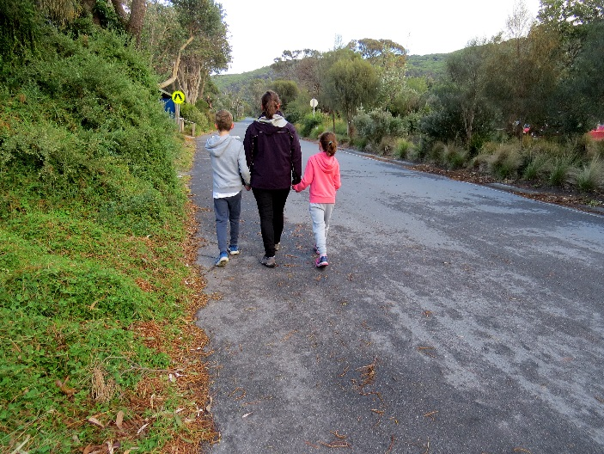
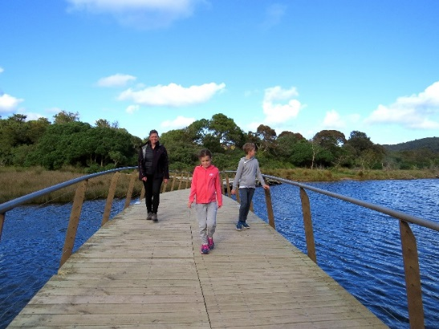
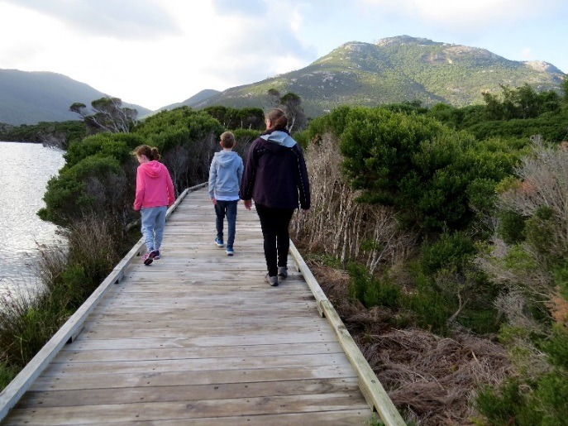
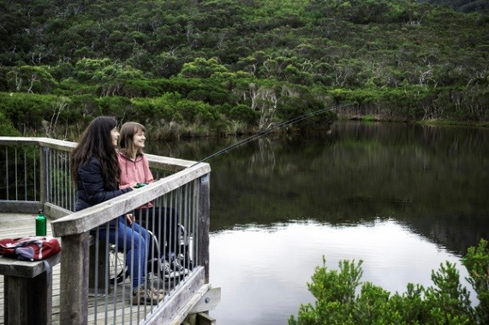
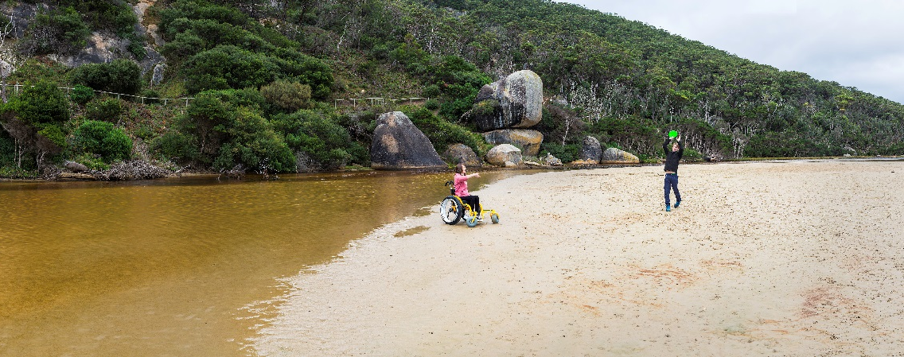
We can walk to the river along the Loo-errn boardwalk. I need to be able to see my adult on the walk. That keeps us safe. There is a bridge over the river we can walk on. When I am near the water I need to stay near my adult.

We can walk to Norman Beach.
There are people at the beach. I can play in the sand at the beach.
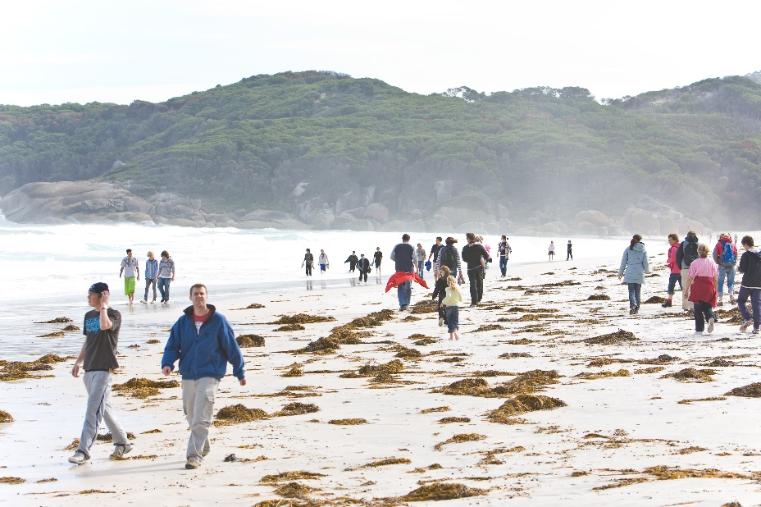
When I am at the beach I stay with my adult.

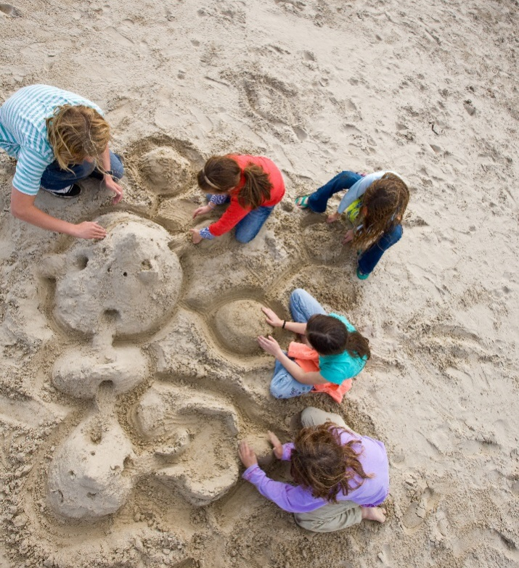
We may see animals at Wilsons Promontory. This is their home. I will be quiet so they feel safe. I can look at the animals and take photos.

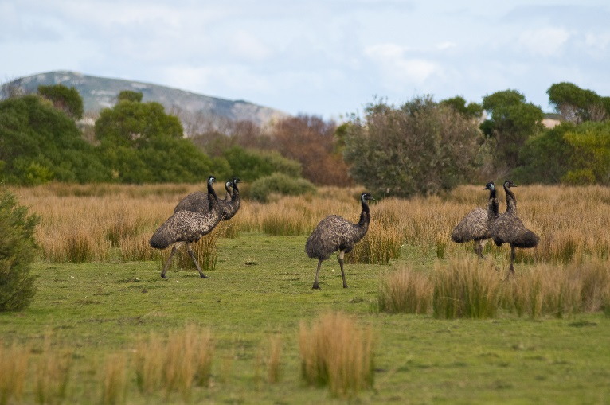
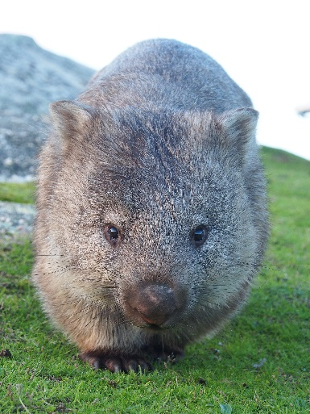

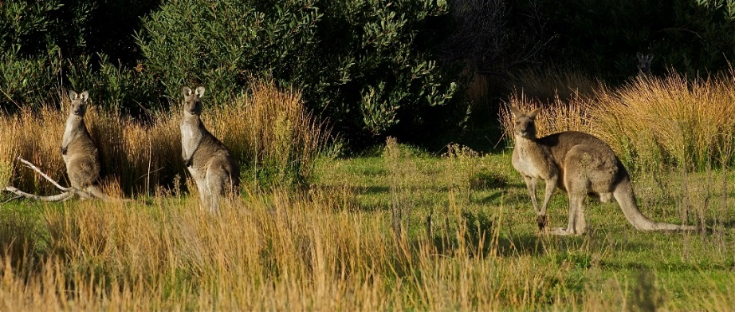

Some birds at Wilsons Promontory like to eat human food. They may take my food. I will stay close to my adult when eating. Birds should only eat food from the bush.

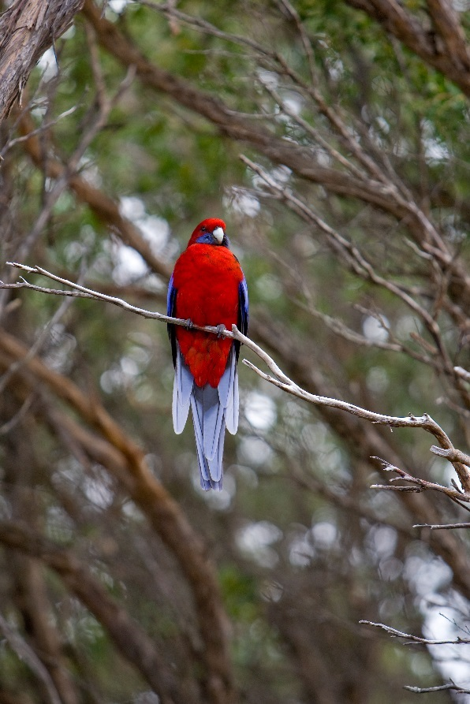
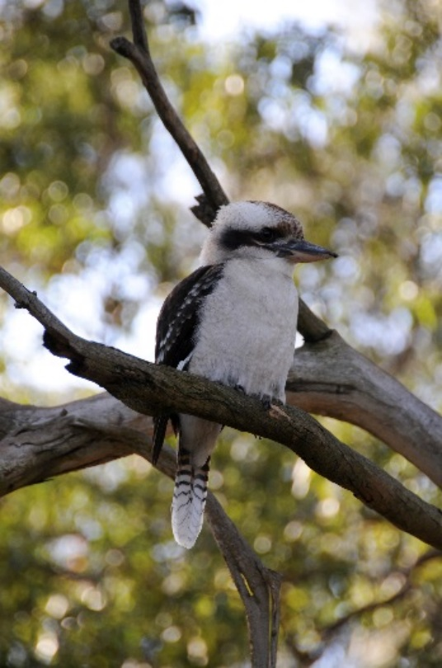

We can stop at the Prom Wildlife Walk.
Sometimes there are animals. If we see an animal we can quietly watch it. When there are lots of people the animals hide in the bush. This makes them feel safe.

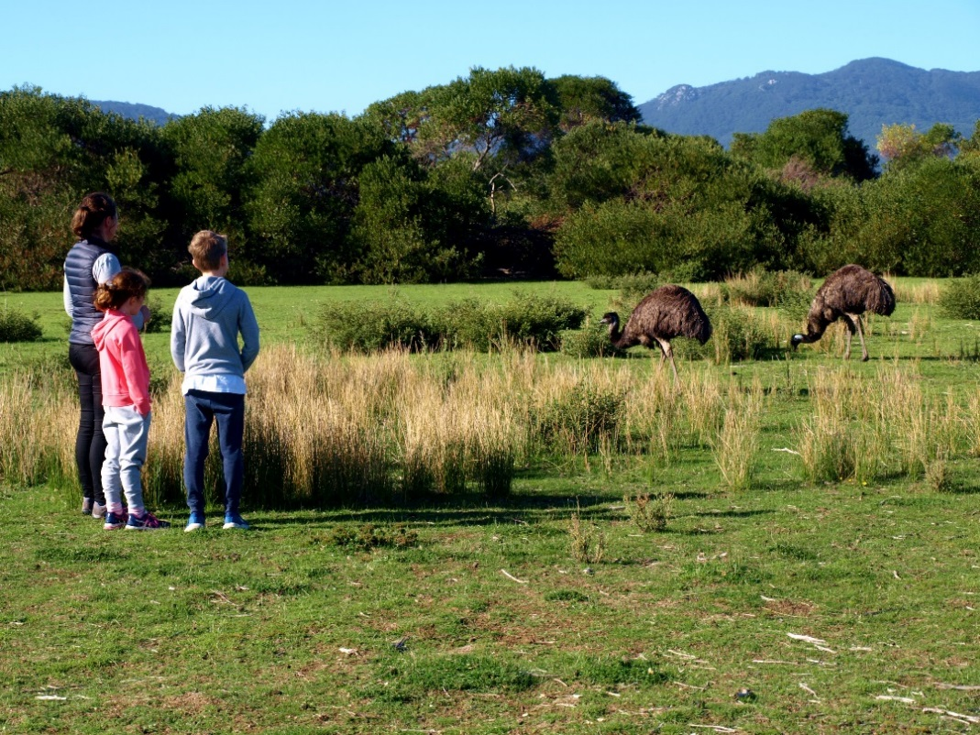

We can stop at Squeaky Beach.
We can walk to the beach. I need to walk with my adult to stay safe.
The sand on the beach is white and bright. Sometimes the sand squeaks when I walk on it. It is fun to make the sand squeak.
I need to stay with my adult when I am at the beach.
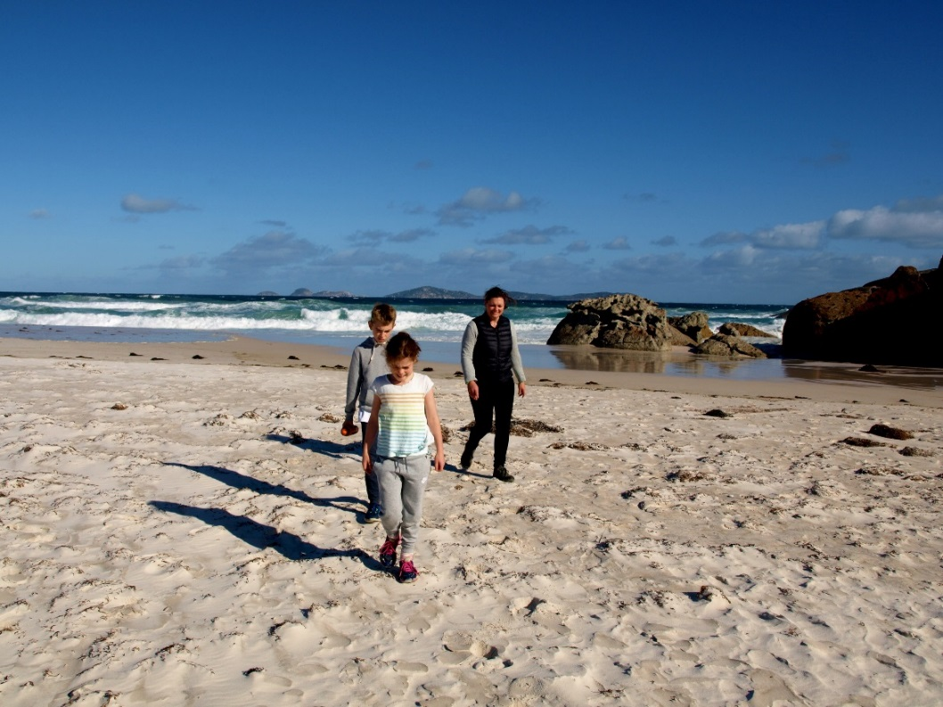

We can walk to the rainforest at Lilly Pilly Gully.
I need to be able to see my adult on the walk. We stay on the path together. That keeps us safe. We can see some tall trees on the walk.

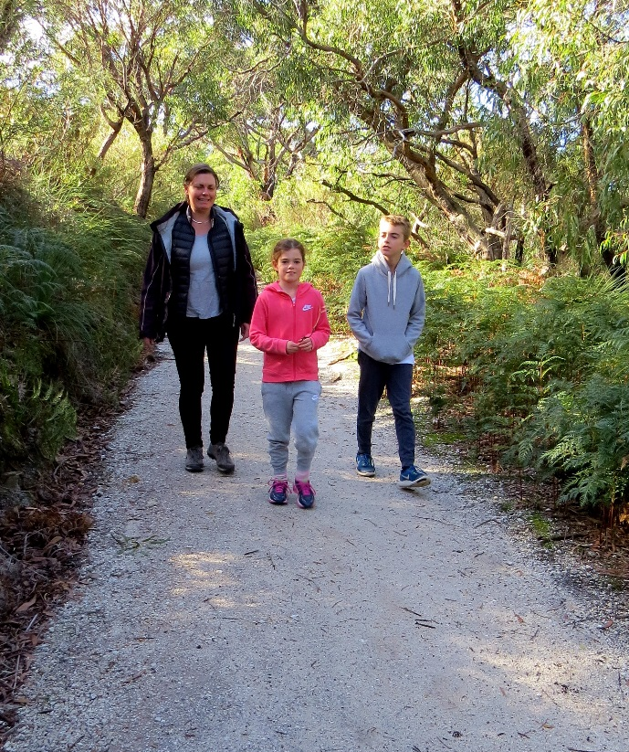

It is darker in the rainforest. There are many plants and it is cool and shady.
There is a boardwalk we must stay on. There is a stream I can look at.

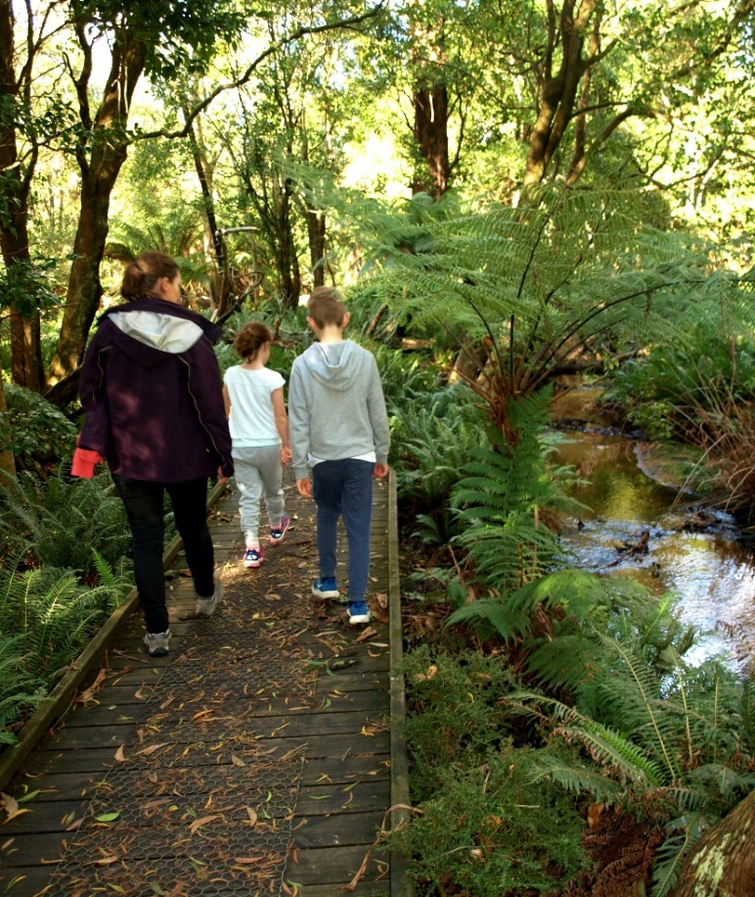

I had fun visiting Wilsons Promontory National Park.

