Victoria’s State of the Parks

Third Edition Summary

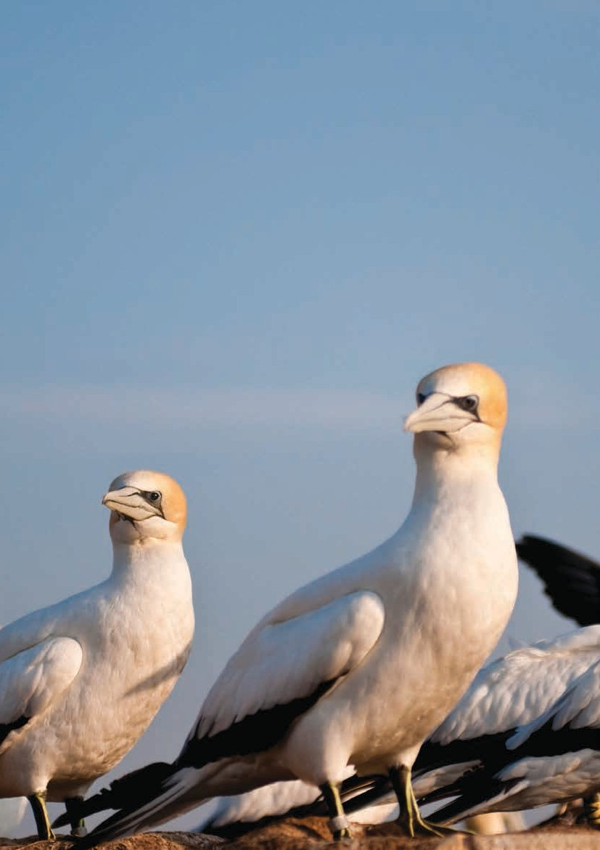Stunning marine and coastal settings, ancient tall forests, wetlands and rivers, semi-arid Mallee landscapes, woodlands, grasslands, remote wilderness areas, urban parks, heritage sites and waterways, Victoria’s parks are some of the most varied and dramatic in the world. They protect and conserve the state’s most significant natural and cultural heritage. They provide essential services such as clean water and climate regulation, and enable millions of Victorians and others to enjoy the benefits of outdoor recreation. They play a fundamental role in the state’s tourism and economy.

As custodians of these special places, Parks Victoria vision is to be a world-class parks service ensuring healthy parks for healthy people. It works with the community, Traditional Owners and many other partners with the goal of leaving the areas in as good or better condition than they were inherited, for future generations.

State of the Parks reporting is an important tool that provides Parks Victoria with in-depth knowledge of the status of our parks. This summary of State of the Parks: Third Edition details how parks are meeting goals for conserving nature, culture and heritage, providing enjoyable visitor experiences and generating broader community benefits. It highlights key achievements and emerging issues, outlines the challenges ahead and identifies improvements for management programs.

State of the Parks: Third Edition is also a call-to-action for the Victorian community and anyone who loves parks. The Healthy Parks Healthy People approach to park management demonstrates that when people get involved in the management of their parks and nature, the park is valued, and the park itself is enhanced. Help us care for Victoria’s parks, and enjoy your connection with nature. Healthy parks for healthy people.

Australasian Gannet found in Port Phillip Heads Marine National Park

Parks Victoria is responsible for managing a diverse network of parks from protected areas such as national, state and wilderness parks and nature conservation reserves to urban, historic and regional parks and waterways.

These parks have many different objectives that include conserving natural and cultural heritage, connecting people with nature and ensuring community safety.

The State of the Parks evaluation program aligns with a global initiative to review and evaluate the condition and management effectiveness of parks and protected areas. The program is consistent with Target 11 of the Aichi targets of the International Convention on Biological Diversity. This recommends an appropriate level of reservation of protected areas and emphasises the need to demonstrate that parks and protected areas are being effectively managed. Evaluating the extent to which park objectives are being met is a major challenge. Parks are not islands and their effectiveness is influenced by management interventions and external issues and pressures such as climate and social change.

Parks Victoria’s State of the Parks program has adopted evaluation methods that are endorsed and supported by the World Commission on Protected Areas. The information gained through these assessments is used to respond to emerging issues, review priorities and plan for the future as part of good adaptive management practise. The information also assists the community in understanding the diversity and significance of Victoria’s parks network as well as the many management challenges faced.

Parks Victoria is to be strongly commended as a leader in evaluating park management.

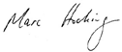

Professor Marc Hockings
Vice-Chair (Science),
IUCN World Commission on Protected Areas

School of Geography, Planning and Environmental Management, University of Queensland

This is a summary of State of the Parks: Third Edition, following previous editions published in 2000 and 2007. More detailed results are available on Parks Victoria’s web site (www.parks.vic.gov.au).

State of the Parks improves knowledge to better enable park managers to track long-term changes to the condition of parks. It will also show the extent that parks are meeting their goals for natural and cultural heritage conservation and visitor experience.

Parks Victoria will continue to report regularly on the State of the Parks in the future as part of broader Victorian Government State of the Environment reporting.

Best practice park management is an evolving process that needs to be adaptive and backed by the best available knowledge. For details on specific management activities undertaken in parks, refer to Parks Victoria’s Annual Reports on (www.parkweb.vic.gov.au).

How is the information obtained?

The State of the Parks program uses multiple sources of evidence to assess Victoria’s parks. This includes:

- analysis of scientific data and other measured evidence to identify extent and representation of park values and key threats.

- results from environmental and visitor monitoring programs.

- systematic park-based assessments completed by park managers. This incorporates results of monitoring programs and where empirical data does not exist, knowledge from other sources including rangers, specialists, Traditional Owners and volunteers.
State of the Parks: Third Edition includes park manager assessments from around 300 parks and reserves or about 90 per cent of the area of
Victoria’s parks network. This includes all terrestrial national, state and wilderness parks, marine parks, metropolitan parks, most regional parks and around 150 significant conservation reserves.

For some indicators such as representation of natural and cultural values and visitor numbers, all of the state’s nearly 3,000 terrestrial and marine parks and reserves are included.

How are the State of the Parks results used?

State of the Parks information is used for two main purposes:

- to help park managers continuously improve the way in which Victoria’s parks are managed by highlighting key and emerging issues and identifying areas for improvement or maintenance.

- to highlight the value of parks to the community and inform the community about the current and emerging issues in managing our complex parks network.

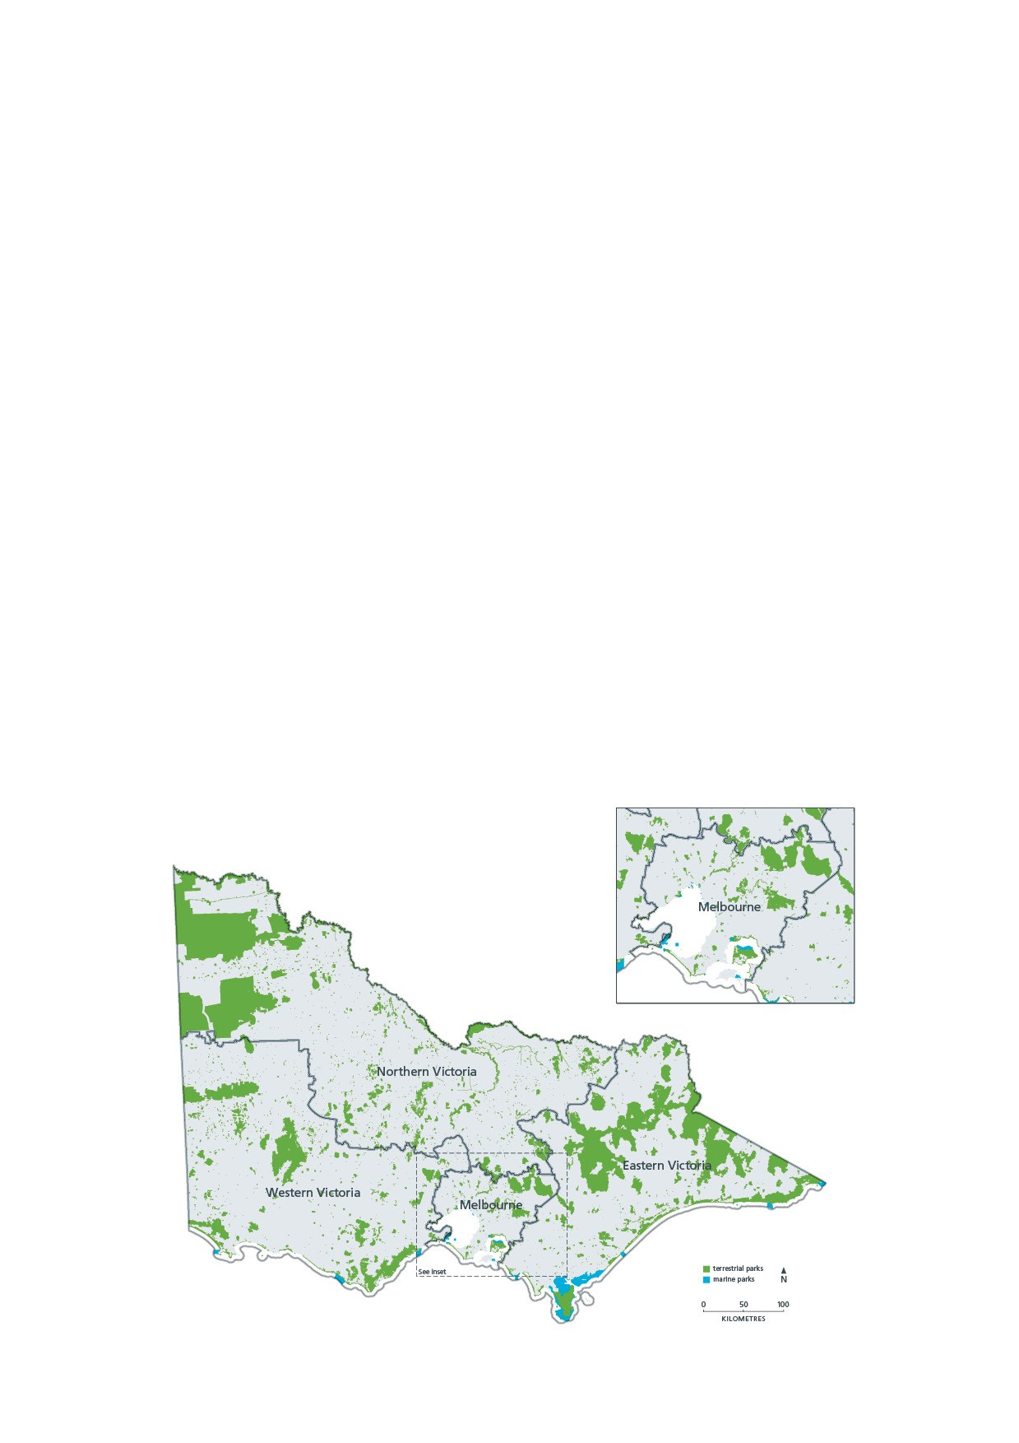Profile of the parks network

- Parks Victoria manages 4.1 million hectares or 18 per cent of Victoria.

- There were 139 parks managed under the National Parks Act 1975 which is 84 per cent of the area of the parks network. The network included more than 2700 Conservation Reserves which accounted for 93 per cent of the total number of parks but only 13 per cent of the area of the parks network. Additionally, the network included more than 80 metropolitan, reservoir and regional parks covering more than 100,000 hectares.

- Between 2010 and 2013 around 50,000 hectares was added to the parks estate.

- The size and shape of parks and reserves is highly variable depending on park type. Forty-four per cent of parks managed under the National Parks Act 1975 parks (national, state and wilderness parks) were greater than 10,000 hectares while 92 per cent of conservation reserves were less than 400 hectares.
- Around 123,000 hectares of the parks network was managed jointly with Traditional Owners with additional areas under co-management agreements (For example, Mount Eccles (Budj Bim) and Wyperfeld national parks).

- The parks network is highly accessible to the community with 98 per cent of the network open for public access and 2 per cent in scientific Reference Areas. Eighty per cent of the area of parks network was available for vehicle based access with 20 per cent designated as wilderness zone or Wilderness Park which allows non-vehicle based access.

- The parks network has 91,000 neighbours on its boundaries.

Conservation significance

Victoria’s parks play a critical role in conserving representative examples of Victoria’s land and marine biodiversity and ecological processes. While the primary purpose of Victoria’s national parks and conservation reserves is to conserve biodiversity, other parks including Melbourne’s metropolitan parks are also important for conserving regional biodiversity and connecting people with nature. Within its finite resources, Parks Victoria focuses its management effort to target those parks and ecosystems of greatest significance and facing the highest threat.

- The parks network conserves representative examples of each of Victoria’s bioregions. All bioregions were at least partly represented in Victorian parks network, with Wilsons Promontory, Greater Grampians and Lowan Mallee Bioregions the most well represented. Victorian bioregions least represented in the parks network included Dundas Tablelands, Strzelecki Ranges, Victorian Riverina, Wimmera and Victorian Volcanic Plain. The poorly represented bioregions largely reflect the legacy of past agricultural land use.

Victoria’s parks play a critical role in conserving representative examples of Victoria’s land and marine biodiversity and ecological processes.

- The Victorian Embayments marine bioregion was the most well represented of Victoria’s marine bioregions that are protected in parks and reserves. Twofold Shelf, Otway and Central Victorian Bioregions were the least well represented.

- There are more than 1,000 wetlands found within Victoria’s parks network. This includes 75 per cent of the area of Victoria’s ten Ramsar wetlands.

- A recent analysis of 600 of the state’s larger and most significant parks and reserves found that parks provided at least 80 per cent of Victoria’s suitable habitat for 516 threatened species; and at least 60 per cent of suitable habitat for 763 threatened species.
- Ninety-two per cent of the nearly 5,000 native species of flora recorded in Victoria were recorded in Victoria’s park network. The Alpine, Grampians, Great Otway, Snowy River and Wilsons Promontory national parks had the greatest number of flora species in the state.

- Ninety per cent of Victoria’s 1,857 listed rare and threatened flora species were recorded in Victoria’s parks network. The Alpine, Murray-Sunset, Grampians and Croajingalong national parks had the highest number of threatened flora in the state.

- Thirty six flora species in Victoria’s parks were limited to a single park and found nowhere else in the world. The Grampians National Park had twelve flora species found nowhere else in the world.

- Victoria’s Marine Protected Areas conserve representative examples south-eastern Australia’s unique marine flora and fauna in which around 80 per cent of species are not found anywhere else in the world.

- Seventy-eight per cent of the state’s 1,400 native species of terrestrial fauna were recorded in Victoria’s parks network. The parks with the greatest number of fauna species included the Alpine, Grampians, Great Otway, Croajingalong and Yarra Ranges national parks.

- Ninety-one per cent of the 306 listed rare and threatened terrestrial fauna species were recorded in Victoria’s parks network. The Murray-Sunset, Wyperfeld, Hattah-Kulkyne, Croajingalong, Great Otway and Grampians national parks had the greatest number of threatened species in the state.

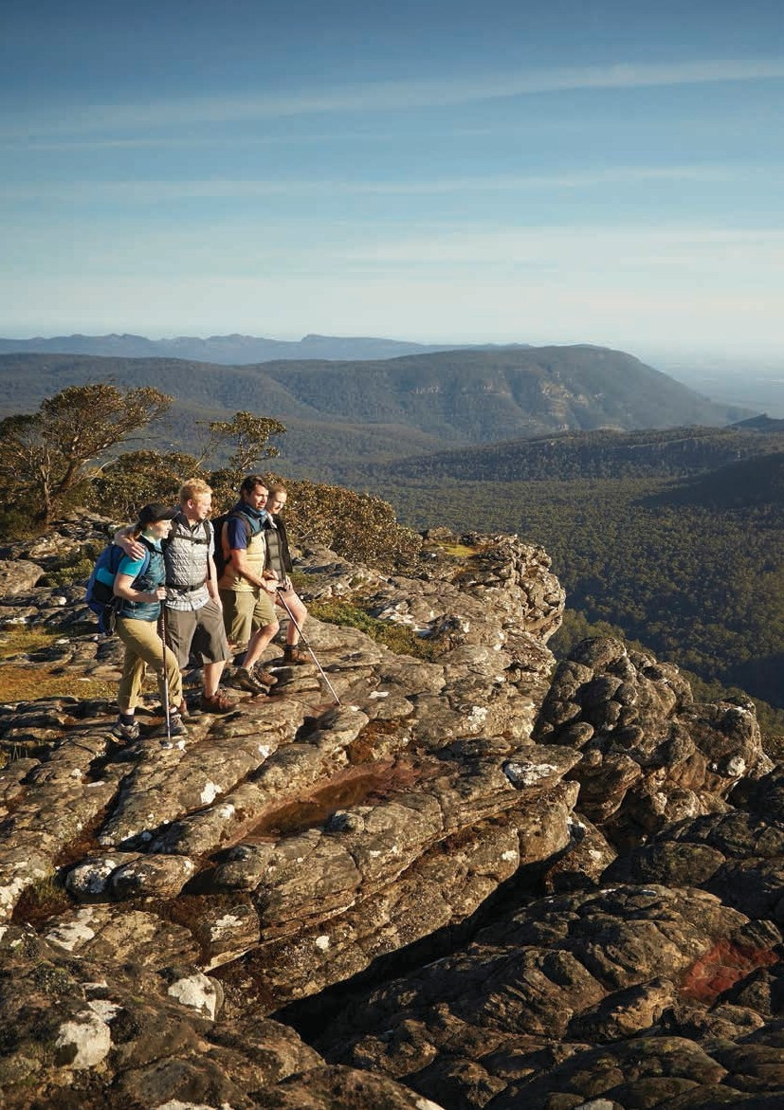State of the Parks: key findings

Victoria’s State of the Parks 7

Conserving Victoria’s special places

Conserving natural assets

  - Sixty-per cent of land based parks (just under 40 per cent by area) were reported as being in excellent
or good condition and 90 per cent of marine parks were in good condition.

  - The majority of terrestrial parks were in stable condition since 2010 with improved environmental conditions following from long term drought.

  - Most marine parks were in a stable condition, with none reporting a decline in overall condition since 2010.

Despite management efforts, the scale and impact of some key threats and stressors increased since 2010.

  - The condition of streams was variable across the state with streams in East Gippsland, the Alps and the Otways in the best condition. Streams in the north, west and Port Phillip and Western Port were in the poorest condition.

  - In most landscapes wetlands in parks were in much better condition than outside parks.
- The status of threatened species that are reliant on healthy park habitats was variable. While there have been positive trends for some species, many continue to be at risk from large-scale and localised threats affecting parks.

- Park managers reported that 48 per cent of the assessed parks (56 per cent of the area of the parks network) fully met management objectives for nature conservation, and around half of the parks partially met their objectives.

Status and management of key threats
- Weed invasion, pest animals, fire frequency and severity and illegal uses were reported by park managers as the most common and widespread threats to the parks’ natural values. These issues were priority threats in at least two- thirds of assessed parks. Other threats including inappropriate water regime (water flow and quality), visitor impacts, overabundant native species, marine pests and Phytophthora dieback were reported across at least 10 per cent of assessed parks.

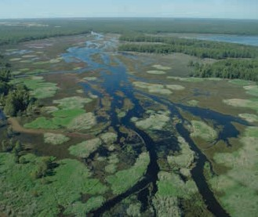

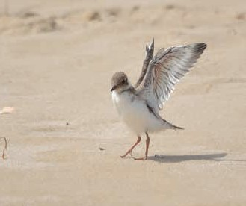Barmah National Park
Hooded Plover chick

- The impact and trend of key threats was variable.
The majority of parks reported that weeds and pest animals were having moderate or major impacts. Around half of the assessed parks reported that impacts from visitors were minor.

- Despite management efforts, the scale and impact of some key threats and stressors increased since 2010. This included impacts from invasive weeds and pest animals, inappropriate fire frequency and severity, pathogens such as Cinnamon Fungus, some overabundant native fauna and illegal uses. More parks reported that key threats have increased than decreased since 2010.

- While a relatively small number of parks reported that impacts from inappropriate fire frequency and severity had major or severe impacts on natural values, this represented more than one third of the parks network by area.

- There have been some successes in reducing and managing key threats in highest priority parks through an increased focus on partnerships. Several parks that were better planned and resourced (for example, parks in the Glenelg Ark, Southern Ark, Grampians Ark fox control programs and Mallee Bounceback rabbit programs) reported that their priority threats had stabilised or reduced.
- The impact of some threats such as deer, Phytophthora dieback, and non-compliance (illegal activities) were reported as increasing and emerging across a large proportion of parks. Increasing threats from pest animals included horses, cats and deer. The management of these species is a key challenge due to currently available control techniques.

- Inappropriate water regime (water flow and quality) was a widespread threat, however, a large number of parks reported declining threats since 2010 possibly resulting from the previous major drought being broken.

- A number of marine parks reported increasing effects from exotic marine pests such as Northern Pacific Sea Star and overabundant native species such as Black Spined Urchin.

- Around half of the assessed parks fully or substantially met their weed management objectives, with less than one-third of parks fully or substantially meeting management objectives for reducing other key threats including pest animals, non-compliance impacts and Phytophthora dieback.

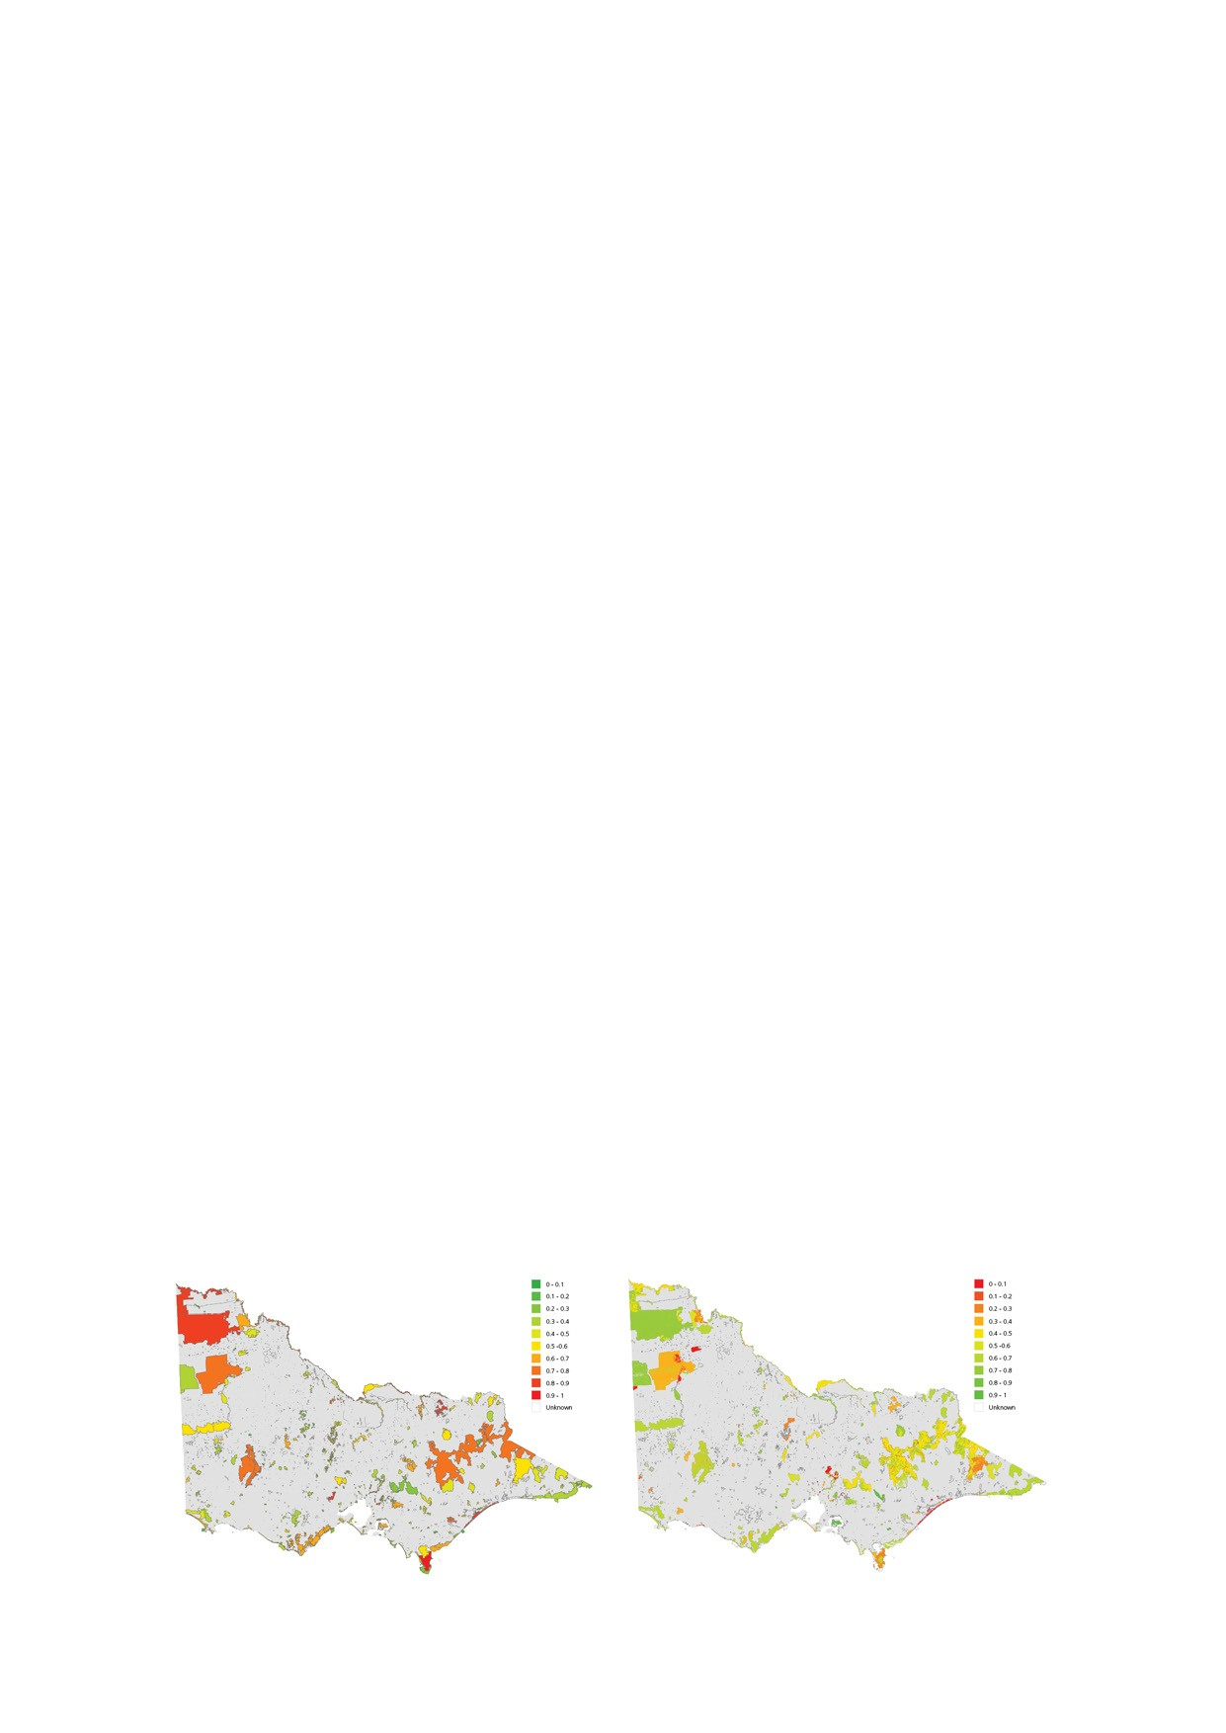

Aggregated threat index Ecosystem condition index

Victoria’s State of the Parks 9

Improved management actions
A number of improvements or innovative programs have been introduced to better manage the natural values of Victoria’s parks. These included:
  - Improved partnerships for weed and invasive species programs and threatened species initiatives with Catchment Management Authorities, Conservation Volunteers Australia, Friends groups and other volunteers, government and non-government agencies, as well as user groups such as Australian Deer Association and Sporting Shooters Association of Australia.

  - Implementation and further development of weed and invasive initiative programs such as the Alps Intensive Management program, Southern, Glenelg, Central Highlands and Grampians Ark fox control programs, and the Otway, Glenelg and Central Highlands Eden weed control programs.

  - Improved strategies and clearer conservation objectives for a number of priority landscapes such as the Alps, Grampians, Great Otways and Wilsons Promontory.

  - Increasing success in habitat restoration programs such as at Wilsons Promontory National Park.
- Improved knowledge through research partnerships such as Parks Victoria’s Research Partners Program.

- Rapid marine pest responses such as at Wilsons Promontory Marine National Parks.

- New and well-designed scientific monitoring programs at highest priority locations as part of Parks Victoria’s Signs of Healthy Parks strategy, and in partnership with the Department of Environment, Land, Water and Planning, volunteers and other organisations.

- Increased knowledge of fire ecology requirements in partnership with the Department of Environment, Land, Water and Planning and research partners.

There have been some successes in reducing and managing key threats in highest priority parks through an increased focus on partnerships.

Challenges
- 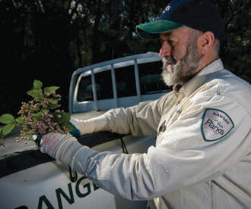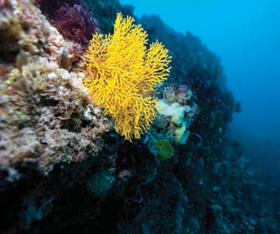The results highlight that there are a number of significant challenges to improve the condition of degraded ecosystems, maintain those ecosystems currently in good condition and improve the status of threatened and other species reliant on healthy park ecosystems

Park maintenance
Twelve Apostles Marine National Park comprehensive biological survey.

  - Some increasing threats such as horses, cats and deer remain a challenge due to available control techniques, while for other threats such as weed invasion, some weed populations are well established and cost-prohibitive to eradicate.

  - Many parks reported a moderate level of effects from key threats, highlighting the need to contain these impacts before they become too costly to control.

  - Key threats such as inappropriate fire frequency and severity and inappropriate water regime are strongly climate driven. Conservation and fire planning that recognises a drier and warmer climate will be required.

  - Balancing environmental objectives with asset protection objectives through risk-based fire management will continue to require improved knowledge.

  - A large number of parks reported that the trends in impact from weeds, pest animals and marine pests were unknown, highlighting the need for improved surveillance and monitoring in these areas. However robust monitoring cannot not be undertaken in all parks and need to be targeted.
- Parks Victoria’s resources for conserving the natural assets of parks declined over the reporting period with a substantial decline in number of staff per hectare managed after 2010

Opportunities
- Well planned, better resourced parks are performing better than other parks in meeting conservation objectives.

- Cross-tenure, landscape scale partnerships will be required to reduce risks from key threats and benefit multiple species.

- A higher proportion of conservation reserves were reported as meeting nature conservation objectives than national and state parks. This result is reflected by the difference in scale of some key threats.

- Well-designed scientific monitoring and data analysis programs will be required to assess the status and trend of ecosystems and species condition and to improve park management. Knowledge partnerships with government and non-government organisations as well as citizen scientists will continue to build knowledge.

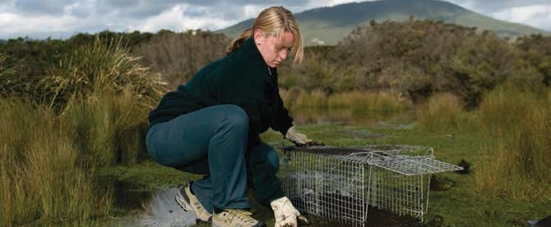

Wildlife monitoring at Wilsons Promontory National Park

Conserving Aboriginal cultural places

  - More than 12,000 Aboriginal places have been recorded within Victoria’s parks network (an increase of more than 50 per cent from 2005). Artefact scatters, scarred trees and shell middens made up the majority of physical sites, however other significant features including fish traps, grinding grooves, rock art, stone structures, quarries and earthen features are also represented. The sites recorded to date represent only a fraction of the actual Aboriginal cultural places in the landscape due to limited survey.

  - While many physical and tangible Aboriginal places have been recorded, there are many diverse intangible Aboriginal cultural values across the parks network that are represented through cultural landscapes and stories. Many significant cultural places that are not formally recorded are associated with ceremony, spiritual value, food and other traditions.

  - A large number of significant burial sites continue to be recorded in parks. Parks Victoria is working with Traditional Owners to document and protect these sites.

Condition of Aboriginal cultural places
- Park managers reported that Aboriginal places were in excellent or good condition in 34 per cent of relevant parks, however around half of the relevant parks reported condition as unknown.

- More parks with Aboriginal places and objects reported that condition had declined rather than improved and more than half of the relevant parks reported that the trend in condition was unknown.

Threats to Aboriginal cultural places
- Park managers from around one quarter of assessed parks reported that damage by visitors was the most common threat affecting Aboriginal cultural places. Lack of knowledge, illegal activities and fire were reported as an issue in 12–16 per cent of parks.

- While few parks reported severe or major impacts from threats such as weathering and erosion by animals, more parks reported impacts as severe or major for other threats such as damage to cultural values by visitors, lack of knowledge and illegal activities.

Rock art at Glenisla Bullima

- The trend in impact of selected threats was reported as stable in the majority of parks; however the impact of non-compliance (illegal activity) on Aboriginal cultural values was reported by park managers as increasing in one quarter of relevant parks.

Partnerships in caring for country
- One-third of assessed parks (around half for national parks) reported that they had a comprehensive established process for consultation and involvement in decision making with Traditional Owners.

Effectiveness in meeting goals
- Park managers reported that around 40 per cent of parks fully or substantially met their management objectives for conserving Aboriginal cultural values, with nearly 30 per cent not meeting their goals.

Improved management actions
- Park manager awareness of the significance of Aboriginal places has increased, and Joint
Management and Co-management agreements with Traditional Owners have increased across the parks network.

- There has been some good progress made
in partnership programs across a range of parks and opportunities are growing for involvement in park management by Traditional Owners.

- Following severe weather and flooding, major rehabilitation works of significant cultural sites were completed at locations such as the Grampians National Park.

- New programs with Traditional Owners to protect burial sites were initiated in Mallee parks in which has increased awareness of the significance of burial sites.

Challenges
- With extreme weather events causing significant loss and damage to some Aboriginal places, the expected increased prevalence of extreme weather due to climate change will need to be accounted for in plans to conserve Aboriginal places.

- Contemporary strategies will need to be developed for managing Aboriginal cultural places in partnership with Traditional Owners.

- There are several widespread threats to Aboriginal cultural places, including site disturbance that will require additional action.

- New technology-based tools will help increase understanding of Aboriginal cultural heritage legislation and compliance requirements.

- Park manager knowledge about the condition and trend of Aboriginal cultural places is lacking in many places. Knowledge could be further shared between park managers and Traditional Owners to assist in conserving Aboriginal places and intangible values.

- Historically, there has been limited monitoring of significant cultural sites. There is a major opportunity to develop a systematic program of monitoring and assessing these sites in partnership with Traditional Owners.

Opportunities
- As Joint Management arrangements increase, more cultural awareness programs for park managers will improve conservation management practices.

- To assist in conserving Aboriginal places and some of their intangible values, there is an opportunity for knowledge to be better shared between park managers

Conserving Heritage places

- More than 2,812 non-indigenous historic places have been recorded within the Victorian parks network. These range from large complex sites such as Werribee Park, Point Nepean Quarantine Station and the Castlemaine Diggings National Heritage Park, to sites including alpine huts, lighthouses, mines, gardens, cemeteries, monuments, landscapes and shipwrecks.

- Parks Victoria community surveys have shown that conserving heritage is valued as an important benefit of Victoria’s parks.

- The parks network included 94 historic reserves that represent a range of past land uses.

- The Victorian parks network included fourteen parks that fall within seven places of National Heritage Listing under the Commonwealth Environment and Biodiversity Protection (EPBC) Act. This included natural, historic and Indigenous places of outstanding heritage value to the nation.

- There were 177 sites listed under the Victorian heritage register across 69 different parks. More than half of these sites reflected activities related to mining heritage.

- More than 13,200 heritage moveable objects such as books, clothes, furniture and utensils have been catalogued across the parks network from 36 collection sites.

Condition of heritage places
- The heritage places and objects in more than one third of parks were reported as being in excellent or good condition. One third of parks reported that heritage places and objects were in fair condition.

- Few parks reported that the condition of heritage places and objects had improved since 2010. Twenty per cent of parks reported that condition of historic places had declined. More than one third of parks reported declining condition of heritage buildings, compared to 14 per cent reporting an improved condition.

Threats to heritage places
- Park managers reported that the most common threats affecting historic heritage places included inadequate maintenance, damage to cultural values by visitors, lack of knowledge and illegal activities. These threats were an issue in around one-quarter of assessed parks. Some commonly reported threats such as inadequate maintenance were listed as having severe or major impacts by more than one third of the survey respondents. Other threats such as lack of knowledge were mostly reported as having minor or moderate effects.

Few parks reported that the condition of heritage places and objects had improved since 2010.

- The trend in impact of selected threats was reported as stable in the majority of parks; however park managers reported that the most common and widespread threats affecting historic heritage places were inadequate maintenance, damage by visitors, lack of knowledge, illegal activities and age-related dilapidation, affecting 20–25 per cent of assessed parks.

- More parks reported that visitor impact, illegal activities and fire were having increasing effects rather than decreasing effects on heritage places. A high proportion of parks reported unknown trend.

Effectiveness in meeting goals
  - Park managers reported that the around half of the assessed parks with historic heritage partially met management objectives for conserving historic heritage places. With less than one-third of parks with historic places fully or substantially meeting management objectives for these places.

Improved management actions
  - Several new partnerships were developed to help restore, maintain and better present significant heritage assets.

  - Data about heritage condition is progressively being validated across the state and is improving information about Victoria’s heritage places.

Challenges
  - Within the limited resources available, conservation and presentation of historic heritage has focused management efforts on a small number of highest priority places such as Point Nepean.

  - Lack of knowledge has been a key threat identified for heritage places. Steps are being taken to improve condition assessments and assess priority heritage places.
- Prioritisation and strategic planning of historic places and assets is required including a review of the most appropriate management arrangements for different types of historic places.

Community surveys have shown that conserving heritage is valued as an important benefit of Victoria’s parks.

- Further review of partnership opportunities for heritage conservation and management is required.

- Parks that have been identified as having a lack of understanding of cultural and heritage values need to be targeted for programs to improve staff and community awareness and understanding of heritage conservation skills.

Opportunities
- Partnerships are being developed to help restore, maintain and preserve significant heritage assets.

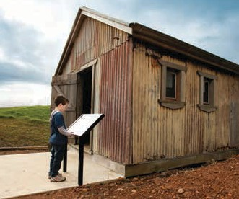

Heritage hut at Wonthaggi State Coal Mine
Werribee Park

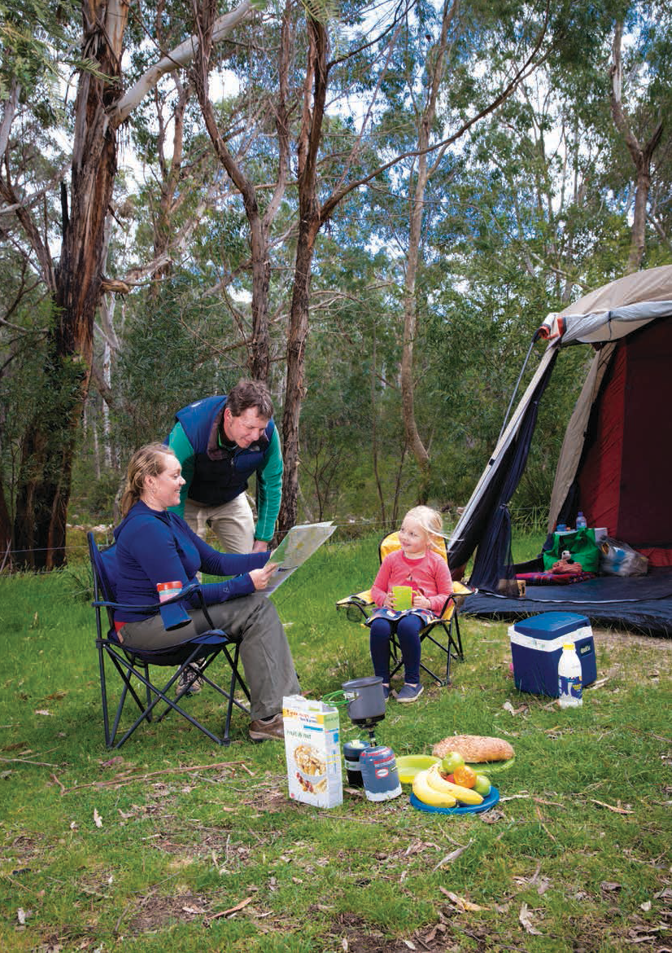

Connecting people and parks

Visitor use of parks
  - Visitor numbers continued to increase with around 51 million visits to national, state and metropolitan parks in 2013, and 45 million visits to piers in the bays. Nearly three-quarters of Victorians had visited a Parks Victoria managed park in the previous 12 months.

Since 2007 the proportion of visits involving physical activity increased from 57 per cent to 67 per cent to around 21 million visits.

  - There were 3.8 million visits to marine national parks and sanctuaries, an increase from 2.7 million in 2003.

  - Parks are an important resource to enable improved human health and wellbeing. Two-thirds of all Victoria’s national and state park visits and 71 per cent of visits to metropolitan parks involved visitors undertaking physical activity. Since 2007 the proportion of visits involving physical activity increased from 57 per cent to 67 per cent to around 21 million visits.
- In 2013 within national and state parks visits included:
- 13 million short walks
- 4.6 million sightseeing visits
- 3.8 million visits for socialising
- 3.8 million picnicking visits
- 3.7 million long walks/hiking visits
- 3.6 million visits to appreciate flora and fauna
- 2.1 million camping visits
- 1.2 million visits for fishing
- one million visits for photography and painting
- 900,000 four wheel driving visits

- In metropolitan parks, the main activities undertaken included around 6 million short walks, three million jogging visits, 1.5 million visits for socialising with family and 1.6 million visits to walk the dog.

- Parks are increasingly important for connecting children to nature and for social connection. This use increased from 14 per cent to 19 per cent of total visits to national, state and metropolitan parks since 2007.

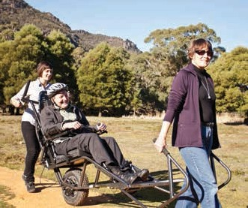Plenty Gorge Park
Trailrider

Condition of visitor facilities and park assets
  - There were more than 25,000 assets and facilities to help visitors enjoy parks across the state. Based on the most recent asset condition assessments:
    - between 40 per cent and 50 per cent of visitor facilities were in excellent or good condition.
    - less than 40 per cent of access trails were in excellent or good condition.
    - most visitor buildings (for example, interpretive centres) are in excellent or good condition.
    - between 40 per cent and 50 per cent of utility assets were in excellent or good condition.
    - nearly 40 per cent of maritime assets were in poor or very poor condition.
  - Nearly 40 per cent of parks reported that the condition of built assets had declined since 2010. The highest priority parks had a lower proportion
of assets in poor condition than other parks. However, there was little difference in the trend in condition.

Visitor satisfaction
  - More than 80 per cent of the community believed recreation opportunities in parks are very good or good.
- The level of visitor satisfaction has remained relatively high with the majority of visitors fully or very satisfied with their visit. For urban parks around 60 per cent of visitors were fully or very satisfied with services and facilities, while in peri-urban and non-urban (for example, national and state) parks, 65–70 per cent were fully or very satisfied. Visitor satisfaction in national and state parks has declined slightly since 2010 while satisfaction with urban and peri-urban parks has slightly increased.

More than 80 per cent of the community believed recreation opportunities in parks are very good or good.

Key threats to visitor experience
- The most widespread threats to visitor experience reported by park managers included inadequate maintenance of assets and facilities, illegal activities, effects from fire and extreme weather, visitor conflict, inadequate assets and facilities, inadequate park servicing

Community involvement
- Volunteers played a critical role in helping to manage parks through on-ground actions and monitoring park health, with the equivalent of around 100 full time staff.

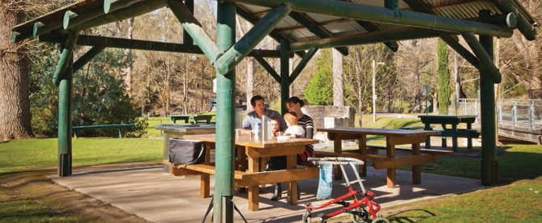

Picnic facilities at Buchan Caves

18

Effectiveness in meeting visitor experience goals
  - Across all assessed parks around two-thirds fully or substantially met their overall objectives for management of visitor experience. More of the highest priority ‘levels of service’ parks met visitor objectives than other parks (81 per cent to 52 per cent).

  - The highest performing visitor services area was visitor safety in which nearly 80 per cent of parks fully or substantially met management objectives. In contrast, less than half of the assessed parks reported that asset management objectives had been fully or substantially met (53 per cent for LoS A parks). Slightly more than half reported that visitor interpretation objectives had been fully or substantially met.

Challenges
  - With population growth and increased visitation there are some significant emerging issues in continuing to provide enjoyable and sustainable visitor experiences. This is demonstrated by the declining condition of built assets (for example, visitor facilities and maritime assets) and some visitor services. Management for visitors has increasingly focused on targeted higher use visitor sites.

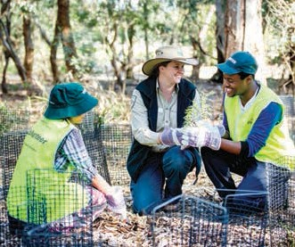

Volunteers at Braeside Park
- Emerging climate-related threats from extreme weather, including fire and flood, may affect the ability to sustainably provide visitor assets and may change patterns of use across the parks network.

- Reduced park services such as education and interpretation programs may be having an impact on the awareness of park values, leading to increased non-compliance and environmental impacts of visitors.

- Visitors to parks are more likely to be older, employed, married, have white collar jobs, be university educated, have higher incomes, and be from an English speaking background. A major effort has been made to increase engagement and access to parks for people from non-English speaking backgrounds, and people with disabilities.

Opportunities
- With the significantly increasing prevalence of non-communicable disease such as cardio-vascular disease, diabetes, depression and anxiety, parks can play an increasing role in providing health benefits for the community.

- Volunteers and citizen scientists can play an increasing role in helping to manage parks and gain physical and social benefits through their on-ground activities and monitoring park health.

Mountain biking at Arthurs Seat State Park

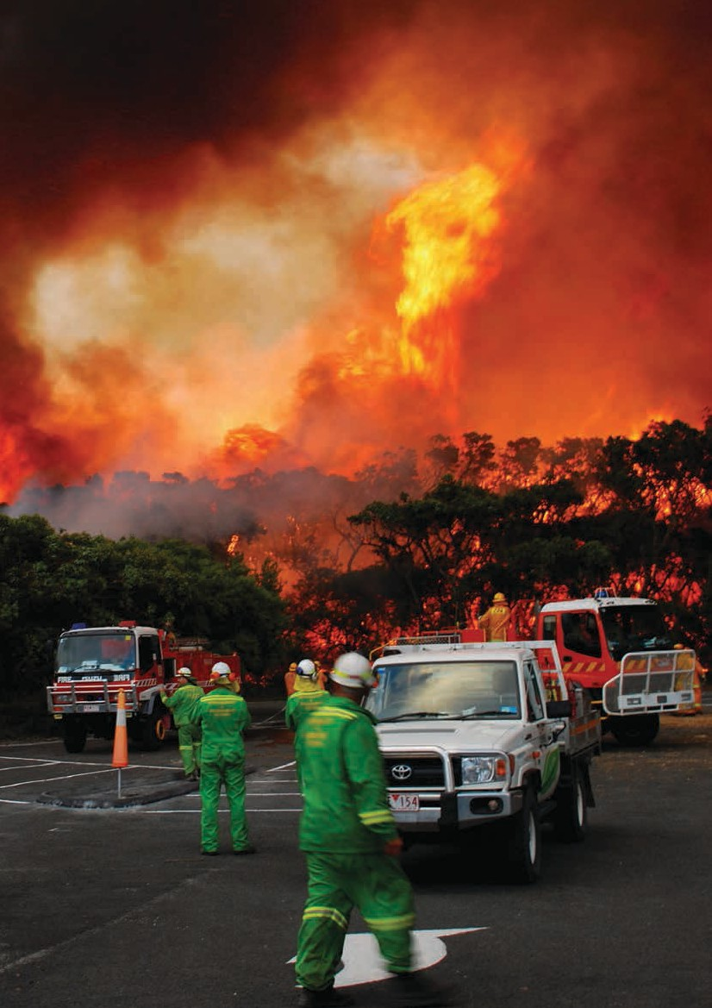

20

Providing benefits beyond park boundaries

Fire management
  - Parks Victoria contributed a large proportion of its resources and skills to emergency planning, response and recovery, supporting the Department of Environment, Land, Water and Planning and other agencies.

  - Extreme weather events, particularly fire and flood events occurred with increasing regularity over the past decade and these events had a major impact on park infrastructure and services as well as on surrounding communities.

  - Following the extensive Black Saturday fires and the return to wetter conditions, Parks Victoria implemented an extensive rebuilding and recovery program.

  - The majority of parks reported that the impact of fire on natural and cultural values between 2010 and 2013 was stable, however 22 per cent of parks reported that impacts on natural values had increased and 17 per cent reported that the impacts of fire on Aboriginal cultural values had increased.

  - Between two-thirds and three-quarters of assessed parks reported that fire management objectives for nature conservation, cultural heritage and asset management had been fully or substantially met between 2010 and 2013.

Benefits to surrounding communities and the State
- Parks are a major provider of clean water for communities, with more than one million hectares of water supply catchment contained within parks.

- Parks supply around one-third of the states’ water for domestic and other uses.

- The parks network acts as a critical carbon sink to help regulate climate with around 270 million tonnes of carbon stored. This is equivalent to nine times the state’s annual greenhouse gas emissions.

Extreme weather events, particularly fire and flood events occurred with increasing regularity over the past decade and these events had a major impact on park infrastructure and services as well as on surrounding communities.

- The Victorian parks network contributes more than 14,000 nature-based tourism jobs and conservatively contributes more than one billion dollars per year to the states’ economy.

- 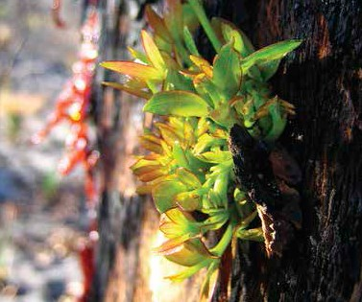The community rates Victoria’s parks highly for their biological and heritage conservation, open space, recreation and liveability benefits.

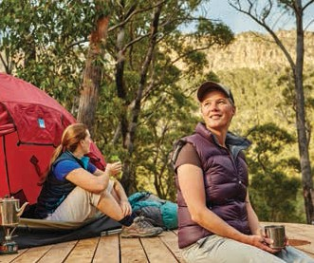Fire recovery
Camping on the Grampians Peaks Trail

Challenges
  - Increased severe and complex weather, particularly fire and flood over the past decade, has resulted in a major reallocation of park management effort. With climate change projections predicting an overall drier climate with more extreme weather events emergency planning, prevention, response and recovery activities in partnership with other agencies will be increasingly required.

Opportunities
  - Parks Victoria’s Research Partners Program with universities has significantly increased knowledge to help improve park management, promote the Healthy Parks Healthy People approach to park management, and provide educational opportunities for many students.

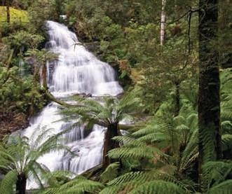

Waterfall in the Otway National Park The Arches Marine Sanctuary

22

23

Authorised and published by Parks Victoria L10, 535 Bourke Street, Melbourne VIC 3000 www.parks.vic.gov.au or call 13 1963 Copyright © Parks Victoria 2015

