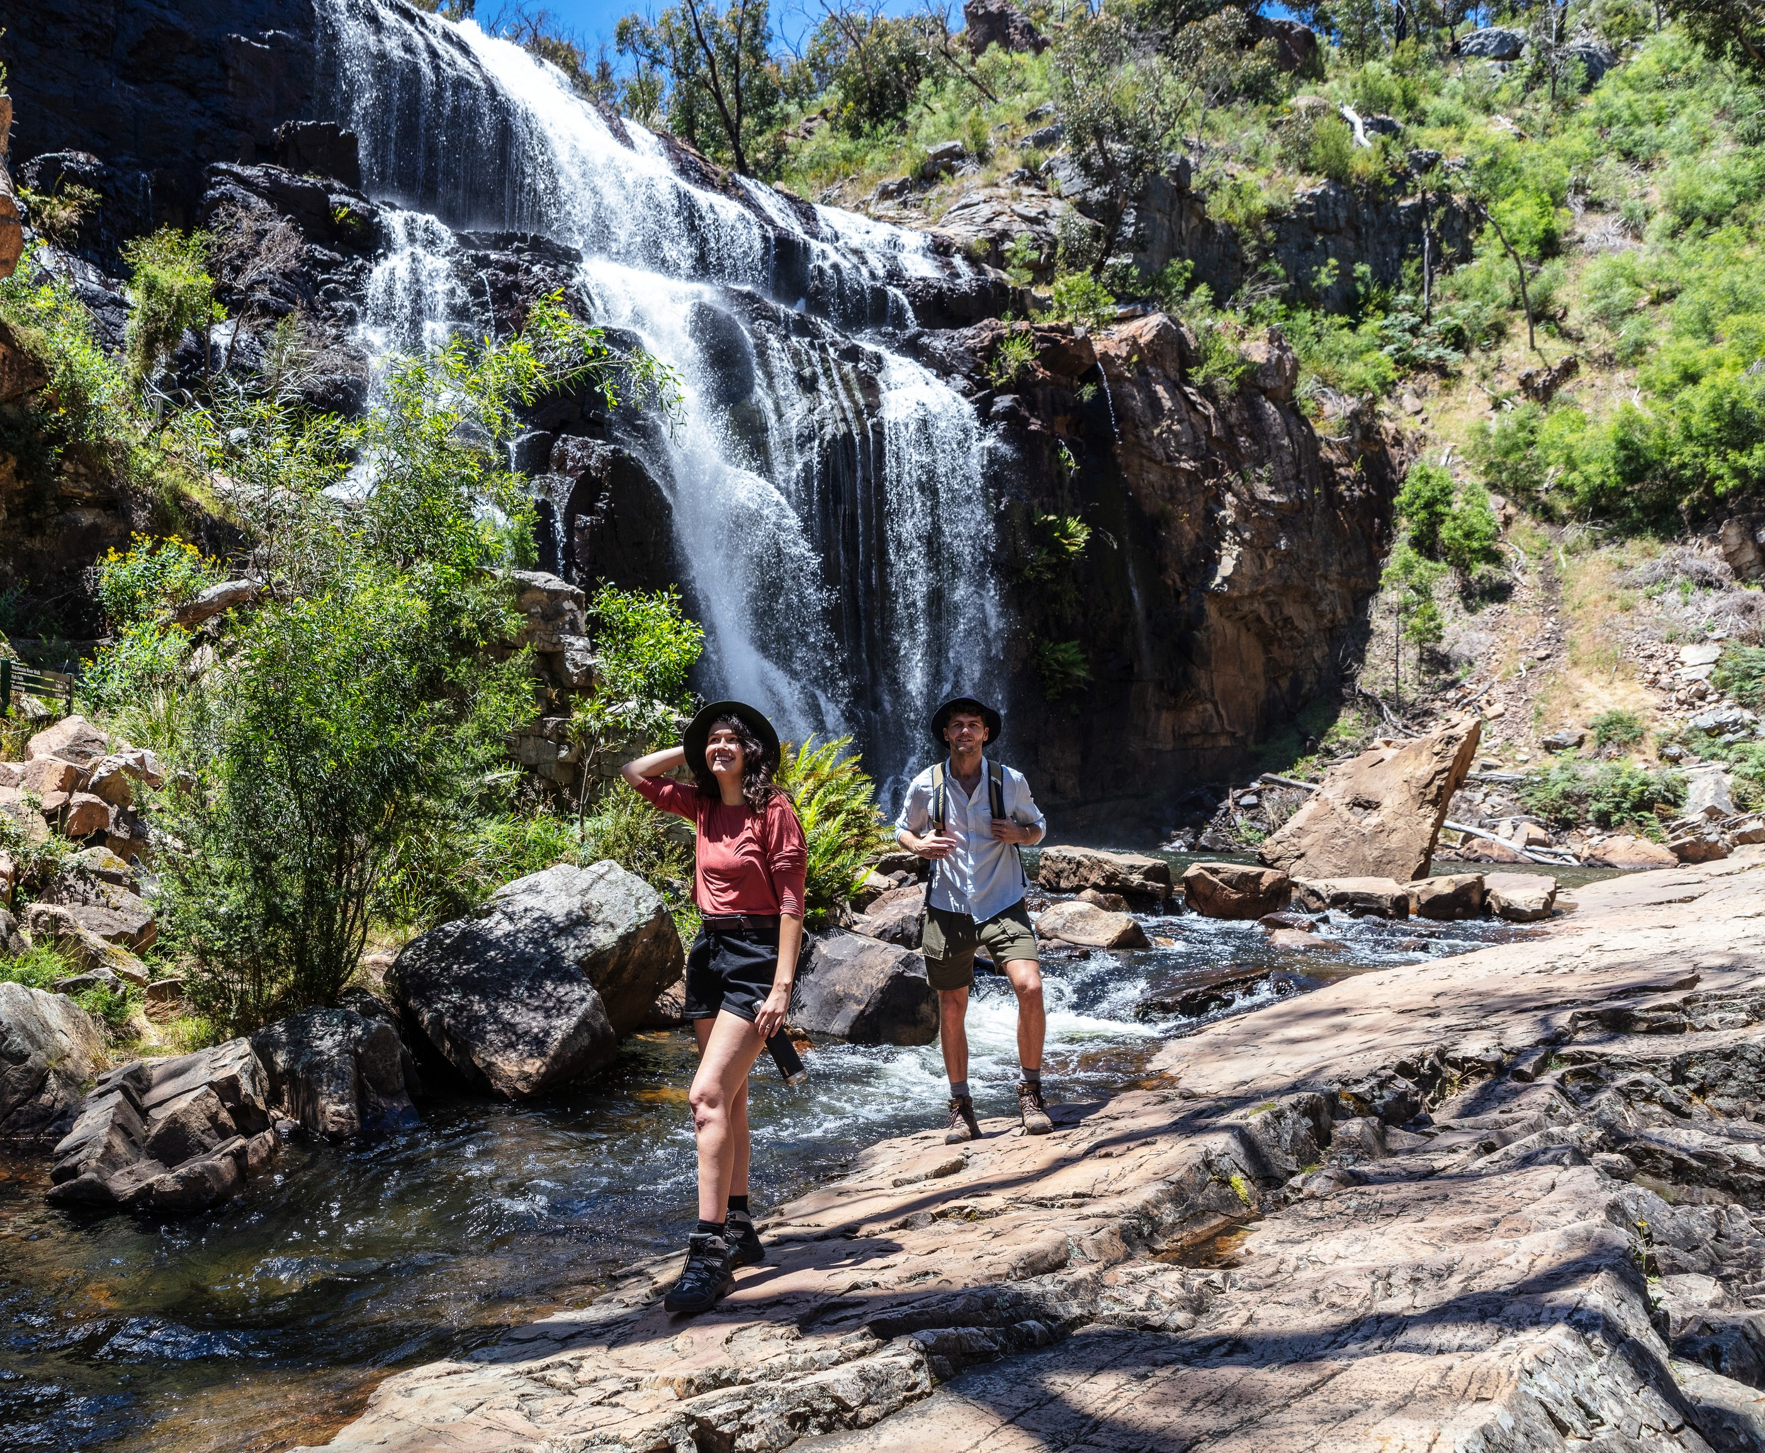

Parks Victoria 1

Application Form

Trial Visitor Information Services
Mackenzie Falls
Grampians (Gariwerd) National Park



Trial visitor information services

Instructions: This is an electronic application form. Simply type your responses into the grey fields which will expand to the content. Once complete, save and email your application (with supporting documentation). Submission details below.

Before completing the application form, make sure you have read the invitation email and supporting documentation.

- Name of Applicant
Business / Trading Name:
Business telephone number Mobile number Email
Note: The agreement is issued in the business / trading name and must match the Certificate of Currency provided to Parks Victoria. An ASIC extract must be attached to evidence the entity. Email address may be used to communicate fire and emergency information
to you in relation to the Park

- Applicant status
Individual | → What is your ABN?
Company | → What is your ACN?
Incorporated Association | → Registration number?
Charitable organisation*
Not-for-profit organisation* | * Must provide evidence of this status with your application

- Business address
Street number and name
Suburb State Postcode

- Postal address
Same as business address OR Street number and name/P.O. Box
Suburb State Postcode

- Infrastructure or mobile trading vehicle details
Type of structure
Structure weight, materials, size, dimensions and power source
Infrastructure installation/removal method and timelines
Mobile trading vehicle registration number and towing vehicle registration number (if applicable).
- Outline all utilities and services required for your operations
Note: There is single phase power available at the site, which will be provided by Parks Victoria. All other services are the responsibility of the operator.

Evaluation Criteria

Proposal Concept 15%

- Provide a comprehensive description of your proposed operations including, full menu with pricing, all equipment/infrastructure with images, staffing, seasonal operations etc
See Appendix A for a site map with maximum footprint. The Service Provider must not bring any equipment on to the site without the prior written consent of Parks Victoria.

- Proposed minimum hours, days and months of operation
 | Monday | Tuesday | Wednesday | Thursday | Friday | Saturday | Sunday | Public Holidays
Time open
Time close
Days and times of operations committed (to be included in the management agreement terms and conditions). Applicants must be clear if operating hours are to change during different months/seasons.

- Proposed start date
The maximum period available is 12-months.

Business management and viability 25%

- Outline your business’ experience and credentials in delivering visitor and safety information, including any accreditation

- Outline your business’ experience and credentials in the delivery of light food and beverage

- Provide 12-month revenue and expense projections with clear assumptions, including proposed fee to Parks Victoria (expressed as a % of gross sales)

Strategic Alignment 20%

- Give a brief description of how your operations and any experience will promote visitor and safety information (to be provided by Parks Victoria)

- Highlight how your menu items align with the Victorian Government’s Healthy Choices Guidelines

- Outline your capacity to track the required sales and visitor data to inform an End of Agreement report

Visitor Experience 25%

- Detail how your operation will enhance the visitor experience at the Mackenzie Falls day visitor area, including how it will provide safety and visitor dispersal information to visitors

- Detail how your operation will enhance the visitor experience in the Grampians National Park, including how it will promote environmental and cultural awareness and advocacy

Environmental management 15%

- Outline how the business will evidence and promote environmental sustainability e.g. litter management, recycling and waste disposal, noise minimisation, energy use, minimising environmental impacts associated with installation etc
At a minimum, an adequate number of rubbish bins must be provided to service the needs of patrons, and the MacKenzie Falls site must be kept tidy and free from all rubbish that is caused by or incidental to the provision of the Park Services. All rubbish and waste must be removed from the MacKenzie Falls site and disposed of at the end of each day. And bins must be housed out of site when centre is not operating

Mandatory supporting material

Please attach the following material to complete your application:

Evidence of applicant business status
Certificate of Currency (Public and Products Liability insurance) for a minimum of twenty million dollars ($20,000,000). This certificate must be in the same name as stated in the applicant details;
12-month financial projections
Photographs or designs of the structure

Declaration and Signature

I declare that:
- I have read the Park Services Agreement document
- By applying to Parks Victoria, I acknowledge and accept all agreement conditions
- I am authorised as the holder of the position cited below to submit this application on behalf of the applicant
- To the best of my knowledge the contents of this application and all attachments are true and correct

I acknowledge that if lodging this request electronically, Parks Victoria will accept this communication as containing my signature for the purposes of the Electronic Transactions (Victoria) Act 2000.

Signature of Applicant (if lodging electronically, type name here) Date
X
Printed name Position

Submission

Once complete, submit your application form and mandatory supporting material to EOI@parks.vic.gov.au with ‘Application - Mackenzie Falls Visitor Information Services’ in the subject line.

Conflict of interest declaration

Application for Trial Visitor Information Services – Mackenzie Falls
All applicants are required to complete the following conflict of interest declaration. Where a relationship exists with any Parks Victoria staff member, please outline the details to be kept on record. Where a conflict of interest detrimental to the assessment process has been identified by Parks Victoria, a person may be asked not to participate in the EOI process.

Section 1: Applicant / prospective tenant

Name:

Position/Title:

Organisation:

Phone Number:

Email:

Address:

Section 2: Conflict of interest
☐ As an applicant in this process I do not have any conflict of interest in this project
(including an actual or a perceived conflict of interest).
OR
- ☐ I have identified a perceived or actual conflict of interest with the following persons

The conflict relates to (tick appropriate box/s):

☐ Relationship with PV staff member | ☐ Outside work activities (paid/unpaid)
☐ Relationship with external parties | ☐ Conflict of duty (e.g. membership of another public sector or private organisation)
☐ Financial interest | ☐ Other (please detail):

The conflict is expected to last (tick appropriate box):

☐ 0-12 months ☐ >12 months ☐ Ongoing

To the best of my knowledge and belief, any actual, perceived or potential conflicts between myself, my business and Parks Victoria and/or the Project Manager have been fully disclosed in this declaration form. I acknowledge and agree to comply with any directions from Parks Victoria in respect of any actual, perceived or potential conflict of interest.
Signed:
Name:
Date:

Appendix A – Site Map

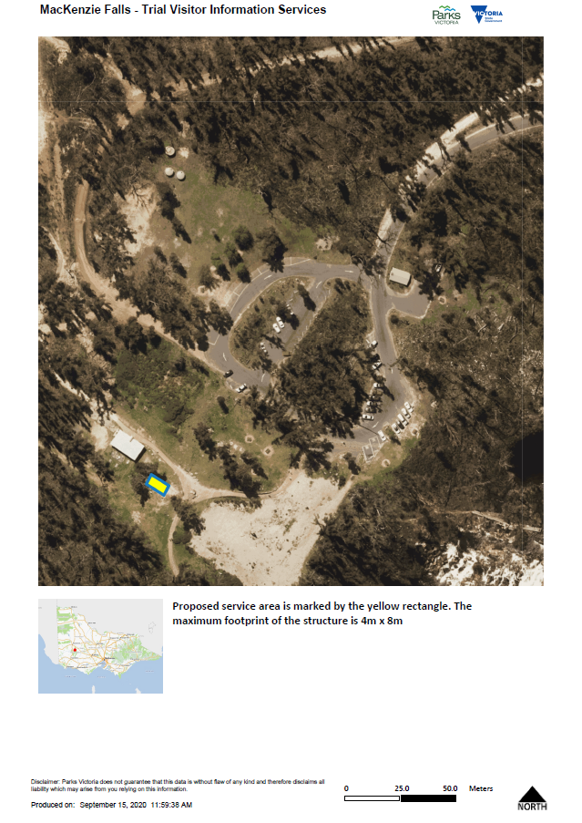

Appendix B – Map Central Grampians

