**EOI**

1

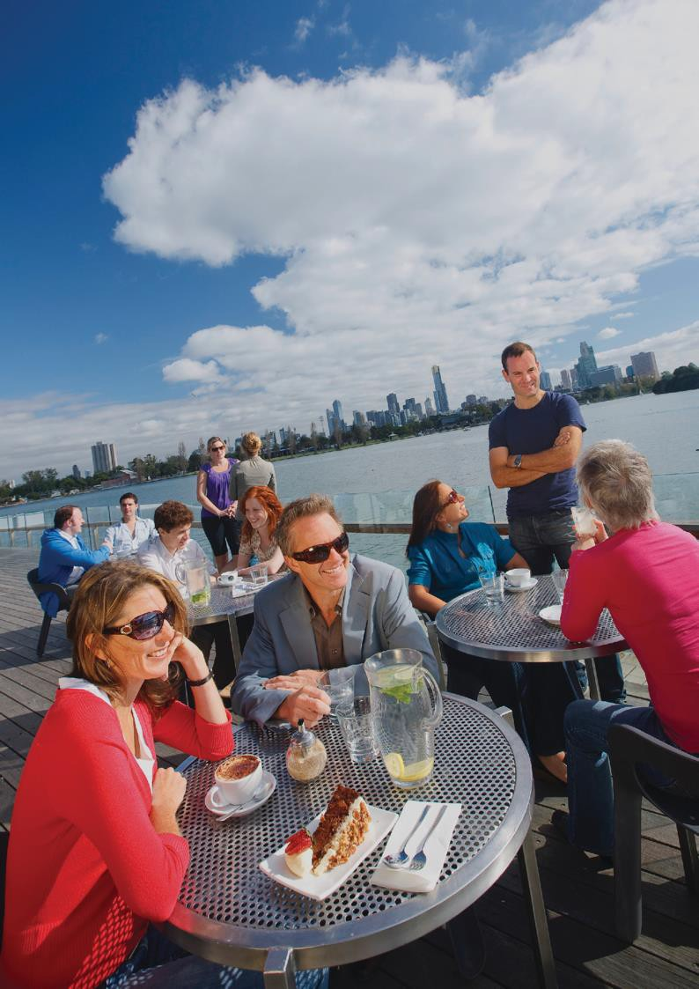

**Essentials**

with Parks Victoria

# Contents

Introducing Parks Victoria 3

Commercial Activities in Parks 5

Commercial Lease Agreements 5

Commercial Licence Agreement 5

Tour Operator Licences 5

EOI and Application Process 8

Proposal Assessment Information 11

Probity 13

Code of Conduct 13

Confidentiality 13

Conflict of Interest 13

Disclaimer 14

Authorised and published by Parks Victoria Level 10, 535 Bourke St,

Melbourne VIC 3000

Copyright © Parks Victoria 2017

2

Introducing

**Parks Victoria** An impressive blend of commercial and community offerings in some of the most stunning landscapes.

**70**



National and

**state parks**

**24**

marine parks

**and sanctuaries**

**148**

places on the

**Victorian Heritage Register**

**$1.4 billion in park tourism**

**440**

Licensed Tour

**Operators**

**98.5m**

**visits**

From bluestone lined oat mills to cliff tottering light stations, majestic hill top manors to quaint cafes, Parks Victoria offers some of the most iconic locations and venues for lease and licence opportunities in Australia.

Here, Parks Victoria presents you with an opportunity to manage your business against some of the nation’s most beautiful backdrops.

With a remarkable balance of community, recreational and commercial prospects, public park and waterway areas managed by Parks Victoria are a key drawcard for staging events, art spaces, business tenancies, restaurants and cafes, retail spaces, accommodation, education and training and so much more.

Capitalise on high value natural estates with strong visitor appeal offering extraordinary ecotourism possibilities for both products and precincts.

If you have a fabulous business concept in relation to any of the Parks Victoria presented EOI opportunities, apply now!

We are looking for innovative entrepreneurs, successful business owners or experienced operators with a desire to help share the benefits and shape the future of Victoria’s park estate.

You might be an investor, traditional owner, social enterprise or community group, ecotourism operator or an individual. Whatever your connection to ‘place’ your idea should enhance the experience and have strong alignment with the sites purpose.

As caretakers of a magnificent estate, Parks Victoria’s vision as a world-class park management service ensuring healthy parks for healthy people will be seeking applicants with a viable business model that focuses on the visitor experience and demonstrates an awareness and commitment to the intrinsic natural and cultural values of each site.

By operating a business on public land managed by Parks Victoria you are helping connect more people to parks, conserving Victoria’s special places and providing benefits beyond park boundaries.

**Our vision**

Parks Victoria is a world-class park service ensuring healthy parks for healthy people.

Healthy Parks, healthy people.

Healthy parks sustain our life and liveability. They improve our physical, mental and spiritual health and wellbeing and generate income, jobs and economic productivity.

By experiencing, understanding and benefitting from the values generated by parks, people advocate, care, invest in, and act for the health of parks.

Our Purpose

At parks Victoria, we inspire the community to conserve and enjoy Victoria’s unique natural and cultural heritage. Together, we care for Country and promote the value of our parks and waterways for the benefit of all Victorians and their Visitors.

State Outcomes

* Health and Wellbeing
* World-class public transport
* Liveable, inclusive and sustainable communities
* A safe and fair society
* Jobs and growth

Connecting people and parks 10 year outcomes

Improve the health and wellbeing of Victorians through the management of a parks estate that is valued by the community.

Conserving Victoria’s special places

**10 year outcomes**

Increase the resilience of natural and cultural assets in parks and maintain ecosystem services in the face of climate change and other stressors.

Providing benefits beyond park boundaries 10 year outcomes

Contribute to the safety, living standards and well-being of Victorians.



**Parks Victoria manages approximately 18% of Victoria, including**

70% of the coastline



**18**

**%**

of Victoria

**70**

**%**

**of Coastline**

# Commercial activities in parks

As land manager, Parks Victoria protects over four million hectares of public land and over 28,000 assets. Together with 1000 commercial and community agreements, we welcome 98.5m visits to parks and waterways each year.

Parks Victoria’s public land portfolio captures over 180 parks including marine sanctuaries, 11,000 Aboriginal cultural heritage places and over 2,500 non-Indigenous historic sites.

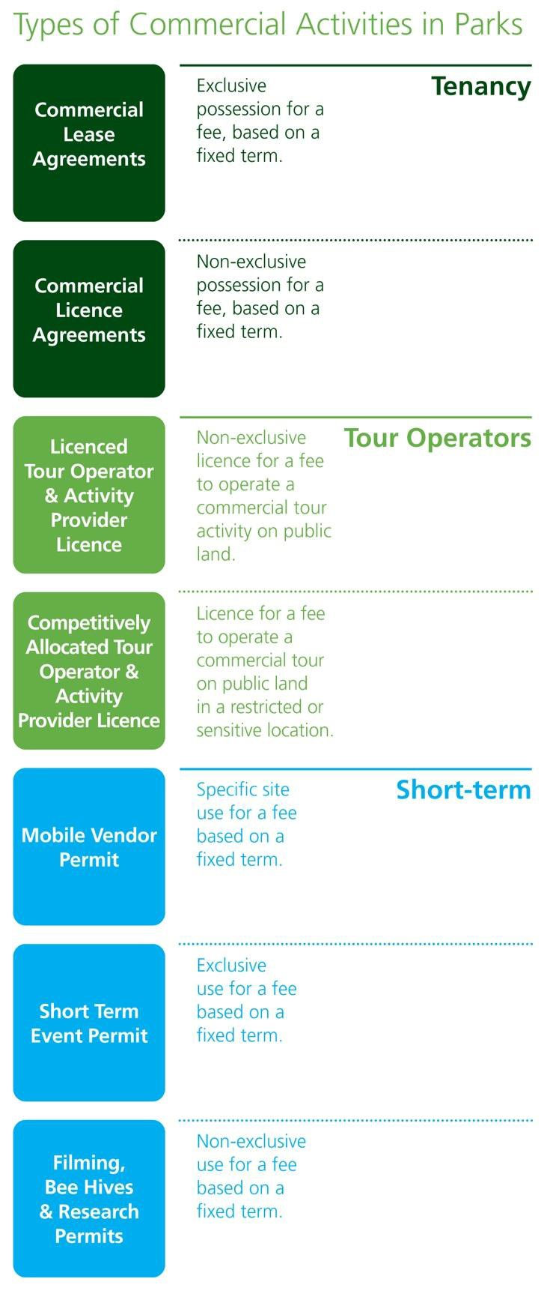

Parks Victoria is also the local Port Manager for Port Phillip Bay, Western Port and Port Campbell and the Waterway Manager for part of the Yarra and Maribyrnong rivers.

Leasing Policy

When considering leasing in parks and waterway areas, the Leasing Policy for Crown Land in Victoria 2010 or the Tourism Leases in National Parks Guidance Note are relevant, in addition to land tenure, permissible uses and other requirements.

Legislation

The legislation and regulations applicable to commercial activities in parks includes:

* Crown Land (Reserves) Act 1978
* National Parks Act 1975
* Parks Victoria Act 1998
* Forests Act 1958
* Forests (Recreation) Regulations 2010
* Land Act 1958
* Marine Safety Act 2010
* Water Industry Act 1994

Any trade or business conducted on public land generally requires a lease, licence or permit.

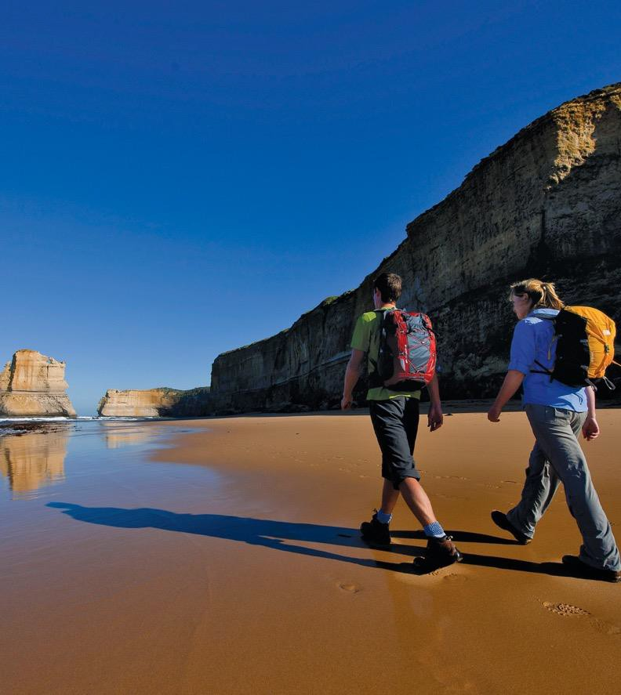

**Key activities under agreement**

**25%**



Sporting

**16%**

Public benefit

**and recreation**

**13%**

Water Based

**12%**

Food, beverage

**& entertainment**

**10%**

Agriculture

Types of agreements for commercial activities in parks

Commercial lease agreements

Offer a tenant exclusive right to occupy a particular site, building or defined area of land for a specified term. The relevant legislation specifies the maximum lease term available (commonly 21 years). Under special circumstances the relevant Minister(s) may consider granting a lease for a maximum of 65 years.

Commercial agreements offered by Parks Victoria provide a range of options to assist the tenants’ operation of the site including sub leasing and licensing, development or improvement works, liquor licensing and permitting assignment of the agreement due to a potential sale of the business (subject to conditions).

Commercial licence agreements

Licences give permission to the holder to carry out a permitted activity without the right of exclusive occupation. Depending on the land tenure of a site, licence terms can range from one to 10 years. In some instances, licences can only be granted if there is an associated lease in which case the licence term may align with the lease term.

Commercial tour operator licence

Any tour operator intending on accessing public land requires a licence. Standard tour operator and activity provider licences are available for one, three or ten years.

Standard Tour Operator Licences are not required to go through an EOI process. For more details or to apply for a tour operator licence today, [click here.](http://parkweb.vic.gov.au/park-management/applications%2C-licences-and-permits/licensed-tour-operators)

Competitively allocated tour operator licence

Some estates, due to fragile natural environments, limited access, safety or visitor management requirements may necessitate a restriction on the number of licensed tour operators that can access an area.

In such instances, a competitively allocated tour operator licence will be made available through an EOI process.

Current and new licensed tour operators can apply for a specified maximum number of available licences for a particular activity such as guided tours in a particular park. Opportunities for Competitively Allocated licences will be featured through an EOI on the Parks Victoria website.

Commercial mobile vendor permits

Seasonal or short term mobile vending operations require a permit to operate a trade or business on public land managed by Parks Victoria.

Businesses interested in a particular area should contact the Parks Victoria office to register their interest and be placed on the Parks Victoria Public Land Interest Register.

Opportunities for multiple mobile vendor locations across Victoria’s public land may go through an EOI process.

Short term event permits

All events on public land require a permit where the event is a wedding, community fundraiser, sporting or recreational event or private function for over 100 people.

Events that include professional catering, temporary furniture or infrastructure, celebrants, filming and photography, require road closures, advertising or ticketed events also require a permit.

Event Permits are not required to go through this EOI process (except in certain parks). For more details or to apply for an event permit now, [click here.](http://parkweb.vic.gov.au/park-management/applications%2C-licences-and-permits/event-permits)

Filming/photography permits

Any commercial activity where filming or photography is conducted as a part of a trade or business requires a permit on public land. In addition, wedding and portrait photographers not already covered by an event permit and student productions will require a permit.

Filming and photography applications (including CASA licensed drones) are not required to go through an EOI process to obtain a permit. For more details or to apply for a permit now, [click here.](http://parkweb.vic.gov.au/park-management/applications%2C-licences-and-permits/filming-and-photography)

Research permits

To ensure alignment with park management objectives, most research requires a permit under legislation administered by the Department of Environment, Land, Water and Planning (DELWP). Permit application forms are on the [DELWP](http://www.depi.vic.gov.au/environment-and-wildlife/forms-for-wildlife-national-parks-and-the-flora-and-fauna-guarantee-act) [website.](http://www.depi.vic.gov.au/environment-and-wildlife/forms-for-wildlife-national-parks-and-the-flora-and-fauna-guarantee-act)

8

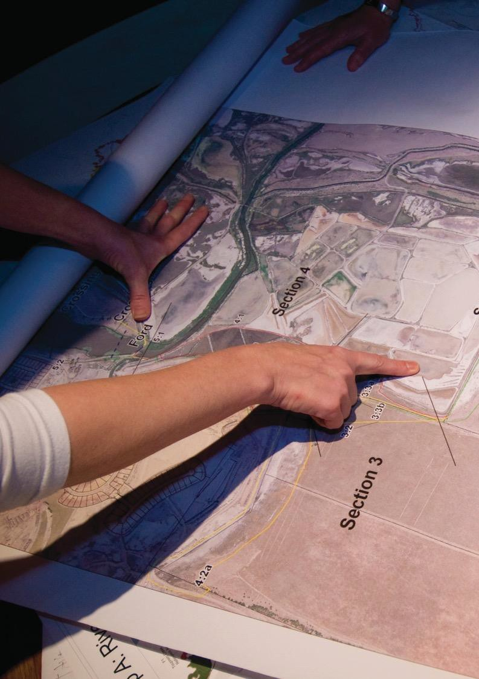

EOI and **Application process**

### The successful appointment of an applicant for a competitive lease or licence is undertaken in two stages.

Parks Victoria **7**

# EOI process

Stage 1:

register your interest

Stage one allows applicants to describe their intended business model, the proposal concept and the vision for the site; demonstrate their background and experience and their capacity and capability to manage and fund the business. This EOI stage is a pre-qualifier to determine suitable applicants to move to stage two.

In some instances, including EOIs for small sites or Competitively Allocated Tour Operator Licences, a single stage process may apply to appoint an operator. Please refer to ‘The Opportunity’ document for more details on each sites proposal schedule.

Stage 2:

invitations for full proposals

Stage two applies to successful applicants from stage one. Here applicants will be invited to submit a full proposal including concept plans, business plan and development plans, where applicable to the site. Applicants as a part of this stage may be asked to present their proposal to the assessment panel. More detailed site information will be available to applicants in stage two to help inform the submission.

Stage 3:

Stage three only applies to large, complex Estates and projects requiring extensive detail as a part of the submission. ‘The Opportunity’ document for each sites EOI will outline if this applies.



Stage 1 Expression of Interest

**1. Review documentation**

* EOI Essentials
* EOI – The Opportunity
* Further reading

Stage 2 Invitation for application

1. **Shortlisted applicants are invited to submit a full proposal**

* Detailed proposal requirements
* Further reading / investigations

1. Book a site visit
2. **Submit your EOI proposal**

**2. Submit full proposal**

* EOI proposals are assessed
* **Applicants are shortlisted**
* **Applicants are notified in writing of the outcome**
* **Full proposals are assessed**
* **Preferred proponent is recommended to the Minister or Parks Victoria Board**
* **Other relevant approvals and delegations**
* **Applicants are notified in writing**
* **Commercial agreement negotiations**

9

10

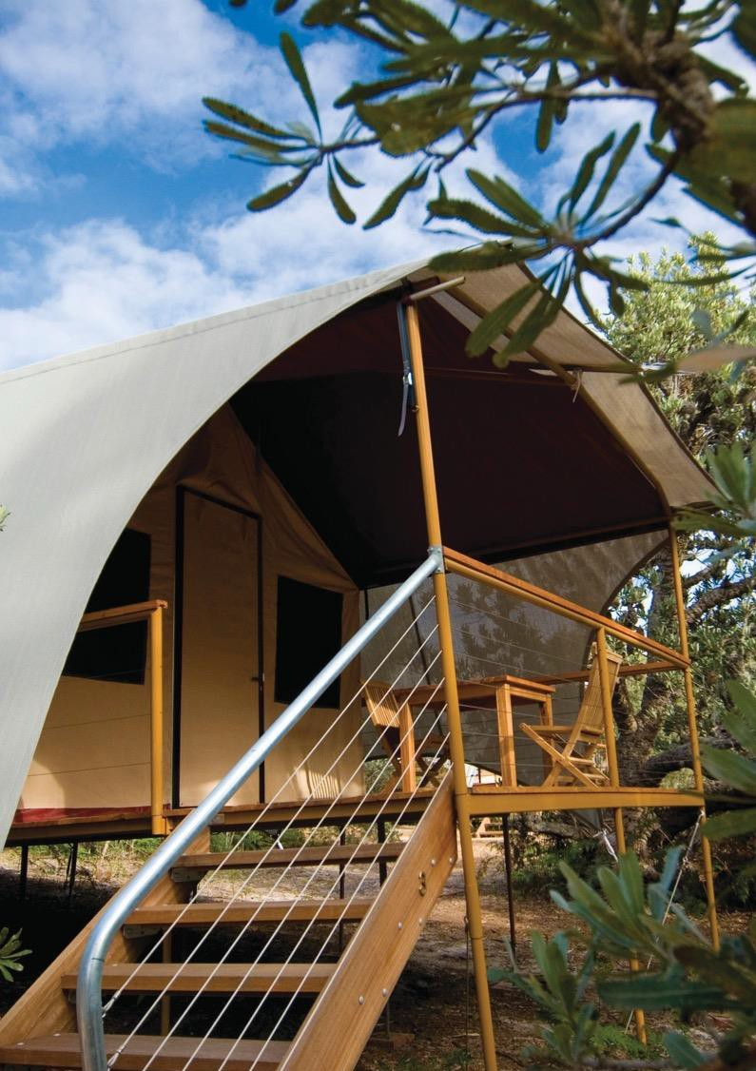

# Proposal assessment information

**What you need to know before submitting your proposal.**

**Proposal**

In some instances, further assessments may be required to be undertaken by the applicant at their own cost such as schematic designs, consultation with stakeholders, vegetation removal offset, flora and fauna report etc.

If asked to demonstrate something, applicants must ensure that supporting documentation is attached.

Where specific plans or consultation are required to support the submission in stage two, Parks Victoria may identify these based on the applicants’ concept, any proposed development and site uses as highlighted by the applicant in stage one.

Check the application prior to submission as any commitments made by the applicant may be incorporated into lease or licence conditions if the application is successful.

Applicant submissions

Site visits, compilation of the proposals and presentations will be at the applicants own expense. In addition, it is the applicant’s responsibility to conduct or obtain their own independent research, planning, legal and financial advice.

During the assessment process, the nominated Parks Victoria Project Manager may contact an applicant for further information or clarification on proposal details to aid in the evaluation of the proposal.

Proposal lodgement

Proposals are accepted electronically as outlined in ‘The Opportunity’ document for each EOI process. Upon receipt, you will receive a notification that your proposal has been lodged.

Any proposal received after the lodgement date and time may not be accepted, in Parks Victoria’s absolute discretion.

Direct negotiations

Parks Victoria may enter into direct negotiations with a stage one applicant (where appropriate) and may not require these applicants to complete the invitation for full proposal stage two.

Notification of results

Approval of the Parks Victoria Board, the Secretary to the Department of Land Water and Planning or Minister for Energy, Environment and Climate Change are obtained before offering a lease or licence. Where further negotiations are required prior to approval, preferred proponent status may apply to an applicant.

All successful and unsuccessful applicants will receive a letter from the Project Manager.

Unsuccessful applicants from stage two invited to submit a full proposal are offered a verbal debrief and feedback on their application from the Project Manager, if requested.

Outcomes of an EOI

Where there are no suitable outcomes from an EOI process, Parks Victoria may decide not to appoint a proponent.

Parks Victoria may at any time change or terminate an EOI process and will not enter into correspondence or discussion in relation to the process.

12



# Probity

To ensure an equitable competitive process, probity principles and a governance structure applies to the assessment of all proposals. This includes ethical conduct, confidentiality and conflict of interest.

**Governance structure**

An assigned Project Manager, a project assessment panel and associated technical specialist advisors are appointed to each EOI project.

Ethical conduct

Applicants must not participate in any anti-competitive conduct and must respect the decision of Parks Victoria.

Parks Victoria may reject an application if an applicant made or makes a public statement in relation to any aspect of the process without prior written consent.

It is a condition of the EOI process that no gifts, benefits or hospitality are to be made to any Parks Victoria employee at any time. Any inducement in contravention of this condition may result in an applicant’s EOI proposal not being considered.

Project contact

Applicants should not contact any staff other than the Project Manager as it may be detrimental to the integrity of the assessment. All contact with the Project Manager must be in writing.

A record of all applicant correspondence will be kept during the EOI process. Information shared with applicants will be consistent and where possible provided at the same time.

Conflict of interest

As a part of the application, applicants will be required to complete a conflict of interest declaration (including perceived conflict of interest). Where a conflict of interest detrimental to the assessment process has been identified, a person may be asked not to participate in the EOI process.

Confidentiality

Applicant’s intellectual property outlined in the proposal will not, subject to legal obligations, be disclosed to competitors or used for illegitimate purposes.

In addition, initial discussions about the project will be treated as confidential and only shared with Parks Victoria employees and/or DELWP and Ministerial advisors and appropriate bodies for the purposes of assessment.

Applicants must acknowledge that the details of the proposal are accurate at the time of submission. Applicants must notify the Project Manager, where details change.

Upon entering into an agreement, details about the agreement (or the agreement itself) may be made publicly available (subject to information which Parks Victoria deems to be commercial in confidence).

# Disclaimer

##### Applicants are advised to make independent enquiries in relation to their application.

This EOI is intended to provide background information.

14



Parks Victoria does not give any warranty, expressed or implied, as to the accuracy or completeness of any information contained in this EOI or which may be provided in association with it, or before the date of this EOI or in future by Parks Victoria, its officers or agents.

Parks Victoria do not take responsibility for any sites impediments such as heritage status, permissible uses, encumbrances on title, native title claims and environmental, planning and other approvals.

Parks Victoria does not accept any responsibility to any applicant or third party under the law of contract, tort or otherwise for any loss or damage which may arise from anything contained in the EOI, any matter deemed to form part of this EOI, the supporting information or documents referred to in this EOI or any information supplied on behalf of Parks Victoria.

All information given to an applicant and ultimately the preferred proponent by Parks Victoria or its respective officers or agents will be given on an ‘all care and no responsibility basis.

Applicants acknowledge and agree that the submission of a proposal does not create a process contract.

By receiving this EOI, the applicant agrees, without qualifications, to have acknowledged and accepted this disclaimer.