Pope’s Eye, Port Phillip Heads Marine National Park

A marine protected area excursion from your classroom

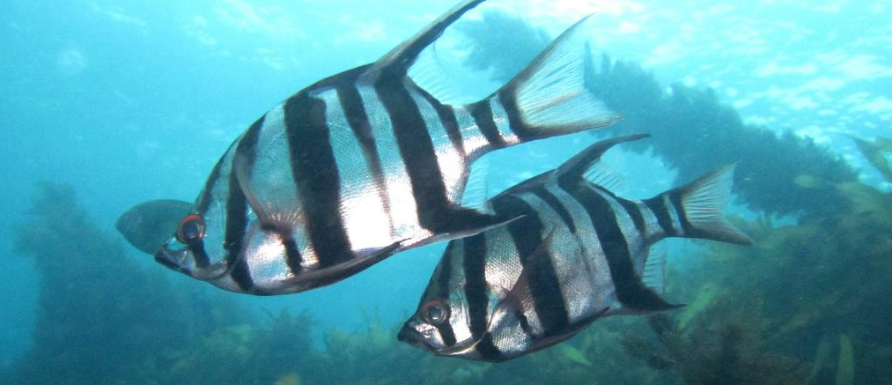
Time to jump online!
Excursions and field trips are an important part of the educational experience for students, offering hands-on, concrete experiences that are important for reinforcing key concepts taught in the classroom. But not all environments are accessible for schools, meaning sometimes we must access them in alternative ways.
Excursions using new digital technologies enable students to experience places otherwise unreachable, giving them a greater appreciation not only of their unique values, but how these are connected to other places and larger issues, and a desire and the know-how to get involved in making a difference.
Our digital resources aim to help students:
- develop a sense of wonder, curiosity and respect for our parks and the people and environments they support
- develop their knowledge of their own locality and region and how places are connected
- understand the changes that are occurring in our parks and what strategies are being employed to manage these changes
- consider some of the complex interrelationships between the physical environment and the flora, fauna and fungi that live in our parks
- become informed, responsible and active citizens who contribute to the protection of our special places
We would love to hear about ways we can improve this resource to support teachers who use these resources. Please contact education@parks.vic.gov.au with your feedback.

Why explore?
Situated near the entrance to Port Phillip, Pope’s Eye is Victoria’s first marine reserve, protected since 1979. The structure itself was established in the late 1800s as part of a series of fortifications designed to protect Melbourne from potential enemy ships.
Pope’s Eye’s fortifications were never completed, leaving behind a semicircular ring of rocks. Since then, the site has been extensively colonised by a wide range of marine plants and animals and is now a protected cool water reef habitat, complete with extensive kelp forests, resident and transitory fish, and a wide range of invertebrates that form colourful sponge gardens.
No fishing or other extractive activities have been allowed at Pope’s Eye since 1979, and it is now an important part of the Port Phillip Heads Marine National Park, popular with snorkelers and divers for its diverse marine life. The sizes and numbers of resident fish demonstrate the benefits of this long-term protection of the reef environment. These fish include several species of leatherjackets, Magpie Perch, Blue Throated Wrasse, Long Snouted Boarfish, Victorian Scalyfin, Dusky Morwong, Blue Groper, and many more.
Above the water, Pope’s Eye is also a home to a colony of spectacular diving birds. Australasian Gannets breed on platforms and the rocks making it an important nesting site in Port Phillip Bay. Building their nests from seaweeds and guano, the birds mate in late winter and then rear their chicks on the platform over the following few months.
Live streaming cameras have been installed at Pope’s Eye by The Nature Conservancy as a part of their Southern Seascapes program, both above and below water, providing students and visitors from across the state, and around the world, a unique opportunity to regularly visit this important marine protected area without the need for a boat or to even get wet.
For teachers
This resource is designed to provide teachers an opportunity to utilise streaming video from Pope’s Eye in the Port Phillip Heads Marine National Park, Victoria’s first fully protected marine area, through The Nature Conservancy’s Reef cam project http://www.natureaustralia.org.au/our-work/oceans/coming-soon-reef-cam-your-window-into-port-phillip-bay/ to gain an insight into Victoria’s unique and diverse marine life.
There are two cameras to view:
- Below water – focussed on the rich and diverse underwater world of a sub-tidal reef including kelp forests and the many fish and other marine life that make this place home
- Above water – focussed above the water on a colony of seabirds, Australasian Gannets, that nest and breed on a platform located immediately above the reef
This virtual excursion is designed to be linked to the Victorian Curriculum for the subjects of geography, science and biology, but also can be enjoyed by students, naturalists, or interested members of the public who want to explore, discover and learn about marine protected areas.
It is suitable and scalable from Levels 5–10 to VCE Biology and Outdoor and Environmental Education.
Some suggested linkages to the Victorian Curriculum are provided below:
Subject | Level | Content descriptions
Geography | 5-6 | Factors that shape places and influence connections
 | 7-8 | Water in the world  Landforms and landscapes
 | 9-10 | Environmental change and management
Science | 5-6 | Biological sciences
 | 7-8 | Biological sciences  Earth and space sciences
 | 9-10 | Biological sciences
VCE Biology | Unit 2 | How is continuity of life maintained?
VCE Outdoor and Environmental Studies | Unit 2 | Discovering outdoor environments
The virtual field work component of this excursion depends on the nature of the investigation and may be simply one-off visit or alternately a regular visit to the site enabling repeated observations to track change over time.
It is also possible to arrange a complementary field trip to Pope’s Eye and the Marine National Park with one of Parks Victoria’s Licenced Tour Operators that conduct boat trips and snorkelling or SCUBA diving programs.
For additional information on the park, download the visitor guide, or visit the Port Phillip Heads Marine National Park webpage for additional information including tour operators, facilities, management plans, maps, and images.

Collecting data
Students can access the live streams through both Parkweb as well as through The Nature Conservancy’s websites.
On occasions, the live streams will not be available due to the need for camera maintenance. During these times, students will still be able to access pre-recorded video highlights captured by the cameras.

Activity 1: A Pope’s Eye Fish Count

Background
Victoria has a wide diversity of temperate or cool-water fish species, many of which are only found in this part of Australia.
Some species of fish are residents and use the reef environments and kelp forests that cover the rocks at Pope’s Eye for shelter, finding food, and breeding throughout the year. Others may be transitory and simply pass through the area from time to time.
Since it has been a protected area for nearly forty years, the fish that live at Pope’s Eye in the Port Phillip Heads Marine National Park have had a chance to grow larger, making this a great place for fish watching.

Instructions
The underwater webcam will provide a unique opportunity to observe the range of fish that occur at Pope’s Eye, including both common and more unusual species.
We encourage you to watch the live feed for ten minutes every week or as often as possible and check in on what is going on, observe changes in behaviours or activity, and make note of the fish that are seen through the camera.
You can record what you see each time you visit using a record sheet like the example included, or make up your own, and use this information to build a picture of both the diversity of fish that live here and their numbers.
The species illustrated are only a sample of the fish species found at Pope’s Eye and there are many more that can be seen. Some fish species have different appearances depending on if they are male or female, or whether they are adults or juveniles.
An excellent guide for identifying fish is Museum Victoria’s Port Phillip Bay Taxonomic Toolkit at http://portphillipmarinelife.net.au/.
Don’t forget to also keep a record of the date, time, weather conditions, and other useful information that might help you understand what is happening over time.

Screen Shots
While watching fish you might like to capture an image of what you see and keep this with your records, and use it to help identify unusual species.
Refer to your computers Print Screen options before starting the live feed. Watch the feed in full screen to get the best results.
If you spot something unusual don’t forget to share this image and your data with education@parks.vic.gov.au.

Pope’s Eye Underwater Reef Cam

Fish Species Record Sheet
Date:
Time of day:
Length of time observed:
Observer Names:
Weather Conditions:
Image | Species | Tally | Final count
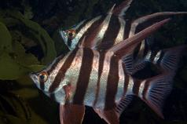 | Old Wife  Enoplosus armatus
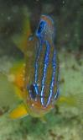  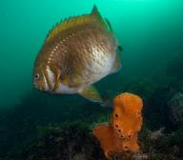 | Victorian Scaly Fin  Parma victoriae  (Left - adult; Right - juvenile)
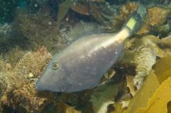 | Yellowstriped Leatherjacket  Meuschenia flavolineata
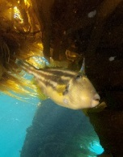  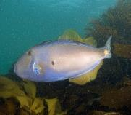 | Sixspine Leatherjacket  (Left – Male; Right - Female)  Meuschenia freycineti
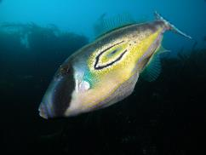 | Horseshoe Leatherjacket  Meuschenia hippocrepis
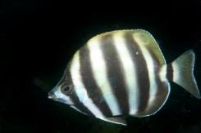 | Moonlighter  Tilodon sexfasciatus
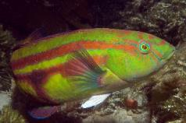 | Senator Wrasse  Pictilabrus laticlavius
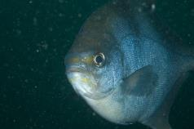 | Sea Sweep  Scorpus aequipinnis
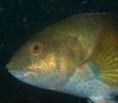  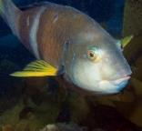 | Blue Throated Wrasse  (Left – male; Right - female)  Notolabrus tetricus
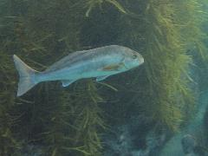 | Dusky Morwong  Dactylophora nigricans
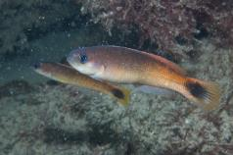 | Southern Hulafish  Trachinops caudimaculatus
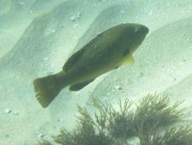 | Blue Groper (Juvenile)  Achoerodus viridis (Eastern) or  Achoerodus gouldii (Western)
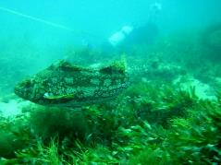 | Marblefish  Aplodactylus arctidens
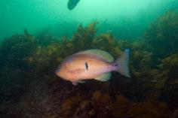 | Barber Perch  Caesioperca rasor
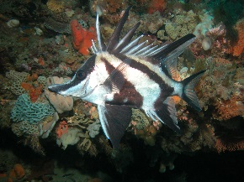 | Longsnout Boarfish  Pentaceropsis recurvirostris
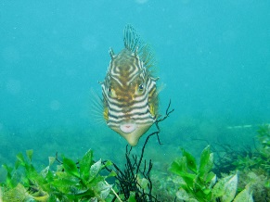 | Shaw’s Cowfish (female)  Aracana aurita
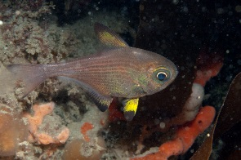 | Bullseye  Pempheris multiradiata
 |  |  | Total

Activity 2: The Life Cycle Australasian Gannets

Background
Australasian Gannets (Morus serrator) are large seabirds found along the coast of Victoria and Tasmania, as well as in New Zealand, that can often be seen off shore diving to capture their prey. They are closely related to Cape Gannets found in South Africa, and are very similar in appearance to Northern Gannets in the northern Atlantic Ocean. These birds are all in the family of birds known as the Sulidae, which includes several well-known tropical birds called Boobies.
Australasian Gannets are superbly adapted for flying over water and have keen eyesight, enabling them to detect schools of small fish or other prey items, such as squid, beneath the surface. Plunging from great heights, Gannets fold their wings back and dive head first into the water, snatching their prey from beneath the surface. Gannets have no external nostrils on their beaks, a useful adaptation for their diving behaviours, and have cushion like structures in their necks and body to help absorb the shock of hitting the water at high speed.
Australasian Gannets normally live in large colonies comprising thousands of birds on offshore islands, but they are also known to inhabit structures in Port Phillip Bay, such as platforms built for navigation lights. The Australasian Gannets at Pope’s Eye have been there for over twenty years and initially built their nest on the rocks. Two platforms have been built to help accommodate them and provide places for them to nest.
Gannet pairs may remain together over several seasons. The pairs separate when their chicks leave the nest but they pair up again the following year. They fiercely defend the area around their nest and if space allows, the distance between nests is double the reach of an individual.

Instructions
Visit the webcams to closely follow and observe the lifecycle of Australasian Gannets throughout their entire breeding season, from nest making and mating, through to egg laying and incubation, and watch the chicks as they grow quickly and eventually fledge as young adults.
We encourage you to drop by for ten minutes every week or as often as possible and check in on what is going on, observe changes in behaviours or activity, and make note of the growth of chicks.
We also encourage you to record what you see each time you visit using a record sheet like the example provided, or make up your own, and use this information to build a picture of the life cycle of these birds.
Don’t forget to also keep a record of the date, time, weather conditions, and other useful information that might help you understand what is happening in the bird colony.

Screen Shots
While watching the Gannets you might like to capture an image of what you see and keep this with your records, and use it to help document any interesting or unusual behaviours.
Refer to your computers Print Screen options before starting the live feed. Watch the feed in full screen to get the best results.
If you spot something unusual don’t forget to share this image and your data with education@parks.vic.gov.au.

Australasian Gannet Observations: A Case Study
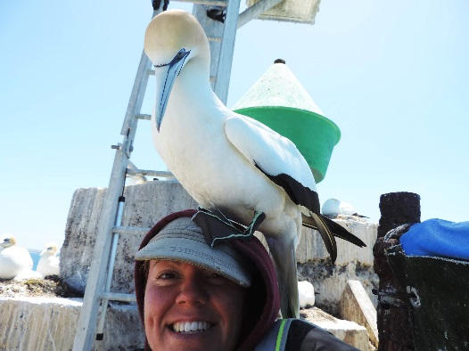
Melanie Wells is a young Victorian scientist and bird researcher from Deakin University who has spent many hours monitoring the behaviours and diets of Australasian Gannets. She has closely studied the birds both at Pope’s Eye and at the large colony at Point Danger near Portland in Western Victoria. She compared the feeding patterns and behaviours of birds living in the shallow bay and the deeper offshore environments. Melanie used GPS trackers and micro cameras attached to some birds to them follow them closely and was able to capture some amazing images of them feeding in the water.
You can find her published paper and images on this research at http://bio.biologists.org/content/early/2016/05/27/bio.018085.
Below are some of Melanie’s wonderful images, which provide a glimpse of these magnificent birds at Pope’s Eye.

Australasian Gannet Colony at Pope’s Eye, Port Phillip Heads Marine National Park | 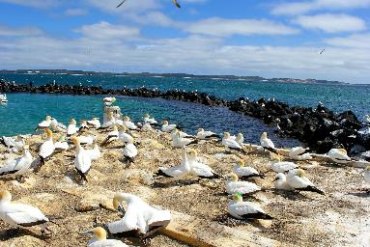
Australasian Gannets build their nest on the ground from seaweed and guano (bird poo). | 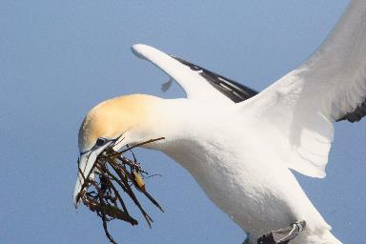
After hatching gannet chicks have no feathers and rely on their parents taking turns to keep them warm. | 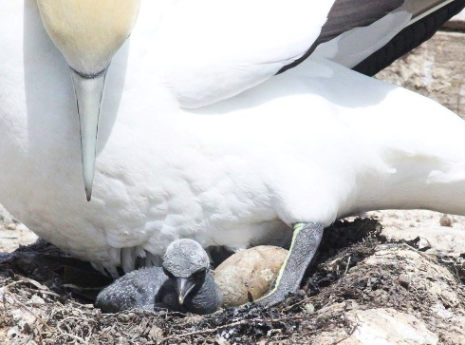
Australasian Gannet family groups are closely bonded and can recognise each other in a large colony. | 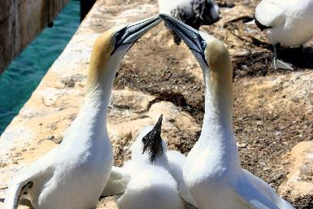
Australasian Gannet chicks soon develop a soft down to keep them warm and are cared for by both parents. | 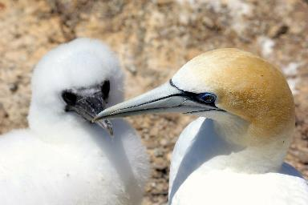
Moulting juvenile Australasian Gannets lose their fluffy down and have black and white feathers underneath. They cannot fly so depend on their parents for food and protection. | 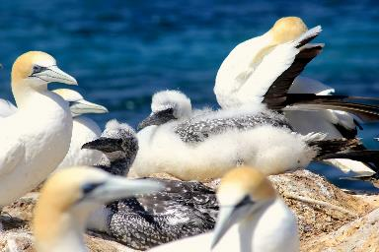
Juvenile Gannets grow quickly on a rich diet of fish and other marine life caught by their parents. | 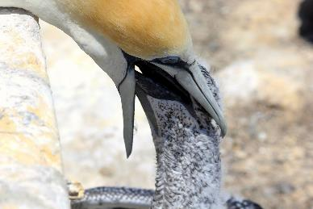
Australasian Gannets have webbed feet and are comfortable resting on the surface of the water. | 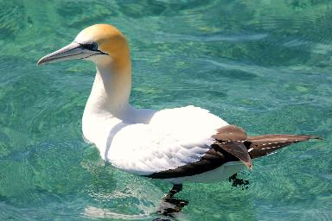
Australasian Gannets search widely across the surface of the sea to find their food, and when spotted dive out of the air under the water to capture fish and other prey. | 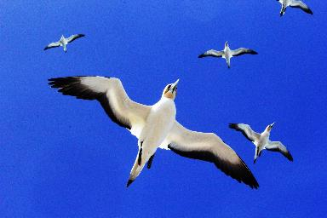

Australasian Gannet Life Cycle

Observations and Record Sheet
Date:
Time of day:
Length of time observed:
Observer Names:
Weather Conditions:
Number of nests on platform:
Number of Adult Birds:
Number of Chicks
(White fluffy):
Number of Juveniles
(Black and white feathers):
Description of Adult behaviours observed:

Description of Chick behaviours observed:

Other Observations and Comments:

Discover and reflect
You might like to enhance your excursion with some activities and inquiries that help students record and extend their learning back into the classroom. You might like to complete one or more of the following:
- Undertake a virtual survey of fish species to explore diversity and abundance at different times of day and throughout the year (see Activity 1 for some ideas).
- Closely observe fish to better understand some of their behaviours and strategies for survival in the marine environment.
- Monitor the behaviours of a colony of nesting seabirds and their various interactions with other birds in the colony.
- Closely follow and observe the lifecycle of Australasian Gannets throughout their entire breeding season from nest making and mating, through egg laying and incubation, and watch the chicks as they grow quickly and eventually fledge as young adults (see Activity 2 for some ideas).
- Discover and record unusual marine species that visit the site.
- Investigate the impacts of major natural events such as storms, extreme tides, and heat waves on marine species.
- Observe the interactions and impacts of human visitors to this protected site including by boats, snorkelers, tourism operators, and SCUBA divers.

Get involved
Continue to learn and care for Port Phillip Heads Marine National Park and the Victorian coastline by participating in Sea Search or Reef Life Surveys. Contact the ParkConnect team if you would like to get your students involved in some hands-on volunteer activities in the marine national park and surrounding areas.

Parks Victoria respectfully acknowledges the Traditional Owners of what is now known as Victoria. For many thousands of years they have lived in harmony with, and carefully managed the Country for which they have a deep spiritual connection. Contemporary Aboriginal people are proud of their ancestry and in addition to their inherent rights, they have spiritual and cultural obligations to ensure that their ancestral land and culture is managed responsibly and appropriately.

