Brambuk: Live Music & Art Workshops
Inviting Musicians & Artists to Register Interest!
Brambuk is about strengthening, celebrating and sharing the cultures of Gariwerd’s Traditional Owners.

Barengi Gadjin Land Council, Eastern Maar Aboriginal Corporation, Gunditj Mirring Traditional Owners Aboriginal Corporation and Parks Victoria are seeking interested Traditional Owner artists to share their story and heritage at Brambuk with visitors and community members, through playing a concert or hosting an arts / craft workshop.

We invite artists who are Traditional Owners of Gaiwerd to register their interest in delivering an arts activity at Brambuk during Spring / Summer 2021. If you’d like to register, please complete the form attached and send it in by Midnight Wednesday 15 September 2021.

Concerts:
- A mix of experienced and emerging artists will be selected from the registrations of interest to conduct a series of small, intimate concerts in venues around the Brambuk precinct (the cultural centre is currently closed for maintenance works).
- Music can be either contemporary or traditional, or a blend of both. We welcome registrations from solo artists and up to 4-piece bands.
- Gigs will involve 2 x 1 hour sets for each artist / band (one band per day).
- Performances by featured musicians / bands will be scheduled predominantly on weekends and school holidays during Spring / Summer.

Workshops:
- We are seeking practitioners of traditional, or contemporary interpretations of traditional, arts / craft practices who are experienced in delivering workshops.
- Workshops will involve 2 x 2-hour sessions on the one day per artist, with small groups of up to 20 participants. Workshops delivered by featured artists will be scheduled predominantly on weekends and school holidays during Spring / Summer.
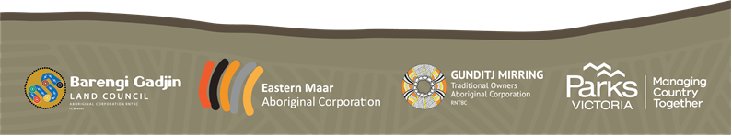
- Artists will be required to supply all materials for use in their workshops.

Artist Registration Form
Instructions: Please type your responses into the fields below. Once completed, save and email your application. Details to submit the form are listed at the end of the document.

Artist / Band Name

Contact Name:

Business telephone number Mobile number Email address

Where are you based (town / state)?

How can we confirm that you are a Traditional Owner of Gariwerd? Eg. membership of Gunditj Mirring TOAC, Barengi Gadjin LC or Eastern Maar AC, or other indicator

Official website address (if available)

Facebook page (if available)

Youtube (if relevant)

Other links to digital samples of your work

If a musician – number of performers (solo, or up to 4 band members)

How would you describe your music (if you propose to deliver a gig), or the art / craft practice you would feature in a workshop? 1-4 sentences

Bio / Previous Experience (up to 200 words)

Please indicate if you (if you’re a solo artist) or your band has Public Liability Insurance:
- YES / NO

If you are proposing to deliver a musical performance, can you provide and run your own PA system?
- YES / NO / Not applicable

Submitting a Registration
Completed registration forms are to be submitted to Lee Morgan, Event Organiser, on:
leesonnyboy@gmail.com

Applications are due by Midnight Wednesday 15 September 2021.

Please note that as we may receive a large number of registrations, we will only be in contact if we wish to discuss your submission further.

Selection
Registration forms will be assessed, and artists and musicians selected, by representatives of Barengi Gadjin Land Council, Eastern Maar Aboriginal Corporation, Gunditj Mirring Traditional Owners Aboriginal Corporation and Parks Victoria.

Enquiries
All enquiries should be directed to Lee Morgan on ph. 0409 149 610 or leesonnyboy@gmail.com

These performances and workshops are funded by the Australian Governments’ Regional Arts Fund, which is provided through Regional Arts Australia. The fund is administered in Victoria by Regional Arts Victoria.
