
Draft Rhyll Local Port Area Plan
June 2024

This publication may be of assistance to you but Parks Victoria and its employees do not guarantee that the publication is without flaw of any kind or is wholly appropriate for your particular purposes and therefore disclaims all liability for any error, loss or other consequence which may arise from you relying on any information in this publication.
Authorised and published by Parks Victoria
Level 10, 535 Bourke St, Melbourne
Cover image: Rhyll Jetty (Source: Better Boating Victoria, 2023)

Acknowledgement of Country
Victoria’s network of parks and reserves form the core of Aboriginal cultural landscapes, which have been modified over many thousands of years of occupation. They are reflections of how Aboriginal people engaged with their world and experienced their surroundings and are the product of thousands of generations of economic activity, material culture and settlement patterns. The landscapes we see today are influenced by the skills, knowledge and activities of Aboriginal land managers. Parks Victoria acknowledges the Traditional Owners of these cultural landscapes, recognising their continuing connection to Victoria’s parks and reserves and their ongoing role in caring for Country.

Contents
1 Introduction 4
2 The Local Port Area Plan 4
2.1 Site location and study area 4
2.2 Strategic context 5
2.3 Policy context 6
2.4 Purpose and objectives 6
3 Developing the Plan 7
3.1 Stakeholder and community consultation 7
3.2 The design criteria 8
4 Proposing a future for Rhyll Jetty 9
4.1 The vision 9
4.2 The preferred design solution 9
5 Next steps 11
6 References 12

Introduction
Maintaining piers that are safe to the public is core business for local ports managers. This draft Local Port Area Plan sets out a future direction for Rhyll Jetty to ensure it responds to the current and future needs of users and continues to support local and regional tourism. This Local Port Area Plan is being delivered under the Sustainable Local Ports Framework 2021 which recognises the important economic, cultural, and social values of local ports and provides a consistent planning and decision-making pathway to prioritise future investment in local ports and support local area planning.

The Local Port Area Plan
The preparation of this draft plan began with a review of existing condition reports, analysis of current and future demand and technical assessments (Refer to Background Technical Report, Rhyll Jetty – Local Port Area Plan 2024 for details). We have also met with key stakeholders to identify key challenges, values and their aspirations to inform the design solution for the future jetty layout. To help prepare the final plan, we’re now interested to hear broader community feedback on this draft plan.

Site location and study area
Rhyll is located on Bunurong Land and Sea Country on the north-eastern coastline of Phillip Island, 6km east of Cowes. The local port area is popular with people accessing the many great recreational boating and fishing opportunities on offer in Western Port. Rhyll Jetty provides on-water access to Phillip Island tourism attractions (such as marine wildlife cruises) and supports local tour operators. It is also an important destination for the cruise shipping industry, which brings domestic and international visitors to the region. The number of passengers arriving at Rhyll has significant economic benefits, enhances its status as a desirable tourist destination, and provides for the Rhyll Community Association who welcome visitors and promote tourism at Rhyll.
Historically, a jetty was originally constructed at the site in 1877 and has subsequently been replaced several times. The current structure was built in the 1980s and is nearing the end of its serviceable life.
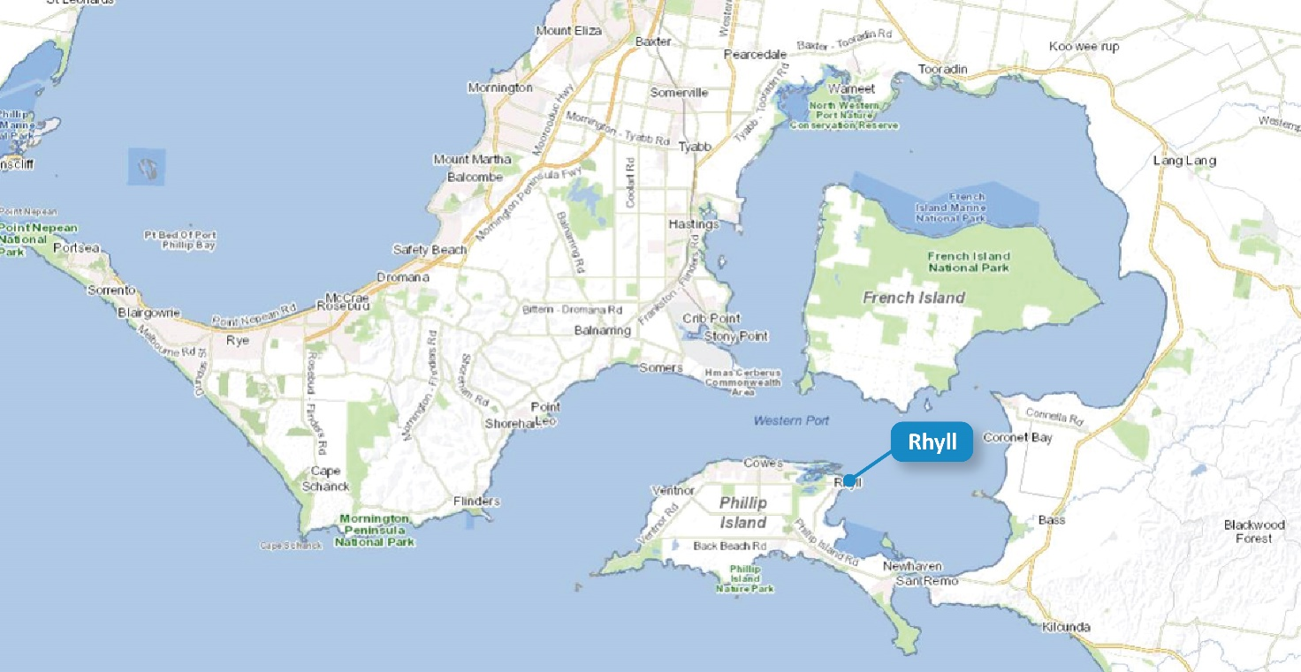
Figure 1: Site Location (Source: MapshareVic, 2024)

Rhyll is a quiet, seaside village supporting a range of water-based tourism and recreational activities. Figure 2 shows the study area for this plan, including the following notable features:
- Rhyll Jetty
- Rhyll Boat Ramp
- Rhyll Slipway
Parks Victoria is the port manager for the local port of Western Port and the Committee of Management for Rhyll Jetty. The Rhyll boat ramp is managed by Bass Coast Shire (Council) and was recently upgraded in 2022. Council is also responsible for managing the adjacent Crown Land reserve, which includes the carpark and picnic facilities.
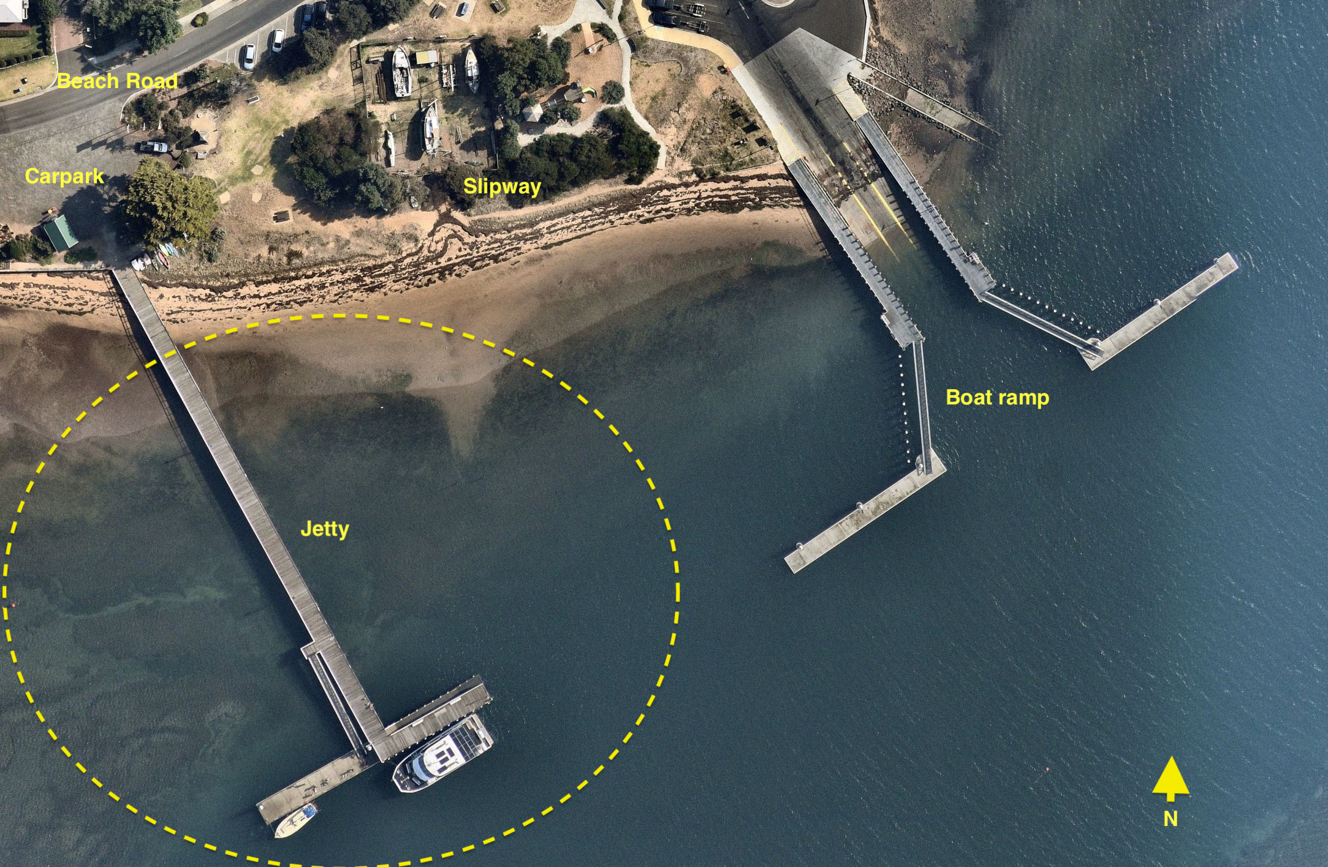
Figure 2 – Study area (Source: FSC Range, 2024)

Strategic context
The Victorian Government has developed the Sustainable Local Ports Framework 2021 (framework) which serves as a long term strategy for the management and maintenance of our piers and jetties.
The framework provides a consistent planning and decision-making pathway to support wider precinct planning through local port area plans. Four principles will be applied to prioritise future upgrades and improvements. These include Local Economy and Job Growth, Tourism and Recreation, Emergency Response Capabilities, and Community and Cultural Value.
Guided by the framework, the Plan is being developed through technical investigations and studies, while leveraging local knowledge and expertise to prepare for the future of local port assets and services.

Policy context
The objective and principle of the Marine and Coastal Act 2018 centres around the preservation and maintenance of the marine and coastal environment, with a focus on ensuring its longevity for future generations. In line with this, the Marine and Coastal Policy 2020 (Policy) provides a 15-year vision that envisions a ‘healthy, dynamic and biodiverse marine and coastal environment that is valued in its own right and that benefits the Victorian community, now and in the future’. It serves as a strategic guide for planning processes, management approaches, as well as decision-making protocols.
Furthermore, the Policy is supported by the Marine and Coastal Strategy 2022 (Strategy). This strategic framework outlines a series of prioritised actions to be undertaken over the course of the next five years to effectively achieve the objectives set forth in the Policy. The Strategy recognises that formal and informal collaboration is required for effective and integrated delivery. The Victorian Government, Traditional Owners, marine and coastal managers, communities, and individuals all have important roles and responsibilities in the joint implementation of this Strategy.
The Plan utilises both the Marine and Coastal Policy 2020 and Marine and Coastal Strategy 2022 to lead the management of Victoria’s marine and coastal environment at this site.

Purpose and objectives
The purpose of this plan is to ensure the Rhyll Local Port Area can continue to support a range of water-based commercial and recreational activities. This will be achieved by developing a future layout for a rebuilt Rhyll Jetty that:
- Provides berthing for Licensed Tour Operator (LTO) vessels.
- Provides short-term berthing for cruise ship tenders and recreational vessels to load and unload passengers.
- Provides for the safe and efficient movement of passengers.
- Provides recreational fishing, walking and viewing opportunities.
- Complies with relevant standards.
- Considers the local wave climate and climate change impacts such as sea level rise.

Figure 3 – Rhyll Jetty, and part of the boat ramp in the foreground (Source: Better Boating Victoria, 2023)

Developing the Plan

Stakeholder and community consultation
A Project Reference Group (PRG) comprising representatives from Parks Victoria, Bass Coast Shire Council, Destination Phillip Island, the Department of Transport and Planning and Bunurong Land Council Aboriginal Corporation (BLCAC) has been established to advise on the development of the plan. BLCAC was unable to provide input into the draft plan however Parks Victoria will continue to engage with BLCAC in the development of the final plan.
Stakeholder and community input is being sought at key stages in the development of this plan as follows:
- Stage 1 (November 2023-February 2024): Key stakeholders were engaged to gather insights around current uses, key considerations, and ideas to help inform a draft plan.
- Stage 2 (Winter 2024): Community views will be sought on this draft plan. Feedback will be captured through survey participation on the Engage Vic digital engagement platform, written submissions, and meetings.

Figure 4 – Rhyll Jetty from the foreshore (Source: www.vintagevictoria.net.au, 2024)

The design criteria
After reviewing existing condition reports, background technical reports and stakeholder input; the following considerations were developed to guide the design criteria. Design criteria are goals that the proposed plan must respond to in order to achieve the vision for Rhyll Jetty.
Table 1: Development of the design criteria
Consideration | Design criteria
Rhyll Jetty is approaching the end of its service life and will not be able to facilitate future recreational and commercial demands. | Ensure Rhyll Jetty continues to facilitate long-term berthing of LTO vessels and short-term berthing of recreational vessels and cruise ship tenders.
The site is constrained by the proximity of the boat ramp infrastructure to the northeast and the relatively shallowness of the water inside the jetty head and to the west. | Reconstruction of the jetty on the same alignment and length, ensuring size and layout of overall structure remain similar in scale to existing jetty to reflect identified site constraints.
There is potential for crowd congestion on the jetty when cruise ship tenders are loading or unloading passengers. | Provide a wider section along the jetty approach to allow for crowd dispersal and reduce congestion.
Safety and accessibility should be prioritised. | Improve safety and accessibility on the jetty.
Rhyll has a large tidal range, which restricts access to the fixed jetty structure at high and low tides. | Improve functional performance across full tidal range, ensuring the structure is designed for the local wave climate.

Proposing a future for Rhyll Jetty

The vision


The preferred design solution
The preferred design solution for the redevelopment of Rhyll Jetty involves a full upgrade of the structure. The jetty head would consist of symmetrical pontoon design which utilises the existing pontoon and a new pontoon to the east. The berths created by the new pontoon will be shared between commercial and recreational users. As a guide, it is proposed recreational vessels would use the northern side and commercial vessels would use the southern side.
A pontoon jetty head provides all-tide accessibility for commercial and recreational users, with consideration for berthing requirements, recreational uses (such as fishing), and future sea level rise. Although the wave climate at Rhyll is not severe, determining the appropriate wave loading will be a significant factor in the detailed design phase.
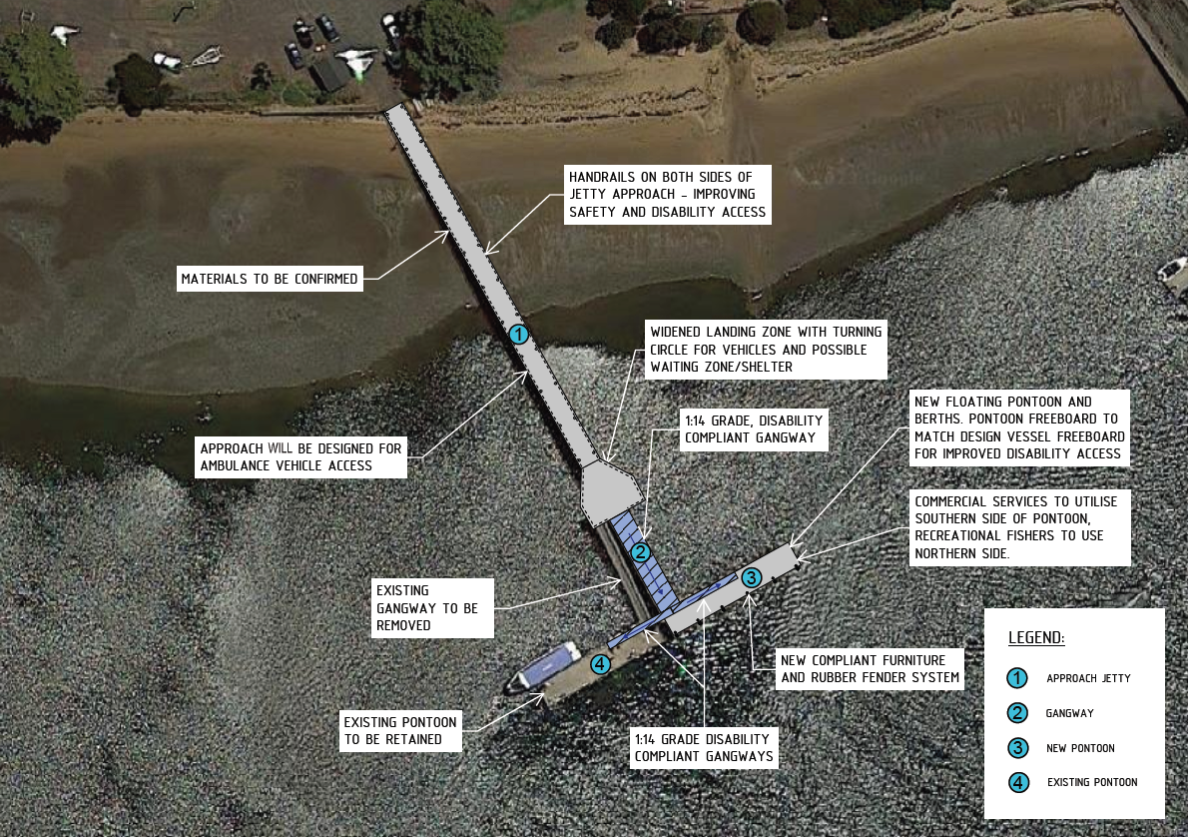
Figure 5: The preferred design solution for Rhyll Jetty (Source: FSC Range, 2024)

Table 2: How the proposed plan responds to the design criteria
Design criteria | Proposed plan
Ensure Rhyll Jetty continues to facilitate long-term berthing of LTO vessels and short-term berthing of recreational vessels and cruise ship tenders. | - Facilitates the specified berthing requirements.  - Recreational vessels will berth on the northern side of the new pontoon.  - Commercial vessels will berth on the southern side of the new pontoon, and the existing pontoon.
Reconstruction of the jetty on same alignment and length, ensuring size and layout of overall structure remain similar in scale to existing jetty to reflect identified site constraints. | - On the same alignment, with the same overall length and T-head length which responds to the identified site constraints.
Provide a wider section along the jetty approach to allow for crowd dispersal and reduce congestion. | A widened landing zone will reduce congestion and allow for crowd dispersal, particularly during the arrival/departure of cruise ship tenders.
Improve safety and accessibility on the jetty. | - Handrails on both sides of the jetty will improve safety, accessibility, and will result in greater pedestrian flow.  - A new 1:14 DDA compliant gangway will provide the main access to the T-head, and will be wider than the current gangway.  - Commercial and recreational activities using a floating berth will result in all-tide accessibility.  - The approach will be designed for ambulance vehicle access.
Improve functional performance across full tidal range, ensuring the structure is designed for the local wave climate. | The proposed new pontoon provides berthing and pedestrian access across the full tidal range, which the current fixed jetty head and low landing do not.

Next steps
Parks Victoria is seeking community and stakeholder feedback on this draft plan. Feedback will be used to prepare the final plan, which will include the final vision and layout of Rhyll Jetty. A consultation summary report will be developed and released with the final plan.
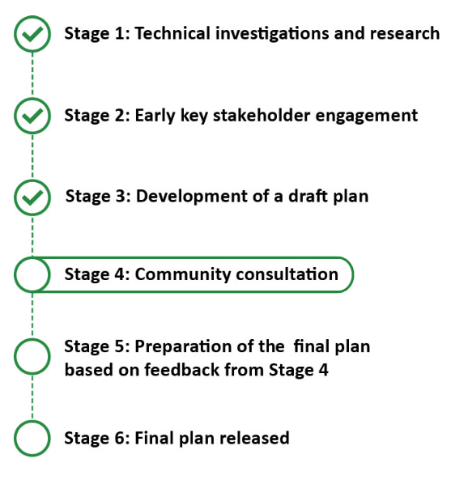

Figure 6 – Project schedule (Source: Parks Victoria, 2024)

References
Title | Author | Date
Marine and Coastal Act 2018 | Department of Energy, Environment and Climate Action | 2018
Marine and Coastal Policy 2020 | Department of Energy, Environment and Climate Action | 2020
Marine and Coastal Strategy 2022 | Department of Energy, Environment and Climate Action | 2022
Sustainable Local Ports Framework | Department of Transport | 2021
Bass Coast Shire Economic Impact of Cruise Ships | Urban Enterprise, for Bass Coast Shire Council | May 2023
Background Technical Report, Rhyll Jetty – Local Port Area Plan 2024 | FSC Range | March 2024

