Arthurs Seat State Park
  - Visitor Guide
Arthurs Seat is one of the most prominent and recognisable landmarks on the Mornington Peninsula. Reaching 314m above sea level, Arthurs Seat Park offers spectacular panoramic views and an opportunity to experience an abundance of native plants and animals. Popular activities include taking a ride on a gondola, bushwalking, jogging, mountain bike riding and picnicking at Seawinds Gardens.
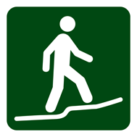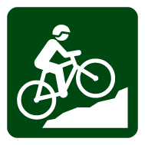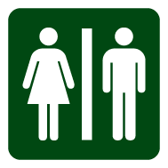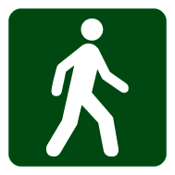
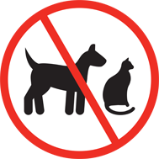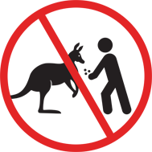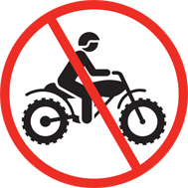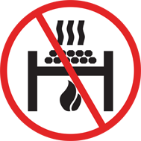

Getting there
Arthurs Seat State Park is located 60km south of Melbourne CBD on the Mornington Peninsula.
Access to the park from Melbourne is via the Mornington Peninsula Freeway and the Arthurs Seat Tourist Road. Seawinds Gardens is accessed via Purves Road ‒ a short distance from Arthurs Seat Summit.

Things to see and do

Seawinds Gardens
Located near Arthurs Seat Summit, Seawinds Gardens is a great location for a picnic or short walk. Spectacular views across Port
Phillip are available from the Bay and Northern Lookouts. Delightful exotic and indigenous gardens can be explored along a network of walking tracks which hide gems such as the William Ricketts sculptures.
In Spring, enjoy the colour as the trees and shrubs begin to flower in late August. Summer provides a cooler environment than the surrounding coast at 305m above sea level. Deciduous trees delight in Autumn, and the bare birch and willow branches contrast against the pine in Winter.

Arthurs Seat Summit
As the highest viewpoint on the Mornington Peninsula, the summit lookout provides magnificent views of Port Phillip. On a clear day, views stretch as far as the city skyline, the You Yangs and Mount Macedon. Access to the summit lookout is via car or gondola from the tourist road.

Walking
The park offers a variety of walking and jogging trails. The trails are located throughout the park and can be accesssed from major roads and carparks.

Summit Circuit Walk – 1.8km, 1 hour circuit
A great short walk suitable for most visitors, this loop guides visitors to major interest points including the Seawinds Gardens, Matthew Flinders Cairn, William Ricketts sculptures, lookouts and the Seawinds Nursery Volunteers Indigenous Garden.
The formed track is moderately difficult with some steps.

Kings Waterfall Circuit Walk – 1km, 1 hour return
This short walk begins from the Kings Falls carpark on Waterfall Gully Road. Stroll past grass trees, through casuarina forest and into damp fern-lined gullies. View the waterfall which can be seen flowing during the wetter parts of the year.
The formed track is moderately difficult with some steps and hills.

OT Dam Circuit Walk – 3km, 2 hours return
Best accessed from Arthurs Seat Road near Main Creek Road, this walk offers views of OT Dam. Located in a deep gully surrounded by native forest, it was originally constructed by the OT company to water their crops. Moderately difficult, formed track with hills.

TC McKeller Walk – 1km, 45 minutes circuit
This loop track starts from the Seawinds Gardens information shelter. The wide, shaded walking track showcases some of the best remnant vegetation in the park.
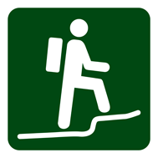 | Two Bays Walking Track – 26km, 8 to 10 hours one way
This scenic track enables people to walk from the Dromana foreshore on Port Phillip to Bushrangers Bay near Cape Schanck. The full trail can be undertaken by experienced walkers over two days.
Parts of the trail can be completed in smaller sections that intersect with roads. This formed track is moderately difficult, with some steps and hills. A Two Bays Walking Track fact sheet is available online at www.parks.vic.gov.au
For the even more adventurous, try the 100km Mornington Peninsula Walk which links a network of tracks across the Peninsula.

Mountain bike riding
The peaceful bushland and steep rocky terrain makes Arthurs Seat State Park an exciting mountain bike destination. The combination of single trail and management vehicle tracks provides opportunities for most skill levels.
Car parking for the trail network is available at several locations including near the OT Dam on Arthurs Seat Road, near the junction of Main Creek Road, Boundary Road, Dromana at Hill View Community Reserve, and at Seawinds Gardens. A separate mountain bike trail map is available online at www.parks.vic.gov.au

Arthurs Seat Eagle

For a bird's-eye view over Port Phillip climb aboard the all-weather Eagle, a state-of-the-art gondola which soars high above the trees. The Eagle caters to people of all abilities, the eldery and children. It is wheelchair and pram friendly. Food and coffee is available at the summit station.

Facilities
Electric barbecues and picnic tables are located at Arthurs Seat Summit and Seawinds Gardens. Public toilets and baby change facilities are located throughout the park at Seawinds Gardens, Arthurs Seat Summit and the gondola base station.
Please note – drinking water is not provided in Arthurs Seat State Park.

Accessibility
The public toilets at the gondola base station contain a Changing Places toilet, suitable for people with disablities and their carers. A key can obtained from the lower gondala office for access.
Several areas in the Seawinds and Summit precinct are accessible for all abilities.

Caring for the park
Help us look after Arthurs Seat State Park by remembering the following points:
- Dogs, cats, horses and motorbikes are not permitted in Arthurs Seat State Park.
- Heat beads are not permitted.
- Please take all your rubbish home with you.
- Do not feed the animals.

- Bicycles are not permitted on walking only tracks.
- Pedestrians are not permitted on cycling-only tracks.
- Firearms, fires and camping are not permitted.
- Snakes live in this park and sometimes sunbake on the paths. Do not approach.
Permits from Parks Victoria are required for the following activities:
- All events and professional entertainment.
- Weddings, including ceremonies, photography and receptions are by booking only and require a permit.
- All professional or commercial photography.
- Any drone activity .
- Any other commercial activity.

Be prepared and stay safe
For emergency assistance call Triple Zero (000). If there is a green emergency marker sign near you, read the information on the marker to the operator. Arthurs Seat State Park is in the Central fire district. Bushfire safety is a personal responsibility. Anyone entering parks and forests during the bushfire season needs to stay aware of forecast weather conditions. Check the Fire Danger Rating and for days of Total Fire Ban at emergency.vic.gov.au, on the VicEmergency smartphone app or call the VicEmergency Hotline on 1800 226 226. No fires may be lit on Total Fire Ban days.

On Catastrophic Fire Danger Rating days this park will be closed for public safety. Warnings signs may be erected, but do not expect a personal warning. Do not enter the Park. If you are already in the Park, leave the night before or as early as possible in the morning.
Check the latest conditions at parks.vic.gov.au or by calling 13 1963.

