Larni Yirrip Campground Guide
Bendigo Regional Park

Immerse yourself in Dja Dja Wurrung culture and Country at Larni Yirrip (Home of the Ironbarks) Campground in Bendigo Regional Park. This contemporary cultural space is designed around traditional Dja Dja Wurrung values with cultural landscaping and stories, and large gathering shelters with informal seating. The campground offers twelve bookable walk-in tent sites with fireplaces, picnic shelters and toilets among shady Box-Ironbark forest rich in wildlife.



Womindjika (Welcome)

Bendigo Regional Park is part of the traditional lands of the Djaara (Dja Dja Wurrung People) whose rights were recognised through a Recognition and Settlement Agreement with the State of Victoria in March 2013. The Dja Dja Wurrung People maintain a close and continuing connection to Djandak, their traditional Country.

Djandak is a cultural landscape that includes both tangible objects such as scarred trees, oven mounds, rock wells and stone artefact scatters; and intangible stories. Djandak is a living entity, which holds stories of creation and histories that cannot be erased.

Parks Victoria pays our respects to Dja Dja Wurrung Elders, past, present, and future, and asks visitors to do the same. Aboriginal artefacts are protected by law, and it is prohibited to disturb them in any way.

Getting here
Larni Yirrip Campground is located on the southern side of Bendigo, 145km north of Melbourne via the Calder Highway. Turn off the highway onto Furness St and take an immediate left onto Granter Street.
The campground entrance is just before the bridge over the Coliban Main Channel and Number 7 Park.
Vehicle access to and from the campground is restricted by a gate. Day visitors are welcome but should park at Number 7 Park (just over the bridge) and walk in.

Entry and exit gate
To enter and exit the campground by vehicle, booked campers need to enter a code via the keypad to the right of the gate. There will be a slight delay (approximately ten seconds) before the gate starts opening.
For your safety, wait for the gate to fully open before driving through, and only drive through one vehicle at a time. The gate will stop moving if the sensor is obstructed and will only continue opening when clear.
A unique code for the entry gate will be emailed to you the week before arrival. If you don’t it in time, call 13 1963 and provide details of your booking. If calling after hours or on a Sunday, hold the line to be put through to the after-hours service.
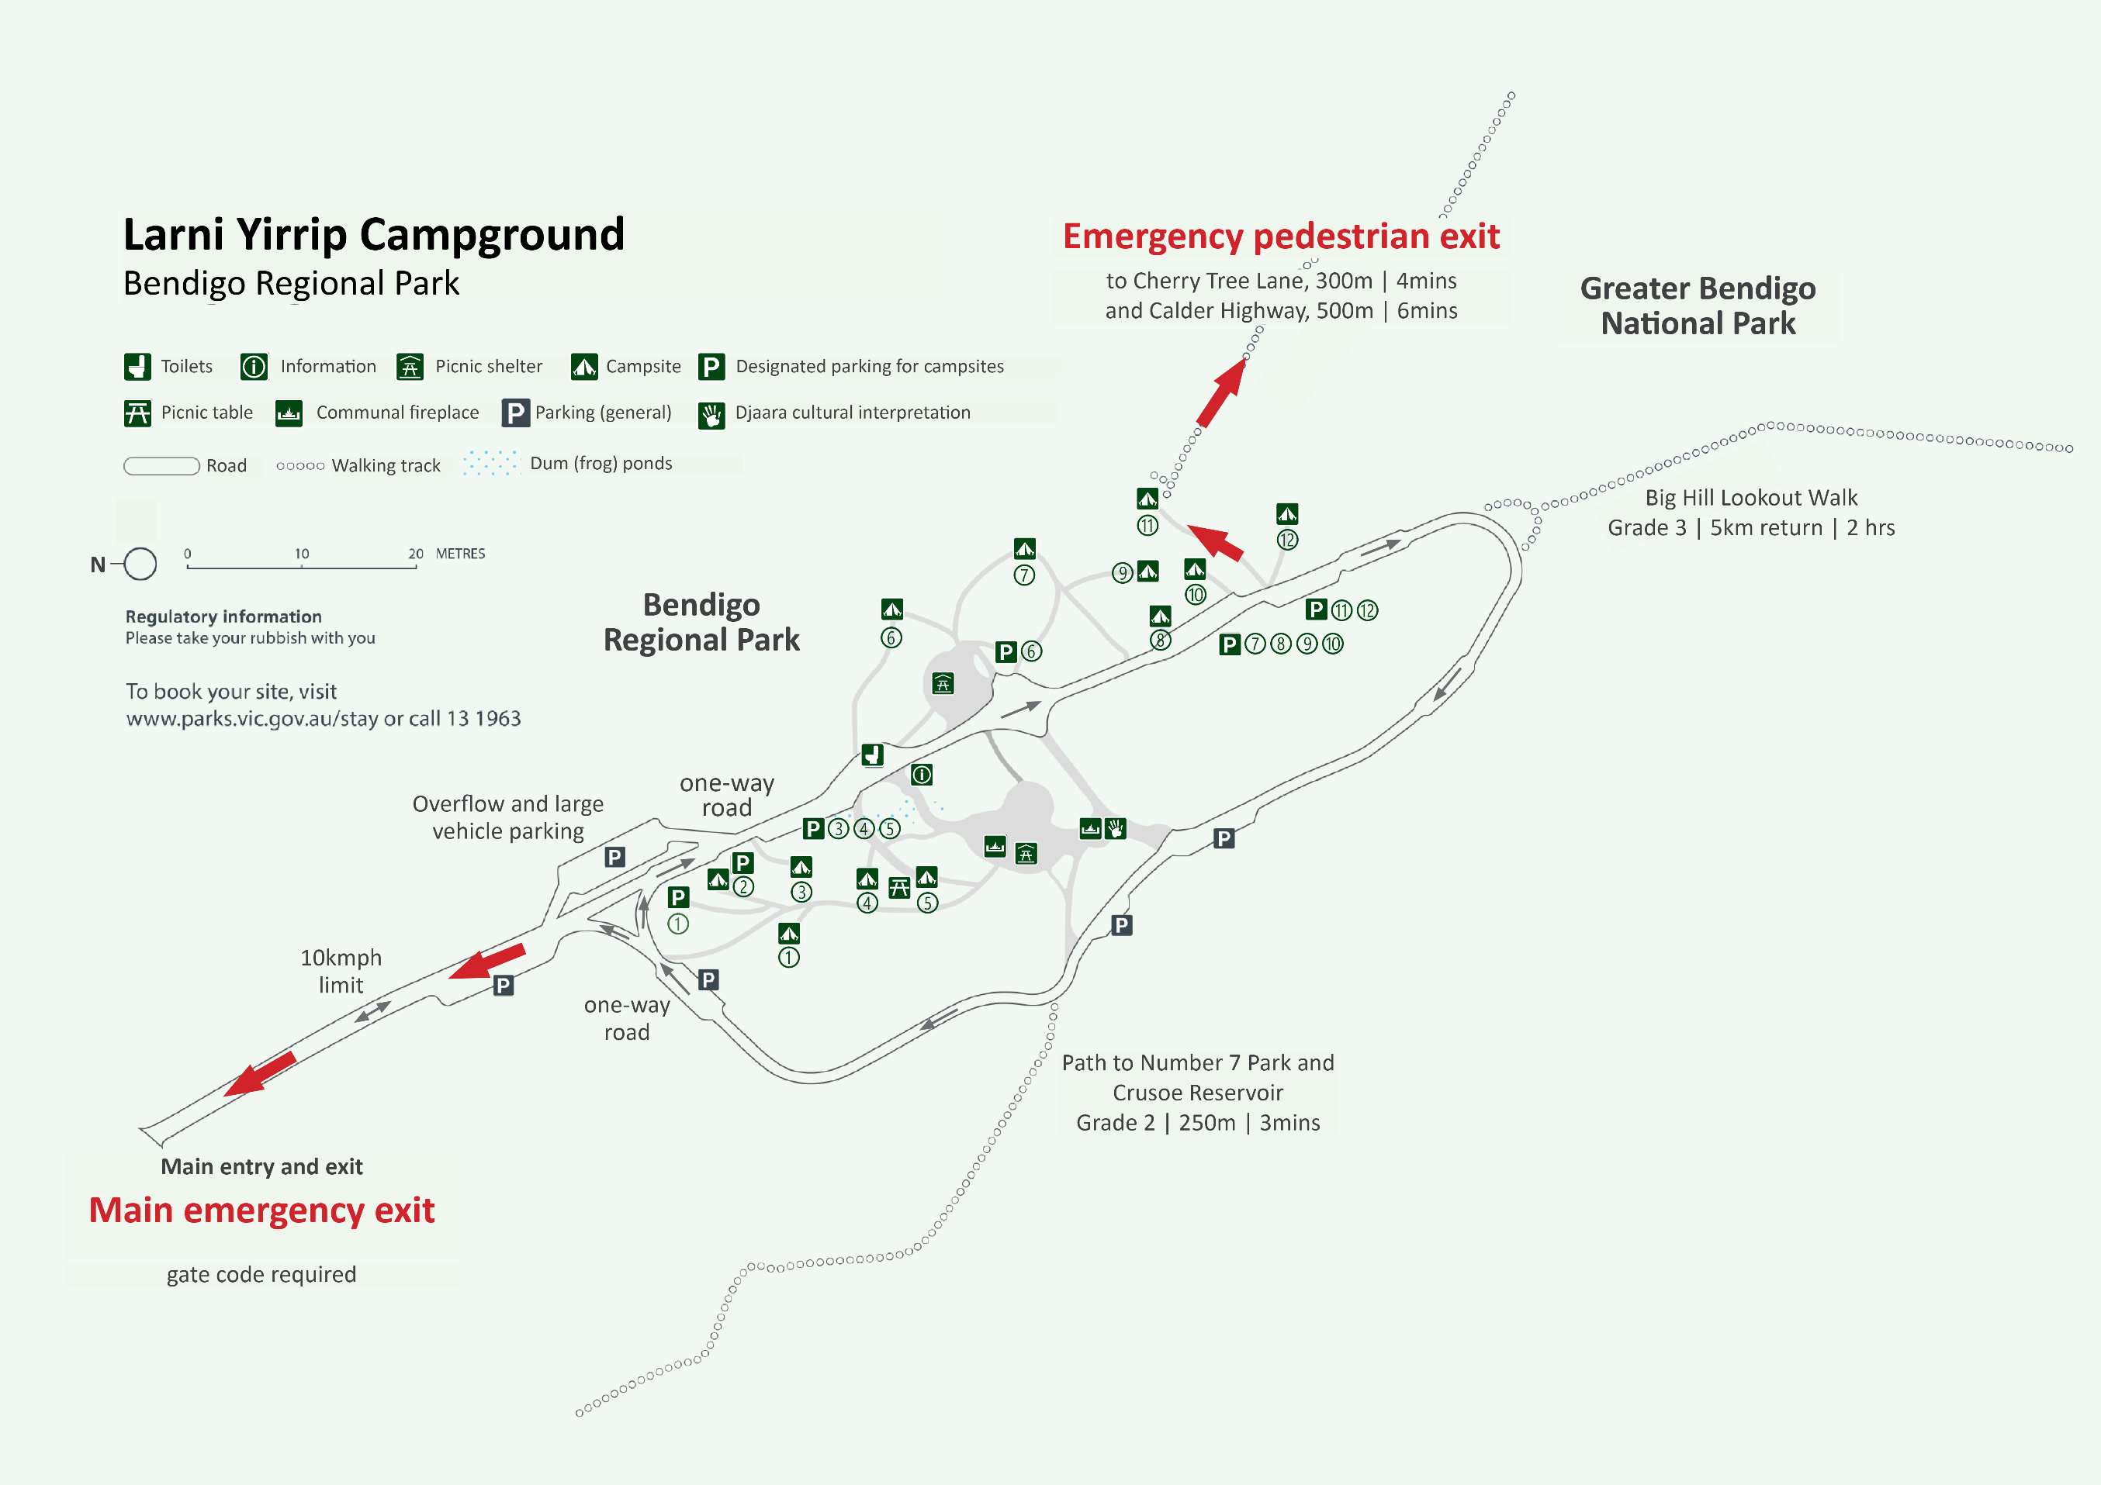

Campground facilities
Cultural and communal spaces
A welcome and ceremonial space introduces visitors to Dja Dja Wurrung culture through artwork, signs and storytelling.
A multi-use gathering space with informal seating and shelter has been designed around an amphitheatre of natural materials.
A communal cooking area features a large gathering shelter, seating and fire pit.
Gatjin (water) is held on site for the benefit of dum (frogs) through a series of small ponds that brings water and culturally important food and fibre plants back into the landscape. The water is not drinkable and swimming or entering the water is prohibited.
The picnic shelters and Dja Dja Wurrung artwork, signs and cultural spaces can be accessed via a very gently sloping gravel road and almost flat gravel paths. Temporary parking is also available near these features.
Toilets
The toilet block has four all-gender non-flushing toilets, two of which are fully accessible, and tank water for hand-washing only. There are no showers.
Campsites

There are twelve unpowered walk-in tent sites (with no caravan, trailer or motorhome access) in small clearings surrounded by shady Box-Ironbark forest. The tree canopy and healthy understory provide a natural shady bushland setting, rich in plants and wildlife.
Sites can accommodate more than one tent. Check the descriptions for the size of individual sites. A maximum of six people are permitted per site. All sites have their own fireplace (without cooking plates) in a cleared gravel area, and a designated parking bay suitable for a single car.
Five sites have raised wooden platforms (made from recycled materials):

Each platform has 17 tent tie-down points:

Seven sites have compacted gravel pads:

Campsite descriptions

Site ①

Raised circular wooden platform, 8m in diameter, with 17 tent tie-down points. 30m from designated parking bay via gravel path. Around 45m to toilet block.

Site ②
Wheelchair accessible circular wooden platform, 8m in diameter, with 17 tent tie-down points. 4m from designated parking bay with level gravel access onto the camping platform. 55m to toilet block (parking available) along gently sloping gravel road.
If you don’t require wheelchair or similar restricted mobility access, please leave this site available for those who do, unless all other sites are booked out. Alternative sites for campers with mobility challenges: 3, 8, 10.


Site ③
Circular compacted fine gravel surface, 6m in diameter. 10m from designated parking bay via gravel path. Around 30m to toilet block.
Not designed to be wheelchair accessible but may suit campers with mobility aids or prams.


Site ④
Raised circular wooden platform, 8m in diameter, with 17 tent tie-down points. 35m from designated parking bay via gravel path. Around 30m to toilet block. Picnic table shared with campsite 5.

Site ⑤
Circular compacted fine gravel surface, 7m in diameter. 35m from designated parking bay via gravel path. Around 30m to toilet block. Picnic table shared with campsite 4.

Site ⑥
Circular compacted fine gravel surface, 7m in diameter with slight slope – best suited to swags and small tents, and to campers travelling light. 45m from designated parking bay via gravel path. Around 70m to toilet block.
Set well back from the road, offering more seclusion.

Site ⑦
Circular compacted fine gravel surface, 7m in diameter. 60m from designated parking bay via gravel path. Around 90m to toilet block.
Set well back from the road, offering more seclusion. Best suited to campers travelling light.

Site ⑧
Circular compacted fine gravel surface, 7m in diameter. 20m from designated parking bay. Around 100m to toilet block along gently sloping gravel road. Not designed to be wheelchair accessible, but access to the site is directly from the road which may suit campers with mobility aids, prams or large amounts of camping gear.
The tent site is located behind the cleared gravel area around fireplace. Access is almost flat at the side closest to the toilets.

Site ⑨
Circular compacted fine gravel surface, 5m in diameter. 30m from designated parking bay via gravel path. Around 110m to toilet block.

Site ⑩
Raised circular wooden platform, 8m in diameter, with 17 tent tie-down points. 20m from designated parking bay via gravel path. Around 120m to toilet block.
Not designed to be wheelchair accessible but may suit campers with mobility aids or prams.

Site ⑪
Circular compacted fine gravel surface, 5m in diameter. 65m from designated parking bay via gravel path. Around 150m to toilet block.
Set well back from the road, offering more seclusion. Best suited to campers travelling light.

Site ⑫
Circular compacted fine gravel surface, 5m in diameter. 40m from designated parking bay via gravel path. Around 150m to toilet block.

Is the campground always open?
Larni Yirrip is open for booked camping all year round, with 24-hour gate access for campers. The space may sometimes be used for community gatherings, Junior Ranger activities, or cultural tours. Campers will be informed if parts of the campground or communal facilities are closed for Djaara cultural events.

Can I have a campfire?

Yes. Every campsite has a firepit. Please light fires only in the pits provided, and ensure that:
- the three-metre gravel area around your pit is kept clear of anything flammable
- an adult is in attendance (awake, within 50m and with a clear line of sight) at all times
- you have at least 10 litres of water available for immediate use
- put your fire out with water, not soil. It is only safe to leave when it is cool to touch.
No fires may be lit on a day of Total Fire Ban, including campfires, solid and fuel barbecues and ovens. Portable gas or electric camping stoves and barbecues may be used, provided they meet the first three criteria above. Larni Yirrip is in the Northern Country Fire District.

Can I collect firewood?
Firewood collection is prohibited in the campsite and surrounding parks. Please bring your own coals or firewood. Both can be purchased from service stations and hardware stores in nearby Kangaroo Flat.

Where can I park additional or large vehicles?


If you are travelling with more than one car or a large vehicle, please park it in the overflow parking area after unloading.

Can I bring a dog or other animals?
Dogs, cats, horses and other domestic animals are not permitted in the campground, apart from registered service animals.

Can I bring a bicycle?
 | Yes. Bicycles can be ridden:  - on the access road through the campground  - on the shared use paths around Number 7 Park and Crusoe Reservoir  - on formed open roads in Greater Bendigo National Park and Bendigo Regional Park.  Please go slow, watch out for pedestrians, follow the one way system and abide by all road signs.
 | Bicycles must not be ridden on walking tracks within the campground or in Greater Bendigo National Park.  Please dismount on all walking tracks between campsites and other facilities.

Is drinking water available?
No. The toilets have rainwater tanks for hand-washing only. Please bring all the water you need for drinking, cooking, washing and extinguishing your campfire.

Where can I get supplies?

The Lansell Plaza shopping precinct and the shops, pharmacies and medical facilities of Kangaroo Flat are only 5-10 minutes away by car. You purchase fuel, food, water, firewood, coals and anything else you need. There’s also a wide range of cafés, hotels and restaurants in Kangaroo Flat and Bendigo.

What should I do with my waste?

No bins are provided. Take all rubbish away with you for recycling and disposal. Please do not feed wildlife – it can change an animal’s behaviour and harm its health.
Do not burn rubbish, including food scraps, in your campfire, or throw it into the toilets. This may result in us having to close facilities.
There is a container deposit machine for bottles and cans located beside Lansell Plaza between the main shopping precinct and Bunnings.

Things to do nearby


Larni Yirrip is adjacent to the Crusoe Reservoir and Number 7 Park which are popular for walking, jogging, cycling and birdwatching. Both are managed by the City of Greater Bendigo and camping is not permitted.
Swimming, fishing, and non-powered water sports are permitted in Crusoe Reservoir.
Larni Yirrip is also adjacent to Greater Bendigo National Park which offers nature-based activities including bushwalking, birdwatching and cycling (on mapped roads only).

From late winter through spring, the parks are full of wildflowers. You can learn about some of the birds and plants you might see from the information boards at Number 7 Park. All native plants and animals are protected by law. Please leave the parks as you find them.

If you need a break from the weather, the art galleries, theatres, cinemas, shops, cafés and restaurants of Bendigo are only 20 minutes by car. Visit the Bendigo Visitor Information Centre, 51-67 Pall Mall, Bendigo or call 1800 813 153 to learn more about what to do in the area.

Bushwalking

Larni Yirrip is connected to the following walks. Wear sturdy footwear, clothing appropriate for the season, and carry plenty of water.
 | Big Hill Lookout Walk  Grade 3, 5km return, 2hrs, gravel track with moderate hills.  This walk follows a management vehicle track through Greater Bendigo National Park, up to a scenic viewpoint along the Big Hill Range. Some bush-walking experience recommended.
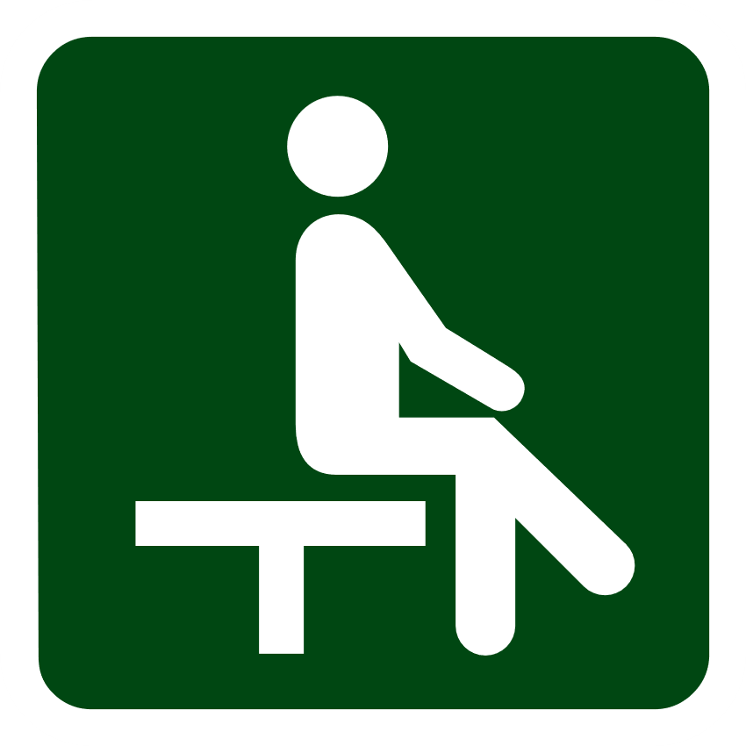 | Number 7 Park Circuit Walk  Grade 2, 1.4km circuit, 45mins, gravel and earth path, slight hills.  This short walk starts at the Number 7 information shelter. It skirts the edge of the reservoir, passing through shady forest rich in birds and wildflowers and goldrush features. There are seats at frequent intervals.
Number 7 and Crusoe Reservoir Circuit Walk
Grade 2, 6.1km circuit, 2hrs, gravel and earth path, slight hills.
This long but leisurely walk starts at the Number 7 information shelter and combines the circuit walks around both reservoirs. Look for wildflowers, birds and other wildlife, including the mouse-like Yellow-footed Antechinus and Eastern Grey Kangaroos. There are seats at frequent intervals.

When to visit

Spring

The Box-Ironbark forest around Larni Yirrip puts on a fantastic display of wildflowers from late winter to early summer. It is a beautiful time for bushwalking, birdwatching and photography.

Summer

Enjoy bushwalking in the early morning or late afternoon, and spend the heat of midday relaxing at your campsite, swimming at Crusoe Reservoir or in one of Bendigo’s many galleries or cafés.

Autumn

This is a great time of year to explore the local walking tracks. Keep an eye out for migratory birds, and fungi on the forest floor and tree trunks. Be prepared for changing weather.

Winter

Long nights offer more hours to cosy up around a campfire under the stars or look for nocturnal wildlife. The forest is very photogenic on foggy or frosty mornings. Wattles begin to flower.

Be prepared and stay safe

- When driving around Larni Yirrip, please follow the one way system, drive under 10kmph and look out for walkers.
- Take care when using or crossing the access road on foot and watch out for vehicles.
- The dum (frog ponds) are unfenced and young children should be supervised nearby at all times. Entry to the ponds and use of the water is prohibited.
- Watch out for snakes, especially in warmer weather. Be aware that snakes and other animals may seek shelter under the raised camping pads.
- Do not park, sit or camp under large trees with overhanging branches. Branches may fall at any time and swing away from the trunk.

Emergencies
For emergency assistance call Triple Zero (000). If there is a green emergency marker sign near you, read the information on the marker to the operator.
Larni Yirrip is in the Northern Country Fire District. Bushfire safety is a personal responsibility. Anyone entering parks and forests during the bushfire season needs to stay aware of forecast weather conditions.
Check the Fire Danger Rating and for days of Total Fire Ban at emergency.vic.gov.au, on the VicEmergency smartphone app or call the VicEmergency Hotline on 1800 226 226. No fires may be lit on Total Fire Ban days.
On Extreme and Catastrophic Fire Danger Rating days the campground will be closed for public safety. Do not enter the campground. If you are already in the campground, leave the night before or before 10am in the morning.
You may not receive a personal warning or see signs indicating that the campground is closed. Check for closures and the latest conditions at parks.vic.gov.au or by calling 13 1963.
Evacuation
There is no safe place to shelter at Larni Yirrip.
If a bushfire starts in or near the campground, evacuate via the main vehicle exit or the emergency pedestrian exit before calling 000.
Following the walking track past campsite 11 leads you to Cherry Tree Lane (Grade 2 | 300m | 4min) and the Calder Highway (500m | 6min).

Updated April 2026

BLANL PAGE

