Day’s Mill is listed on the Victorian Heritage Register and is classified by the National Trust. The Historic Buildings Council purchased the property in 1986 to develop a museum of farming and flour milling and it is now managed by Parks Victoria.
Day’s Mill & Farm

A beautifully preserved 19th Century flour mill
Day’s Mill and Farm is the best preserved 19th century flour mill in Victoria and contains one of the finest examples of traditional milling technology in working form in its original setting in Australia. The property consists of the mill, a house and several farm buildings on four hectares of land south of Murchison in the Goulburn Valley, 150 km north of Melbourne.
Parks Victoria
Phone 13 1963
www.parks.vic.gov.au
Day’s Mill offers visitors a unique glimpse into the past in an authentic rural setting, and the opportunity to learn about the operation of the property and the family that lived and worked here for four generations.

The Day family
In the late 1830s and 1840s this area of the Goulburn Valley was newly occupied by squatters. The squatters did not have freehold possession but held Crown Land on annual licenses from the Government to establish sheep runs. They had little demand for labour, except at shearing time, so there were no permanent settlements beyond a few hamlets which sprang up at river crossings like Murchison. In the late 1850s, when alluvial gold became less easily won, new arrivals began calling for the unlocking of land from the squatters.
William and Ann Day, from Kent in southern England, arrived in 1852 at the height of the gold rush. Not interested in life on the diggings, William established himself as a carter while Ann set up a store and garden on Noorilim Station on the other side of the Goulburn River to Days Mill. They sold vegetables, meat and other produce to the gold diggers. The proceeds allowed them to buy 260 acres within the Parish of Noorilim in 1863.
William Day took advantage of the 1865 Land Act to purchase a further 420 acres in the Parish of Murchison and established a two-storey flour mill, now known as Day’s Mill, astutely realising that the Act would greatly increase agriculture in his locality. True entrepreneurs, William and Anne also operated a bush sawmill and a punt over the Goulburn River, and Ann ran a local store.
William died tragically in 1872, leaving Ann to support seven children, aged 5 to 19 with an estate of over £5,000. From 1872 until 1891 the farm and mill was run by Ann Day. Historical accounts suggest it was one of the most advanced properties in the district, and indicate that Ann ran a successful business in the male-dominated Victorian business world of the time.
Although the farm was highly successful, the mill ceased commercial operation in the 1880s. This was not due to bad management, but because traditional mill stones were not suitable for the hard grains of Australia. Changing over to new iron roller mills, developed in the 1870s, was expensive and beyond the means of many country millers. The Day family did not adopt this new technology and sometime in the late 1880s they stopped milling flour.

Ann retired in 1891. Her oldest son Joseph, took over management of the mill and farm until he passed away in 1919. Joseph operated the property solely as a farm, although the mill was used to occasionally grind chicken feed for his neighbours. Day family descendants continued to run the farm until it was purchased by the government in 1986.

The house
It is not known for certain when the house was built, but according to members of the Day family the kitchen area dates from about 1865, the same time as the mill, while the two-storey house was added later. The two-story cast iron veranda was another later addition. The inside walls have hand-painted stencils and marbling that were commissioned by Joseph Day in 1910 at a cost of £28 plus board and lodgings for the painter.
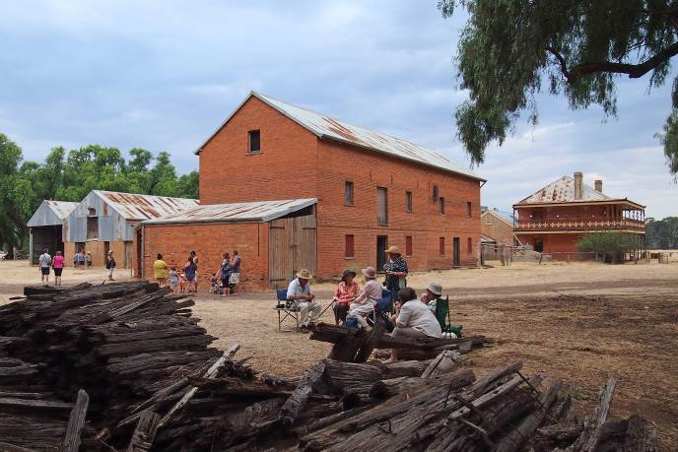
Day’s Mill with the house in the background (photograph by Chris Smith).

Outbuildings
The mill and house dominate the site but there are many fascinating outbuildings to explore as well, including a milking shed, stables, shearing shed, diary, butchery and a piggery. Consistent use of materials and style in the brick buildings, including the gate house, chaff shed and blacksmiths complex, suggests that they date back to when the mill was operating (1865 to late 1880s), while the other timber and iron buildings were probably constructed or extended later.

Conservation

With the support of volunteers, members of the Day family, and other government agencies, a range of conservation and maintenance works have been undertaken to the various buildings on the site over the years. Funding from the Victorian Government’s Living Heritage Grant Program has enabled a significant range of conservation works to the Gatehouse and Residence buildings, including reconstruction and repair works to the roof, brickwork, windows, chimney, and Pulley House, to be undertaken in 2018.
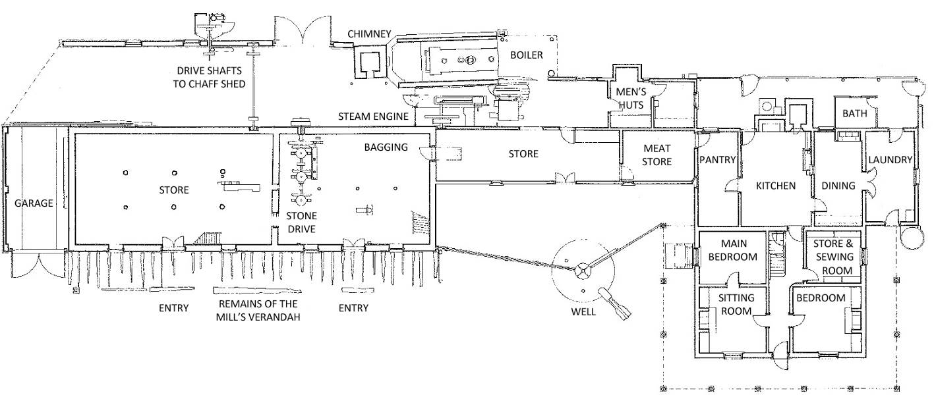
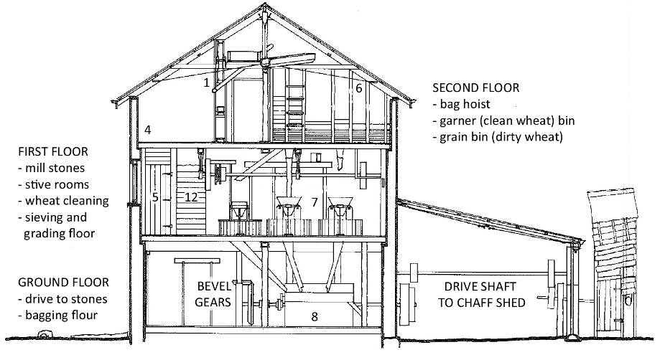
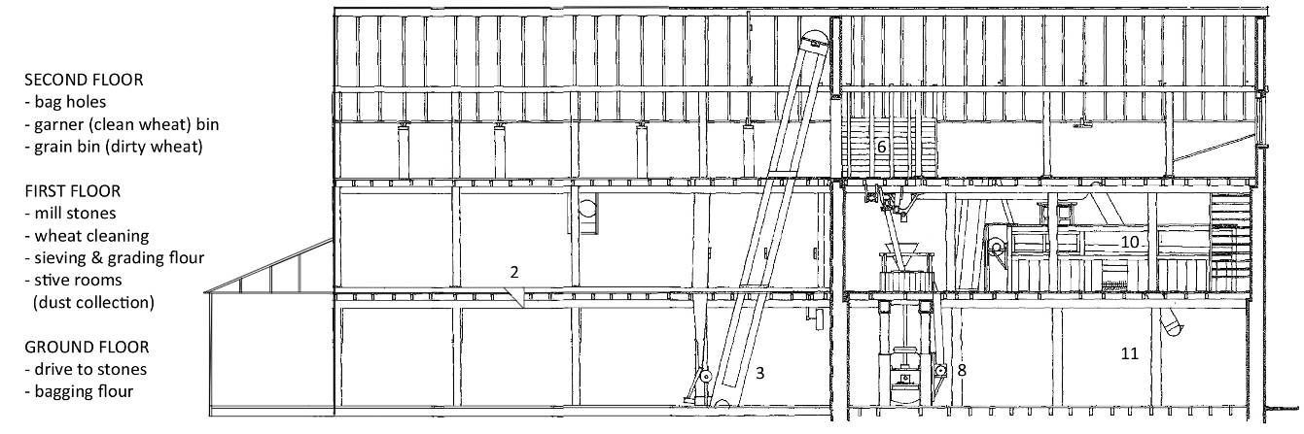
Ground floor plan of the mill and house
Cross section of the mill
Longitudinal section of the mill

The milling process
Milling flour was a complex process with many steps involved. The numbers in the description of the milling process correspond to the numbers in the line drawings, and will help you locate where in the mill the different steps of the process took place.
- Sacks of wheat were loaded off wagons, brought in through the front doors and raised to the first floor by a bag hoist (1).
- Bags were tipped into a hopper (2) to be raised by an elevator (3) to the top floor grain (dirty wheat) bin (4).
- Grain was cleaned on the first floor by an oscillating sieve; a vertical thresher and a leg aspirator (5).
- An elevator raised the grain back up to the garner (clean wheat) bin (6) on the top floor from where it was fed down to the mill

stones (7) on the first floor.
- Wholemeal from the stones fell to the horizontal screw conveyer (8) on the ground floor which moved it across to another elevator (9) to be moved back up to the first floor.
- The hexagonal bolting reel (10) on the first floor sieved out the white flour from the bran.
- Flour and bran were bagged off on the ground floor (11).
- Fine dust, known as ‘stive’, from the stones and cleaning equipment was extracted by fans and collected in the stive rooms (12).
- All these operations were driven by the steam engine with its Cornish boiler which can be seen on the north side of the mill (13).

Acknowledgements
The text and drawings in this factsheet were adapted from the Day’s Mill and Farm brochure produced by the Friends of Day’s Mill in 1995 and the Day’s Mill and Farm Summer School Report, prepared by the Historic Places Section of the former Department of Conservation and Environment.

Friends Group
Parks Victoria is looking to re-establish a Friends of Day’s Mill Group to be involved with the preservation and maintenance of the mill. If you would like to get involved, please contact Parks Victoria on 13 1963.

