Grampians National Park
  - Visitor Guide
Grampians National Park is Victoria’s fourth largest national park. The park is in an area known as Gariwerd and is listed on Australia’s National Heritage List for its Aboriginal cultural heritage, fauna and flora diversity, landscapes, and protection of threatened species. The park is well known and popular for its scenery and outdoor activities such as hiking, car touring, camping, rock climbing and wildlife viewing.
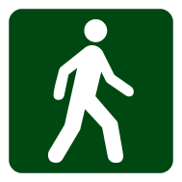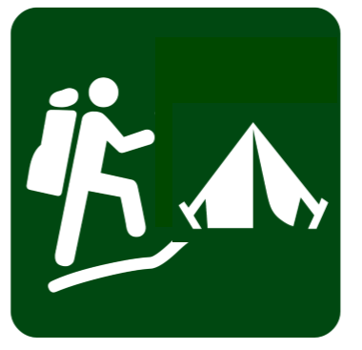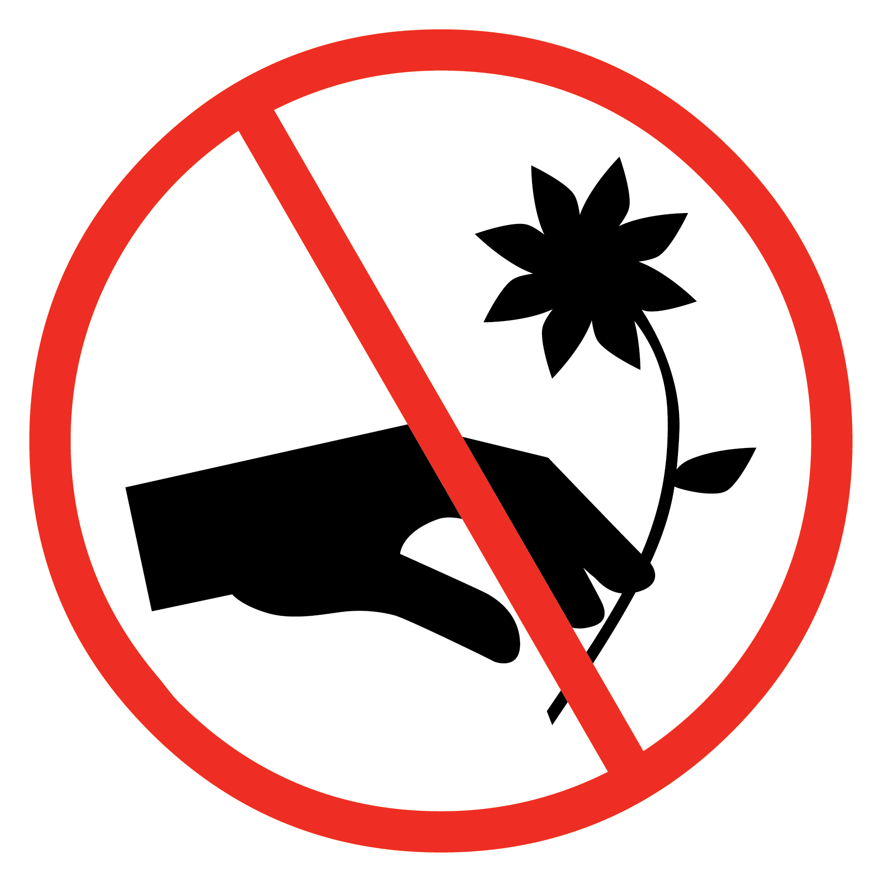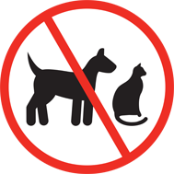

Getting there
The park is located in Western Victoria, a three-hour (260km) drive from Melbourne and a five-hour (460km) drive from Adelaide. It is easily accessed from the villages of Halls Gap, Wartook and Dunkeld and a scenic day trip from the regional towns of Hamilton, Horsham, Stawell and Ararat. It is also a key destination on the internationally renowned Great Southern Touring Route.

Brambuk – The National Park and Cultural Centre
Start your visit at Brambuk NPCC in Halls Gap where you will find the latest park information, maps and guidebooks. Immerse yourself in the cultural heritage of Gariwerd through interpretive displays, the Dreaming Theatre, the bushfoods cafe and cultural activities.
From July 2020 – the Centre is closed for upgrades. For park information call (03) 8427 2258, or visit www.parks.vic.gov.au

When to visit
Recreational activities such as car touring, short walks and camping can be enjoyed throughout the park during any season.
Autumn offers mild temperatures and generally stable weather, it is popular for camping, bushwalking, rock climbing and cycling.
Winter is cool and wet and popular for seasonal waterfalls, bushwalking and winter camping.
Spring is variable with mild to warm temperatures. Popular for wildflowers, camping, bushwalking, rock climbing and cycling.
Summer is usually hot and dry. Start activities early when it is cooler and avoid remote areas of the park during hot weather.

Things to see and do
At 168,241ha in size the park has plenty to offer. There are three main visitor areas: Northern, Central and Southern Grampians and each distinctive area has a range of different activities.

Day trips, picnics and car touring
The Central Grampians offers the best selection of 2WD car touring, short walks, lookouts, waterfalls and picnic areas. Other car touring options are available across a large network of unsealed roads and tracks, with four-wheel drive vehicles required for some areas.
The Grampians Road and Touring Map covers car touring and is an essential tool to help plan your route. The Grampians Iconic 4WD brochure details a popular easy-medium route.
Check the latest access conditions by downloading the park’s road report from www.parks.vic.gov.au

Bushwalking
The park is well-known for it’s variety of bushwalking opportunities.
Central Grampians: dominated by the Wonderland Range, Mt Victory Road and the Mackenzie River (Zumstein), has the most day walks, including the Pinnacle, the Balconies and Mackenzie Falls.

Northern Grampians: the Mt Difficult Range and the
Mt Stapylton areas include easy walks to Aboriginal rock art sites and more difficult day walks to several exposed mountain peaks.
Southern Grampians: is spread across Mt William, Serra and Victoria Ranges. This expansive area offers rugged and remote bushwalks, and short walks to view Aboriginal rock shelters.
Planning information for four multi-day walks, including stage one of the Grampians Peaks Trail, bushwalking guides and an All-Abilities Walking Track and TrailRider Guide are available for download at www.parks.vic.gov.au or as hardcopies from Brambuk.
To increase accessibility, TrailRider all terrain wheelchairs for people with limited mobility are available for free hire from Brambuk NPCC.

Camping
The park has 12 vehicle based campgrounds. Book your campsite before you arrive at www.parks.vic.gov.au, call 13 1963 or visit Brambuk NPCC in Halls Gap. Campgrounds with no fees operate on a first-in first-served basis and cannot be booked in advance.
Campground |  |  | 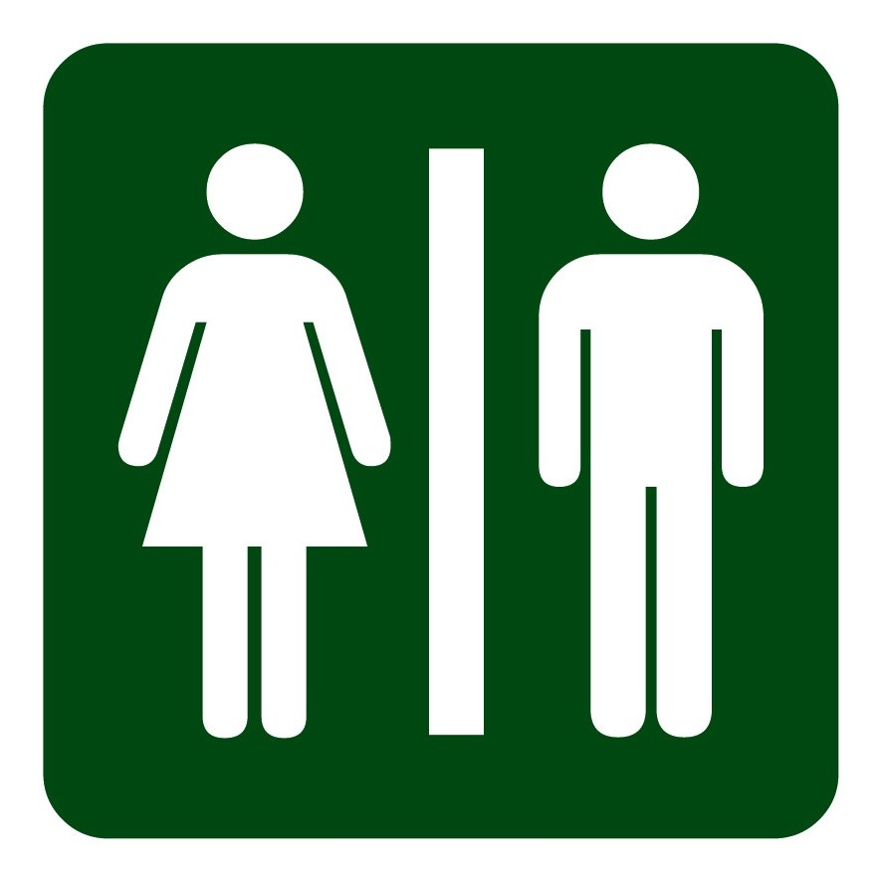 |  |  | 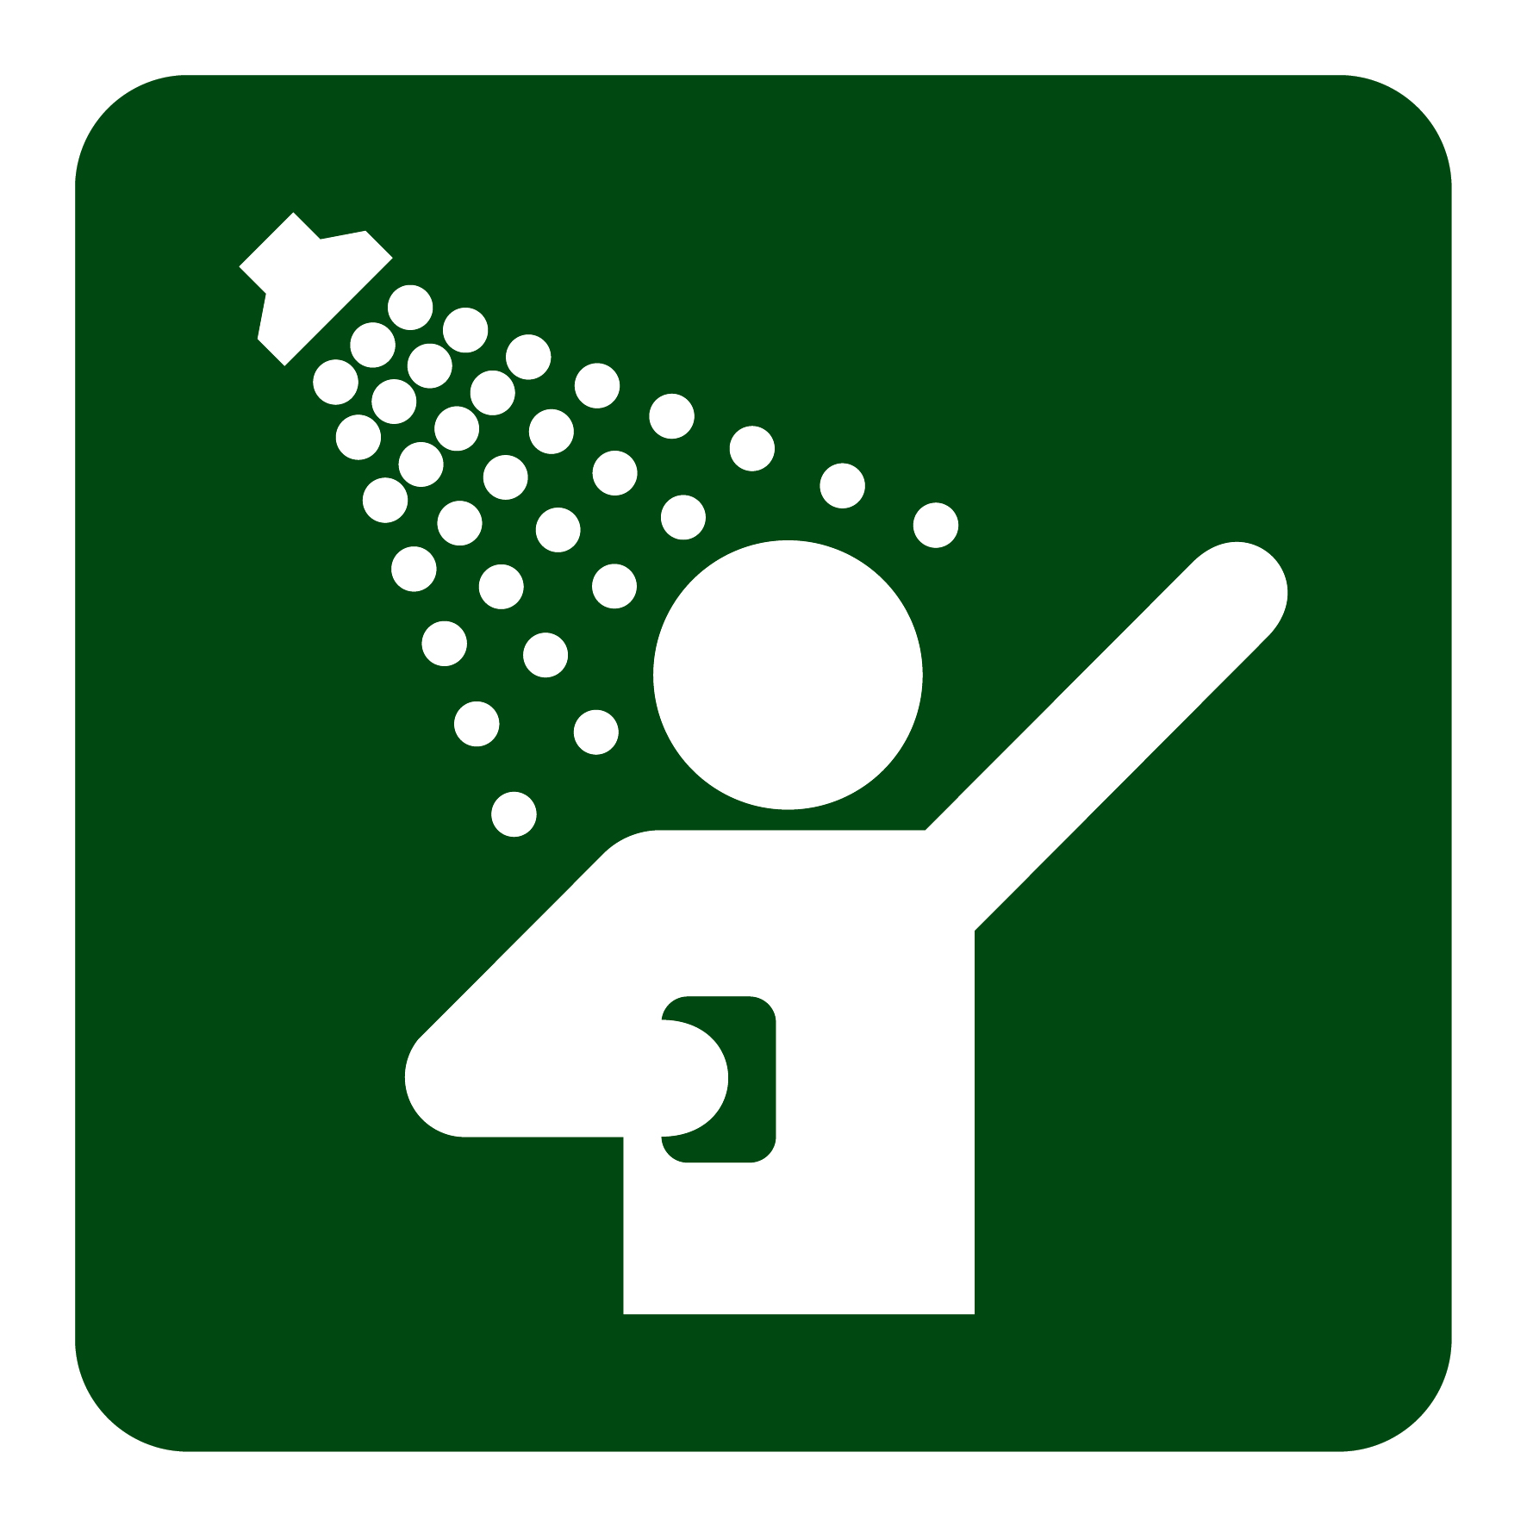 | $
Boreang  Secluded, unsealed access | 12 | 11
Borough Huts  Popular, sealed access | 30 | 5
Buandik  Rock art, unsealed access | 13 | 4
Coppermine  4wd access only | 0 | 4
Jimmy Creek  Popular, sealed access | 13 | 8
Kalymna  Secluded, unsealed access | 5 | 0
Smiths Mill  Central, sealed access | 22 | 11
Stapylton  Popular, unsealed access | 11 | 6
Strachans  Secluded, unsealed access | 8 | 0
Troopers Creek  Variety of sites, sealed access | 9 | 4
Wannon Crossing  Small, sealed access | 6 | 1
Plantation*  State Forest, unsealed access | 20 | 30
*Dogs on-lead are permitted at Plantation and in state forest areas.
Dispersed or bush camping is not permitted inside the hatched areas displayed on the park map. While bush camping, remember:
- Campfires are not permitted – fuel stoves only
- Only bush camp in previously cleared areas
- Leave no trace of your visit – take all rubbish home with you
- Camp at least 25m from waterways and 1km from campgrounds.

Cycling
Road cyclists will find classic climbs to destinations such as Mt William Carpark, Boroka and Reed Lookouts. Mountain bikers can explore the parks open public unsealed roads and 4WD tracks.

Rock climbing, abseiling and bouldering
The Grampians National Park is an internationally known climbing destination. Licensed tour operators organise trips, training and skill development. No-impact climbing is permitted in many areas of the national park, though is not permitted in Special Protection Areas (see website for details). Stay on designated walking tracks and do not damage vegetation. The installation of new bolts or fixed protection is prohibited in order to protect, cultural, geological and ecological values. Climbers must adhere to all National Park regulations. Observe signage where climbing is not permitted.

Water-based activities
Fishing, boating and swimming occur at Lake Wartook, Lake Bellfield and Moora Moora Reservoir. Visit www.gwmwater.org.au for more information. Swimming is not permitted at Mackenzie Falls.
Please take care as inland waterways, including rivers, creeks, lakes and dams, while popular for water recreation have hidden dangers, such as submerged objects, debris, slippery rocks, flooding and strong currents. Visit www.watersafety.vic.gov.au for information.

Photography, filming and events
There are many spectacular views and excellent opportunities for photography. For your safety and to protect the environment please stay on tracks and lookouts. Do not climb over barriers.
For information on planning events such as weddings and undertaking commercial photography or filming in the park, call 13 1963 or visit www.parks.vic.gov.au
A permit is required to use a drone in national parks as
their use often impacts on wildlife and park visitors.

Environment, culture and heritage

Aboriginal cultural heritage
The park is in an area known as Gariwerd and is in the traditional lands of Aboriginal people with cultural history dating back at least 22,000 years. This landscape tells their story and protects cultural sites including over 80% of all rock art found in Victoria. Five rock shelters are open to public viewing; Ngamadjidj, Gulgurn Manja, Billimina, Manja and Bunjils Shelter (Black Range Reserve near Stawell). Begin your cultural journey at Brambuk NPCC.

Post settlement
The Grampians was named after the Grampian Mountains in Scotland by Major Thomas Mitchell on his 1836 expedition through western Victoria. Since this time the area has seen much change, particularly through industries such as forestry, stone quarrying, gold mining and water harvesting. The park has historically had dams and pipelines constructed for regional water supply.
People have been drawn here for thousands of years and tourism established its roots in the early 1900s. More than 1.3 million people from all over the world visit the park annually.

Geology
The sandstone ranges of the Grampians began forming approximately 430 million years ago as sediment deposited on the sea floor. Geological processes of pressure, heat, folding, faulting and erosion continue to shape the mountain ranges appearance. This geology is fundamental to soil composition, and has had direct impact on the flora found within the national park.

Wildlife
The park provides habitat for at least 230 bird, 40 mammal, 30 reptile, 11 amphibian and 6 native fish species. 50 species in the park are classified as threatened, including Brush-tailed Rock Wallabies, Smokey Mice and Powerful Owls. Halls Gap and Fyans Valley are one area to see Eastern-grey Kangaroos, Emus and to hear kookaburras at dawn and dusk.

Plants
The park protects one third of Victoria’s flora species and is the most important botanical reserve in the state. Close to 970 native species occur and over 40 are found nowhere else in the world. The area is known for its colourful spring wildflower displays and popular walks include Heatherlie area, Sundial Peak, The Piccaninny and Mt Zero.

Caring for the national park
- Please take all rubbish with you and leave no trace of your visit - there is no rubbish collection in the national park
- Keep wildlife wild – do not feed the native wildlife
- Dogs and domestic pets are not permitted in the park
- Campfires are only permitted in the steel fireplaces provided
- Campfires are not permitted while bush camping – use fuel stoves
- Generators, chainsaws and firearms are not permitted.

Be prepared and stay safe

In an emergency dial 000 for police, ambulance or fire.

Important things to know
The park has many remote areas, plan wisely before your visit:

- Mobile phone service does not exist in many areas, you may get emergency phone coverage at high elevations
- Drinking water is not provided – bring plenty of your own
- Creekwaters dry up and should not be relied on
- Drive carefully on roads, wildlife regularly cross without warning
- Walking tracks, roads and visitor sites may be closed due to fire damage, seasonal storms or maintenance.

Be fire ready
Bushfires can occur during the warmer months. It is your responsiblity to check current and forecast weather conditions.
The park is located in the Wimmera and South West fire districts.
Campfires cannot be lit on days of Total Fire Ban, however gas cookers (fuel stoves) can be used for preparing food. On Code Red days this park will be closed for public safety. Closure signs will be erected, but do not expect an official warning from park rangers.
For emergency updates and fire information call 1800 226 226, listen to local radio (94.1FM, 89.3FM, 91.7FM or 594AM), download the VicEmergency phone app or visit www.emergency.vic.gov.au
For park conditions visit www.parks.vic.gov.au or call us on 13 1963.

Further information
Visit the Grampians National Park page on www.parks.vic.gov.au for further information on activities, the environment, culture and heritage and park management.
Grampians Tourism and local Visitor Information Centres (V.I.C.s.) can assist with accomodation, dining, tours, activities, festivals and events and a range of experiences just outside the national park. Visit www.visitgrampians.com.au
Ararat V.I.C. | 1800 657 158 | or | 03 5355 0281
Halls Gap V.I.C. | 1800 065 599 | or | 03 5361 4444
Hamilton V.I.C. | 1800 807 056 | or | 03 5572 3746
Horsham V.I.C. | 1800 633 218 | or | 03 5382 1832
Stawell V.I.C. | 1800 330 080 | or | 03 5355 0281
Dunkeld V.I.C. | 03 5577 2558

Other parks nearby
There are a number of other parks in the Grampians region that offer camping and other park-based activites including Arapiles-Tooan State Park, Black Range State Park, Budj Bim National Park, Little Desert National Park, Mt Buangor State Park, Mt Langi Ghiran State Park. Visit www.parks.vic.gov.au for information.

