Lake Tyers State Park
Krautungalung Country
  - Visitor Guide
Lake Tyers State Park covers 7,100 hectares, extending from Lake Tyers Beach to Mount Nowa Nowa. The park offers opportunities for low impact bush camping in a natural environment, with fishing in the lake and on the Ninety Mile Beach. Lake Tyers also offers several areas for picnics, beautiful bush walks and forest drives.
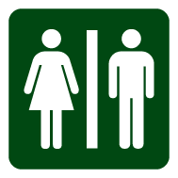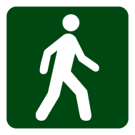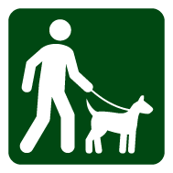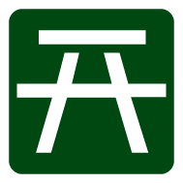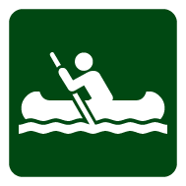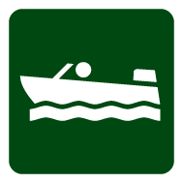

Welcome to Country
The Gunaikurnai people are the Traditional Owners of the Country featured in this visitor guide.
Through a new way of managing public land called Joint Management, the State has created an equal partnership with the Gunaikurnai people. The benefits of this partnership are many and include: the knowledge and culture of traditional owners incorporated into natural resources (land) management, cultural awareness and knowledge of local history, improved park management through knowledge-sharing and increased opportunities for new initiatives.
By conserving and protecting the natural environment and cultural values, the education and enjoyment experience is enhanced for all community members and visitors.
Lake Tyres State Park is one of the jointly managed parks within Gippsland. This agreement recognises the fact that the Gunaikurnai people have always been connected to their land and are the rightful people who speak for that Country. These parks and reserves are cultural landscapes which are part of our living culture.

Getting there
Lake Tyers State Park is situated approximately 350km east of Melbourne or 20km northeast of Lakes Entrance. The main access into the park is via Burnt Bridge Road or Tyers House Road. These are unsealed roads.

Things to see and do

Walking

Toorloo Arm Walk – 2 km, 45 min return
In a tranquil setting, the walk meanders along the Toorloo Arm from Cherry Tree to Burnt Bridge.

Lonely Bay Walk – 4 km, 1hr 30 min return
The track leaves Blackfellow Arm Track and continues to Lonely Bay picnic area, meandering through old growth forest.

Marsdenia Rainforest Walk – 25 min circuit
This walking track passes through a good example of Warm Temperate Rainforest.

Boating and canoeing
Lake Tyers is a popular location for boat based fishing. The tranquil waters of the numerous arms are ideal for canoeing with many species of birds being observed. Water skiing is only permitted in the lower lake.

Fishing
Burnt Bridge, Long Point, Crystal Bay and Cherry Tree are all very popular fishing spots. Surf fishing is popular on the ocean beach at Pettmans and Gibbs Beaches. A recreational fishing licence is required to take fish (including bait and shellfish) in all Victorian marine, estuary and fresh waters.

Camping
Camping is allowed east of Nowa Nowa Arm. There are five areas: Pettmans Beach, Glasshouse, Camerons Arm (No. 1 Track) and Trident Arm and Ironbark. All of these areas have limited facilities. Booking is not required and no fees apply. Camping is not permitted within 20m of the water.

Caring for the park
Help us look after your park by following these guidelines:
- Vehicles, including trail bikes, may only be driven or ridden on formed roads open to the public. They must be fully road registered and drivers must be licenced.
- Firewood collection for domestic purposes is prohibited. Firewood for a campfire is to be collected from the ground.
- Light fires only in fireplaces provided, and extinguish fires before leaving. No fires, including barbecues may be lit on a day of Total Fire Ban.
- Use existing toilets or bury your waste at least 100m from any water.
- Do not use soap, toothpaste or detergents near watercourses.
- Please keep your dog on a leash at all times.
- Please do not disturb or remove any plants, animals or artefacts.
- Take all rubbish home with you or to the local tip.
- Firearms are not permitted

Be prepared and stay safe
Lake Tyres State Park is in the East Gippsland fire district. Bushfire safety is a personal responsibility. Anyone entering parks and forests during the bushfire season needs to stay aware of forecast weather conditions. Check the Fire Danger Rating and for days of Total Fire Ban at www.cfa.vic.gov.au or call the VicEmergency Hotline on 1800 226 226.
No fires may be lit on Total Fire Ban days. On Code Red Fire Danger Rating days this park will be closed for public safety. Check the latest conditions at www.parks.vic.gov.au or by calling 13 1963. For emergency assistance call Triple Zero (000). If there is a green emergency marker sign near you, read the information on the marker to the operator.

